अनुक्रमणिका / INDEX

SL NO | CHAPTER | PAGE NO.
1 | REAL NUMBERS | 04 - 26
2 | POLYNOMIALS | 27 - 47
3 | PAIR OF LINEAR EQUATION IN TWO VARIABLES | 48 - 67
4 | QUADRATIC EQUATIONS | 68 – 87
5 | ARITHMETIC PROGRESSIONS | 88 - 105
6 | TRIANGLES | 106 - 130
7 | COORDINATE GEOMETRY | 131 – 160
8 | INTRODUCTION TO TRIGONOMETRY | 161 - 177
9 | APPLICATION OF TRIGONOMETRY | 178 - 202
10 | CIRCLES | 203 - 225
11 | AREA RELATED TO CIRCLES | 226 - 250
12 | SURFACE AREA & VOLUMES | 251 - 277
13 | STATISTICS | 278 - 296
14 | PROBABILITY | 298 - 315

CHAPTER – 1
REAL NUMBER

SYLLABUS:
Fundamental Theorem of Arithmetic - statements after reviewing work done earlier and after illustrating and motivating through examples, Proofs of irrationality of $\sqrt{2}$, $\sqrt{3}$, $\sqrt{5}$

SL NO | QUESTION | MARK
 | MULTIPLE - CHOICE QUESTIONS
1 | In my colony, number of males and females living are 32 and 36 respectively. What is the minimum number of sweets to be purchased on 77th Independence Day 2023 so that everyone will get equal number of sweets?  a) 272 b) 288 c) 274 d) 144 | 1
2 | In the following factorization of x, which relationship is true? 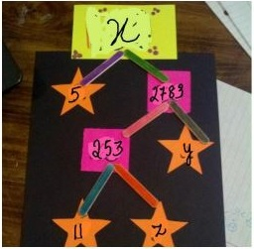  (a)y = x b) y > x c) z < y d) z > y | 1
3 | If x is a prime number and a be any positive integer such that a² is a multiple of x, the which of the following statement is true?  a) x can divide a² b) x may or may not divide a  c) x divides a d) Both (a) and (b) are correct | 1
4 | If a and b are any two integers and b = 3, then a can be expressed as  a) 3q, 3q+ 1, 3q + 2 b) 3q c) none of the above d) 3q+ 1  * Here q is some integer | 1
5 | 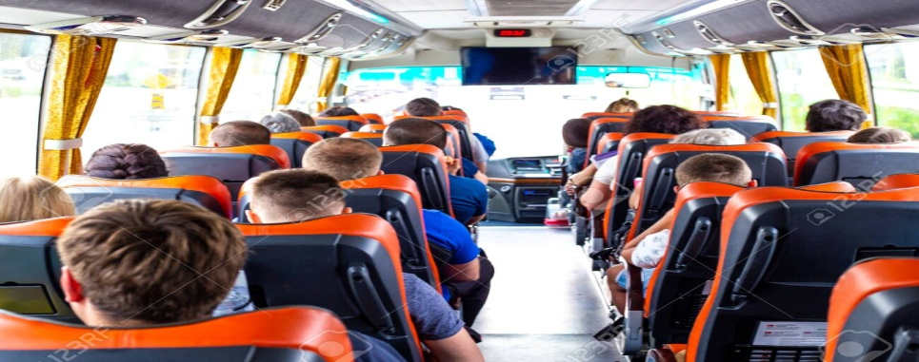  In a Block, the villagers from three Panchayats with strength 280, 504 and 672 respectively want to go on a picnic. Buses are to be hired to take these villagers to the picnic. What is the maximum number of villagers who can sit in a bus if each bus takes equal number of villagers?  a) 72 b) 56 c) 77 d) 85 | 1
6 | If X, Y and Z are three are positive integers such that X = m³n²p , Y = mn³p² and Z = m²n²p² , the find the HCF(X,Y,Z).  - mnp (b) m²np (c) mn²p (d) mnp² | 1
7 | The HCF of y and 153 is 51, where y is a natural number. Which of these can be true for some values of y ?  i) y is a multiple of 51  ii) y is a multiple of 153  iii) y is a an even number  iv) y is a an odd number  a) only (ii) and (iii) b) only (i), (ii) and (iii)  c) only (i), (iii) and (iv) d) all (i), (ii),(iii) and (iv) | 1
8 | The LCM of the two numbers is 20² X 3. Which of the following cannot be their HCF? Justify your reason.  a) 200 b) 400 c) 600 d) 500 | 1
9 | If 3 is the least prime factor of number a and 7 is the least prime factor of number b, then the least prime factor of a + b is  a) 5 b) 2 c) 3 d) 10 | 1
10 | If HCF (26, 169) = 13, then LCM (26, 169) =  (a) 26  (b) 52  (c) 338  (d) 13 | 1
11 | If two positive integers m and n are expressible in the form m = pq3 and n = p3q2 where p, q are prime numbers, then HCF (m, n) =  A. pq  B. pq2  C. p3q3  D. p2q3 | 1
12 | If n = 23 × 34 × 54 × 7, then the number of consecutive zeros in n, where n is a natural number, is  (a) 2  (b) 3  (c) 4  (d) 7 | 1
13 | To enhance the reading skills of grade X students, the school nominates you and two of your friends to set up a class library. There are two sections- section A and section B of grade X. There are 32 students in section A and 36 students in section B.  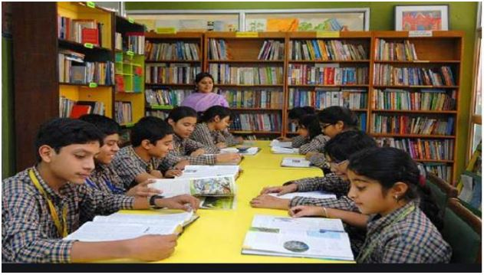  What is the minimum number of books you will acquire for the class library, so that they can be distributed equally among students of Section A or Section B?  a) 144 b) 128 c) 288 d) 272 | 1
14 | To enhance the reading skills of grade X students, the school nominates you and two of your friends to set up a class library. There are two sections- section A and section B of grade X. There are 32 students in section A and 36 students in section B.  If the product of two positive integers is equal to the product of their HCF and LCM is true then, the HCF (32, 36) is  a) 2 b) 4 c) 6 d) 8 | 1
15 | Three farmers have 490 kg, 588 kg and 882 kg of wheat respectively. Find the maximum capacity of a bag so that the wheat can be packed in exact number of bags.  (a) 98 kg  (b) 290 kg  (c) 200 kg  (d) 350 kg | 1
16 | A seminar is being conducted by an Educational Organization, where the participants will be educators of different subjects. The number of participants in Hindi, English and Mathematics are 60, 84 and 108 respectively. In each room the same number of participants are to be seated and all of them being in the same subject, hence maximum number participants that can accommodated in each room are  a) 14 b) 12 c) 16 d) 18 | 1
17 | A seminar is being conducted by an Educational Organization, where the participants will be educators of different subjects. The number of participants in Hindi, English and Mathematics are 60, 84 and 108 respectively. What is the minimum number of rooms required during the event?  a) 11 b) 31 c) 41 d) 21 | 1
18 | A seminar is being conducted by an Educational Organization, where the participants will be educators of different subjects. The number of participants in Hindi, English and Mathematics are 60, 84 and 108 respectively. The LCM of 60, 84 and 108 is  a) 3780 b) 3680 c) 4780 d) 4680 | 1
19 | A Mathematics Exhibition is being conducted in your School and one of your friends is making a model of a factor tree. He has some difficulty and asks for your help in completing a quiz for the audience.  Observe the following factor tree and answer the following:  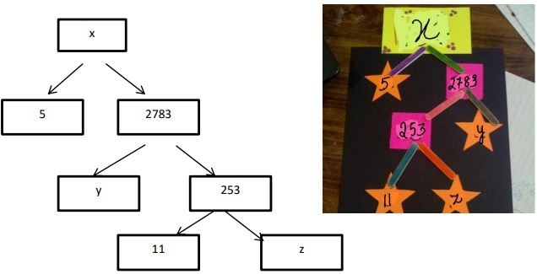  What will be the value of x?  a) 15005 b) 13915 c) 56920 d) 17429 | 1
20 | If n is a natural number, then 9^{2n} – 4^{2n} is always divisible by  - 5  - 13  - Both 5 and 13  - None of these | 1
21 | Ishani was teaching counting from 1 to 10 to her brother who is a Kindergarten student. Suddenly one question came to her mind. Are there any numbers which are divisible by all the numbers from 1 to 10? She found that least number that is divisible by all the numbers from 1 to 10 which is  a) 10 b) 100 c)504 d) 2520 | 1
22 | If 3 is the least prime factor of p, and 7 is the least prime factor of q, then the least prime factor of (p+q) is:  a)11 b)2 c)5 d)10 | 1
23 | n² -1 is divisible by 8 if n is  a)an integer b) a natural number  c) an odd integer d) an even integer | 1
24 | L.C.M. of two co-prime numbers is always  (a) product of numbers (b) sum of numbers  (c) difference of numbers (d)none | 1
25 | The smallest irrational number which should be added to  4 − √5 to get a rational number is:  a ) √4 - 5 b) -√5 c) -4 +√5 d) √5 | 1
 | ANSWERS
1 | b) 288 | 1
2 | d) z > y | 1
3 | d) Both (a) and (b) are correct | 1
4 | a) 3q, 3q+ 1, 3q + 2 | 1
5 | b) 56 | 1
6 | - HCF(X,Y,Z) = mn²p | 1
7 | c) only (i), (iii) and (iv) | 1
8 | d) 500 | 1
9 | b) 2 | 1
10 | c | 1
11 | b | 1
12 | b | 1
13 | c) 288 | 1
14 | b) 4 | 1
15 | a | 1
16 | b) 12 | 1
17 | d) 21 | 1
18 | a) 3780 | 1
19 | b) 13915 | 1
20 | c | 1
21 | (d)2520 | 1
22 | (b) 2 | 1
23 | c) an odd integer | 1
24 | a) product of numbers | 1
25 | d) √5 | 1
 | ASSERTION & REASON QUESTIONS
Choose the correct option in the following questions of Assertion – Reason Questions.
(a) Both A and R are correct; R is the correct explanation of A.
(b) Both A and R are correct; R is not the correct explanation of A.
(c) A is true but R is false
(d) A is false but R is true
1 | Assertion (A): If LCM of two numbers is 2475 and their product is 12375, then their HCF is 5.  Reason (R): HCF (a, b) × LCM (a, b) = a × b. | 1
2 | Assertion (A): For no value of n, where n is a natural number, the number 6n ends with the digit zero.  Reason (R). Choose the correct answer out of the following choices. | 1
3 | Assertion (A) :-LCM of 13 and 61 is 739  Reason (R):- If a and b are prime ,then LCM(a,b) = a X b | 1
4 | Assertion (A) :-HCF of 105 and 225 is 15 and LCM( 105,225)=225 x K, then the value of K is 7.  Reason (R):- If any two positive number a and b, HCF (a,b) x LCM(a,b) = a x b | 1
5 | Assertion (A) :-√3 is an irrational number.  Reason (R):- If p is prime then √p is an irrational number | 1
 | ANSWERS
1 | a | 1
2 | a | 1
3 | d | 1
4 | a | 1
5 | a | 1
 | 2 MARKS TYPE QUESTIONS
1 | If P= 2(4)(6)….(20) and Q = 1(3)(5)….(19), what is the HCF of P and Q? | 2
2 | A, B and C starts cycling around a circular path in the same direction at the same time. Circumference of the path is 1980 m. If speed of A is 330 m/min, speed of B is 198 m/min and that of C is 220 m/min and they start from the same point, then after what time will they be together at the starting point? | 2
3 | The length, breadth and height of a room are 825 cm, 675 cm and 450 cm respectively. Find the longest tape which can measure the three dimensions of the room exactly. | 2
4 | In a morning walk, three persons step off together. Their steps measure 80 cm, 85 cm and 90 cm respectively. What is the minimum distance each should walk so that all can cover the same distance in complete steps? | 2
5 | There are 576 boys and 448 girls in a school that are to be divided into equal sections of either boys or girls alone. Find the total number of sections thus formed. | 2
6 | What is the greatest number of four digits which is divisible by 15, 25, 40 and 75 is? | 2
7 | Let N be the greatest number that will divide 1305, 4665 and 6905, leaving the same remainder in each case. Then what is the sum of the digits in N? | 2
8 | A merchant has 120 liters and 180 liters of two kinds of oil. He wants to sell the oil by filling the two kinds in tins of equal volumes. Find the greatest volume of such a tin. | 2
9 | Find the least number of soldiers in a regiment such that they stand in rows of 15, 20, 25 and form a perfect square. | 2
10 | Given that (1-x)(1+x+x²+x³+x⁴) = 31/32 and x is a rational number. Then find the value of (1+x+x²+x³+x⁴) | 2
 | ANSWERS
1 | HCF = 34 x 52 x 7 = 81x25x7 =14175 | 1+1
2 | As time = Distance / Speed  Time taken by A to complete one round = 1980/330 = 6 min  Time taken by B to complete one round = 1980/198 = 10 min  Time taken by C to complete one round = 1980/220 = 9 min  The three cyclists will be together after  LCM (6, 10, 9)  6 = 2 × 3  10 = 2 × 5  9 = 3 x3  LCM (6, 10, 9) = 2 x 3 x3 x 5 = 90 min.  They will meet after 90 min | 2
3 | To find the length of the longest tape which can measure the three dimensions of the room, we need to find the H.C.F of length, breadth, and height of the room respectively.  825=3×5×5×11  675=3×3×3×5×5  450=2×3×3×5×5  So, H.C.F=3×5×5=75  Hence, the length of the longest tape should be 75cm. | 2
4 | The required distance each should walk would be the L.C.M of the measures of their steps i.e. 80 cm, 85 cm, and 90 cm  80 = 24 x 5  85 = 17 x 5  90 = 2 x 32 x 5  L.C.M of 80, 85 and 90 = 24 x 32 x 5 x 17 = 12240 cm  Hence minimum 12240 cm distance each should walk so that all can cover the same distance in complete steps. | 2
5 | Correct option is C)  576=2×2×2×2×2×2×3×3  448=2×2×2×2×2×2×7  HCF =2×2×2×2×2×2=64  ∴ HCF of 576 and 448 = 64  ∴ Number of sections = 576/64 + 448/64 = 9 + 7 = 16 | 2
6 | Required number = H.C.F. of (91 - 43), (183 - 91) and (183 - 43)  = H.C.F. of 48, 92 and 140 = 4. | 2
7 | N = H.C.F. of (4665 - 1305), (6905 - 4665) and (6905 - 1305)  = H.C.F. of 3360, 2240 and 5600 = 1120.  Sum of digits in N = ( 1 + 1 + 2 + 0 ) = 4 | 2
8 | It is given that the quantities of the three kinds of oils are 120 litres, 180 litres and 240 litres.  Factorize all three numbers 120, 180, 240.  120=2×2×2×3×5 180=2×2×3×3×5 240=2×2×2×2×3×5  Thus, HCF (120, 120, 240) = 60.  Therefore, the greatest capacity of the tin is 60 litres. | 2
9 | That is the least common multiple of (15, 20, 25).  LCM (15, 20, 25) = 300  So, we need 300 soldiers such that they stand in rows of 15, 20 , 25  But, it has to form a perfect square (as per the question).  To make 300 as perfect square, we have to multiply 300 by 3.  Then, it is 900 which is a perfect square.  Hence, the least number of soldiers required is 900. | 2
10 | (1-x) (1+x+x²+x³+x⁴) = 1 - x⁵= 1 - 1/32  x⁵ = 1/32 or x = ½  Therefore, 1+x+x²+x³+x⁴+x⁵= (1-x⁶)/1-x  = (1-1/64)/(1-½)  = 63/32 | 2
 | 3 – MARKS TYPE QUESTIONS
1 | Prove that √5 is irrational and hence show that 3 + √5 is also irrational. | 3
2 | The product of the LcM and HcF of two natural numbers is 24. The difference of two numbers is 2. Find the numbers. | 3
3 | Find the value of a, if 6/(3√2 – 2√3) = 3√2 – a√3 . | 3
4 | Show that 5 + √3 is irrational. | 3
5 | The Muscle Gym has bought 63 treadmills and 108 elliptical machines. The gym divides them into several identical sets of treadmills and elliptical machines for its branches located throughout the city, with no exercise equipment left over. What is the greatest number of branches the gym can have in the city?
6 | There are 7 friends playing with marbles. When they divide the marbles evenly between three friends, there are two marbles left over. When the same marbles are divided evenly among five friends, there are two marbles left over. When the marbles are divided among seven friends there are two marbles left over. What is the least possible number of marbles in the bag. Is there any other possible number of marbles in the bag? | 3
7 | Dinesh says that if √4x2 is irrational then √4 + √2 is also irrational. Therefore, if √ab, √bc and √ca is an irrational number, then show that √a + √b + √c is also irrational. | 3
8 |   Shreya takes 35 seconds to pack a gift and label it. For Ravi the same job takes 42 seconds and for Priya, it takes 28 seconds. If they all start using the labeling machine at the same time, after how many seconds will they be using the labeling machine together and by then what is the total number of gifts they all would have packed and labeled together? | 3
9 | An army contingent of 612 members is to march behind an army band of 48 members in a parade. The two are to march in the same number of columns. What is the maximum number of columns in which they can march? | 3
10 | On a morning walk three person steps out together and their steps measure 30 cm, 36 cm and 40 cm respectively. What is the minimum distance each should walk so that each can cover the same distance in complete steps? | 3
 | ANSWERS
1 | : Let $\sqrt{5}$ is a rational number then we have  $\sqrt{5}$ =$\frac{p}{q}$ , where p and q are co-primes.  Squaring both sides, we get  p² = 5q²  p2 is divisible by 5  p is also divisible by 5  So, assume p = 5m where m is any integer.  Squaring both sides, we get p² = 25m²  But p² = 5q²  Therefore, 5q² = 25m²   q² = 5m²   q² is divisible by 5   q is also divisible by 5  From above we conclude that p and q has one common factor i.e. 5 which contradicts that p and q  are co-primes.  Therefore, our assumption is wrong.  Hence$\sqrt{5}$ is an irrational number.  Now, we know 3 is a rational number and $\sqrt{5}$ is irrational.  Rational + Irrational = Irrational  So, 3+$\sqrt{5}$ is irrational.
2 | Let the numbers be p and (p + 2).  ∴ Product of numbers = HCF × LCM  ⇒ p (p + 2) = 24  ⇒ p² + 2p – 24 = 0  ⇒ p² + 6p – 4p – 24 = 0  ⇒ p (p + 6) – 4 (p + 6) = 0  ⇒ (p – 4) (p + 6) = 0  ⇒ p = 4 or p = – 6  Numbers = p = 4 and p + 2 = 4 + 2 = 6.  ∴ Numbers are 4 and 6.
3 | Given,  6/(3√2 – 2√3) = 3√2 – a√3….(i)  Consider LHS,  6/(3√2 – 2√3)  Rationalizing the denominator, we get;  [6/(3√2 – 2√3)] [(3√2 + 2√3)/ (3√2 + 2√3)]  = [6(3√2 + 2√3)]/ [(3√2)2 – (2√3)2]  = [6(3√2 + 2√3)]/ (18 – 12)  = 6(3√2 + 2√3)/6  = 3√2 + 2√3….(ii)  From (i) and (ii),  -a = 2  a = -2
4 | Let us assume that 5 + √3 is a rational number.  We can find coprime a and b (b ≠ 0) such that 5 + √3 = a/b.  So,  √3 = (a/b) – 5  √3 = (a – 5b)/b  Since a and b are integers, we get (a/b) – 5 is rational, and so √3 is rational.  But this contradicts the fact that √3 is irrational.  This contradiction has arisen because of our incorrect assumption that 5 + √3 is rational.  Therefore, we conclude that 5 + √3 is irrational.
5 | Let the greatest number of branches in the city be 'n'.  Let the number of treadmills sent to each branch be 't' and the number of ellipticals sent to each branch be 'e'.  63 treadmills were distributed to 'n' branches with each branch getting 't' treadmills.  i.e., nt = 63  108 elliptical machines were distributed to 'n' branches with each branch getting 'e' elliptical machines.  i.e., ne = 108.  HCF of 108 and 63 is 9. So, the greatest number of branches the gym can have in the city is 9.
6 | x ÷ 3 = 2  x ÷ 5 = 2  x ÷ 7 = 2  LCM(3,5,7) = 105  Least possible number of marbles in the bag = 102 + 2 = 104  Another possible number of marbles in the bag = 102 x 2 = 204 + 2 = 206
7 | Let (√a + √b + √c) be a rational number  √a + √b + √c = p / q  Squaring both sides  (√a + √b + √c)² ⁼ (p/q)²  a + b + c + 2√ab + 2√bc + 2√ac = p²/q²  2(√ab + √bc + √ac) = p²/q² - (a + b + c)  √ab + √bc + √ac = p²/2q²- (a + b + c)/2  But is given that √ab, √bc, √ac are irrational, therefore our assumption is wrong  √a + √b + √c is an irrational number
8 | 35 = 7 x 5  42 = 7 x 2 x 3  28 = 7 x 2 x 2  LCM (35, 42, 28) = 7 x 5 x 2 x 3 x 2 = 420  Ans - All of them will be using labelling machine together after 420 seconds  In 420 seconds, Shreya will pack 420 ÷ 35 = 12 gifts  Similarly, in 420 seconds, Ravi and Priya will pack 420 ÷ 42 = 10 gifts and 420 ÷ 28 = 15gifts respectively  Therefore, total gifts packed 12 + 10 + 15 = 37
9 | Clearly, the maximum number of columns = HCF(612, 48)  Now, 612 = ($2^{2}×3^{2}×17$ and 48 = $2^{4}×3$  HCF(612, 48) = $2^{2}×3=12$
10 | Required distance = LCM( 30 cm, 36 cm, 40 cm)  Now, 30 = 2x3x5 and 36 = 2x2x3x3 and 40 = 2x2x2x5  Required distance = LCM(30, 36, 40)  = ($2^{3}×3^{2}×5)$ cm  = 360 cm
 | 4 – MARKS TYPE QUESTIONS (CASE BASED QUESTIONS)
1 | 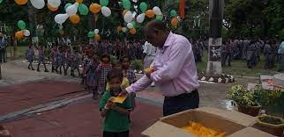  The School has to distribute 12000 chocolates, 8400 cakes and 7200 biscuits to students on occasion of Independence Day celebration. These items were brought from a famous store which packed 60 chocolates, 42 biscuits and 36 cakes in a box. These items are contained in a box and will be distributed equally among a specific number of students. Find the total number of students who will get items from the same box and also find the quantity of each item they will get.  a) What is the total number of students who will get items from the same box?  b) Find the total number of students among which these items were distributed? | 4
2 | A result of global warming the ice of some glaciers is melting. Twelve years after the ice disappears, tiny plants, called lichen, start to grow on the rocks. Each lichen grows approximately in the shape of a circle. The relationship between the diameter of this circle and the age of the lichen can be approximated with the formula: d =7.0 × √(t – 12) for t ≥ 12 where d represents the diameter of the lichen in millimeters, and t represents the number of years after the ice has disappeared.  a) Using the formula, calculate the diameter of the lichen, 16 years after the ice disappeared.  b) Mandeep measured the diameter of some lichen and found it was 35 millimeters. How many years ago did the ice disappear at this spot? | 4
3 | A, B and C starts cycling around a circular path in the same direction at the same time. Circumference of the path is 1980 m. If speed of A is 330 m/min, speed of B is 198 m/min and that of C is 220 m/min and they start from the same point, then after what time will they be together at the starting point?  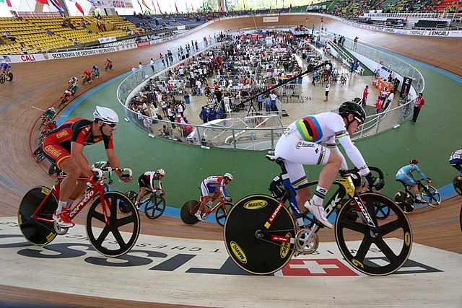  - Find time taken by A to complete one round?  - Find time taken by B to complete one round?  - Find time taken by C to complete one round?  At what time they will be together at the starting point? | 4
4 | 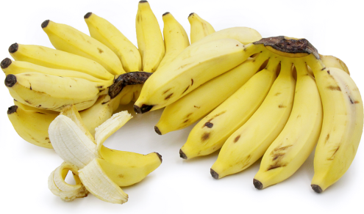  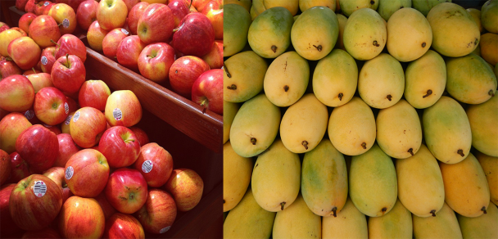  Mira a very health conscious mathematics teacher of class 10 she avoids fast food, cakes, ice-cream etc. on her birth day she decided to serve fruits to her friends and students. She had 60 bananas 36 apples which are to be distributed equally among all.  - How many maximum guests Mira can invite?  - 6  - 96  - 12  - 180  - How many apples will each guest get?  - 3  - 6  - 4  - 5  - If Mira also decides to distribute 42 mangoes, how many maximum guests she can invite?  - 12  - 6  - 8  - 180 | 4
5 | Lavanya wants to organize her birthday party. She is very happy on her birthday. She is very health conscious, thus she decided to serve fruits only in her birthday party. She has 36 apples and 60 bananas at home and decided to serve them. She wants to distribute fruits among guests. She does not want to discriminate among guests, so she decided to distribute fruits equally among all.  (i) How many maximum guests Lavanya can invite?  (ii) How many apples and bananas will each guest get?  (iii) Lavanya decide to add 42 mangoes also. In this case how many maximum guests Lavanya can invite?  (iv) How many total fruits will each guest get? | 4
6 | Ravish runs a book shop. He received 480 science books, 192 Hindi books and 672 Mathematics books of class X. He wishes to average these books in minimum number of stacks such that each stack consists of the books on only one subject and the number of books in each stack in the same.  - Find the number of books in each stack.  - Find the number of stacks of Mathematics books.  Find the difference in number of stacks of Mathematics books and sum of stacks of Science and Hindi books. | 4
7 | 18 chocolates and 15 biscuit packets have been donated in several smaller identical boxes with the same number of chocolates and biscuit packets in each.  - How many biscuit packets will each box contain?  (i)3 (ii) 5 (c) 2 (d) 15  (b) How many chocolate packets will each box contain?  (i) 6 (ii) 3 (c) 3 (d) 9  (c) Find the maximum number of chocolate and biscuit packets that can be placed in one box .  (i) 2 (ii) 5 (c) 3 (d) 9 | 4
8 | To enhance the reading skills of grade X students, the school nominates you and two of your friends to set up a class library. There are two sections- section A and section B of grade X. There are 32 students in section A and 36 students in section B.  1. What is the minimum number of books you will acquire for the class library, so that they can be distributed equally among students of Section A or Section B?  a) 144 b) 128 c) 288 d) 272  2. If the product of two positive integers is equal to the product of their HCF and LCM is true then, the HCF (32 , 36) is  a) 2 b) 4 c) 6 d) 8  3. 36 can be expressed as a product of its primes as  a) 22 × 32 b) 21 × 33 c) 23 × 31 d) 20 × 30  4. 7 × 11 × 13 × 15 + 15 is a  a) Prime number b) Composite number  c) Neither prime nor composite d) None of the above | 4
 | ANSWERS
1 | a)To distribute all these items equally we have to find out the highest common factor which will be total number of students who gets share from the same box.  60 = 2 X 2 X 3 X 5  42 = 2 X 3 X 7  36 = 2 X 2 X 3 X 3  HCF of 60, 42, 36 = 2 X 3  = 6  Hence 6 students will get share from each box.  b) For each student  Number of chocolates = 60 / 6 = 10  Number of biscuits = 42/6 = 7  Number of cakes = 36/ 6 = 6  Total number of students among which 12000 cakes distributed = 12000/10 = 1200  Or,  Total number of students among which 12000 cakes distributed = 8400/7 = 1200  Or,  Total number of students among which 12000 cakes distributed = 7200/6 = 1200  (Any one method, out of the three methods above, is correct) | 4
2 | a) 14mm b) 37 years | 4
3 | a)Time taken by A to complete one round = 1980/330 = 6 min  b)Time taken by B to complete one round = 1980/198 = 10 min  c)Time taken by C to complete one round = 1980/220 = 9 min  d)The three cyclists will be together after LCM (6, 10, 9)  6 = 2 × 3  10 = 2 × 5  9 = 32  LCM (6, 10, 9) = 21 × 32 × 5 = 90 min. | 4
4 | - c. 12  - a. 3  - iii b. 6 | 4
5 | (i) Lavanya can invite a maximum of 12 guests.  (ii) Each guest will get:  - Apples: 36 apples / 12 guests = 3 apples per guest  - Bananas: 60 bananas / 12 guests = 5 bananas per guest  (iii) Adding 42 mangoes to the existing fruits:  - Apples: 36 apples  - Bananas: 60 bananas  - Mangoes: 42 mangoes  To find the greatest common divisor (GCD) of 36, 60, and 42, which will give the maximum number of guests Lavanya can invite with an equal number of fruits:  GCD(36, 60, 42) = 6  So, Lavanya can invite a maximum of 6 guests when considering apples, bananas, and mangoes.  (iv) With the addition of mangoes, the total number of fruits is 36 + 60 + 42 = 138 fruits. Each guest will get 138 fruits / 6 guests = 23 fruits per guest. | 4
6 | - HCF of 480 , 192 and 672 = 96 .  - 692/96 = 7  - $\frac{672}{96}- \frac{480}{96}+ \frac{192}{96}$  7 – 7 = 0 | 4
7 | - (ii) 5  - (iv) 9  - (iii) 3 | 4
8 | 1. c) 288  2. b) 4  3. a) 22 × 32  4.b) Composite number | 4
 | 5 – MARKS TYPE QUESTIONS
1 | 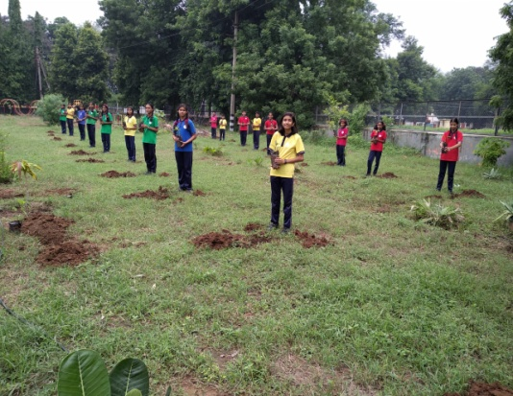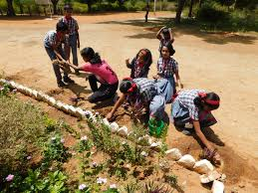  The students of Kendriya Vidyalaya wants to do a plantation drive on the occasion of World Environment Day. They planned to plant trees in two rectangular fields of same width but different lengths. they are required to plant 105 trees in smaller field and 252 trees in larger field. In both the fields the trees will be planted in same number of rows but different number of columns.  a) What is the greatest number of rows that can be planted in this arrangement?  b) If the trees are planted in the number of rows obtained in part (a), how many columns will each field has?  c) What is the relationship between the number of rows and the difference between the number of columns in two fields? | 5
2 | A hall has a certain number of chairs. Guests want to sit in different groups like in pairs, triplets, quadruplets, fives and sixes etc. When organizer arranges chairs in such pattern like 2’s, 3’s ,4’s.5’s and 6’s then 1,2,3,4 and 5 chairs are left respectively. But when he arranges in 11’s no chair will be left  A) In the hall how many least numbers of chairs are available?  B) If one chair is added to the total number of chairs, how many chairs will be left when arranged in 7̕s | 5
3 | Kerosene, paraffin, or lamp oil is a combustible hydrocarbon liquid which is derivative from petroleum. Kerosene’s uses vary from fuel for oil lamps to cleaning agents, jet fuel , heating oil or fuel for cooking Two oil tankers contain 825 litres and 625 litres of kerosene oil respectively.  i)Find the maximum capacity of a container which can measure the Kerosene oil of both the tankers when used an exact number of times.  ii)How many times we have to use container for both the tanker to fill? | 5
4 | Shree Sundar Kamla Nagar Society decided to give some food packets and grocery packets to the needy on Independence Day. They have 36 food packets and 72 grocery packets to distribute. They do not want to discriminate among the needy, so they decided to distribute packets equally among all.  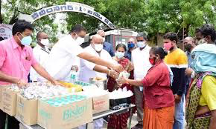  (i) To how many maximum people can they distribute the packets?  (ii) How many food and grocery packets will each one gets?  (iii) Now, they decide to add 54 packets of vegetables also. In this case to how many maximum people can they distribute the packets?  (iv) How many total packets will each person get?  (v) If they decide to add 18 more vegetable packets and remove 36 grocery packets, in this case to how many maximum people can they distribute the packets? | 5
5 | Students of class VI in their free period started playing a game. One of the students announced a prime number 3 in the class and the next students multiplied it by a prime number and passed it to the next student. Then again it was multiplied by a prime number and passed on to the next student. In this way by multiplying to a prime number the last student got 90090 which the student announced in class.  Answer the following questions  (i) How many students are in the class?  (ii) Which is the highest prime number used by the student?  (iii) What is the least prime number used by the student?  (iv) Which prime number has been used maximum number of times?  (v) Which prime number has been used minimum number of times? | 5
 | ANSWERS
1 | - To find the number of rows we have to find the HCF of 105 and 252.  So, the total number of rows = HCF (105, 252)  = 21  b) Number of columns in smaller field = 105/21= 5  Number of columns in larger field = 252/21 = 12  c) The number of rows = 21  The difference between the number of columns in two fields = 12 – 5 = 7  Therefore, the relationship is as follows,  The number of rows is 3 times the difference between the number of columns in two fields.  Or,  The number of rows is a multiple of the difference between the number of columns in two fields. | 5
2 | A)When chairs are arranged in pair , 1 chair left  When chairs are arranged in 3^{,s} , 1 chair left  When chairs are arranged in 4^{,s}, 1 chair left  And so on  So,we find (2-1)=(3-2)=(4-3)= (5-4)= (6-5)=1(k)  LCM of 2,3,4,5,6= 2x2x3x5=60  Required number= (60n-1)/11=remainder 0 (n is a natural number)  Taking n=9  (60x9-1)/11=539/11=remainder 0  Therefore least possible number is 539  B) 539+1=540  540/7 = remainder 1  1 chair left. | 5
3 | (i) HCF of 825 and 625  825 = 3 x 5 x 5 x 11  675 = 3 x 3 x 3 x5 x 5  HCF = 3 x 5 x 5 = 75  Maximum capacity reqired is 75 litres  (ii) The first tanker will require 875/75 = 11 times to fill  The second tanker will require 675/75 = 9 times to fill | 5
4 | (i) Maximum people to whom the packets can be distributed = HCF(36,72)  36 = 18 x 2, 72 = 18 x 4  Ans - 18  (ii) Each one will get 2 food packets and 4 grocery packets  (iii) Maximum people to whom the packets can be distributed = HCF(36,54,72)  36 = 18 x 2, 54 = 18 x 3, 72 = 18 x 4  Ans - 18  (iv) Each one will get 2food packets and 3 grocery packets and 4 vegetable packets  (v) No. of vegetable packets = 54 + 18 = 72  No. of grocery packets = 72 - 36 = 36  Maximum people to whom the packets can be distributed = HCF(36,36,72)  36 = 36 x 1, 36 = 36 x 1, 72 = 36 x 2,  Ans - 36 | 5
5 | 90090 = 3 x 30030  30030 = 3 x 10010  10010 = 5 x 2002  2002 = 2 x 1001  1001 = 11 x 91  91 = 7 x 13  13 = 13 x 1  90090 = 2 x 3² x 5 x 7 x 11 x 13  (i) Total number of students in the class = No of prime numbers used to multiply and reach 90090 = 7  (ii) Highest prime number used by the students = 13  (iii) Least prime number used by the student = 2  (iv) 2, 5, 7, 11 and 13 have been used minimum number of times. | 5

CHAPTER – 2
POLYNOMIALS

SYLLABUS:
Zeros of a polynomial. Relationship between zeros and coefficients of quadratic polynomials.

SL NO | QUESTION | MARK
 | MULTIPLE - CHOICE QUESTIONS
1 | Raju, Hari and Ramesh are playing a game in which Raju is asked to write the first letter of the word apple. Then Hari is asked to add 7 with this letter. At last Ramesh is asked to square the number written by Hari. What could be the maximum number of zeroes of the polynomial obtained by Ramesh?  - 1 (b) 2 (c) 3 (d) 4 | 1
2 | 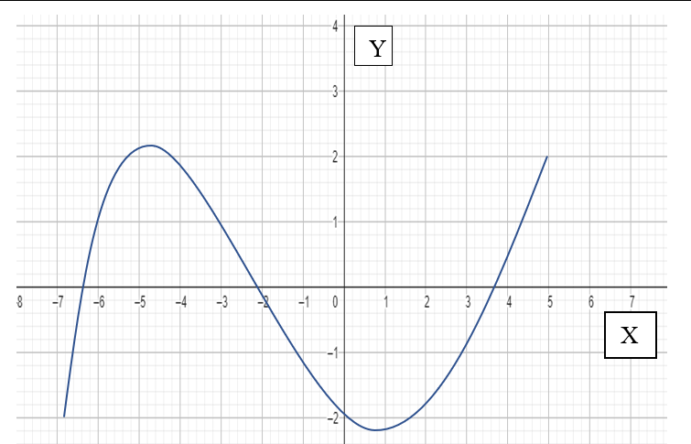  The graph of f(x) is as shown. The product of zeroes of f(x) is  - Positive (b) negative (c) zero (d) cannot say | 1
3 | The maximum number of zeroes a cubic polynomial can have is  (a)1 (b) 4 (c) 2 (d) 3 | 1
4 | If $\left(a-2\right)x^{2}+3x-5 is a quadratic polynomial then$  (a) $a$ can take any real value  (b)$a$ can take any non-zero value  ( c)$a≠2$  (d)$a=2$ | 1
5 | The zeroes of the quadratic polynomial F(x) = x² – 12x + 32 are  - Both positive  - Both negative  (c) One positive one negative  (d) Both equal | 1
6 | 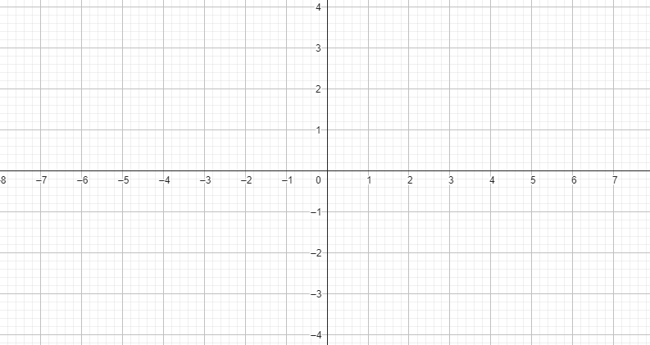  Due to heavy storm the electric wire is bent down as shown in the figure. Find the zeroes of the curve traced by the electric wire.  - -2, 3  - -2, -2  - -2, 2  - 2,2 | 1
7 | If one of the zeroes of the quadratic polynomial $2x^{2}+ k x - 12$ is – 4, the value of k is ----------  a) ± 5 b) 5 c) – 5 d) none of the above | 1
8 | If α and β are the zeroes of the polynomial $p(x)= {x }^{2}- 4x - 21$ then the value of $\frac{1}{α}+\frac{1}{β} is$  a) – 1/21 b) 4/21 c) 25/84 d) – 4/21 | 1
9 | If α and β are the zeros of the polynomial $2 {x }^{2}- 5 x - 18$, the value of αβ is:-  a) – 9 b) – 18 c) 9 d) 36 | 1
10 | $x+2$ is a factor of $x^{2}$+$ax+2b$ and$a +b=4$ then  $\left(a\right) a=1,b=3$ (b) $a=3,b=1$ (c) $a=-1,b=5$(d) $a=5,b=-1$ | 1
11 | If $p(x)$ is a polynomial of at least degree one $and p(k) = 0,$ then $k$ is known as  - Value of p(x) b) zero of p(x)  (c) constant term of p(x) (d) none of these | 1
12 | 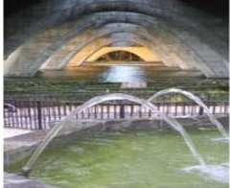  The graph of parabola opens downwards, if _______  a) a ≥ 0  b) a = 0  c) a < 0  d) a > 0 | 1
13 | Which of the following is not the graph of quadratic polynomial?  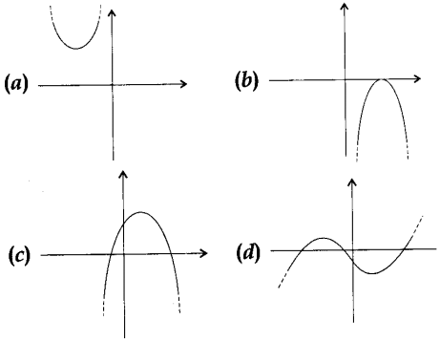 | 1
14 | The zeroes of x²–2x –8 are:  (a) (2,-4)  (b) (4,-2)  (c) (-2,-2)  (d) (-4,-4) | 1
15 | what is the quadratic polynomial whose sum and the product of zeroes is √2, ⅓  respectively?  (a) 3x²-3√2x+1  (b) 3x²+3√2x+1  (c) 3x²+3√2x-1  (d) None of the above | 1
16 | If the zeroes of the quadratic polynomial ax²+bx+c, c≠0 are equal, then  (a) c and b have opposite signs  (b) c and a have opposite sings  (c) c and b have same signs  (d) c and a have same signs | 1
17 | The degree of the polynomial, x⁴ – x² +2 is  (a) 2 (b) 4 (c) 1 (d) 0 | 1
18 | If one of the zeroes of cubic polynomial is x³+ax²+bx+c is -1, then product of other  two zeroes is:  (a) b-a-1 (b) b-a+1 (c) a-b+1 (d) a-b-1 | 1
19 | If p(x) is a polynomial of degree one and p(a) = 0, then a is said to be:  (a) Zero of p(x) (b) Value of p(x) (c) Constant of p(x) (d) None of the above | 1
20 | Zeroes of a polynomial can be expressed graphically. Number of zeroes of  polynomial is equal to number of points where the graph of polynomial is:  (a) Intersects x-axis (b) Intersects y-axis  (c) Intersects y-axis or x-axis (d) None of the above | 1
21 | A polynomial of degree n has:  (a) Only one zero (b) At least n zeroes  (c) More than n zeroes (d) At most n zeroes | 1
22 | If one zero of the quadratic polynomial x² + 3x + k is 2, then the value of k is  (a) 10  (b) -10  (c) 5  (d) -5 | 1
23 | If one of the zeroes of the quadratic polynomial (k – 1) x² + kx + 1 is – 3, then find the value of k .  - 4/3  - -4/3  - 2/3  -2/3 | 1
24 | If the zeroes of the quadratic polynomial x2 + (a + 1) x + b are 2 and -3, then  (a) a = -7, b = -1  (b) a = 5, b = -1  (c) a = 2, b = -6  (d) a – 0, b = -6
25 | If one of the zeroes of the cubic polynomial x3 + ax² + bx + c is -1, then the product of the other two zeroes is  (a) b – a + 1  (b) b – a – 1  (c) a – b + 1  (d) a – b – 1
 | ANSWERS
1 | (b) 2 | 1
2 | (a)Positive | 1
3 | (d) 3 | 1
4 | c | 1
5 | (a)Both positive | 1
6 | (c) -2, 2 | 1
7 | b | 1
8 | d | 1
9 | a | 1
10 | b | 1
11 | b | 1
12 | c | 1
13 | d | 1
14 | b | 1
15 | a | 1
16 | d | 1
17 | b | 1
18 | a | 1
19 | a | 1
20 | a | 1
21 | d | 1
22 | b | 1
23 | a | 1
24 | d | 1
25 | a | 1
 | ASSERTION & REASON QUESTIONS
Choose the correct option in the following questions of Assertion – Reason Questions.
(a) Both A and R are correct; R is the correct explanation of A.
(b) Both A and R are correct; R is not the correct explanation of A.
(c) A is true but R is false
(d) A is false but R is true
1 | Assertion(A): The polynomial f(x) = x² -2x + 2 has two real zeroes.  Reason(R): A quadratic polynomial can have at most two real zeroes. | 1
2 | Assertion(A): A quadratic polynomial can have two zeroes.  Reason(R): x²+7x+12 has no real zeroes. | 1
 | ANSWERS
1 | d | 1
2 | c | 1
 | 2 MARKS TYPE QUESTIONS
1 | If $α and β are the zeros of the polynomial p\left(x\right)=3x^{2}-2x-1,$ without finding the actual value of $α and β$evaluate $(1-α)(1-β)$. | 2
2 | If one zero of the polynomial $\left(a^{2}+16\right)x^{2}+16x+8$ is reciprocal of other, find the value of $a$. | 2
3 | If the sum of the zeroes of the polynomial $p\left(y\right)=ky^{2}+2y-3k$ is twice their product find the value of k. | 2
4 | If one zero of the polynomial $x^{2}-4x+1$ is $2+√3$ what is other zero? | 2
5 | When Aryan was watching a boy playing football, he visualized that the path traced by the ball resembles a parabola, which can be represented by the quadratic polynomial ax² + bx + c , a $≠$ 0.  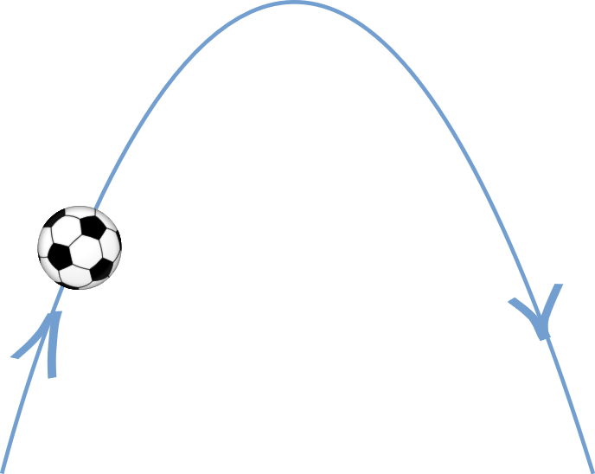    If the polynomial is – 6x² + 3 + 7x ,then find the sum of the reciprocal of zeroes. | 2
6 | In a pool at an aquarium, a dolphin jumps out of the water travelling at 20 cm per second. Its height above water level after t seconds is given by h = 20 t – 16 t².  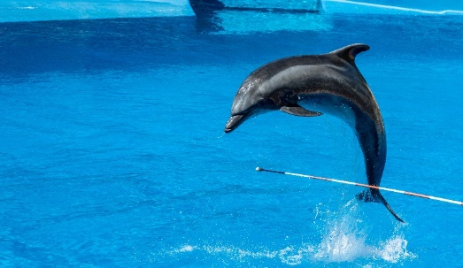  Find the distance the dolphin has covered before hitting the water level again? | 2
7 | Find the distance between the two zeroes of the polynomial 2x² – x – 6 . | 2
8 | If p and q are the zeroes of the polynomial 2x² + 5x – 4 ,  find the value of ( 1 – p ) ( 1 – q ) . | 2
9 | If the zeroes of the polynomial p(x) = 2x² – 6x – 3 are of the form $\frac{3 ±\sqrt{k}}{2}$ , where k is a real number. Find the value of k. | 2
10 | If α and β are the zeroes of the quadratic polynomial p(y)=5y2-7y+1, find the value of $\frac{1}{α}+\frac{1}{β}$ | 2
 | ANSWERS
1 | $α+β=-\frac{b}{a}$=$\frac{-(-2)}{3}=\frac{2}{3}$ ,$αβ=\frac{c}{a}=-\frac{1}{3}$  $$\left(1-α\right)\left(1-β\right)=1-\left(α+β\right)+αβ=1-\frac{2}{3}-\frac{1}{3}=0$$ | 2
2 | If $α and β$ are the zeros of $p\left(x\right)=\left(a^{2}+16\right)x^{2}+16x+8$then  $αβ=\frac{8a}{a^{2}+16}=1$ $⟹a^{2}+16=8a⟹a^{2}-8a+16=0⟹{\left(a-4\right)}^{2}=0⟹a=4$ | 2
3 | $$p(y)=ky^{2}+2y-3k$$  Here $a=k,b=2,c=-3k$.  Sum of zero=2x product of zeros$⟹-\frac{b}{a}=\frac{c}{a}⟹-\frac{2}{k}=2×(-\frac{3k}{k})$.  $$⟹k=\frac{1}{3}$$ | 2
4 | If $a$ is the other zero of the polynomial $x^{2}-4x+1, then$,$2+\sqrt{3}+a=-\frac{b}{a}=-\left(\frac{-4}{1}\right)⟹a=4-2-\sqrt{3}=2-√3$ | 2
5 | $α$ + $β$ = 7/6  $α β$ = - 1 /2  So $\frac{1}{α}$ + $\frac{1}{β}$ = - 7/3 | 2
6 | Solving for t , t = 0 and t = 5/4  So in 5/4 seconds , distance covered = 20 $×$ 5/4 = 25 cm | 2
7 | 2x² – x – 6 = 2x² – 4x + 3x – 6 = 2x( x – 2 ) + 3 ( x – 2 )  = ( x – 2 ) ( 2x + 3 )  x = 2 and x = - 3 /2  So the distance between two zeroes is 2 + 3/2 = 7/2 units | 2
8 | p + q = - 5 /2, pq = -4/2 = - ½  ( 1 – p ) ( 1 – q )= 1 – (p + q ) + pq = 1 + 5/2 – ½ = 1 + 2 = 3 | 2
9 | $\left(\frac{3+ \sqrt{k}}{2}\right)$ $\left(\frac{3- \sqrt{k}}{2}\right)$ = - 3 /2  For solving as k = 15 | 2
10 | p(y)=5y²-7y+1  α+β =$\frac{7}{5}$ αβ =$\frac{ 1}{5}$  $\frac{1}{α}+\frac{1}{β}$ = $\frac{α+β}{αβ}=\frac{7}{1}$=7
 | 3 - MARKS TYPE QUESTIONS
1 | If $α$ and $β$ are the zeroes of the polynomial 2x² – 3x + 1 , form a quadratic polynomial whose zeroes are 3$α$ and 3$β$.
2 | Lavanya throws a ball upwards, from a rooftop, which is 20 m above from ground. It will reach a maximum height and then fall back to the ground. The height of the ball from the ground at time t is h , which is given by h = - 4t² +16t + 20 .  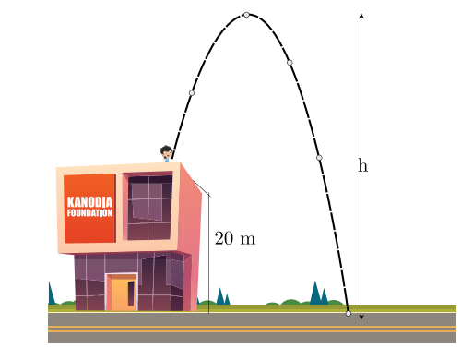  What are the two possible times to reach the ball at the same height of 32 m?
3 | A parabolic shape object used for receiving signals from a satellite, especially television signals. A satellite dish works in the same way as the reflector for a torch or car headlights. A signal is produced or reflected from a focal point.  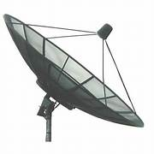  If the parabola represents the polynomial p(t) = t² – p(t+1) – c and $α$ and $β$ are its zeroes then prove that ($α$ + 1) ($β$ + 1) = 1 – c .
4 | Football is a family of team sports that involve, to varying degrees, kicking a ball to score a goal. In a football match ball bounce resembles the movement of parabola.  If α,β be the zeros of the polynomial 2x2+5x+k such that α2+β2+αβ=$\frac{21}{ 4}$ then find the value of k. | 3
5 | Find the zeroes of the quadratic polynomial f(x)= abx2 +(b2-ac) x-bc and verify the relationship between zeroes and it's coefficients. | 3
6 | 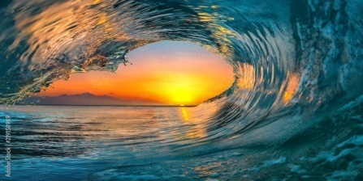  In nature we find many examples for polynomials everywhere. If α,β are zeroes of such a polynomial f(x)=x2−p(x+1)−c, then find the value of (α+1)(β+1). | 3
7 | Find the zeros of the polynomial p(x) = 4$\sqrt{3}$x2 + 5x – 2$\sqrt{3}$ and verify the relationship between the zeroes and its coefficients. | 3
8 | If' $a$ and b are the zeros of the quadratic polynomial f(x) =$x^{2}$ – x – 4, find the value of $\frac{1}{ a}$ + $\frac{1}{ b}$ - $ab$ | 3
9 | If the square of the difference of the zeros of the quadratic polynomial f(x) = x2+ px +45 is equal to 144, find the value of p. | 3
10 | Find the value of k such that the polynomial x²-(k+6)x+2(2k-1) has sum of its zeroes equal to half of their product. | 3
 | ANSWERS
1 | $α$ + $β$ = 3/2, $α β$ = 1/2  Sum of the zeroes of the required polynomial = 3 $α$ + 3 $β$ = 9/2  Product = 9 $α β$ = 9/2  So the polynomial is x² – 9/2 x + 9/2 | 3
2 | h = - 4t² +16t + 20 .  32= - 4t² +16t + 20  4t² – 16t + 12 = 0  For solving t = 1 and 3. | 3
3 | p(t) = t² – p(t+1) – c= t² – pt – p – c  ($α$ + 1) ($β$ + 1) = $α β$ + $α$ + $β$ + 1 = - p – c +p + 1 = 1 – c | 3
4 | α and β are zeroes of polynomial  2x² + 5x + k  α+β=$\frac{-b}{a}$ =$\frac{-5 }{2}$and α.β=$\frac{c}{a}$=$\frac{k}{2}$  α²+β²+αβ=$\frac{21}{4}$  (α²+β²+2αβ)- αβ =$\frac{21}{4}$  (α+β)²- αβ =$\frac{21}{4}$  $\frac{25}{4}$ –$\frac{k }{2}$=$\frac{21}{ 4}$  k=2 | 3
5 | f(x)= abx2+(b2−ac)x−bc=0  ⟹abx2+b2x−acx−bc=0  ⟹bx(ax+b)−c(ax+b)=0  ⟹(bx−c)(ax+b)=0  Solving the above equation for x, we get  ⟹(bx−c)=0 or (ax+b)=0  X=$\frac{-b}{a}$ or x = $\frac{c}{b}$  Zeroes of f(x), α$=\frac{-b}{a}$ ,β = $\frac{c}{b}$  α+β=$\frac{-b}{a}$+ $\frac{c}{b}$ =$\frac{ac-b^{2}}{ab}$ =$\frac{- (Coefficient of x ) }{(Coefficient of x^{2}) }$  αβ= $\frac{-b}{a}$ x $\frac{c}{b}$ =$\frac{-c}{ a}$ =$\frac{Constant term}{(Coefficient of x^{2})}$ | 3
6 | f(x)=x²−p(x+1)−c  = x²−px-(p+c)  α+β = -(p+c), αβ= p  (α+1)(β+1)=αβ+α+β+1  = -(p+c)+p+1  =-c+1 | 3
7 | Given, p(x) = 4$\sqrt{3}$x2 + 5x – 2$\sqrt{3}$  = 4$\sqrt{3}$x2 + (8-3) x - 2$\sqrt{3}$  = 4$\sqrt{3}$x2 + 8x – 3x -2$\sqrt{3}$  = 4x ($\sqrt{3}x$+ 2) – $\sqrt{3}$ ($\sqrt{3}x$+ 2)  = ($\sqrt{3}x$+ 2) (4x – $\sqrt{3}$)  ⸫ The two zeroes are: $\frac{-2}{\sqrt{3}}$ and $\frac{\sqrt{3}}{4}$ | 3
8 | Given polynomial: $x^{2}$ – x – 4  a, b are the two zeroes.  ⸫ a+b = $\frac{1}{1}$ = 1 ab = $\frac{-4}{1}$ =-4  ⸫ $\frac{1}{a}$ + $\frac{1}{b}$ - ab = $\frac{a+b}{ab}$ - ab  = $\frac{1}{-4}$ -(-4)  = $\frac{-1}{4}$ + 4  = $\frac{-1+16}{4}$ = $\frac{15}{4}$ | 3
9 | Given, f(x) = x2+ px +45  Let m and n be the two zeroes.  m + n =-p mn = 45  ATQ (m – n )²=144  ⸫ m² + n² – 2mn = 144  ⸫ (m + n )²- 2mn – 2mn = 144  ⸫ p² – 4(45) = 144  ⸫p² = 324  ⸫ p =± 18 | 3
10 | K= 7 | 3
 | 4 – MARKS TYPE QUESTIONS (CASE BASED QUESTIONS)
1 | Water flowing in a mountain follows trajectory as shown in the figure.  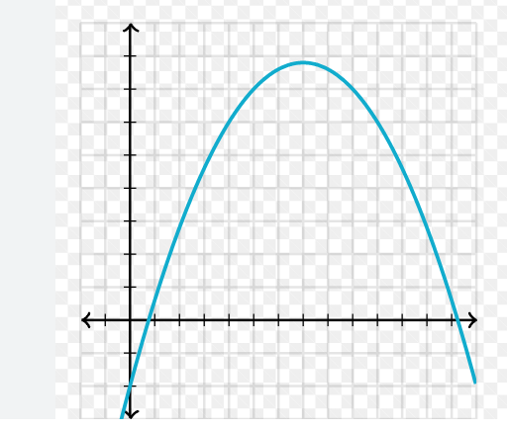  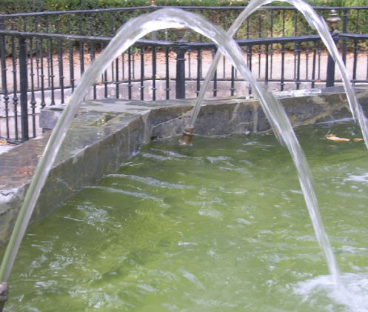  (i)The shape formed by the water trajectory is  (a) ellipse (b) parabola (c) oval (d) spiral  (ii) Number of zeroes of polynomial made up of x is equal to the number of points where the graph of the polynomial  (a)intersects x-axis  (b) intersects y-axis  (c) intersects y –axis or x-axis  (d) none of the above  (iii) If the trajectory is represented by $x^{2}-3x-18$,then its zeroes are___(a)(6,-3) (b) (-6,3) (c) (3,-3) (d) (-6,-3)  (iv)If – 1/3 is one of the zero of $9x^{2}-kx-5$, then the value of k is _  (a)9 (b) 3 (c) 12 (d) 4 | 4
2 | While playing badminton Ronit seeing the barrier chains between two posts at the edge of the walk way of a street. It is hung in the shape of the parabola. Parabola is the graphical representation of a particular type of polynomial.  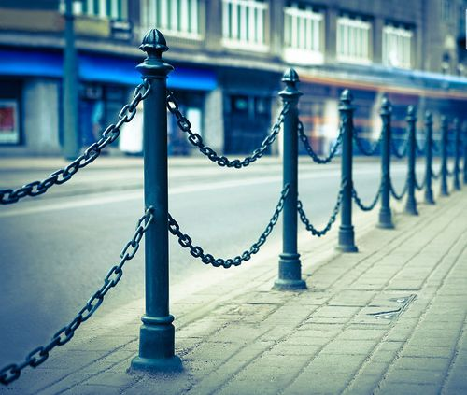  Based on the above information, answer the following questions.  - Which polynomial is graphically represented by a parabola?  - If a polynomial p(x) represented by a parabola intersects the x-axis at – 3 and 4 and y-axis at – 2 , then its zero(es) is/are  If the barrier chains between two posts is represented by the polynomial x² – x – 12 , find the distance between two consecutive posts.___________ | 4
3 | 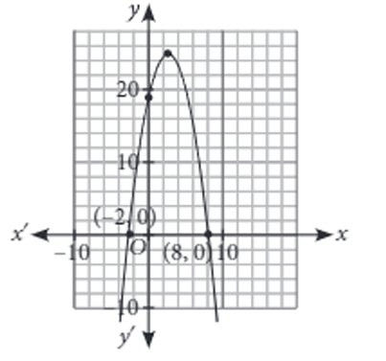  Shweta and her husband Sunil who is an architect by profession , visited France . They went to see Mont Blanc Tunnel which is a highway tunnel between France and Italy, under the Mont Blanc Mountain in the Apls, and has a parabolic cross-section. The mathematical representation of the tunnel is shown in the graph.  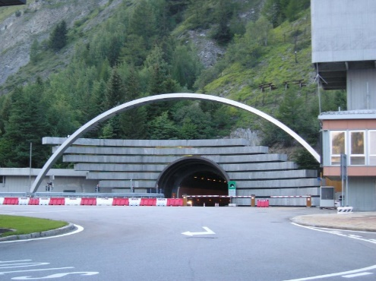  Based on the above information, answer the following questions.  - Write an expression of the polynomial given in the diagram.  - If one zero is 4 and sum of zeroes is – 3, then write a polynomial representing the tunnel. | 4
4 | 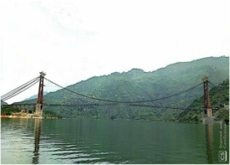  India's longest single-lane suspension bridge is now open to the public. The Dobra-Chanti bridge over Uttarakhand's Tehri lake. The bridge with hanging wires showing a mathematical shape.  (i)Graph of a quadratic polynomial is.  a) linear b)Spiral c)Parabola d)Ellipse  (ii)The representation of hanging wires on the bridge whose sum of the zeroes is -3 and product of the zeroes is 5 is  a)x2-3x-5 b)x2-3x+5 c)x2+3x-5 d)x2+3x+5  iii)What will be the expression of the quadratic polynomial.  a)ax+b,a≠0 b)ax2+bx+c,a≠0 c)ax3+bx2+cx+d ,a≠0 d)none of the above | 4
5 | 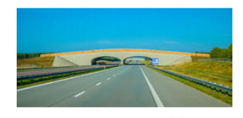  A highway underpass is parabolic in shape.  (i) If the highway overpass is repesented by x²-2x-8.Then its zeroes are  a)2,-4 b)4,-2 c)-2,-2 d)-4,-4  (ii)If 2 and $\frac{1}{2}$ are zeroes of px²+5x+r,then  a)p=r=2 b) p=r=-2 c) p=2,r=-2 d) p=-2,r=2  (iii)The number of real zeroes that polynomial f(x)=(x-2)²+4 can have is  a)1 b)2 c)0 d)3 | 4
6 | 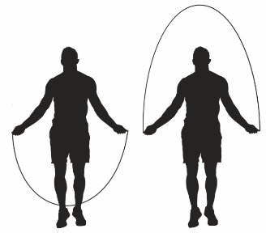  During the skipping through skipping rope, its look like the in the form of parabola. It is a natural example of parabolic shape which is represented by a quadratic polynomial. Similarly, we can observe in many other cases forming a in a variety of forms of different parabolas.  (i)In the standard form of quadratic polynomial,  ax² + bx + c, the condition between a, b and c are  (a)‘a’ may be 0, but b and c must be non-zero.  (b)a, b and c all may be zero.  (c)‘a’ is a non-zero real number and b and c are any real numbers.  (d)All are integers.  (ii)If the parabola is opening downward, what can you say regarding the coefficient of $x^{2}$ ?  (iii) If one zero of a quadratic polynomial is reciprocal of the other, form the quadratic polynomial. | 4
7 | A child was flying a kite, its string got struck into a tree and touched ground as shown in figure.  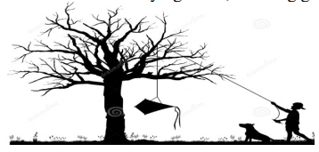  (i)The string of the kite represents the graph of a_____ polynomial.  (a) Linear (b) Quadratic (c) Cubic (d) Constant  (ii) The number of zeroes of a quadratic polynomial is  (a) 1 (b) 2 (c) 3 (d) none of the above.  (iii) If one zero of polynomial x²-12x+(3k-1) is five times the other then k is  (a) 2 (b) 3 (c) 10 (d) 7 | 4
 | ANSWERS
1 | (i)c-parabola  (ii)a- intersects x-axis  (iii) (a)(6,-3)  (iv) (c) 12 | 4
2 | - Quadratic polynomial  - – 3 and 4  - x² – x – 12= x² – 4x + 3x – 12  x = 4 and x = - 3  Distance between two consecutive posts is 7 units. | 4
3 | - Two zeroes are – 2 and 8.  Sum of zeroes = 6  Product of zeroes = - 16  So the required polynomial is x² – 6x – 16  As the graph opens downwards so the polynomial is – x² + 6x + 16.  - One zero is 4.  Sum = - 3 . so the other zero is – 7 .  So a polynomial representing the tunnel is = - x² - 3x + 28 | 4
4 | (i)Parabola  (ii) x²+3x+5  (iii) ax²+bx+c,a≠0 | 4
5 | (i)b)4,-2  (ii) b) Sum of zeroes = 2 + $\frac{1}{2}$ = $\frac{-5}{p}$  $\frac{ 5}{2}$ =$\frac{-5}{p}$  P=-2  Product of zeroes 2 x$\frac{1 }{2}$=$\frac{r}{p}$  ⇒ $\frac{r}{p}$ =1  ⇒r=p=-2  (iii) c)0 | 4
6 | - (c)‘a’ is a non-zero real number and b and c are any real numbers.  - Coefficient of x² is negative.  - Let m and $\frac{1}{m}$ be the two zeroes.  ⸫ m + $\frac{1}{m}$ = $\frac{m^{2}+1}{m}$ = $\frac{-b}{a}$ m$(\frac{1}{m}$) = $\frac{m}{m}$ = $\frac{c}{a}$  $⸫$ a = m, b = -(m² + 1) , c = m  ⸫ The required polynomial is, ax² + bx + c  = mx² - (m² + 1) x + m | 4
7 | - (a) Linear  - (b) 2  - The given polynomial x²-12x+(3k-1)  Let one zero = $α$  ATQ, the other zero = 5 $α$  Sum of the zeroes = $α$ + 5 $α$ =6 $α$ = 12  ⸫ $α$ =2  Product of the zeroes = ${5α}^{2}$= 3k – 1  ⸫ 5(4) = 3k – 1  ⸫ k = 7 | 4
 | 5 – MARKS TYPE QUESTIONS
1 | Rani, a diver was standing on a diving board, 48 feet above the water level. She took a dive into the pool. Her height above the water level at any time ‘t’ in seconds is given by the polynomial y(t) such that y(t) = -16 t² + 8t + k.  - What is the value of k?  - At what time will she touch the water in the pool?  - Seema’s height above the water level is given by another polynomial h(t) with zeroes -1 and 2. Then, h(t) is given by  - A polynomial q(t) with sum of zeroes as 1 and the product as -6 is modelling Anu’s height in feet above the water at any time t. then, q(t) is given by  The zeroes of the polynomial r(t) = -12 t² +(k – 3) + 48 are negative to each other. Then k is | 5
2 | A highway underpass is parabolic in shape.  (i) it is represented by the polynomial x² – 2x – 8. Then its zeroes are….  (ii) number of the zeroes of the polynomial representing highway underpass is equal to number of points where the graph of polynomial  - intersects x-axis (b) intersects y-axis  - ( c ) intersects x-axis or y-axis (d) none of these  (iii) Graph of quadratic polynomial is a  (a) straight line (b) circle ( c ) parabola (d) ellipse  (iv) The number of real zeroes that polynomial  f(x) = (x-2)² +4 can have is  (a) 1 (b)2 (c)0 (d) 3 | 5
3 | The path moved by a group of ants has been traced on a floor which is shown below.  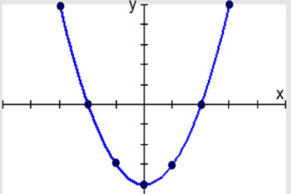  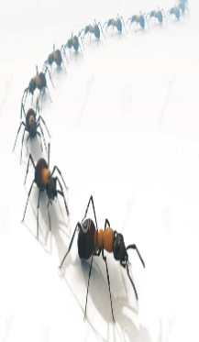  (i)The shape followed by the path is ____  (a) ellipse (b) oval (c) parabola(d) spiral  (ii) If the path is represented by $x^{2}+2x-3$, then its zeros are _______  (a)(-3,1) (b) (3,-1) (c) (2,-3) (d) (-2,3)  (iii)The number of zeroes of the polynomial represented by the path is …  - One (b) at most two (c) at least two (d) less than two  (iv)If the sum and product of zeroes of a polynomial representing a path are 6 and -16, then the polynomial is  (a)$x^{2}-10x+96$ (b) $x^{2}-6x+16$  (c) $x^{2}-6x-16$ (d) $x^{2}+6x$  (v) The number of zeros of the polynomial $x^{2}-8$ are  (a)0 (b) 1 (c) 2 (d) 3 | 5
4 | The below pictures are few examples of parabolic shape which is represented by a quadratic polynomial. A parabolic arch is an arch in the shape of a parabola. In structures, their curves represent an efficient method of loads, and so can be found in bridges and in architecture in a variety of forms. Observe the pictures and answer the following questions.  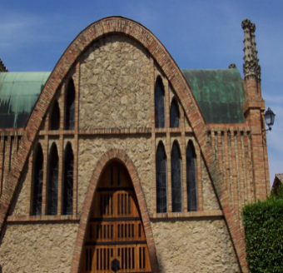  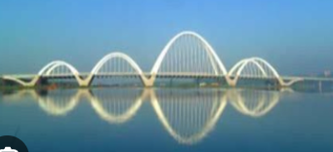  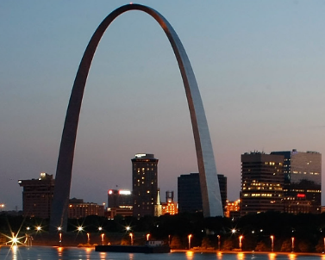  (i) In the standard form of a quadratic polynomial, ${ax}^{2}+bx+c, a,b and c are:$  (a) All are natural numbers  (b) All are integers  (c) $a is a non-zero real number$ and b and c are any real numbers.  d)all are non-zero real numbers  (ii) The graph of a parabola (quadratic polynomial) opens upwards if  $$\left(a\right)a=0 \left(b\right)a<0 \left(c\right)a>0 \left(d\right)a≥0$$  iii) If $α and \frac{1}{α}$ are the zeros of the quadratic polynomial  $2x^{2}-x+8k$ then k= ____$$\left(a\right) 4 \left(b\right)\frac{1}{4} \left(c\right)- \frac{1}{4}\left(d\right)2$$  iv)The graph of $x^{2}+1=0$:  - intersects x-axis at two different points  - touches x-axis at a point  - neither touches nor intersects x-axis.  - either touches or intersects x-axis  v) If the sum of the zeroes is –p and product of the zeroes is -1/p, then the quadratic polynomial is :  a) $k(-px^{2}+\frac{x}{p}+1$)  b) $k(-px^{2}-\frac{x}{p}-1$)  c) $k(-px^{2}+px-\frac{1}{p}$)  d)$k(x^{2}+px-\frac{1}{p}$) | 5
5 | If p and q are the zeroes of the polynomial 4y² -4y+1. Then Rahul make an equation and ask his friend What is the value of  $\frac{1}{p}$ +$\frac{1}{q}$ + pq | 5
 | ANSWERS
1 | - Rani’s height at any time is given by y(t) = -16 t² + 8t + k  Initially at t= 0 Rani is standing at a height of 48 feet above the water level. So, at t=0, y = 48.  Substituting all the values k = 48  - When she touches the water level  y(t) = 0  => -16 t² + 8t + 48 = 0  => 2 t² - t - 6 = 0  => (t-2) (2t+ 3) = 0  => t = 2  (iii) Another polynomial having zeroes as -1 and 2 is given by  h(t) = k (t+1) (t-2)  when time t= 0 height h = 48  so, k (1) (-2) = 48  => k = - 24  Hence h(t) = -24(t+1)(t-2)  = -24t² + 24t +48  (iv) the polynomial q(t) will be given by  q(t) = k (t² -t – 6)  at t= 0 height h = 48  so, 48= k (-6)  => k = - 8  Hence q(t) = -8 (t² -t – 6)  (v) It is given that the zeroes of the polynomial r(t) = -12 t² +(k – 3) + 48 are negative to each other. It means sum of the zeroes will be zero.  So, k-3/ 12 = 0  => k = 3 | 5
2 | (i) the zeroes are 4 and -2  (ii) intersects x-axis  (iii) parabola  (iv) 0 | 5
3 | i)c-) parabola  ii)a-) (-3,1)  iii)b-) at most two  iv)c. ) $x^{2}-6x-16$  v)c-) 2 | 5
4 | i-(c) $a is a non-zero real number$ and b and c are any real numbers.  ii-(c ) $a>0$  iii- b)1/4  iv- c)neither touches nor intersects x-axis.  v-c) $k(-px^{2}+px-\frac{1}{p}$) | 5
5 | Given polynomial is 4y²-4y+1 =1  Sum of zeroes = - (-4/4) =1  and product of zeroes = 1/4  Now,  $\frac{1}{p}$ +$\frac{1}{q}$ + pq = $\frac{q+p}{pq}$ +pq  We have proved above, p + q = 1 and pq = 1/4  So,  $\frac{q+p}{pq}$ +pq=1/$\frac{1}{4}$+$\frac{1}{4}$  =4 +1 /4 =17 / 4 | 5

CHAPTER – 3
LINEAR EQUATIONS IN TWO VARIABLES

SYLLABUS:
Pair of linear equations in two variables and graphical method of their solution, consistency/inconsistency. Algebraic conditions for number of solutions. Solution of a pair of linear equations in two variables algebraically - by substitution, by elimination. Simple situational problems.

SL NO | QUESTION | MARK
 | MULTIPLE - CHOICE QUESTIONS
1 | Which of the followings is true for the following pair of linear equations in two variables?  2x + 3y = 12 ---- (1)  4x + 6y - 15 = 0 ----(2)  - Has 1 common solution ( b)Has a lot of common solu^{n}.  (c ) Can’t find a common solu^{n}. (d) Has only 2 solutions | 1
2 | Graphs of a pair of linear equations; x - 2y = 0 and  3x + 4y = 20 has been shown. Coordinates of which point in the graph represents the common solution?  Point P (b ) Point Q (c) Point A (d) Point 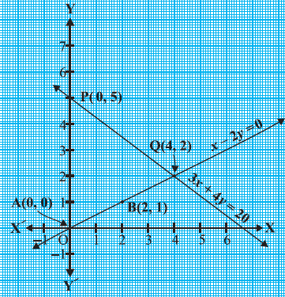 | 1
3 | If the lines given by 3x + 4ky = 2 and 2x + 5y + 1 = 0 are parallel, then the value of ‘k’ is  - 15 (b) 15/2 (c ) 15/4 (d) 15/8 | 1
4 | Find the coordinates of the points where line ;  2x + 3y -12 = 0 intersects X-axis and Y-axis respectively | 1
5 | Area of the Triangle formed by the lines ; y = x , x = 8 and y = 0 is ;  - 64 sq.units (b) 8 sq.units (c) 32 sq.units (d) 16 sq.units. | 1
6 | Cost of a Pen and a Pencil is Rs.20 .Also cost of 2 Pens and 2 Pencils is Rs.40. Then the actual cost of the Pen and the Pencil respectively in rupees are ;  ( a) 10 ,10 only ( b) 12 , 8 only  (c ) 15, 5 only (d) Any possible values whose sum is 20  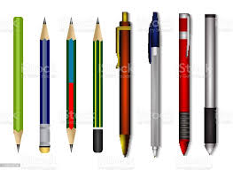 | 1
7 | Sum of two positive numbers is 27 and their difference is 15. what is the largest number?  (a)27 (b) 21 (c ) 6 (d) 12 | 1
8 | Rohan has only Re.1 and Rs.2 coins with her. If the total number of coins that she has is 30 and the amount of money with her is Rs.50, then the number of Re.1 and Rs.2 coins are respectively  - 10 and 20 (b) 20 and 10 (c ) 12 and 18 (d) 16 and 14 | 1
9 | The solution of 4/x+3y=14 and 3/x-4y=23 is:  (a) ⅕ and -2  (b) ⅓ and ½  (c) 3 and ½  (d) 2 and ⅓ | 1
10 | The angles of cyclic quadrilaterals ABCD are: A = (6x+10), B=(5x)°, C = (x+y)° and D=(3y-10)°. The value of x and y is:  (a) x=20° and y = 10°  (b) x=20° and y = 30°  (c) x=44° and y=15°  (d) x=15° and y=15° | 1
11 | The pair of equations x = a and y = b graphically represents lines which are  (a) parallel  (b) intersecting at (b, a)  (c) coincident  (d) intersecting at (a, b) | 1
12 | The value of ‘𝑘’ for which the system of equations 4𝑥 + 𝑘𝑦 + 8 = 0 𝑎𝑛𝑑 2𝑥 + 2𝑦 + 2 = 0 has a unique solution is  a) k=3 b) k ≠ 4 c) k ≠ 0 d) k=0 | 1
13 | The pair of linear equations 3𝑥 + 5𝑦 = 3 𝑎𝑛𝑑 6𝑥 + 𝑘𝑦 = 8 do not have a solution if k  a) =5 b) = 10 c) ≠10 d) ≠ 5 | 1
14 | The pair of equation 𝑥 = 𝑎, 𝑦 = 𝑏 represent lines which are  a) Parallel  b) intersect at (b, a)  c) coincide  d) intersect at (a, b) | 1
15 | The equation 𝑥 − 𝑦 = 0.9 and $\frac{11}{x+y}$ = 2 have the solution  a) 𝑥 = 5, 𝑦 =1 b) 𝑥 = 2.3, 𝑦 = 3.2  c) 𝑥 = 3, 𝑦 = 2 d) 𝑥 = 3.2, 𝑦 = 2.3 | 1
16 | If (6, k) is a solution of the equation 3𝑥 + 𝑦 = 22 𝑡ℎ𝑒𝑛 𝑘  a) - 4 b) 4 c) 3 d) -3 | 1
17 | The value of k for which the line 5x+ 7y =3 and 15x + 21y =k coincide is  a) 9 b) 5 c) 7 d) 18 | 1
18 | The pair of linear equations 𝑥 = 0, 𝑥 = −5 has  a) One solution b) two solutions  c) infinite no: of solution d) no solution | 1
19 | The number of solutions of 3^{x+y} = 243 𝑎𝑛𝑑 243^{x-y} = 3 is  a) 0 b) 1 c) 2 d) None | 1
20 | If 217𝑥 + 131𝑦 = 913 and 131𝑥 + 227𝑦 = 827 then 𝑥 + 𝑦  a) 5 b) 6 c) 7 d) 18 | 1
21 | One equation of a pair of dependent linear equations is 2x + 5y = 3. The second equation will be  (a) 2x + 5y = 6 b) 3x + 5y = 3  (c) -10x – 25y + 15=0 d) 10x + 25y = -15 | 1
22 | If a pair of linear equations is consistent, then the lines are:  (a) Parallel (b) Always coincident  (c) Always intersecting (d) Intersecting or coincident | 1
23 | The pairs of equations 9x + 3y + 12 = 0 and 18x + 6y + 26 = 0 have  (a) Unique solution (b) Exactly two solutions  (c) Infinitely many solutions (d) No solution | 1
24 | If the lines 3x+2ky – 2 = 0 and 2x+5y+1 = 0 are parallel, then what is the value of k?  (a) 4/15 (b) 15/4 (c) ⅘ (d) 5/4 | 1
25 | The solution of the equations x-y=2 and x+y=4 is:  (a) 3 and 1 (b) 4 and 3 (c) 5 and 1 (d) -1 and -3 | 1
 | ANSWERS | 1
1 | 2x + 3y = 12 ---- (1)  4x + 6y - 15 = 0 ----(2)  Here a₁/a₂ = b₁/b₂ ≠ c₁/c₂.Answer (c ) Can’t find a common solu^{n}. | 1
2 | (b) Point Q (4, 2) | 1
3 | (d) 15/8 | 1
4 | The graph intersects X-axis at (6,0) and Y-axis at (0,4) | 1
5 | (c) 32 sq.units. | 1
6 | (d) Any possible values whose sum is 20 | 1
7 | (b) 21 | 1
8 | 10 and 20 | 1
9 | (a) ⅕ and -2 | 1
10 | (b) x=20° and y = 30° | 1
11 | (d) intersecting at (a, b) | 1
12 | B | 1
13 | B | 1
14 | D | 1
15 | D | 1
16 | B | 1
17 | A | 1
18 | D | 1
19 | B | 1
20 | A | 1
21 | C | 1
22 | (d) Intersecting or coincident  Explanation: Because the two lines definitely have a solution. | 1
23 | (d) No solution  Explanation: Given, 9x + 3y + 12 = 0 and 18x + 6y + 26 = 0  a1/a2 = 9/18 = 1/2  b1/b2 = 3/6 = 1/2  c1/c2 = 12/26 = 6/13  Since, a1/a2 = b1/b2 ≠ c1/c2  So, the pairs of equations are parallel and the lines never intersect each other at any point, therefore there is no possible solution. | 1
24 | (b) 15/4  Explanation: The condition for parallel lines is:  a1/a2 = b1/b2 ≠ c1/c2  Hence, 3/2 = 2k/5  k=15/4 | 1
25 | (a) 3 and 1  Explanation: x-y =2  x=2+y  Substituting the value of x in the second equation we get;  2+y+y=4  2+2y=4  2y = 2  y=1  Now putting the value of y, we get;  x=2+1 = 3  Hence, the solutions are x=3 and y=1. | 1
 | 2 MARKS TYPE QUESTIONS
1 | The larger of two supplementary angles exceeds the smaller angle by 20⁰ . Find them.  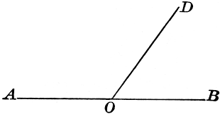 | 2
2 | In a two digit number, the unit’s digit is twice the ten’s digit. If 36 is added to the number, the digits interchange their places. Find the number. | 2
3 | Sum of two numbers is 100 and the difference between their squares is 3000. Find the two numbers. | 2
4 | At present the father is 3 times as old as his son. Five years later, the father will be two and half times as old as his son. Find their present ages. | 2
5 | Perimeter of a rectangular field is 200 m. Its length is 10 m more than twice its breadth. Find its area in sq mtr. | 2
6 | ABCDE is a pentagon with BE ll CD and BC ll DE.BC is perpendicular to CD. AB=5cm.AE=5cm.BE=7cm,BC=x-y and CD= x+y. If the perimeter of ABCDE is 27cm Find the values of x and y , given x,y ≠ 0.  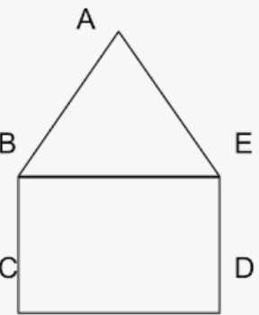 | 2
7 | If thrice the son`s age in years is added to the father`s age the sum is 70. If twice the father`s age is added to the son`s age the sum is 85. Find the ages of father and son. | 2
8 | A man starts his job with a certain monthly salary and fixed annual increment. If his salary was Rs 15000 after 4 years of service and Rs 17000 after 8 years of service. Find his starting salary and his annual increment. | 2
9 | Three years ago, a father was 5 times as old his son. Three years later his age will be 2 more than 3 times the age of the son. Find the present age of the father and the son. | 2
10 | Ratio between boys and girls in a class of 40 students is 2:3. 5 students new joined the class. How many of them must be boys so that the ratio between girls and boys is 4:5. | 2
 | ANSWERS | 2
1 | Let the larger angle= x , smaller angle = y ; also x = y + 20  x + y = 1800. (linear pair of angles)  ⇒ y+200+y = 1800 ⇒ 2y = 1800-200 ⇒ 2y = 1600 ⇒ y = 800 ;  x = 800+200=1000. Hence the larger angle is 1000 and the smaller angle is 800 | 2
2 | Let, the unit digit is x and tens digit is y.  Then, x=2y. The number would be 10y+x.  The number obtained by reversing the digits is 10x+y  If 36 is added to the number, digits interchange their places  Therefore, 10y+x+36=10x+y ⇒36=10x−x+y−10y  ⇒36=9x−9y ⇒9(x−y)=36  ⇒x−y=4 _____(1)  Substituting the value of x=2y in equation (1), we get  ⇒2y−y=4  ⇒y=4  Substituting the value of y in equation (1), we get  ⇒x−4=4 ⇒x=8. Hence the number is 48. | 2
3 | Let the numbers are x and y  According to the question x+y=100.....eq1  ⇒x2−y2=3000  ∵x2−y2=(x+y)(x−y) ⇒100(x−y)=3000 ⇒x−y=30.....eq2  Adding eq1 and eq2  ⇒2x=130⇒x=65  Put the value of x in eq1  ⇒65+y=100⇒y=35. The numbers are 65 and 35 | 2
4 | Let age of son be x years; Age of father is 3x years  After 5 years; Age of son be x+5 years; Age of father is 3x+5 years  According to question  3x+5=2.5(x+5)  ⇒ 0.5x=7.5  x=15  Age of son be 15 years  Age of father is 45 years | 2
5 | Given that, the perimeter of the rectangular field is 200 m and its length is 10 m more than twice its breadth.  ⇒ 2(l+b)=200  ⇒ l+b =100; Also length = 2b+10  ⇒ 2b +10+b =100  ⇒ 3b = 90 ; ⇒ b = 30 m and length = 90 m  Then, Area = l b = 90 m × 30 m = 2700 sq.metre . | 2
6 | BCDE is a rectangle. BC=DE=x-y and CD=BE . x+y=7 AND PERIMETER of ABCDE=27cm . So 5+x-y+7+x-y+5=27. Which gives x-y=5 . Solving we get x=6 and y=1 | 2
7 | Let the father’s and son’s age are x and y respectively. Then 3y+x=70 and 2x+y=85. Solving we get y=11 and x=37. | 2
8 | Let the starting salry of man is x and his annual increment is y . then as per question x+4y=15000 and x+8y=17000, solving we get y=500 and x=13000. | 2
9 | Let the present age of father and son are x and y respectively.  x-3=5(y-3) and 3(y+3)+2=x+3 solving we get x=38 and y=10 | 2
10 | Let no. of girls 2x and no. of boys 3x. solving we get x=8 and so girls =16 and boys=24.  Let out of 5 students y denotes no. of boys.  Then no. of girls=5-y.  so as per question 16+5-y/24+y = 4/5  solving y=1.  So there must be 1 boy among 5 new students. | 2
 | 3 – MARKS TYPE QUESTIONS
1 | 4 chairs and 3 tables cost Rs.2100 and 5 chairs and 2 tables cost Rs.1750. Find the cost of one chair and one table separately. | 3
2 | A boat takes 12 hours to cover a distance of 24 km upstream and it takes only 3 hours to come back the same distance. Find the speed of the boat in still water and that of the stream. | 3
3 | A man can row a boat downstream 20km in 2 hours and upstream 4km in 2 hours. Find his speed of rowing in still water and also find the speed of the stream. | 3
4 | Points A and B are 80km apart on a highway. A car starts from point A and another from B simultaneously. If they travel in the same direction they meet in 8 hours , but if they travel towards each other , they meet in 1 hour. Find the speed of each car. | 3
5 | Determine graphically the coordinates of the vertices of a triangle, the equations of whose sides are given by 2y-x=8 5y-x=14 and y-2x=1` | 3
6 | The ratio of incomes of two persons is 11:7 and the ratio of their expenditures is 9:5. If each of them manages to save Rs 400 per month, find their monthly incomes. | 3
7 | The total cost of a certain length of a piece of cloth is Rs. 200. If the piece was 5 m longer and each metre of cloth costs Rs 2 less, the cost of the piece would have  remained unchanged. How long is the piece and what is its original rate per metre? | 3
8 | Draw the graph of x - y+ 1= 0 and 3x + 2y – 12 = 0 and find its solution. Also find the coordinates of the triangle formed by these lines with x axis | 3
9 | Determine the values of a and b for which the following system of linear equations have infinite solutions  2𝑥 − (𝑎 − 4) 𝑦 = 2𝑏 + 1 ;  4𝑥 − (𝑎 − 1) 𝑦 = 5𝑏 − 1 | 3
10 | A fraction becomes 1 /3 when 2 is subtracted from the numerator and it becomes 1 /2 when 1 is subtracted from its denominator. Find the fraction | 3
 | ANSWERS
1 | Let x denotes the cost of a chair and y denotes the cost of a table.  ⇒4x+3y=2100...(1) ;  ​and 5x+2y=1750...(2)  On multiplying equation (1) by 2 and equation (2) by 3 to make the coefficients of y equal, we get  ⇒8x+6y=4200....(3) ; 15x+6y=5250...(4)  On subtracting equation (3) from (4), we get  7x=1050; ⇒x=150  On substituting this value of x in equation (1), we get  4(150)+3y=2100 ; ⇒3y=1500  ⇒y=500  Thus, x=150 and y=500  ∴The cost of a chair is ₹150 and table is ₹500 . | 3
2 | Let speed of the motor boat in still water be x km/hour  and of the speed of the stream is y km/hr  Speed of boat during upstream journey =x−y  Speed of boat during downstream journey=x+y  Time taken for upstream journey = distance / time = 24 / ( x-y )  Time taken for downstream journey= 24 / ( x+y )​  According to the given condition, 24 / (x-y) = 12 ⇒ x-y = 2  Also 24 / (x+y) = 3 ⇒ x+y = 8  Adding we get x-y+x+y + 10 ⇒ 2x = 10 ;  ⇒ x=5 .putting in the equation we get, y = 3  Hence speed of the motor boat in still water = 5 km/hour  and of the speed of the stream is 3 km/hr | 3
3 | Let speed of rowing is x km/h and speed of current is y km/h so upstream speed is x-y and downstream speed is x+y km/h. So 20/x+y =2 and 4/x-y =2 . so x+y=10 and x-y=2 solving we get x=6 and y=4. | 3
4 | Let the speed of cars be x and y . if they move in same direction the relative speed is x-y and in opposite direction relative speed is x+y.  Then x-y=10 and x+y=80 so x=45 km/h and y=35 km/h | 3
5 | 2y-x=8 5y-x=14  Y - 2x=1  Correct graph plotted. Vertices are (-4,2),(1,3),(2,5) | 3
  x | 0 | 2
  y | 4 | 5
  x | 1 | 6
  y | 3 | 4
  x | 0 | 1
  y | 1 | 3
6 | Let the incomes of two persons be 11x and 7x .  Also the expenditures of two persons be 9y and 5y .  11x - 9y = 400 ...(1)  and 7x - 5 y= 400 ...(2)  Multiplying equation (1) by 5 and equation (2) by 9  we have  55x - 45 y = 2000 ...(3)  and 63x - 45 y= 3600 ...(4)  Subtracting, above equation we have  -8x =− 1600  or, x = -1600/-8  x = 200  Hence ,Their monthly incomes are 11 x 200= Rs 2200  and 7 x 200 = Rs 1400. | 3
7 | Let x be the length of the cloth and y be the cost of  cloth per meter.  Now X x Y = 200  Y = 200/X ….....(1)  According to given conditions,  1. If the piece were 5 m longer  2. Each meter of cloth costed Rs 2 less  i.e., (x+5) )(y-2) =200  xy - 2x+5y =210  xy-2x+5y = 210  x(200/x) - 2x +5(200/x) = 210  200 - 2x + 1000/x = 210  1000/x - 2x = 10  1000 - 2x²= 10x  X²+25 x -20x-500 = 0  X(x+25) – 20 (x+25) = 0  (x+25) (x-20) = 0  X = -25 ,20  Neglecting x =− 25 we get x = 20.  Now from equation (1), we have  y = 200/x  = 200/20  = 10  Hence ,length of the piece of cloths is 20m and rate per metre is Rs 10. | 3
8 | The vertices of triangle are (−1,0),(2,3),(4,0) | 3
9 | A pair of linear equation has infinitely many solutions, if a1/ a2 = b1/ b2 = c1/ c2  a = 7 and b = 3 | 3
10 | x=7 and y=15  Required fraction is 7 /15 | 3
 | 4 – MARKS TYPE QUESTIONS (CASE BASED QUESTIONS)
1 | The taxi charges in a city consist of a fixed charge together with the charge for the distance covered. For a distance of 10km the charge paid is Rs 165 and for a journey of 18km the charge paid is Rs 277.  - The fixed charges and charges per km respectively are?  - The taxi fare for a distance of 25 km would be?  - What type of solution the pair of linear equation -3x+4y=5 and 9/2 x-6y+15/2 has?  - What is the value of k for which 2x+3y=7 and (k-1)x+(k+2)y=3k have infinitely many solutions. | 4
2 | Mr. joe decided to go to an amusement park along with his family. The cost of an entry ticket is rs 25 for children and rs 50 for adults . on that particular day attendance at the circus is 2000 and the total gate revenue is rs 70,000.  - If we let the number of children and adults who bought ticket on that day as x and y respectively, form the pair of linear equations describing the above situation.  - Find the number of children and adults who bought tickets on that particular day.  - Find the points where the lines represented by 2x-3y+4=0 and x+2y-5=0 intersect x axis.  - Write the number of solutions of the system of linear equations 2x-3y+4=0 and x+2y-5=0.  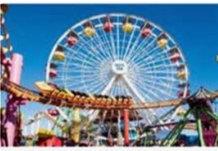 | 4
3 | Raman usually go to a dry fruit shop with his mother. He observes the following two situations.  On 1st day: The cost of 2 kg of almonds and 1 kg of cashew was Rs 1600.  On 2nd day: The cost of 4 kg of almonds and 2 kg of cashew was Rs 3000.  Denoting the cost of 1 kg almonds by Rs x and cost of 1 kg cashew by Rs y, answer the following questions. (i) Represent algebraically the situation of day-I.  (ii) Represent algebraically the situation of day- II.  (iii) The linear equation represented by day-I, intersect the x axis at  (iv) The linear equation represented by day-II, intersect the y-axis at  (v) Linear equations represented by day-I and day -II situations, are | 4
  (a) x + 2y = 1000 | (b) 2x + y = 1600 | (c) x - 2y = 1000 | (d) 2x - y = 1000
  (a) 2x + y= 1500 | (b) 2x- y= 1500 | (c) x + 2y=1500 | (d) 2x + y = 750
  (a) (0,800) | (b) (0,-800) | (c) (800,0) | (d) (-800,0)
  (a) (1500,0) | (b) (0, -1500) | (c) (-1500,0) | (d) (0,1500)
  (a) non parallel | (b) parallel
  (c) intersect at one point | (d) overlapping each other.
4 | From a shop , sudhir bought 2 books of Mathematics and 3 books of Physics of class X for Rs 850 and Suman Bought 3 books of mathematics 2 books of physics of class X for Rs 900. consider the price of one Mathematics books and that of one Physics books be Rs x and Rs y respectively.    Based on the above information ,answer the following questions .  (i) Represent the situation Faced by sudhir , algebraically  - 2x + 3y = 850 (b) 3x+2y =850  (c ) 2x-3y =850 (d) 3x -2y = 850  (ii) Represent the situation faced by Suman, algebraically  - 2x + 3y =850 (b) 3x + 2y = 900  ( c ) 2x -3y = 900 (d) 3x - 2y = 900  (iii) The price of one mathematics book is  Rs 80 (b) Rs 100 (c ) Rs 150 (d ) Rs 200 | 4
5 | Nidhi and Ria are very close friends. Nidhi’s parents own a Maruti Alto. Ria’s parents own a Toyota Liva. Both the families decide to go for a picnic to Somnath temple in Gujrat by Nidhi’s car travels x km/h while Ria’s car travels 5 km/h more than Nidhi’s car. Nidhi’s car took 4 hrs more than Ria’s car in covering 400 km  (i)What will be the distance covered by Ria’s car in two hours?  (a) 2 (x+5) km (b) (x – 5) km  (c) 2 (x +10) km (d) (2x+5) km  (ii) Which of the following quadratic equation describe the speed of Nidhi’s car?  - x² - 5x -500=0 (b) x²+ 4x - 400=0  (c) x² + 5x -500=0 (d) x²- 4x + 400=0  (iii) What is the speed of Nidhi’s car?  - 20 km/hour (b) 15 km/hour  (c) 25 km/hour (d) 10 km/hour  (iv) How much time took Ria to travel 400 km?  - 20 hour (b) 40 hour (c) 25 hour (d) 16 hour | 4
6 | An alumni association is an association of former students. These associations often organize social events, publish newsletters or magazines and raise funds for the organization. The alumni meet of two batches of a college- batch A & batch B were held on the same day in the same hotel in two separate halls “Rose” and “Jasmine”. The rents were the same for both the halls. The expense for each hall is equal to the fixed rent of each hall and proportional to the number of persons attending each meet. 50 persons attended the meet in “Rose” hall, and the organizers had to pay ₹ 10000 towards the hotel charges. 25 guests attended the meet in “Jasmine” hall and the organizers had to pay ₹ 7500 towards the hotel charges. Denote the fixed rent by ₹ x and proportional expense per person by ₹ y.  (i) Represent algebraically the situation in hall “Rose”.  a) 50𝑥 + 𝑦 = 10000 b) 50𝑥 − 𝑦 = 10000  c) 𝑥 + 50𝑦 = 10000 d) 𝑥 − 50𝑦 = 10000  (ii) Represent algebraically the situation in hall “Jasmine”  a) 𝑥 + 25𝑦 = 7500 b) 𝑥 − 25𝑦 = 7500  c) 25𝑥 + 𝑦 = 7500 d) 25𝑥 − 𝑦 = 7500  (iii) What is the fixed rent of the halls?  - ₹2500 b) ₹3300 c) ₹ 4000 d) ₹5000  (iv) Find the amount the hotel charged per person.  a) ₹ 150 b) ₹ 190 c) ₹130 d) ₹ 100 | 4
7 | A test consists of ‘True’ or ‘False’ questions. One mark is awarded for every correct answer while ¼ mark is deducted for every wrong answer. A student knew answers to some of the questions. Rest of the questions he attempted by guessing. He answered 120 questions and got 90 marks.  i. If answer to all questions he attempted by guessing were wrong, then how many questions did he answer correctly?  ii. How many questions did he guess?  iii. If answer to all questions he attempted by guessing were wrong and answered 80 correctly, then how many marks he got?  iv. If answer to all questions he attempted by guessing were wrong, then how many questions answered correctly to score 95 marks? | 4
 | ANSWERS
1 | - let the fixed charge be x and the charge per km is y. so x+10y=165 and x+18y=277 so x=25 and y=14  - X+25y= 25+350=375  - Infinitely many solutions  - K=7 | 4
2 | (a)x+y=2000 and x+2y=2800  (b) 1200 children and 800 adults  (c) on x axis y=0 . substituting this in equations we get x=-2 and x=5  The given system of equations will intersect x axis at points (-2,0) and (5,0) respectively.  (d)a₁/a₂=2 and b₁/b₂=-3/2 so a₁/a₂≠b₁/b₂ so they will have unique solution. | 4
3 | (i) (b): Algebraic representation of situation of day-I is 2x + y = 1600.  (ii) (a): Algebraic representation of situation of day- II is 4x + 2y = 3000 ⇒ 2x + y = 1500.  (iii) (c) : At x-axis, y = 0  ∴ At y = 0, 2x + y = 1600 becomes 2x = 1600  ⇒ x = 800  ∴ Linear equation represented by day- I intersect the x-axis at (800, 0).  (iv) (d) : At y-axis, x = 0  ∴ 2x + Y = 1500 ⇒ y = 1500  ∴ Linear equation represented by day-II intersect the y-axis at (0, 1500).  (v) (b): We have, 2x + y = 1600 and 2x + y = 1500  Since a1a2=b1b2≠c1c2 i.e., 11=11≠1615  ∴ System of equations have no solution.  ∴ Lines are parallel. | 4
4 | (i) (a) Situation faced by sudhir can be represented algebraically as  2x + 3 y = 900  (ii) (b); Situation faced by Suman can be represented algebraically as  3x + 2y = 900  (iii) (d); We have 2x + 3y = 850 ………..(i)  3x + 2y = 900 ………..(ii)  multiplying equation (i) by 3 and (ii) by 2 and subtracting, we get  5y = 750  y = 150  Thus, the price of one physics book is Rs 150  now, from equation 1 , we have  2x + 3y = 850  2x + 3 x 150 = 850  2x = 850 - 450  2x = 400  x = 200  Hence, cost of one Mathematics book = Rs 200 | 4
5 | (i)Nidhi’s car travels x km/h while Ria’s car travels 5 km/h more than Nidhi’s car. Thus, Ria’s car speed is x + 5 km/hour. Distance covered in two hours is 2 (x+5). Thus (a) is correct option  (ii) x² + 5x-500 = 0  (iii) x = 20, − 25  Since x =− 25 is not possible, we get x = 20  (iv) Rias car speed = 20 + 5 = 25 km/hour Time Taken 400/25 = 16 hour | 4
6 | Let us denote the fixed rent by ₹ x and proportional expense per person by ₹ y.  * Algebraic representation of the situation in “Rose” hall  x+50 y=10000  (i) Answer- Option C  ii. Algebraic representation of the situation in “Jasmine” hall  x+25y=7500 Answer- Option A  Subtracting the equations represented by (i) and (ii)  x+50y-x+25y=10000-7500  25 y=2500  y=100 Substituting y=100 in x+50 y=10000, we get  x+50 x 100=10000  x+5000=10000  x=5000  iii. D  iv. D | 4
7 | Let the no. of questions whose answer is known to the student x and questions attempted by guessing be y  x + y =120  x – 1/4y =90  solving these two  x = 96 and y = 24  i. He answered 96 questions correctly.  ii. He attempted 24 questions by guessing.  iii. Marks = 80- ¼ 0f 40 =70  iv. x – 1/4 of (120 – x) = 95  5x = 500, x = 100 | 4
 | 5 – MARKS TYPE QUESTIONS
1 | 8 Men and 12 Women can finish a piece of work in 10 days while 6 men and 8 women can finish it in 14 days. Find the time taken by one man alone and that by one woman alone to finish the work. | 5
2 | On selling a T.V. at 5 % gain and a fridge at 10 % gain, a shop keeper gains Rs.2000. But if he sells the T.V. at 10 % gain and the fridge at 5 % loss, he gains Rs.1500 on the transaction. Find the actual prices of T.V. and fridge. | 5
3 | A shopkeeper sells a saree at a profit of 8% and a sweater at a discount of 10%, thereby getting a sum rs 1008.If he had sold the saree at a profit of 10% and the sweater at a discount of 8% he would have got rs 1028.Find the cost of the saree and the list price (price before discount) of the sweater.  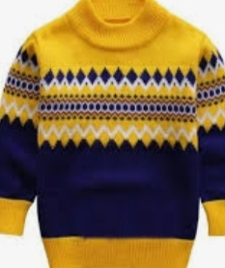 | 5
4 | Determine algebraically and graphically the vertices of the triangle formed by the lines 3x-y=3,2x-3y=2 and x+2y=8. | 5
5 | A house is to be floored with two types of tiles and they are rectangular and square shaped. The length and breadth of the rectangular tiles is 60cm and 50cm respectively. The length of the square shaped tile is 40cm. The length and breadth of the house to be floored are 14m and 10m respectively. The total number tiles ordered for flooring are 700. the cost of the rectangular tile and square tiles are 100 and 60 rupees respectively.  - Find the number of rectangular and square shaped tiles.  - How much money to be expenditure for buying the tiles?  If the number of rectangular and square shaped tiles are interchanged then how much area can be floored? | 5
 | ANSWERS
1 | Suppose that one man alone can finish the work in x days and one woman alone can finish it in y days. Then,  One man's one day's work =1/x; One woman's one day's work =1/y​  ∴ Eight men's one day's work =8/x; 12 women's one day's work =12/y  Since 8 men and 12 women can finish the work in 10 days ⇒10(8/x+12/y)=1 ⇒80/x+120/y =1 ..(i) Again, 6 men and 8 women can finish the work in 14 days. ∴14(6/x+8/y)=1 ⇒84/x + 112/y =1 (ii) Putting 1/x=u and 1/y=v in equations (i) and (ii), we get  80u+120v−1=0  84u+112v−1=0 ; By using cross-multiplication method, we have  u = (-120+112)/(8960-10080) = -8/-1120 = 1/140 ; ⇒ 1/x = 1/140 ; ⇒ x = 140  v = (-84+80)/-1120 = -4/-1120 = 1/280 ; ⇒ 1/y =1/ 280 ; ⇒ y = 280  Thus, one man alone can finish the work in 140 days and one woman alone can finish the work in 280 days. | 5
2 | Let, the price of a TV be Rs.x and that of a fridge be Rs.y  Then, we have:  5x/100 +10y/100 =2000  ⇒ 5x+10y=200000; ⇒x+2y=40000 ;  ⇒x=40000−2y....(i)  Now, 10x/100 − 5y/100 =1500  ⇒10x−5y=150000  ⇒2x−y=30000  ⇒2(40000−2y)−y=30000 from equation (i)  ⇒80000−4y−y=30000  ⇒5y=80000−30000  ⇒5y=50000​  ⇒y=Rs10000  ∴x=Rs40000−Rs20000  ⇒x=Rs.20000  ∴ Price of a T.V. =Rs.20000; Price of a fridge =Rs.10000 | 5
3 | Let the cost price of a saree is x and the list price of a sweater is y.  As per question 108% of x + 90% of y =1008 which solving gets 6x+5y=5600 and 110% of x +92% of y =1028 which gives by solving 55x+46y=51400 solving the equations we get x=600 and y =400. | 5
4 | Let lines represent the sides of a triangle ABC AB,BC,CA respectively.  On solving 1st two equations we will get intersection point B.On solving we get x=1 and y=0.  On solving 2nd and 3rd lines we get point C. x=4 and y=2  On solving 1st and 3rd lines we will get point A. x=2 and y=3  So the vertices of triangle ABC are A(2,3),B(1,0),C(4,2). Correct graph to be drawn. | 5
5 | Let, the number of rectangular and square shaped tiles are $x$and $y$respectively.  According to the given information,  Length of the house $=14m=1400cm$  Breadth of the house $=10m=1000cm$  Area of the house to be floored $=1400×1000 sq.cm.=1400000 sq.cm$  Area of the rectangular shaped tile $=60×50 sq.cm.=3000 sq.cm$  Area of the square shaped tile $=40×40 sq.cm.=1600 sq.cm$  So, $3000x+1600y = 1400000$  By simplifying we have  $15x+8y = 7000$ --------------------- equation I  It is also given that the total number of tiles $=700$  So, $x+y = 700$ --------------------- equation II  By solving equation I and equation II,  We get $x=200 ,y = 500$  - Total number of rectangular and square shaped tiles are 200 and 500 respectively.  - The total cost of expenditure for buying tiles are $= 200×100+500×60=20000+30000=50000$  - The are area that can be floored by exchanging the number of tiles is given by $3000×500+1600×200=1500000+320000=1820000sq. cm$ | 5

CHAPTER – 4
QUADRATIC EQUATIONS

SYLLABUS:
Standard form of a quadratic equation ax2 + bx + c = 0, (a ≠ 0). Solutions of quadratic equations (only real roots) by factorization, and by using quadratic formula. Relationship between discriminant and nature of roots. Situational problems based on quadratic equations related to day to day activities to be incorporated.

SL NO | QUESTION | MARK
 | MULTIPLE - CHOICE QUESTIONS
1 | 1.The discriminant of the quadratic equation 2x² -4x + 3 =0  is a) 8 b)-8 c) 6 d) -6 | 1
2 | 2.If p = -7,q= 12 and x² + px + q = 0, then the value of x  Is equal to  - 2 ,3 b) 2 ,-3 c) 3,4 d) 3, -4 | 1
3 | 3.For what value of p,the quadratic equation 2x² +px +9/2  has real and equal roots ?  6,-6 b) 5, -5 c) 4 ,-4 d) 3,-3 | 1
4 | 4.The sum of roots of quadratic equation x² + 4x -320 = 0 is  a) – 4 b) 4 c)2 d) - 2 | 1
5 | 5.The product of roots of quadratic equation 2x² + 7x -4 is  a) 2 b) -2/7 c) -4/7 d) -2 | 1
6 | 6.The sum of squares of three consecutive natural numbers is 110. The numbers are  a)2,3 ,4 b) 3,4,5 c)4,5,6 d) 5,6,7 | 1
7 | 7.If ½ is a root of the equation x² + k x -5/4 = 0 ,then  The value of k is  2 b) -2 c)3 d) -3 | 1
8 | 8.For what value of k ,x= a is a solution of the equation  x²– (a+ b)x + k = 0  a)a b) b c) ab d) - ab | 1
9 | The nature of roots of quadratic equation 4x² +4$√3$x +3 =0  - Real & equal (b) real & unequal (c) imaginary (d) real & distinct | 1
10 | If I had walked 1 km per hour faster, I would have taken 10 minutes less to walk 2km. Than the rate of my walking  - 8km/hr  - 6 km/hr  - 3km/hr  - 4 km/hr | 1
11 | The total number of pens and pencils seema have is 27, and the product of the number of pens and pencils is 182. The number of pens and pencils seema have are:  a) 12 and 13  (b) 13 and 14  (c) 12 and 15  (d) 13 and 24 | 1
12 | 3x²+4x+5=0 have  a) Real Roots b) Real and Equal Roots  c) No Real roots d) Real and Distinct Roots | 1
13 | If I had walked 1 km per hour faster, I would have taken 10 minutes less to walk 2km. Than the rate of my walking  - 8km/hr  - 6 km/hr  - 3km/hr  - 4 km/hr | 1
14 | A rectangular field is 16m long and 10m wide. There is a path of uniform width all around it with an area of 120 sq. m, then the width of the path is  - 5m  - 3m  - 2m  - 4m | 1
15 | Which of the following equations has no real roots?  (a) x² – 4x + 3 2 = 0  (b) x² + 4x – 3 2 = 0  (c) x² – 4x – 3 2 = 0  (d) 3x² + 43 x + 4 =0 | 1
16 | The altitude of a right triangular park is 7cm. Less than its base. If the hypotenuse is 13 cm., the other two sides of the triangle are equal to:  - Base = 10 cm. and altitude = 5cm.  - Base = 12cm. and altitude = 5cm.  - Base = 14 cm. and altitude =10cm.  - Base = 12 cm. and altitude = 10 cm | 1
17 | Had Adyasa scored 10 more marks in her mathematics test out of 30 marks, 9 times these marks would have been the square of her actual marks. How many marks did she get in the test?  - 10  - 15  - 20  - 25 | 1
18 | The roots of the equation 4x² -3x+2=0 are  a) no real roots b) two equal real roots  c) two distinct real roots d) none of these | 1
19 | If one root of the quadratic equation 6x²+kx-5=0 is $-\frac{5}{2}$ then what is the value of k is  - -13 (b) 12  (c)-12 (d)13 | 1
20 | Which of the following equation has the sum of its roots as 3?  a) -x²+3xc+3=0 b)2x²-3/2x-1  c) x²+3x-5=0 d)3x²-3x-3 | 1
21 | The roots of the equation x²+7x+10=0 are  a) -2 nad 5 b)2 and 5  c) -5 and -2 d) 2 and -5 | 1
22 | Root of x²-0.09 is  a) 0.03 b) 0.9  c) 0.3 d) none | 1
23 | Which of the following are quadratic equation?  a) (2x+4) =9(x+8) b) (3x+2) (x+1) =(4x-1) (x-1)  c) ( 2x³+4)=(x-1)² d) (5x² +1)=25x³-1 | 1
24 | Equation (x+1)²-x²=0 has…………real root(s)  a)2 b) 1 c) 4 d) 3 | 1
25 | Standard from of quadratic equation is  a) ax²-bx+c=0 b) ax²+bx+c=0  c) ax2+bx=c d) none of these | 1
 | ANSWERS
1 | - 8 | 1
2 | 3,4 | 1
3 | a)6,-6 | 1
4 | - 4 | 1
5 | -2 | 1
6 | 5,6,7 | 1
7 | 2 | 1
8 | ab | 1
9 | a=4,b=4$√$3,c =3, D = b² -4ac =48 -48 = 0 , real equal roots | 1
10 | d | 1
11 | Let no of pen be x then no of pencils is 27-x  X(27-x)=182 so x²-27x+182 =0 hence x=13 or 14 (b) | 1
12 | D=-44 No real root (c) | 1
13 | X²+X -12=0 SO X=4 (d) | 1
14 | (16+x)(10+x)-160=120  X²+26x -120 =0  X=4 (d) | 1
15 | x2 – 4x + 3 2 = 0 (a) | 1
16 | (x-7)²+(x)²=13²  X²-7x-60=0  X = 12, so base =12 altitude = 5 (b) | 1
17 | Let her actual marks be x Therefore, 9 (x +10) = x2 i.e., x2 – 9x – 90 = 0 i.e. (x + 6) (x –15) = 0 Therefore, x = – 6 or x=15 (b) | 1
18 | a) | 1
19 | d | 1
20 | a) | 1
21 | c) | 1
22 | c) | 1
23 | b) | 1
24 | b) | 1
25 | b) | 1
 | ASSERTION & REASON QUESTIONS
Choose the correct option in the following questions of Assertion – Reason Questions.
(a) Both A and R are correct; R is the correct explanation of A.
(b) Both A and R are correct; R is not the correct explanation of A.
(c) A is true but R is false
(d) A is false but R is true
1 | Assertion: The roots of the quadratic equation x² + 2x + 2 = 0 are imaginary  Reason: If discriminant D = b² – 4ac < 0 then the roots of quadratic equation ax² + bx + c = 0 are imaginary. | 1
2 | Assertion: (2x – 1)² – 4x² + 5 = 0 is not a quadratic equation.  Reason: An equation of the form ax² + bx + c = 0, a ≠ 0, where a, b, c ∈ R is called a quadratic equation. | 1
3 | Assertion: The roots of the quadratic equation x2+2x+2=0 are imaginary.  Reason: If discriminant D = b²-4ac < 0 then the roots of quadratic equation ax²+bx+c= 0 are imaginary. | 1
4 | Assertion: The equation 8x2+3kx+2 = 0 has equal roots then the value of k is ± 8.  Reason: The equation ax2+bx+c = 0 has equal roots if D = b2-4ac = 0 | 1
5 | Assertion: The equation x2+3x+1 = (x-2)2 is a quadratic equation.  Reason: Any equation of the form ax2+bx+c = 0 where a ≠ 0, is called a quadratic equation. | 1
6 | Assertion: 4x2-12x+9 = 0 has repeated roots.  Reason: The quadratic equation ax2+bx+c = 0 have repeated roots if discriminant D > 0. | 1
7 | Assertion: If one root of the quadratic equation 6x² – x – k = 0 is 2/3, then the value of k is 2.  Reason: The quadratic equation ax² + bx + c = 0, a ≠ 0 has almost two roots. | 1
 | ANSWERS
1 | a | 1
2 | a | 1
3 | a | 1
4 | a | 1
5 | d | 1
6 | c | 1
7 | b | 1
 | 2 MARKS TYPE QUESTIONS
1 | Find the value of k for which the following equation has no real roots $x^{2}$+5kx+16=0. | 2
2 | A train travels a distance of 480 km , at uniform speed. If the speed had been 8 km/hr less, than it would have taken 3 hours more to cover the same distance. Form a suitable quadratic equation for this situation.   | 2
3 | Determine whether the given values x=$√2$ and x=-2$√2$are solution of the equation $x^{2}$ + $\sqrt{2x}$ -4 =0 or not. | 2
4 | The speed of a motor boat is 20 km/hr. For covering the distance of 15 km the boat took 1 hour more for upstream than downstream. Let speed of stream be x km/hr, then form the correct quadratic equation for the speed of stream. | 2
5 | Solve for x: 4x² – 4ax + (a – b) = 0 | 2
6 | Find the discriminant of the quadratic equation 2x² – 4x + 3 = 0, and hence find the nature of its roots. | 2
7 | The sum of two numbers is 9 and the sum of their reciprocals is 1/2. Find the numbers. | 2
8 | If the sum of two natural numbers is 8 and their product is 15, find the numbers. | 2
9 | Divide 29 into two parts so that the sum of squares of the parts is 425. | 2
10 | Find the quadratic equation whose roots are 2 +3 and 2-3 | 2
 | ANSWERS | 2
1 | k-$\frac{8}{5}$ , k$<\frac{8}{5}$ | 2
2 | Let the speed of train be x km/h  Time taken 480/x  If the speed had been 8km/h less= x-8  Time taken= 480/(x-8)  ATQ 480/(x-8) - 480/x = 3 | 2
3 | Put x=$√2$ LHS${√2}^{2}$+$√2$ X $\sqrt{2}$ -4 = 2+2-4=0 yes  Put x=-2$√2$ LHS (${-2√2)}^{2}$+ $\left(\sqrt{2}\right)X(-2\sqrt{2})$ +4=8-4+4=0 yes | 2
4 | Let speed of stream be x km/hr  Speed of boat 20km/hr So speed of boat up stream = 20-x km/hr  Speed of boat downstream = 20= x km/hr  ATQ 15/(20-x) - 15/(20+x) =1 | 2
5 | The given quadratic equation is  4$x^{2}$-4ax+($a^{2}-b^{2}$)=0  ⇒4$x^{2}$+(2b-2a)x-(2a+2b)x+(a-b)(a+b)=0  ⇒2x(2x-(a-b))-(a+b)(2x-(a-b))=0  X=$\frac{a+b}{2} ,\frac{a-b}{2}$ | 2
6 | 2$x^{2}$-4x+3=0  Comparing equations with ${ax}^{2}+$bx+c=0  a=2,b=-4,c=3  as we know  D=$b^{2}-4ac$  =$({-4)}^{2}$-4.2.3  =16-24  =-8  Hence nature of root is negative | 2
7 | Let one number be x, then other number will be 9−x  According to the question,  ⇒$\frac{1}{x}+\frac{1}{9-x}=\frac{1}{2}$  ⇒$\frac{9-x+x}{x(9-x)}=\frac{1}{2}$  ⇒$\frac{9}{9x-x^{2}}=\frac{1}{2}$  ⇒ 2(9)=9x−$x^{2}$  ⇒ 18=9x−$x^{2}$  ⇒ $x^{2}$−9x+18=0  ⇒ $x^{2}$−6x−3x+18=0  ⇒ x(x−6)−3(x−6)=0  ⇒ (x−6)(x−3)=0  ⇒ x−6=0 and x−3=0  ∴ x=6 and x=3  One number is 6 and other number is 3  ⇒ The sum of squares of the numbers =$6^{2}$+$3^{2}$  =36+9=45 | 2
8 | Now, x+y=8 and xy=15⟹y=$\frac{15}{x}$  So x+$\frac{15}{x}$​=8  ⟹$x^{2}$−8x+15=0  ⟹(x−5)(x−3)=0  So, x=3 or x=5  and y=5 or y=3  Thus no. are 3 and 5. | 2
9 | Let one part be x and other part is 29 – x  ATQ,  x² + (29 –x)² =425, or x² + 841 +x² – 58x = 425 ,  Or,2x² - 58x + 416 = 0, or x² – 29x + 208 =0, x² -16x -13x +208 =0,  Or, (x-16) (x – 13) = 0 or, x =13 or 16 | 2
10 | Roots are 2+3 and 2 – 3.sum of roots = 4 and product of roots =1  Required equation is x² – 4x + 1 =0 | 2
 | 3 – MARKS TYPE QUESTIONS
1 | The sum of the areas of two squares is 468 m². If the difference of their perimeters is 24 m, find the sides of the two squares.   | 3
2 | The sum of areas of two squares is 468m² If the difference of their perimeters is 24cm, find the sides of the two squares | 3
3 | Solve by factorization 4x² - 4a²x + (a⁴ – b⁴) = 0 | 3
4 | The difference of squares of two numbers is 88. If the larger number is 5 less than twice the smaller number, then find the two numbers. | 3
5 | Find the root of the equation:  1/x + 4 - 1/ x-7 =11/30, x is not equal to-4 and 7 | 3
6 | In a group of children, each child will give a gift to every other child. If the number of gifts is2450, what will be the number of children? | 3
7 | Ritu is x years old, while her mother is x² year old. 5 years hence her mother will be 3 times as old as Ritu. Find present age of RITU and her mother. | 3
8 | A train travels at a certain average speed for a distance of 63 km and then travels a distance of 72 km at an average speed of 6 km/h more than its original speed. If it takes 3 hours to complete the total journey, what is its original average speed? | 3
9 | Raj and Ajay are very close friends. Both the families decide to go to Ranikhet by their own cars. Raj’s car travels at a speed of x km/h while Ajay’s car travels5km/h faster than Raj’s car. Raj took 4 hours more than Ajay to complete the journey of 400 km.  I) What will be the distance covered by Ajay’s car in two hours?  II) Write an equation describing the speed of Raj’s car?  III) What is the speed of Raj’s car?  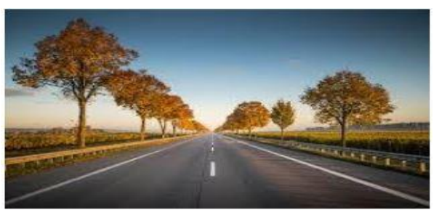 | 3
10 | There is famous picnic spot in Lacchiwala in Dehradun. Many people come there with their family from different states and cities. There is a swimming pool located in this place which is rectangular in shape with area is 1295 m² . its length is 2 more than its width.  - What is the length of swimming pool?  - What is the width of swimming pool?  - Find the distance covered around swimming pool in 1 round.  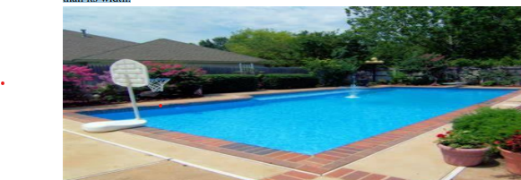 | 3
 | ANSWERS
1 | Let of one square is x  Difference of there perimeter is 24m ,ATQ side of that square is $\frac{4x-24}{4}$= x-6  ATQ sum of there areas is 468 sq m  So $x^{2}$ + (${x-6)}^{2}$ =468  x²  6x  216  0  Using quadratic formula x=$\frac{-\left(-6\right)±\sqrt{{\left(-6\right)}^{2 }}-\left(4\right)\left(1\right)(-216)}{2}$ = 18m  So the sides are 18m and 12m. | 3
2 | Let the side of the first square be 'a'm and that of the second be  ′A ′ m.Area of the first square =$a^{2}$ sq m.Area of the second square =$A^{2}$ sq m.  Their perimeters would be 4a and 4A respectively.  Given 4A−4a=24  A−a=6 --(1) $A^{2}+a^{2}=468$------------(2)  From (1), A=a+6  Substituting for A in (2), we get${\left(a+6\right)}^{2}+a^{2}=468$  $$a^{2}+12a+36+a^{2}=468$$  $a^{2}$+6a+18=234  $a^{2}$+6a−216=0  $a^{2}$+18a−12a−216=0  a(a+18)−12(a+18)=0  (a−12)(a+18)=0  a=12,−18  So, the side of the first square is 12 m. and the side of the second square is 18 m. | 3
3 | On comparing the equation with A$x^{2}$+ Bx +C = 0,  We get, A=4,B=-4$a^{2}$ ,C=$a^{4}-b^{4}$  D=$B^{2}$-4AC  =(-4$a^{2})2$-4.4($a^{4}-b^{4}$)  =16$a^{4}$-16$a^{4}$₊16$b^{4}$=16$b^{4}$  $$x=\frac{±\sqrt{b^{2}-4ac}}{2a}$$  X=4$a^{2}±4b^{2}$ | 3
4 | ⇒ Let smaller number be x and larger number be y  According to the question,  ⇒ $y^{2}-x^{2}$=88 ------ ( 1 )  ⇒ y=2x−5 ----- ( 2 )  Substituting value of y from equation (2) in ( 1 )$$,  ${(2x-5)}^{2}$ −$x^{2}$=88  ⇒ ${4x}^{2}$−20x+25−$x^{2}$−88=0  ⇒ 3$x^{2}$−20x−63=0  ⇒ 3$x^{2}$−27x+7x−63=0  ⇒ 3x(x−9)+7(x−9)=0  ⇒ (x−9)(3x+7)=0  ⇒ x−9=0 and 3x+7=0  ⇒ x=9 and x=−$\frac{-3}{7}$  Number cannot be negative.  ∴ Smaller number =9  ⇒ Larger number =2x−5=2×9−5=18−5=13  ⇒ Product of two numbers =9×13=117 | 3
5 | 1/(x +4) – 1/(x -7) = 11/30 => (x-7) – (x +4) = 11/30  (x+4)(x-7)  - -11/ (x+4)(x-7) =11/30 => -1/x² -3x -28 =1/30 =>x² -3x -28 =-30  - x² -3x +2 =0 =.x² -2x –x +2 = 0 => x(x-2) -1 ( x-2) =0  - (x-2)(x-1) =0 =>x =2 or x= 1  - Hence 1 and 2 are roots of the given quadratic equation. | 3
6 | Let the number of children be x. The no. of gifts each child gives =x – 1  Total no. of gifts = 2450.  ATQ,  x.( x – 1) = 2450 ,or x² –x =2450 ,or x² –x -2450 =0 ,  or x² -50x +49x - 2450 = 0 ,or ( x -50) (x +49) =0  So x = 50 0r x = - 49(not possible). Therefore, number of children is 50. | 3
7 | Ritu`s present age = x years and present age of mother = x² years  After 5 years age of Ritu will be x+5 years and mother`s age will be x² +5 years.  ATQ  (x²+ 5) =3( x+5) => x² +5 =3x +15 =>x²-3x -10 =0 =>x² -5x +2x -10=0  =>x(x-5)+2(x-5) =0 =>(x-5) (x+2) = 0 => x=5 or x=-2( impossible),x²=25  Therefore RITU`s present age is 5 years and mother’s age is 25 years | 3
8 | x2 – 39x – 126 = 0 i.e., (x + 3) (x – 42) = 0 i.e., x = – 3 or x = 42 Since x is the average speed of the train, x cannot be negative. Therefore, x = 42. So, the speed of the train is 42 km/h. | 3
9 | 2(x + 5) km (ii) x² + 5x – 500 = 0 (iii) 20km/h | 3
10 | (i)37m (ii)35 m (iii)144 m | 3
 | 4 – MARKS TYPE QUESTIONS (CASE BASED QUESTIONS)
1 | In a rectangular park of dimensions 50 m x 40 m, a rectangular pond is constructed so that the area of grass strip of uniform width surrounding the pond would be 1184 m².  - Find the length and breadth of the pond.  - What is the width of grass lawn?  - What is the area of pond? | 4
2 | 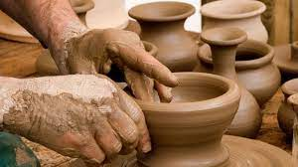  A cottage industry produces certain number of pottery articles in a day. It was observed on a particular day that the cost of production of each article (in Rs.) was found to be 3 more than twice the number of articles produced on that day. The total cost of production on that day was Rs. 90.  i)Frame a quadratic equation to find the number of articles.  ii)Find the number of articles produced.  iii)Find the cost of each article. | 4
3 | The speed of a motor boat is 20 km/hr. For covering the distance of 15 km the boat took 1 hour more for upstream than downstream.  - Let speed of the stream be x km/hr. then what will be the speed of the motorboat in upstream?  - Write the correct quadratic equation for the speed of the current?  - What is the speed of current for given situation?  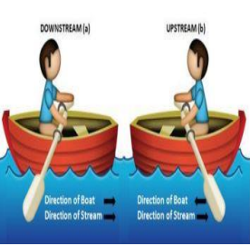 | 4
4 | Riya has a field with a flowerbed and grass land. The grass land is in the shape of rectangle while flowerbed is in the shape of square. The length of the grassland is found to be 3 m more than twice the length of the flowerbed. Total area of the whole land is 1260 m2 .  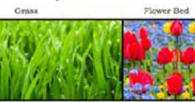  (i) If the length of the flowerbed is x m then what is the total length of the field?  (a) ( 2 x +3) m (b) ( 3 x +3) m (c) 6x m (d) ( 2 x +5) m  (ii) What will be the perimeter of the whole field?  - ( 8 x +6) m (b) ( 6 x +8) m (c) ( 4 x +30 m (d) ( 3 x +4) m  (iii) What is the value of x if the area of total field is 1260 m2 .  21 m (b) 10 m (c) 20 m (d) 15 m | 4
5 | Digital images consist of pixels. A pixel can be considered as the smallest unit on a display screen in a mobile or a computer. The number of pixels, their size and colours depend on the display screen and its graphic card. Display screens are rectangular in shape and their size is denied as the length of the diagonal.  Amit is designing a web page for a display on a screen whose size is 1000 pixels. The width of the screen is 800 pixels  - Which of the following equation can be used to calculate the height (h) of the screen?  (a)${ h}^{2}+200×1800=0$  (b) ${ h}^{2}-200×1800=0$  (c )${ h}^{2}-200=0$  (d)${ h}^{2}-1800=0$  - The size of a screen display can be measured in inches also. If a screen of size 13 inches where the width is 7 inches more than height then which of the following expression is correct?  - $x^{2}-{\left(x+7\right)}^{2}={13}^{2}$  - $x^{2}+{13}^{2}={\left(x+7\right)}^{2}$  - $x^{2}+{\left(x+7\right)}^{2}={13}^{2}$  - $x^{2}-{13}^{2}={\left(x+7\right)}^{2}$  - The size of a screen display can be measured in inches also. If a screen of size 13 inches where the width is 7 inches more than height then the height and width are respectively (in inches).  - 6,13  - 5,12  - 4,11  - 9,16  - If the quadratic equation is${ h}^{2}-200×1800=0$ then the positive value of h is  - $±600$  - $±900$  - $900$  - 600 | 4
6 | Japan's LO series Maglev is the fastest train in the world, with a speed record of 602 km/h. It could go the distance from New York City to Montreal in less than an hour. China has half of the eight fastest trains and the world's largest high-speed railway network. Suppose a fast train takes 3 hours less than a slow train for a journey of 600 km. If the speed of the slow train is 10 km/h less than that of the fast train.  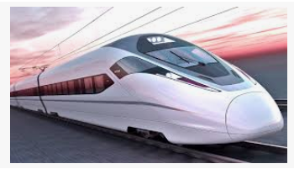  - Find the speed of the slow train.  - Find the speed of the fast train.  - How much time taken by the slow train to cover the distance 600 km?  - How much time taken by the fast train to cover the distance 600 km? | 4
7 |   A cottage industry produces a certain number of pottery articles each day. It was observed on Monday that the cost of production of each article (in rupees) was 3 more than twice the number of articles produced on that day. However, on Tuesday, it was observed that the cost of production was 3 less than thrice the number of articles produced that day. The cost of production was Rs.90 and Rs.60 on Monday and Tuesday, respectively. Based on this information, answer the following questions:  1. Find the number of articles produced on monday ?  - 1  - 4  - 5  - 6  2. Find the cost of each article produced on monday ?  a) Rs 12 b) Rs 18 c) Rs 15 d) Rs 20  3. Find the number of articles produced on tuesday ?  a) 1 b) 4  c) 5 d) 6  4. Find the cost of each article produced on monday ?  a) 12  b) 18  c) 15  d) 20 | 4
 | ANSWERS
1 | Length of rectangular park= 50m, breadth = 40m  Let x m be width of grass lane.  Length of pond = (50 -2x)m, breadth of pond =(40 -2x)m  ATQ, 50 X40 –[ (50-2x)(40 -2x)=1184m²  =>x² -45x+296 =0 =>(x-37)(x-8) = 0 =>x =37 or 8,  X=37 is not possible, because 50-2x37 =-24  So x = 8  i)Length =50 -2 x8 =34m, breadth = 40 -2x8 =24m  ii)width of grass lane =8m  iii)area of pond =34 m x 24m =816 m² | 4
2 | i)Let the number of articles produced in a day be x.  Total cost of production that day = no. of article x cost of each article  = x(2x +3),  Given that total cost of production is Rs.90  ATQ, 2x² +3x -90 = 0  ii) No of article produced =(2x + 15 )( x – 6 ) =0 => 2x +15 = 0 or x – 6 = 0  - X = -15/2 (impossible) or x = 6, x = 6 (no. of articles)  Iii) Cost of each article =2x + 3 =2 x 6 +3 = Rs.15 | 4
3 | (i)20-x km/h (ii)x²+30x-400=0 (iii)10 km/h | 4
4 | (i) The length of the grassland is 3 m, more than twice the length of the flowerbed. Thus, it will be 2 x +3 . Now the total length of field is 2 x+3+ x = 3 x + 3. Thus, (b) is correct option.  (ii) Perimeter = 2 (3x + 3 + x) = 2. Thus, (a) is the correct option.  iii) : We have A = ( 3x+3)  1260 = 3x²+3x  x² +x-420=420 Thus, x = 20 is only possible value. Thus, (c) is the correct option. | 4
5 | (i)(b)${ h}^{2}-200×1800=0$  (ii)(c )$x^{2}+{\left(x+7\right)}^{2}={13}^{2}$  (iii)(b) 5,12  (iv)(d) 600 | 4
6 | (i)40 km/hr  (ii)50 km/hr  (iii)15hrs  (iv)12hrs | 4
7 | 1. d) 6  2.c) Rs 15  3. c) 5  4. a) Rs 12 | 4
 | 5 – MARKS TYPE QUESTIONS
1 | A piece of cloth costs Rs200. If the piece was 5m longer and each meter of cloth costs Rs2 less the cost of the piece would have remained unchanged. How long is the piece and what is the original rate per meter? | 5
2 | Some student planned a picnic. The budget for food was Rs. 500. But 5 of these failed to go and then cost of food for each member is increased by Rs 5. How many students attended the picnic?   | 5
3 | $1/(p+q+x) = 1/p+1/q+1/x solve for by factorization method$. | 5
4 | The sum of reciprocals of Rehman's ages (in years)3 years ago and 5 years from now is13. Find his present age. | 5
5 | Riya has a field with a flowerbed and grass land. The grass land is in the shape of rectangle while flowerbed is in the shape of square. The length of the grassland is found to be 3 m more than twice the length of the flowerbed. Total area of the whole land is 1260 m2 .  (i) If the length of the flowerbed is x m then what is the total length of the field ?  (a) ( 2 x +3) m (b) ( 3 x +3) m (c) 6x m (d) ( 2 x +5) m  (ii) What will be the perimeter of the whole field?  - ( 8 x +6) m (b) ( 6 x +8) m (c) ( 4 x +30 m (d) ( 3 x +4) m  (iii) What is the value of x if the area of total field is 1260 m2 .  21 m (b) 10 m (c) 20 m (d) 15 m | 5
 | ANSWERS
1 | Let the length of piece = x m Rate per metre =200/x New length = ( x + 5) New rate per metre =200/(x+5). ATQ 200/x -200/(x+5) = 2  x² + 5x − 500 = 0  x = −25, x = 20  Rate per metre =10 | 5
2 | Let no. of student = x Cost per head= 500/x When 5 failed to go  New cost per head=500/(x-5) ATQ 500/(x-5) - 500/x =5 x² − 5x − 500 = 0  ( x − 25)( x + 20) = 0 x = 25, x = −20  No of student attended the picnic  = 25 − 5= 20 | 5
3 | $\frac{1}{p}$₊$\frac{1}{q}$+$\frac{1}{x}$=$\frac{1}{p+q+x}$  $\frac{1}{p}$₊$\frac{1}{q}$+$\frac{1}{x}$-$\frac{1}{p+q+x}$=0  ((q+p)[$\frac{1}{pq}$ +$\frac{1}{x^{2+px+qx}}$]  $$x^{2}+px+qx=pq$$  x(x+p)+q(x+p)=0  (x+p)(x+p)=0  X=-p and x=-q | 5
4 | Let the present age of Rehman =x  3 years ago Rehman’s age =(x–3) years  5 years later Rehman’s age =(x+5) years.  Now, according to the condition  $$\frac{1}{x-3}+\frac{1}{x+5}=\frac{1}{3}$$  $$\frac{x+5+x-3}{(x-3)(x+5)}=\frac{1}{3}$$  $$\frac{2x+2}{(x-3)(x+5)}=\frac{1}{3}$$  $x^{2}$+2x-15=6x+6  $x^{2}$-4x-21=0  (x+3)(x-7)=0  Either,x+3=0 Or, x–7=0  Thus, x=7 or –3; but age cannot be negative.  Hence the present age of Rehman is 7 years. | 5
5 | (i) The length of the grassland is 3 m, more than twice the length of the flowerbed. Thus, it will be 2 x +3 . Now the total length of field is 2 x+3+ x = 3 x + 3. Thus, (b) is correct option.  (ii) Perimeter = 2 (3x + 3 + x) = 2. Thus, (a) is the correct option.  iii) : We have A = ( 3x+3)  1260 = 3x²+3x  x² +x-420=420 Thus, x = 20 is only possible value. Thus, (c) is the correct option. | 5

CHAPTER – 5
ARITHMETIC PROGRESSIONS

SYLLABUS:
Motivation for studying Arithmetic Progression Derivation of the nth term and sum of the first n terms of A.P. and their application in solving daily life problems.

SL NO | QUESTION | MARK
 | MULTIPLE - CHOICE QUESTIONS
1 | The (n – 1)th term of an A.P. is given by 7,12,17, 22,… is  (a) 5n + 2 (b) 5n + 3 (c) 5n – 5 (d) 5n – 3 | 1
2 | The sum of all two digit odd numbers is  (a) 2575 (b) 2475 (c) 2524 (d) 2425 | 1
3 | If a, b, c, d, e are in A.P., then the value of a – 4b + 6c – 4d + e is  a) 0 (b) 1 (c) -1. (d) 2 | 1
4 | The 10th term from the end of the A.P. 4, 9,14, …, 254 is  (a) 209 (b) 205 (c) 214 (d) 213 | 1
5 | The sum of all odd integers between 2 and 100 divisible by 3 is  (a) 17 (b) 867 (c) 876 (d) 786 | 1
6 | The list of numbers – 10, – 6, – 2, 2,... is  (a) an AP with d = – 16  (b) an AP with d = 4  (c) an AP with d = – 4  (d) not an AP | 1
7 | Which term of the AP : 21 , 42 , 63 , 84 , … is 210 ?  (a) 9th  (b) 10th  (c) 11th  (d) 12th | 1
8 | The 4th term from the end of the AP: -11, - 8, -5, ..., 49 is  (a) 37  (b) 40  (c) 43  (d) 58 | 1
9 | The sum of first 16 terms of the AP: 10, 6 2, … is  (a) -320  (b) 320  (c) -352  (d) -400 | 1
10 | The sum of first five multiples of 3 is  (a) 45  (b) 55  (c) 65  (d) 75 | 1
11 | The nth term of an A.P. 5 , 2 , - 1 , - 4 , - 7 … is  (a) 2n + 5  (b) 2n – 5  (c) 8 – 3n  (d) 3n – 8 | 1
12 | The sum of first n odd natural numbers is  (a) 2n²  (b) 2n + 1  (c) 2n – 1  (d) n² | 1
13 | If 2x, x + 10, 3x + 2 are in A.P., then x is equal to  (a) 0  (b) 2  (c) 4  (d) 6 | 1
14 | In an AP, if d = -4, n = 7, a_{n} = 4, then a is equal to  (a) 6  (b) 7  (c) 20  (d) 28 | 1
15 | In an AP, if a=3.5, d= 0, n=101, then a_{n} will be  (a) 0  (b) 3.5  (c) 103.5  (d) 104.5 | 1
16 | Which of the following sequence is an AP  - 2, 4, 8, 16, …  - 2, 5/2, 3, 7/2, …  - 0.2, 0.22, 0.222, 0.2222, …  - 1, 3, 9, 27 | 1
17 | For what value of p; 2p, p+10, 3p+2 are in AP?  - 5  - 6  - 4  - 3 | 1
18 | 11th term of the AP; -3, -1/2, 2, … is  - 22  - 28  - -38  - -42 | 1
19 | Find the 31st term of an AP, whose 11th term is 38 & the 16th term is 73.  - 176  - 178  - 179  - 180
20 | If the numbers k-3, 4k-2, 5k+1 are in AP, then the value of k is  - 1  - 2  - 3  - 4 | 1
21 | The sum of 1st 16 terms of the AP 10, 6, 2, … is  - -320  - 320  - -352  - -400 | 1
22 | The sum of 1st 20 terms of an AP in which a = 1 & 20th term is 58, is  - 590  - 588  - 591  - 592 | 1
23 | The sum of n^{th} term of AP whose k^{th} term is 5k+1, is  - n(5n+7)/2  - 1(5n+7)/2  - n(5n+7)  - none of these | 1
24 | The sum of 1st 40 positive integers divisible by 6, is  - 4919  - 4920  - 4921  - None of above | 1
25 | The 1st term of an AP is -76 & the sum of 1st 45 terms is -9360. Which of the following is the last term of this AP?  - 416+76  - 416-76  - -416+76  - -416-76 | 1
 | ANSWERS | 1
1 | Here a = 7, d = 12-7 = 5  ∴ an-1 = a + [(n – 1) – l]d = 7 + [(n – 1) -1] (5) = 7 + (n – 2)5 = 7 + 5n – 10 = 5n– 3 | 1
2 | All two digit odd numbers are 11,13,15,… 99, which are in A.P.  Since there are 90 two digit numbers of which 45 numbers are odd and 45 numbers are even  ∴ Sum = $\frac{45}{2}$[11 + 99] = $\frac{45}{2}$ × 110 = 45 × 55 = 2475 | 1
3 | Let common difference of A.P. be x  ∴ b = a + x, c = a + 2x, d = a + 3x and e = a + 4x  Given equation n-4b + 6c-4d + e  = a – 4(a + x) + 6(a + 2x) – 4(a + 3x) + (a + 4x)  = a – 4a – 4x + 6a + 12x – 4a – 12x + a + 4x = 8a – 8a + 16x – 16x = 0 | 1
4 | Here l =254, d = 9-4 = 5  ∴ 10th term from the end = l – (10 – 1 )d = 254 -9d  = 254 – 45  = 209 | 1
5 | The numbers are 3, 9,15, 21, …, 99  Here a = 3, d = 6 and an = 99  ∴ an = a + (n – 1 )d  ⇒ 99 = 3 + (n – 1) x 6  ⇒ 99 = 3 + 6n – 6  ⇒ 6n = 102  ⇒ n = 17  Required Sum = $\frac{n}{2}$[a + an] = $\frac{17}{2}$[3 + 99] = $\frac{17}{2}$ × 102 = 867 | 1
6 | (b) an AP with d = 4 | 1
7 | (b) 10th | 1
8 | (b) 40 | 1
9 | (a) - 320 | 1
10 | (a) 45 | 1
11 | (c) 8 – 3 n | 1
12 | (d) n² | 1
13 | (d) 6 | 1
14 | (d) 28 | 1
15 | (b) 3.5 | 1
16 | b | 1
17 | b | 1
18 | a | 1
19 | b | 1
20 | a | 1
21 | a | 1
22 | a | 1
23 | a | 1
24 | b | 1
25 | c | 1
 | 2 MARKS TYPE QUESTIONS
1 | What is the common difference of an AP, whose n^{th} term is a_{n}= 3n+7? | 2
2 | What is the 1st negative term of the AP 20, $19\frac{1}{4}$ , $18\frac{1}{2}$ , $17\frac{3}{4}$ , … | 2
3 | Find the 20th term from the end of the AP; 3, 8, 13, …, 235. | 2
4 | Find the middle term of the AP 213, 205, 197, …, 37. | 2
5 | If S_{n} , the sum of 1st n term of an AP is given by  S_{n} = 2n² + n, then find the nth term. | 2
6 | If 17th term of an A.P. exceeds its 10th term by 7. Find the common difference. | 2
7 | Determine the AP whose 3rd term is 5 and the 7th term is 9. | 2
8 | Find the 11th term from the last term (towards the first term) of the AP : 10, 7, 4, . . ., – 62. | 2
9 | Which term of the sequence 48, 43, 38, 33 , … is the first negative term? | 2
10 | If the 3rd and the 9th terms of an AP are 4 and -8 , respectively, then which term of this AP is zero. | 2
 | ANSWERS | 2
1 | a₂ = (3x2+7) = 13  a₁ = (3x1+7)=10; therefore common difference = a₂ - a₁ = 3 | 2
2 | Given AP can be re write as 20, 77/4, 37/2, 71/4, …  Here, a = 20 , d = - ¾  a_{n} = a+ (n-1)d  = 20+ (n-1)(-3/4) = $\frac{83}{4}$ - $\frac{3}{4}$ n  For 1st negative term, a_{n} < 0 or, $\frac{83}{4}$ - $\frac{3}{4}$ n <0 or, 83 < 3n or, n > $\frac{83}{3}$  So, n should be 28.  Hence 28th term is 1st negative term of this AP. | 2
3 | Given, l = 235 & d = 8-3 = 5  $∴$ 20th term from the end = l - (20 -1) d  = 235 – 19 × 5 = 158. | 2
4 | We have a = 213, d = 205 – 213 = -8 & l = 37  Now, l = a+ (n - 1)d $⇒$ 37 = 213 + (n - 1) × (-8)$⇒$ n = 23  $∴$ the middle term will be ( $\frac{n+1}{2}$ )^{th} term  i.e. ($\frac{23+1}{2}$)^{th} = 12th term  now, a₁₂ = 213 + 11 (-8) = 125 | 2
5 | S_{n} = 2n² + n  S_{n-1} = 2 (n -1)² + (n -1)  = 2n² – 4n + 2 + n – 1 = 2n² – 3n + 1  $∴$ n^{th} term, a_{n} = S_{n} – S_{n-1} = 4n -1 | 2
6 | Let a & d are first term and common difference of an A.P.  A/q, a₁₇ = a₁₀ + 7  ⇒ a + ( 17 - 1 ) d = a + ( 10 - 1 )d + 7  ⇒ ( 16 – 9 ) d = 7  ⇒ 7 d = 7  ⇒ d = 1 | 2
7 | Let a & d are first term and common difference of an A.P.  Given, a₃ = 5 and a₇ = 9  ⇒ a + 2d = 5 and a + 6d = 9  Solving both equations we get a = 3 and d = 1  So, the A.P. will be a , a + d , a + 2d , … = 3 , 3 + 1 , 3 + 2 , … = 3 , 4 , 5 , … | 2
8 | Here, a = 10, d = 7 – 10 = -3 & a_{n} = -62  From the end, a₁₁ = a_{n} - ( n – 1 ) d  = -62 - ( 11 – 1 )( - 3 )  = -62 + 30 = -32 | 2
9 | In the given A.P., a = 48 and d = 43 – 48 = -5  Now, as given in question, a_{n} < 0  a + ( n – 1 ) d < 0  ⇒ 48 + ( n – 1 )( - 5 ) < 0  ⇒ ( n – 1 )( - 5 ) < -48  ⇒ n – 1 > 48/5 = 9.6  ⇒ n > 10.6  So, the first negative term will be 11th term. | 2
10 | Let a & d are first term and common difference of an A.P.  Given, a₃ = 4 and a₉ = -8  ⇒ a + 2 d = 4 and a + 8 d = -8  Solving both equations we get a = 8 and d = -2  Now, let a_{n} = 0  ⇒ a + ( n – 1 ) d = 0  ⇒ 8 + ( n – 1 )( - 2 ) = 0  ⇒ n – 1 = 4  ⇒ n = 5  Therefore, 5th term will be zero. | 2
 | 3 – MARKS TYPE QUESTIONS
1 | The sum of three consecutive terms that are in A.P. is 27 and their product is 288. Find the three terms. | 3
2 | The ratio of 6th and 8th term of an A.P. is 7:9. Find the ratio of 9th term to 13th term. | 3
3 | Prove that 7, 11, 15, 19, 23 is an AP. | 3
4 | There are 20 rows of seats in a concert hall with 20 seats in the first row, 21 seats in the second row, 22 seats in the third row, and so on.In total, how many seats are there in the concert hall? | 3
5 | In an A. P. the first term is 8, nth term is 33 and the sum to first n terms is 123. Find n and d, the common differences. | 3
6 | A sum of Rs 700 is to be used to give seven cash prizes to students of a school for their overall academic performances. If each price is Rs 20 less than its preceding prize, find the value of each prize | 3
7 | In an AP  S_{m}=n , S_{n} = m then S_{(m+n)} = ? | 3
8 | Ronit is moving towards a stationary source of sound at a constant speed. At his initial position, he hears a pitch of 5 hertz.  If the pitch from the source increases by 4 hertz for every 5 m Ramit travels, find the distance he would have travelled towards the source when the pitch is exactly 149 hertz. | 3
9 | Your elder brother wants to buy a car and plans to take loan from a bank for his car. He repays his total loan of Rs. 1, 18, 000 by paying every month starting with the first installment of Rs. 1000. If he increases the installment by Rs 100 every month, answer the following:  (i)The amount paid by him in 30th installment.  (ii) The amount paid by him in the 30 installment months is (iii) What amount does he still have to pay after 30th installment? | 3
10 | Solve the equation : 1+4+7+10+ …… + x = 287 | 3
 | ANSWERS
1 | Let the three terms are a - d, a and a + d.  Sum of three consecutive terms = 27  a - d + a + a + d = 27  3a = 27  a = 27/3 = 9  Product of three terms = 288  (a - d) a (a + d) = 288  a($a^{2}$-$b^{2}$) = 288  9($9^{2}$ - $d^{2}$) = 288  ($9^{2}$- $d^{2}$) = 288/9  ($9^{2}$ - $d^{2}$) = 32  - $d^{2}$ = 32 - 81  - $d^{2}$ = - 49  d = 7  1st term = a - d = 9 - 7 = 2  2nd term = a = 9  3rd term = a + d = 9 + 7 = 16  So, the first three terms are 2, 9, 16. | 3
2 | $t_{6}/$ $t_{8}$ = 7 : 9  $t_{6}$ / $t_{8}$ = 7 / 9  (a + 5d) / (a + 7d) = 7/9  9(a + 5d) = 7(a + 7d)  9a + 45d = 7a + 49d  9a - 7a + 45d - 49d = 0  2a - 4d = 0  a - 2d = 0  a = 2d  ratio of 9th term to 13th term  $t_{9}$ : $t_{13}$ = (a + 8d) / (a + 12d)  = (2d + 8d) / (2d + 12d)  = 10d / 14d  = 5 / 7  = 5 : 7  so, the ratio of 9th term to 13th term is 5 : 7. | 3
3 | Given sequence: 7, 11, 15, 19, 23.  To prove that the sequence is AP, find the common difference between two consecutive terms.  d = 11 – 7 = 4  d = 15 – 11 = 4  d = 19 – 15 = 4  d = 23 – 19 = 4  Hence, 7, 11, 15, 19, 23 is an AP with a common difference of 4. | 3
4 | According to the problem conditions, the sequence of the numbers of seats in the concert hall rows is the arithmetic progression with $a_{1}=11$,  the common difference and the number of terms n=20.  The total number of seats in the concert hall is equal to the sum of this arithmetic progression.  = ($a_{1}+\frac{(n-1)d}{2}×n$) = $11+\frac{(6-1)(-1)}{2}×6$ = 11-$\frac{5×6}{2}$ = 51 | 3
5 | a=8  an=33  Sn=123  Now  Sn=$\frac{n}{2}$[2a+(n-1)d]  Sn=$\frac{n}{2}$ [a+an]  123=$\frac{n}{2}$ [8+33]  n=6  Also  an=a+(n−1)d  33=8+(6−1)d  d=5 | 3
6 | Let first prize is a,then seven prizes will be  a, a-20,a- 40,a-60,a-80,a-100,a-120  Now  a+a−20+a−40+a−60+a−80+a−100+a−120=700  7a=1120  a=160  So prizes will be  160,140,120,100,80,60,40 | 3
7 | Sm = n = m/2 [ 2a + (m-1)d ]  2n/m = 2a + (m-1)d  Sn = m = n/2 [ 2a + (n-1)d ]  2m/n = 2a + (n-1)d  Sm+n= -(m+n) | 3
8 | Writes an arithmetic progressions (AP) for the increase in pitch every 5 m as:  5 hertz, 9 hertz, 13 hertz, 17 hertz, ...  Identifies the first term of the AP, a as 5 and the common difference, 4 as 4.  Finds the n th term of the AP when the pitch is exactly 149 hertz as:  5 + 4( n - 1) = 149  n=37  Finds the distance travelled as 36 x 5 = 180 m. | 3
9 | 3900, (ii) 73500 (iii) 44500 | 3
10 | Here,given a=1 d=4−1=3 and, sn​=287  Now,sn​=$\frac{n}{2}$​(2a+(n−1)d)  ⇒287=$\frac{n}{2}$​(2×1+(n−1)3)  ⇒287=$\frac{n}{2}$(2+3n−3)  ⇒574=n(3n−1)  ⇒574=3n²−n  ⇒3n²−n−574=0  On solving the quadratic equation using formula,  ​​We get n=14& $\frac{-41}{3}$[doesnotexist] so,n=14  Now,sn​=$\frac{n}{2}$​(a+1)  ⇒287 = $\frac{14}{2}$(1+x)  ⇒574=14(1+x)  ⇒(1+x)=14574​⇒1+x=41⇒x=41−1 ∴x=40 | 3
 | 4 – MARKS TYPE QUESTIONS
1 | In a tissue paper roll, diameter of the core of the roll is first term and twice the thickness of paper is the common difference. If the sum of n roll of tissue on a roll is S_{n} = 0.1n² + 7.9n, then answer the following questions.  (i) Find S_{n-1}  (ii) Find the radius of the core  (iii) What is the diameter of roll when one tissue sheet is rolled over it? (iv) Find the thickness of each tissue sheet.
2 | Rohan was playing a number card game. In the game, some number cards (having both +ve and -ve numbers) are arranged in a row such that they are following an arithmetic progression. On his first turn, Amit picks up 6th and 14th card and finds their sum to be -76. On the second turn he picks up 8th and 16th card and finds their sum to be -96.  Based on above information, answer the following questions.  (i) What is the difference between the numbers on any two consecutive cards.  (ii) The number on the first card.  (iii) What is the number on the 19th card.  (iv) The sum of the numbers on the first 15 cards is.
3 | Rinku and Pawan live in Delhi. They decided to go on a tour of hill station of Manali with family. Manali is 500 km far from Delhi. Rinku and Pawan started their journey at the same time from same place. Rinku was divining his car at uniform speed of 40 km per hour. Pawan is very new in driving so he decided to drive his car at the rate of 20 km per hour in first hour and increased the speed by 5 km in each succeeding hour. In the return journey they planned to stop at a Hotel after divining 5 hours continuously and will take some refreshment. Again, Rinku was driving his car at uniform speed of 40 km per hour and Pawan started driving his car at the rate of 20 km per hour in first hour and thought to increase his speed per hour as per Plan.  - Will Pawan’s car be able to overtake Rinku’s car before reaching to Shimla? Suppose they do not stop anywhere in their journey.  - How much time it will take Pawan to meet or overtake Rinku’s car? Suppose they do not stop anywhere in their journey.  - At what distance from Delhi Pawan and Rinku will meet or overtake each other?  - In the return journey they planned to stop at a Hotel after 5 hours of journey and take some refreshment. So Rinku told Pawan that I will drive my car at uniform speed of 40 km per hour but you have to increase your speed. Pawan started driving his car at the rate of 20 km per hour in first hour. What should be the rate of increase in his speed so that they reach hotel at the same time after 5 hours?
4 | The distances between planets will vary depending on where each planet is in its orbit around the Sun. Sometimes the distances will be closer and other times they will be farther away.  The reason for this is that the planets have elliptical orbits and none of them are perfect circles. As an example, the distance between the planet Mercury and Earth can range from 77 million km at the closest point, to as far as 222 million km at the farthest. There is a huge amount of difference in the distances between the planets depending on their position on their orbit path.  The table below shows the average distance between earth and different planets  1 AU (astronomical unit) is the distance from the Sun to Earth, which is 149,600,000 km.  PLANET DISTANCE TABLE-  Read the Table given above and answer the following question.  - Distance between Earth and Mercury is 91,691,000 km. convert this distance in AU and write this in standard form.  - 1 AU is equal to 149,600,000 km. Convert it in standard form.  - A planet is 1.275X10⁹ km far from the Earth. Name the planet.  - Which planet is nearest from the Earth? Write the distance of nearest planet in metre and convert it in standard form.
  FROM | TO | DISTANCES (IN km)
  Earth | Mars | 78,340,000
  Earth | Jupiter | 628,730,000
  Earth | Saturn | 1,275,000,000
  Earth | Uranus | 2,723,950,000
  Earth | Neptune | 4,351,400,000
  Earth | Venus | 41,400,000
  Earth | Mercury | 91,691,000
5 | India is competitive manufacturing location due to the low cost of manpower and strong technical and engineering capabilities contributing to higher quality production runs. The production of TV sets in a factory increases uniformly by a fixed number every year. It produced 16000 sets in 6th year and 22600 in 9th year.  Based on the above information, answer the following questions:  1. Find the production during first year.  2. Find the production during 8th year.  3. Find the production during first 3 years.  4. In which year, the production is Rs 29,200.
6 | Mr.Dinkar has just admitted his son Dipu in class I . Dipu is a very bright student and doing well. His father belongs to lower middle-income group so he has planned to save the certain amount of money every year on the name of higher studies of his son. Suppose Dipu never fails in any class and did not repeat in same class. As per his plan Dinkar will need an amount of Rs 5 lakhs for the higher studies of his son after completion of school (10+2). So he started saving an amount of Rs 20,000 in the first year of his study and increased his yearly savings by Rs 5,000 each year. When Dipu will pass his class XII, it will be his choice to decide about his study.  - What will be his saving amount for the year in which Dipu will be in class XII ?  - Will Dinkar be able to have his gross saving sufficient for Dipu’s higher study in the year in which Dipu will pass out Class XII.  - How much amount will be left with Dinkar if he paid 5 lakhs to Dipu for his higher study as per his plan?  - Dipu decided to go to abroad for further study so he needs Rs 9 lakhs. Dipu’s father do not have that much amount of money. He thought about per year increase in his saving. How much amount per year increase he should have been saving to create his total saving equal to Rs 9 lakhs in the year Dipu is in his class XII?
 | ANSWERS
1 | S_{n}=0.1n²+7.9n  - Replace n by n-1  - S₁= diameter = 8 cm  - S₂-S₁= 8.2 cm  ((iii)-(ii) )/2 = 0.1cm
2 | (a+5d)+(a+13d)= -76 and (a+7d)+(a+15d)=-9  a=7 and d=-5  - -5  - a=7  - 19th card=-83  S₁₅= -420
3 | i) yes in 9th hour they will meet /overtake each other.  - 9 hour  - 9X40= 360 km  - d = 10 km/hour per hour increase in speed= 10 km per hour
4 | - 6.1X10⁻¹ AU  - 1.496X10⁸ Km  - 1.275X10⁹ = 1,275,000,000 km  - Venus  41,400,000 km = 41,400,000X1000 = 41,400,000,000 m  4.14X10¹⁰ m
5 | Ans: 1. Rs 5000  2. Production during 8th year is (a+7d) = 5000 + 2(2200) = 20400  3. Production during first 3 year = 5000 + 7200 + 9400 = 21600  4. N = 12 5.
6 | Ans: i) 12th year saving amount = 20000+11x5000 = Rs 75000.  - Gross Saving of DINKAR = S₁₂= Rs 5,70,000  III) Rs 70000  IV)Per year investment = 10, 000
 | 5 – MARKS TYPE QUESTIONS
1 | A company wants to distribute 14‎500 LE among the top 5 sales representatives as a bonus. The bonus for the last-place representative is 1‎300 LE, and the difference in bonus is constant among the representatives. Find the bonus of the representative in the first place. | 5
2 | Katrina starts training for a 4.5 km charity trail run by running every week for 28 weeks.She runs 2 km of the course in the first week, and each week after that she runs 250metres more than the previous week.She continues to increase the distance she runs until the week when she runs far enough to complete the course. Each week after that she completes the course without increase.  - How far does she run in the 11th week? Give your answer correct to two decimal places, if necessary.  What is the total distance that Katrina runs in 28 weeks? Give your answer correct to two decimal places, if necessary. | 5
3 | There are 25 trees at equal distances of 5m in a line with a well, the distance of the well from the nearest tree being 10m. A gardener waters all the trees separately starting from the well and he returns to the well after watering each tree to get water for the next. Find the total distance the gardener will cover in order to water all the trees | 5
4 | The sum of four consecutive numbers in an AP is 32 and the ratio of the product of the first and the last terms to the product of the two middle terms is 7 : 15. Find the numbers | 5
5 | In a pathology lab, a culture test has been conducted. In the test, the number of bacteria taken into consideration in various samples is all 3-digit numbers that are divisible by 7, taken in order  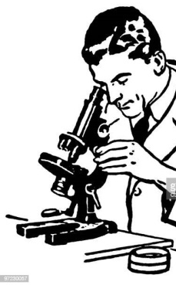 On the basis of above information, answer the following follwing questions.  (i) How many bacteria are considered in the fifth sample? (ii) How many samples should be taken into consideration? (iii) Find the total number of bacteria in the first 10 samples. (iv) How many bacteria are there in the 7th sample from the last? (v) Number of bacteria in the 50th Sample is | 5
 | ANSWERS
1 | We recall that the 𝑛th term of an arithmetic sequence is given by$T_{n}$=$T_{1}$+(𝑛−1)𝑑,where $T_{1}$ is the first term and 𝑑 is the common difference  As there are 5 employees, 𝑛=5,we can write $T_{5}$ in terms of $T_{1}$ and 𝑑 as  $T_{5}$=$T_{1}$+(5−1)𝑑=$T_{1}$+4𝑑.  We are given that the term value for the 5th employee is 1‎300 LE, so, substituting $T_{5}$=1300 into this equation,  we have1300=$T_{1}$+4𝑑  for the sum of the first 𝑛 terms of an arithmetic sequence:𝑆=$\frac{n}{2}$(2$T_{1}$+(𝑛−1)𝑑),where $T_{1}$ is the first term and 𝑑 is the common difference  𝑆=$\frac{5}{2}$ (2$T_{1}$+(5−1)𝑑)  𝑆=5$T_{1}$+10𝑑  we can write that $S_{5}$=14500.Substituting this into the equation above, we have14500=5𝑇+10𝑑.  We now have two equations with two unknowns, which we can solve simultaneously using elimination or substitution:  We can rearrange equation (1) to make $T_{1}$the subject, which gives  $T_{1}$=1300−4𝑑.  Substituting this value for $T_{1}$ into equation (2), we can write this equation as  14500=5(1300−4𝑑)+10𝑑.  14500=6500−20𝑑+10𝑑  14500=6500−10𝑑.  Solving them we have𝑑=−800.  We can substitute 𝑑=−800 into equation (1) or (2) to find the value of $T_{1}$.Substituting into equation (1) and simplifying give1300=$T_{1}$+4(−800)  1300=$T_{1}$−3200, we have4500=$T_{1}$  Now, we have calculated that the first term in the sequence, $T_{1}$,is 4‎ ‎500.This means that we can answer the question that the bonus of the representative in first place is 4‎ ‎500 LE. | 5
   | 1300=$T_{1}$+4𝑑  14500=5𝑇+10𝑑. | (1)  (2)
2 | The nth value in an arithmetic progression is found using the equation a+(n-1)d,  Remember to convert meters into kilometers.  Distance run=$2+\frac{(11-1)×250}{1000}$kilometres  $=2+2.5$kilometres  =4.5kilometres  Distance run4.5kilometres  b.The sum of an arithmetic series is calculated as $\frac{n}{2}$(2a+(n-1)d)  , where n is the number of terms, a is the first term and d is the common difference between consecutive terms.  Total distance$\frac{11}{2}$(2$×2+(11-1)×\frac{250}{1000}$)+(28-11)$×4.5$kilometres  =$\frac{11}{2}\left(4+10×\frac{250}{1000}\right)+17×4.5$kilometres  =$\frac{11×}{2}\frac{13}{2}+17×4.5$kilometres  =35.75+76.5kilometres  = 112.25kilometres | 5
3 | For first tree =20 m distance is covered in to fro from well  For second tree =2(10+1×5)=302(10+1×5)=30 m distance is covered in to fro from well  For third tree =2(10+2×5)=402(10+2×5)=40 m distance is covered in to fro from well  ....  For 25th tree= 2(10+24×5)=2602(10+24×5)=260 m distance is covered in to-fro from well  So total distance  =20 + 30 + 40 +....+ 260  This is a A.P with a=20,d=10 and n=25  Sn=$\frac{n}{2}$[2a+(n-1)d  S=$\frac{25}{2}$[40+24×10]=3500m | 5
4 | Let the four consecutive numbers in AP be (a - 3d), (a - d), (a + d) and (a + 3d) According to the question.  a−3d+a−d+a+d+a+3d=32  4a=32  a=8 ......(1)  Now,  (a−3d)(a+3d)(a−d)(a+d)=715  15$(a^{2}-{9d}^{2}$=7${(a}^{2}-d^{2}$)  15$a^{2}$−135$d^{2}$=7$a^{2}$−7$d^{2}$  8$a$=128$d^{2}$  Putting the value of a = 8 in above we get.  8${(8)}^{2}$=128$d^{2}$  d2=4  d=±2  Putting a=8, d=+2  the four consecutive numbers are 2, 6, 10 and 14  Putting a=8 ,d=-2 ,we get  the four consecutive numbers are 14, 10, 6 and 2 | 5
5 | Smallest 3 digit number divisible by 7 is 105. So AP is 105,112,119,….,994  - Term 5  - Total no of terms n=128  - Sum of 10 terms = 1365  - Term 7 from end=952  Term 50 = 448 | 5

CHAPTER – 6
TRIANGLES

SYLLABUS:
Definitions, examples, counter examples of similar triangles.
1. (Prove) If a line is drawn parallel to one side of a triangle to intersect the other two sides in distinct points, the other two sides are divided in the same ratio.
2. (Motivate) If a line divides two sides of a triangle in the same ratio, the line is parallel to the third side.
3. (Motivate) If in two triangles, the corresponding angles are equal, their corresponding sides are proportional and the triangles are similar.
4. (Motivate) If the corresponding sides of two triangles are proportional, their corresponding angles are equal and the two triangles are similar.
5. (Motivate) If one angle of a triangle is equal to one angle of another triangle and the sides including these angles are proportional, the two triangles are similar.

SL NO | QUESTION | MARK
 | MULTIPLE - CHOICE QUESTIONS
1 | In two equilateral triangle the ratio of their area is 25: 36 then what is the ratio of each side of triangle ?  - 5: 4  - 5: 6  - 6: 7  - 4: 5 | 1
2 | The shadow of a small tree of height 12m is 3m. At the same time the shadow of a big tree of height 30m is _________.  - 10m  - 10.5m  - 15m  - 7.5m | 1
3 | In the triangle ABC  $\frac{BE}{EA}$ = $\frac{BF}{FC}$ and ∠BEF = ∠FCA  Then ABC is which type of triangle ?  - Right angle triangle  - Isoscale triangle  - Equilateral triangle  - Scalene triangle | 1
4 | The side of two similar triangular field are in the ratio 5: 12 . Then the area of these fields are in the ratio  - 125: 124  - 125 :100  - 50 : 258  - 50 : 144 | 1
5 | Δ ABC is such that AB = 3cm BC = 2 cm and CA = 2.5cm. If Δ ABC ∼ ΔDEF, EF = 4, the perimeter of Δ DEF is  - 7.5cm  - 15cm  - 225 cm  - 30cm | 1
6 | Rahul claims that congruent figures are similar as well. Aman claims that similar figures are congruent as well. Who is/are correct?  Option 1: only Rahul  Option 2: only Aman  Option 3: Both Rahul and Aman  Option 4: Neither Rahul nor Aman | 1
7 | Consider the statements below.  Statement 1: All circles are similar.  Statement 2: All squares are similar.  Statement 3: All right triangles are congruent.  Statement 4: All equilateral triangles are congruent.  Which statement is/are correct?  Option 1: Statement 1 and Statement 3  Option 2: Statement 2 and Statement 4  Option 3: Statement 1 and Statement 2  Option 4: Statement 3 and Statement 4 | 1
8 | Which of the following are DEFINITELY similar to each other?  1. any two rhombuses  2. any two right triangles  3. any two regular pentagons  4. any two isosceles triangles | 1
9 | Leela has a triangular cabinet that fits under his staircase. There are four parallel shelves as shown below.  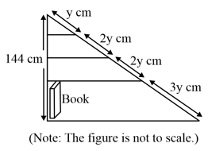  The total height of the cabinet is 144 cm. What is the maximum height of a book that can stand upright on the bottom-most shelf?  1. 18 cm  2. 36 cm  3. 54 cm  4. 86.4 cm | 1
10 | Shown below is a rectangle PQRS. LUTQ is a right angle.  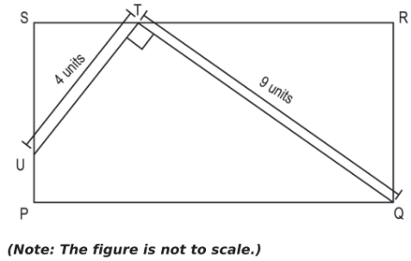  Which of these is TRUE about AUST and ATRQ?  1. The perimeters are in the ratio 16:81.  2. The ratio of ZSUT: ZRTQ is 4:9.  3. The ratio of US:TR is 4:9.  4. The ratio of US:QR is 4:9. | 1
11 | While driving through the hills, Aman observed a bridge in the shape of a trapezium with the diagonal AC and BD intersecting each other at the point O.  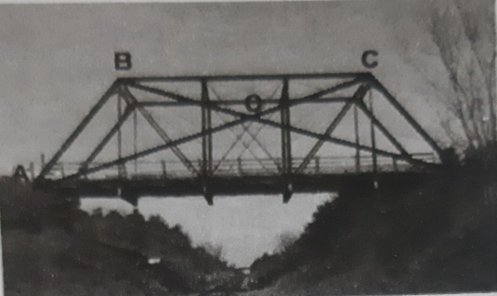  Which of the following statement is true regarding similarity of triangles formed?  - $∆$BOC $\sim$ $∆$AOD by SAS similarity criterion.  - $∆$AOB $\sim$ $∆$COD by AA similarity criterion.  - $∆$BOC $\sim$ $∆$DOA by AA similarity criterion.  - $∆$AOB $\sim$ $∆$DOC by SSS similarity criterion. | 1
12 | In $∆$ABC and $∆$DEF, ∠F = ∠C, ∠B = ∠E and AB = $\frac{1}{2}$ DE. Then, the two triangles are:  - Congruent but not similar.  - Similar but not congruent.  - Neither congruent nor similar.  - Congruent as well as similar. | 1
13 | $∆$ABC $\sim$ $∆$PQR. If AM and PN are altitudes of $∆$ABC and $∆$PQR respectively and ${AB}^{2}$:${PQ}^{2}$ = 4:9, Then AM:PN equals to:  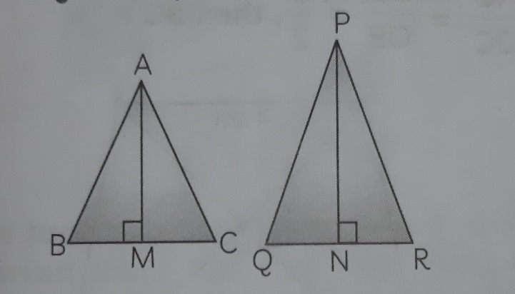  a)16:81  b)4:9  c)3:2  d)2:3 | 1
14 | Pari and her friends love wafers, though her parents always scold her for eating only junk food and fried items as she has gained considerable weight recently. One day, she went to the market and got these wafers which really fascinated her as all of these were triangular in shapes.  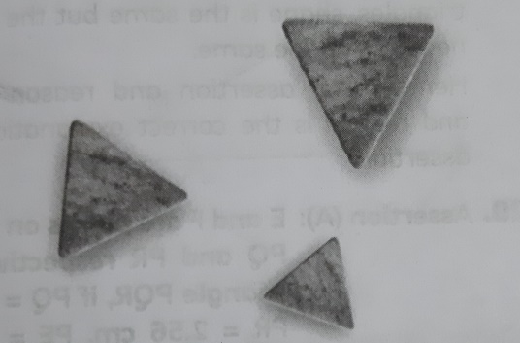  She took two triangular shaped wafers and marked them ABC and PQR. Then if in the triangles ABC and PQR, $\frac{AB}{QR}$ = $\frac{BC}{PR}$ = $\frac{CA}{PQ}$, then:  a)$∆$PQR $\sim$ $∆$CAB  b)$∆$PQR $\sim$ $∆$ABC  c)$∆$CBA $\sim$ $∆$PQR  d)$∆$BCA $\sim$ $∆$PQR | 1
15 | A farmer has a field in the shape of trapezium whose map with scale 1cm = 20m, is given below:  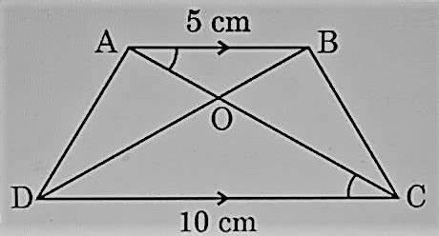  The field is divided into four parts by joining the opposite vertices.  If the ratio of the perimeter of $∆$AOB to the perimeter of $∆$COD is 1:4, then:  a)AB = 2 CD  b)AB = 4 CD  c)CD = 2 AB  d)CD = 4 AB | 1
16 | Two equilateral triangles of sides 5cm and 21 m are—  a)congruent  b) similar  c) congruent and similar  d) either congruent or similar | 1
17 | M and N are respectively points on the sides AB and AC of triangle ABC such that AM = 3cm, BM = 5cm, BC = 12,8 cm and MN II BC. Then length of MN(in cm) is-  a)4.8cm b)7.6 c) 19.2 d) 2.5 | 1
18 | In triangle ABC and DEF , ∠B = ∠E, ∠F = ∠C and AB = 3DE. Then the two triangles are-  - Congruent but not similar  - Similar but not congruent  - Neither congruent nor similar  - Congruent as well as similar | 1
19 | In the following figure DE II BC, find value of x.  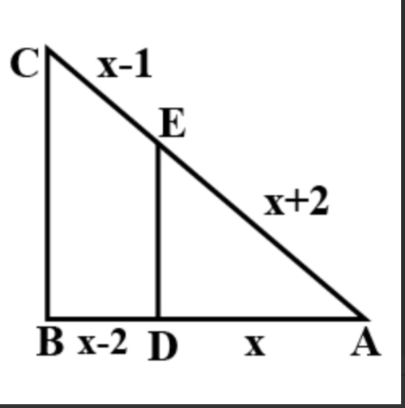  a)2 b) 3 c) 4 d)1 | 1
20 | If triangle ABC is similar to triangle RPQ, AB = 3cm, BC = 5cm, AC =6cm, RP = 6cm and PQ = 10 cm Then find QR.  (a)12 (b) 10 (c) 21 (d) 16 | 1
21 | Meenal was trying to find the height of tower near his house. She is using the properties of similar triangles. The height of Meenal's house is 20 m. When Meenal's house casts a shadow of 10 m long on the ground, at the same time, tower casts a shadow of 50 m long and Arun's house casts a shadow of 20 m long on the ground as shown below. What is the height of tower.  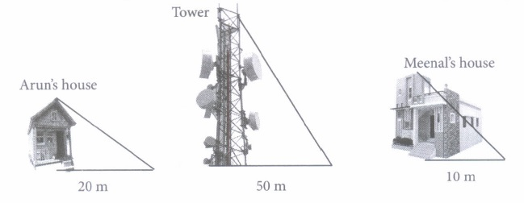  (a) 50 m (b) 15m (c) 45m (d) 100 m | 1
22 | Rohit's father is a mathematician. One day he gave Rohit an activity to measure the height of building. Rohit accepted the challenge and placed a mirror on ground level to determine the height of building. He is standing at a certain distance so that he can see the top of the building reflected from mirror. Rohit eye level is at 1.8 m above ground. The distance of Rohit from mirror and that of building from mirror are 1.5 m and 2.5 m respectively  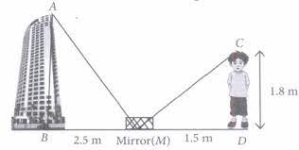  Two similar triangles formed in the above figure is :  (a) $Δ$AMB and CDM (b) ΔABM and ΔCMD  (c) ΔABM and ΔCDM (d)None of these | 1
23 | In ∆PQR, PS is the bisector of ∠P. If PQ = 6.4cm, PR = 14cm, QS = 6cm. What will be the length of PS and QR?  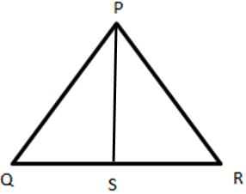  a) 10.5 cm b) 12.74 cm c) 10.74 cm d) 11.74 cm | 1
24 | Two congruent triangles are actual similar triangles with ratio of corresponding side as  - 1:2  - 2:1  - 1:3  - 1:1 | 1
25 | If corresponding angles of two triangles are equal, then the triangles are  (a) Equilateral (b) Isosceles (c) Right-angled (d) Equiangular | 1
 | ANSWERS
1 | b | 1
2 | d | 1
3 | b | 1
4 | c | 1
5 | b | 1
6 | Correct Answer: Option 1 | 1
7 | Correct Answer: Option 3 | 1
8 | 3.any two regular pentagons | 1
9 | 3.54 cm | 1
10 | 3.The ratio of US:TR is 4:9. | 1
11 | c)$∆$BOC $\sim$ $∆$DOA by AA similarity criterion. | 1
12 | b)Similar but not congruent. | 1
13 | d)2:3 | 1
14 | a)$∆$PQR $\sim$ $∆$CAB | 1
15 | d)CD = 4 AB | 1
16 | b) similar | 1
17 | 4,8 cm | 1
18 | Similar but not congruent | 1
19 | 4 | 1
20 | QR = 12 cm | 1
21 | d | 1
22 | c | 1
23 | d | 1
24 | d)1:1 | 1
25 | D | 1
 | 2 MARKS TYPE QUESTIONS
1 | △ABC∼△DEF and their areas are respectively 64 cm2 and 121 cm2. If EF=15.4 cm, find BC. | 2
2 | In the given figure, ∠A = 90°, AD ⊥ BC. If BD = 2 cm and CD = 8 cm, find AD  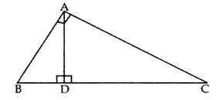 | 2
3 | In the figure ABC and DBC are two right triangles. Prove that AP × PC = BP × PD.  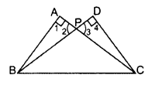 | 2
4 | In the figure, DE || BC. Find the length of side AD, given that AE = 1.8 cm, BD = 7.2 cm and CE = 5.4 cm.  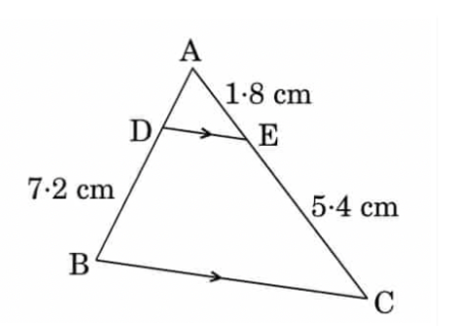 | 2
5 | In the figure, if ∠ACB = ∠CDA, AC = 6 cm and AD = 3 cm,  then find the length of AB. 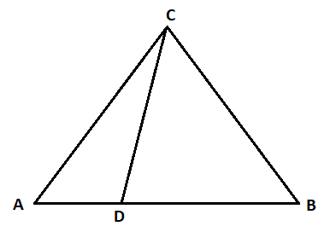 | 2
6 | Given two triangles ABC and DEF ,AG and DH are perpendiculars on BC and EF respectively ∠B = ∠E , AB=5, DE=8 .What is = ? | 2
7 | A vertical stick 30 m long casts a shadow 15 m long on the ground. At the same time, a tower casts a shadow 75 m long on the ground. Find the height of the tower. | 2
8 | Given two triangles ABC and PQR such that, AB = 2 cm , PQ = 3cm, ∠B = ∠Q BC = 5 cm, QR = 7.5 cm. AG and PS are medians .Find | 2
9 | Ram is very intelligent in Mathematics. He always tries to relate the concept of mathematics in daily life. One day he plans to cross a river and want to know how far it is to other side. he takes measurements on his side of the river and make the drawing as shown below.  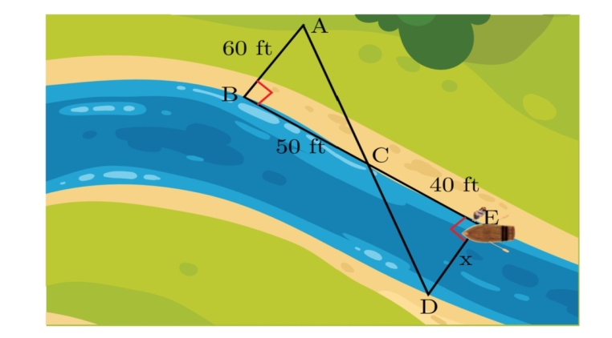  What is the distance x across the river? | 2
10 | Raman is very intelligent in mathematics. he always try to relate the concept of mathematics in daily life. one day he is walking away from the base of a lamp post at a speed of 1m/s. Lamp is 4.5 m above the ground.  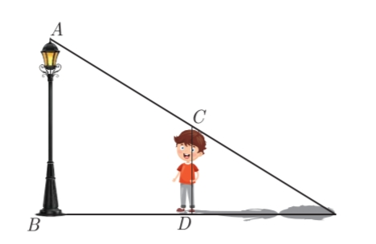  What is the minimum time after which his shadow will become larger than his original height? | 2
 | ANSWERS | 2
1 | Since △ABC∼ΔDEF ∴ $\frac{area(ΔABC)}{area(ΔDEF)}$ = $\frac{{BC}^{2}}{{EF}^{2}}$  [∵ the ratio of the areas of two similar triangles is equal to the ratio of the squares of the corresponding sides]  ⇒$\frac{64}{121}= \frac{{BC}^{2}}{{(15.4)}^{2}}$  ⇒${BC}^{2}$=$\frac{64 154 154}{121 10 10 }$= $\frac{64 ×14 ×14}{10 ×10}$  ⇒ BC = $\frac{8 ×14}{10}$ = 11.2 cm | 2
2 | ∆ADB ~ ∆CDA …[If a perpendicular is drawn from the vertex of the right angle of a rt. ∆ to the hypotenuse then angles on both sides of the ⊥ are similar to the whole D and to each other  ∴ $\frac{BD}{AD}$ = $\frac{AD}{CD}$ …[∵ Sides are proportional  $${AD}^{2}=BD ×CD$$AD2 = 2 $×8$ = 16 ⇒ AD = 4 cm | 2
3 | In ∆APB and ∆DPC,  ∠1 = ∠4 … [Each = 90°]  ∠2 = ∠3 …[Vertically opp. ∠s]  ∴ ∆APB ~ ∆DPC …[AA corollary]  ⇒ $\frac{BP}{PC}=\frac{AP}{PD}$ … [Sides are proportional]  ∴ AP × PC = BP × PD | 2
4 | Given, DE || BC  AE = 1.8 cm, BD = 7.2 cm and CE = 5.4 cm  By basic proportionality theorem,  AD/DB = AE/EC  AD/7.2 = 1.8/5.4  AD = (1.8 × 7.2)/5.4 = 2.4  Therefore, AD = 2.4 cm. | 2
5 | ΔACB $\sim$ ΔADC (AA criterion)  So, $\frac{AC}{AD}=\frac{AB}{AC}$ => $\frac{6}{3}=\frac{AB}{6}$ => AB = 6$×$2  $∴$ AB = 12 cm | 2
6 | 5/8 | 2
7 | 150m | 2
8 | 2/3 | 2
9 | 48 ft | 2
10 | 3 seconds | 2
 | 3 – MARKS TYPE QUESTIONS
1 | Two poles of height 6m and 11m stand on a plane ground. If the distance between the feet of the poles is 12m. Find the distance between their tops ? | 3
2 | $∆$ABC is similar to $∆$PQR. The ratio of the perimeter of $∆$ABC to the perimeter of $∆$PQR is 4:9.  i) Sara said $\frac{AB}{PQ}$ = $\frac{4}{9}$. Is it true? Justify your answer.  ii) Find the ratio of the area of $∆$ABC to the area of $∆$PQR. | 3
3 | In the figure below, P and R are points on the sides XZ and YZ respectively. PR II XY and PR bisect the area of $∆$XYZ.  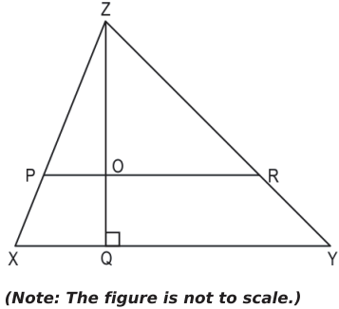  If ZQ = 10cm, Find the length of OQ. Show your steps and give valid reasons. | 3
4 | A farmer has a field in the shape of a right-angled triangle with legs (sides other than the hypotenuse) are of length 16m and 8m. She wants to leave a space in the form of a square of largest area for growing wheat and remaining area for growing vegetables.  i)Find the length of the side of such a square.  ii)Find the area of the square. | 3
5 | 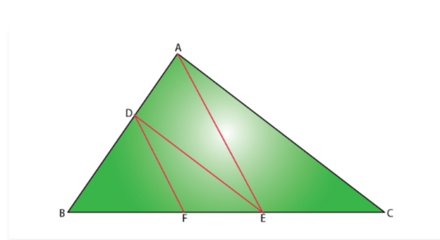  In the figure, DE II AC and DF II AE. Prove that BF /FE = BE/ EC | 3
6 | In triangles PQR and MST, ∠P = 55°, ∠Q = 25°, ∠M = 100° and ∠S = 25°. Is ΔQPR~ΔTSM? Why? | 3
7 | Determine the length of an altitude of an equilateral triangle of side ‘2a’ cm | 3
8 | A man called a carpenter to repair his favorite mountain shaped wooden wall shelf. The shelf has a triangular part consisting an upper shelf parallel to the horizonal base of the shelf whose measurement of all the sides except broken side are shown in the image.  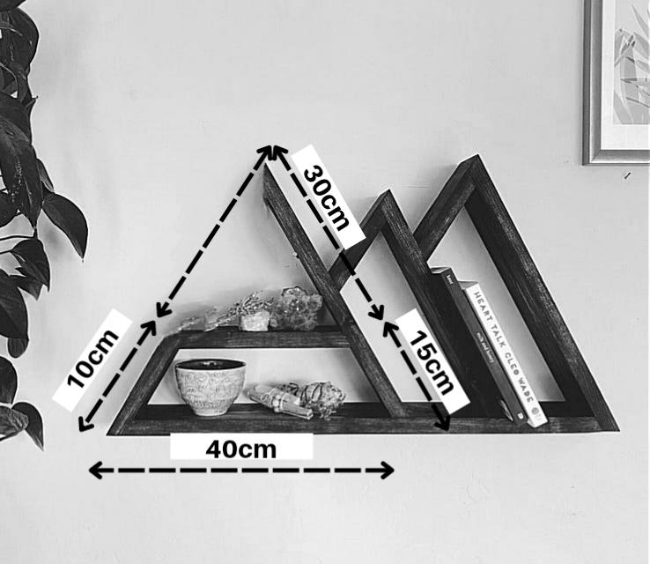  The length of the wooden plank used in fixing the broken side of the shelf will be? What will be the cost of sun mica used for lamination around the three sides of the same triangle at the rate of ₹400 per metre. | 3
9 | A boy of height 80 cm is walking away from the base of a lamp-post at a speed of 1.1 m/s. If the lamp is 3.2 m above the ground, find the length of her shadow after 3 seconds. | 3
10 | Arjun is 5 feet tall. He places a mirror on the ground and moves until he can see the top of a tower. At the instant when Arjun is 3 feet from the mirror, the tower is 54 feet from the mirror. How tall is the tower? | 3
 | ANSWERS
1 | AC = 13cm | 3
2 | i)Writes that sara’s claim is true.  Uses the given information, $∆$ABC is similar to $∆$PQR to write:  AB = k PQ, BC = k QR, CA = k RP, where k is a constant.  Uses the ratio of the perimeters to write:  $\frac{AB+BC+CA}{PQ+QR+RP}$ = $\frac{4}{9}$  Uses steps 1 and 2 to solve for k and finds the ratio $\frac{AB}{PQ}$ as $\frac{4}{9}$.  ii) Finds the ratio of the areas of the two triangles as:  $\frac{Area-of-∆ABC }{Area-of- ∆PQR}$ = ${(\frac{4}{9})}^{2}$ = $\frac{16}{81}$. | 3
3 | Proves $∆PRZ$ $\sim$ $∆XYZ$ by giving appropriate reasons. For example: -  In $∆PRZ$ and $∆XYZ$:  ∠ZPR = ∠ZXY (Corresponding Angles)  ∠ZRP = ∠ZYX (Corresponding Angles)  Hence, $∆PRZ$ $\sim$ $∆XYZ$ using the AA similarity criterion.  Applies the similarity and writes:  $\frac{ZQ}{ZQ}$ = $\frac{\sqrt{Area}-of-∆ZPR}{\sqrt{Area}-of-∆ZXY}$ = $\frac{1}{√2}$.  Finds that ZO = $\frac{10}{√2}$ cm and OQ = ZO – ZO = 10 - $\frac{10}{√2}$ or 10 - 5$√2$cm. | 3
4 | 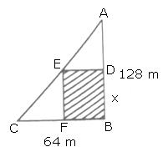  Let ABC be the right triangular field. Also, let BDEF be the required square space of the largest size for growing the wheat and let BD = x m.  So, AD = (128 - x) m  In $∆$ADE and $∆$ABC,  ∠ADE = ∠ABC (Each = 90$°$)  ∠DAE = ∠BAC (Common)  $∴$ $∆$ADE $\sim$ $∆$ABC (By AAA Similarity)  So, $\frac{AD}{AB}$ = $\frac{DE}{BC}$ ⇒ $\frac{128-x}{128}$ = $\frac{x}{64}$  ⇒ 128 x 64 – 64x = 128x  ⇒ x = $\frac{128 × 64}{192}$ m = $\frac{128}{3}$ m.  Thus, side of the required square space is $\frac{128}{3}$m. | 3
5 | Given that, in triangle ABC, DE II AC.  By basic proportionality theorem, BD / DA = BF / FE…….(1)  Also given DF II AE  Again by basic proportionality theorem,  BD / DA = BF /FE…………(2)  From equation 1 and 2 BE / EC = BF / FE  Hence proved | 3
6 | We know that the sum of three angles of a triangle is 180°.  In ΔPQR, ∠P + ∠Q + ∠R = 180°  ⇒ 55° + 25° + ∠R = 180°  ⇒ ∠R = 180° – (55° + 25°)= 180° – 80° =100°  In ΔTSM, ∠T + ∠S + ∠M = 180°  ⇒ ∠T + ∠25°+ 100° = 180°  ⇒ ∠T = 180°-(25° +100°)  =180°-125°= 55°  In ΔPQR and A TSM, and  ∠P = ∠T, ∠Q = ∠S and ∠R = ∠M  ΔPQR ~ ΔTSM [since all corresponding angles are equal]  Hence, ΔQPR is not similar to ΔTSM, since the correct correspondence is P ↔ T, Q < r→ S and R ↔M | 3
7 | Applying Pythagoras theorem  AD= √3 a cm | 3
8 | x/10=30/15 (Applying BPT) ⇒ x=20 cm  (20+10+40+15+30)cm= 115cm = 1.15m. Cost= 1.15×400=₹460 | 3
9 | Distance= Speed× Time = 1.1×3= BD= 3.3 m  Clearly, ∆ABE~∆CDE (by AA-similarity criterion)  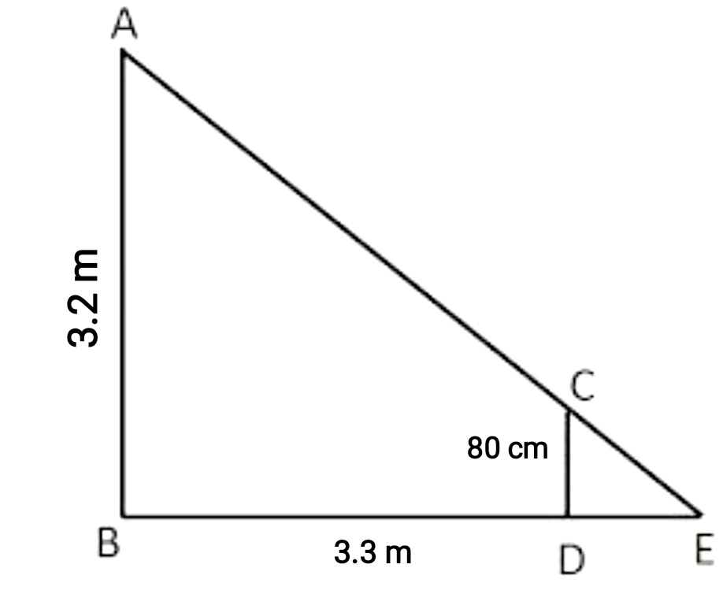  $$\frac{0.8}{3.2}=\frac{DE}{3.3+DE}$$  ⇒ DE= 1.1 m | 3
10 | $$Since the triangles are similar by AA criterion,therefore \frac{h}{4}=\frac{54}{3}$$  ⇒ h $=72 meters$ | 3
 | 4 – MARKS TYPE QUESTIONS (CASE BASED QUESTIONS)
1 | Venkatesh, a student of School of Planning and Architecture is trying to find the height of iconic Vikas Minar, once Delhi's tallest building that was built in 1976 to surpass the Qutub Minar in height. The Minar is located opposite to his school. If the height of Venkatesh’s school building is 30m casts a shadow 45m long on the ground and at the same time, the minar casts a shadow 123m long on the ground, then  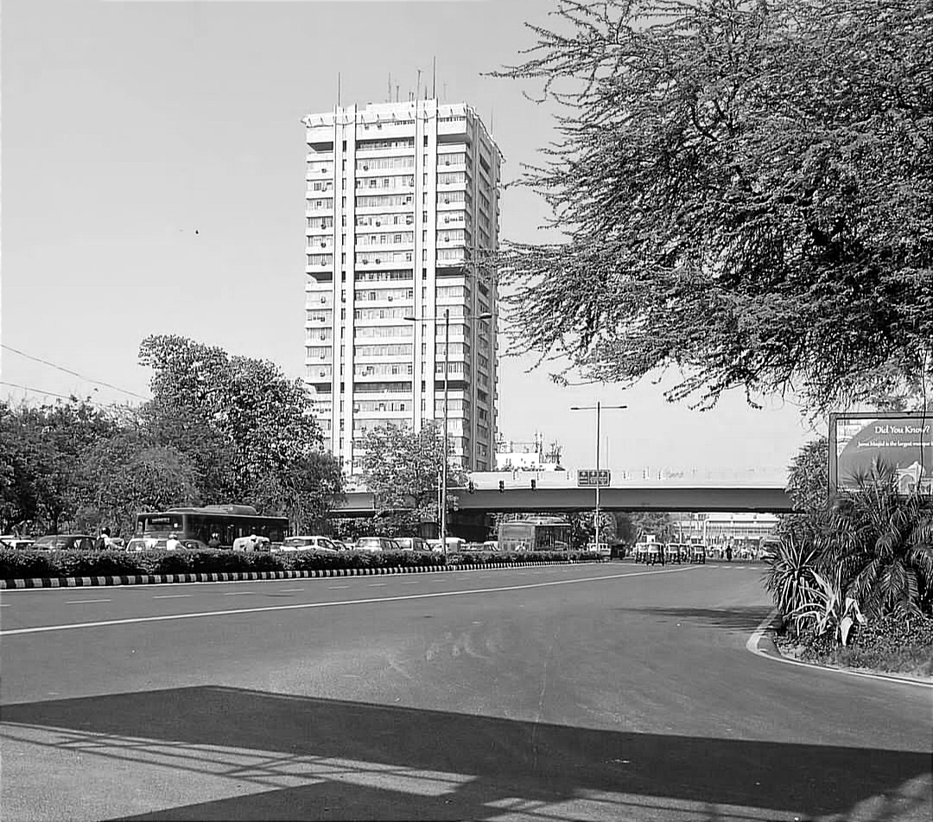  - What is the height of Vikas Minar?  - Write the criterion of similarity used for answering the question.  - How tall is Vikas Minar than the Qutub Minar if height of latter is 72.50m? | 4
2 | Ram was trying to find the height of the tower near his house. He is using the properties of similar triangles. The height of Ram’s house is 20 m. When Ram’s house casts a shadow of 10m long on the ground, at the same time, the tower casts a shadow of 50 m long and Mohan’s house casts a shadow of 20 m long on the ground as shown below.  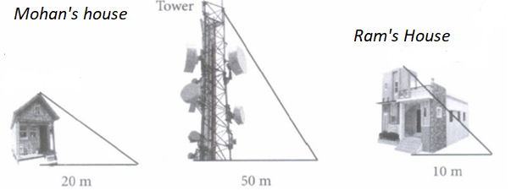  (i) What is the height of the tower?  (a) 100 m (b) 50 m (c) 45 m (d) 30 m  (ii) What will be the length of the shadow of the tower when Ram’s house casts a shadow of 15 m?  (a) 75 m (b) 40 m (c) 55 m (d) 60 m  (iii) Height of Mohan’s house is:  (a) 24 m (b) 45 m (c) 40 m (d) 80 m  (iv) If the tower casts a shadow of 40 m, then find the length of the shadow of Mohan’s house:  (a) 15 m (b) 16m (c) 17 m (d) 18 m | 4
3 | Minister of a state went to city Q from city P. There is a route via city R such that PR⊥RQ. PR = 2x km and RQ = 2(x + 7) km. He noticed that there is a proposal to construct a 26 km highway which directly connects the two cities P and Q.  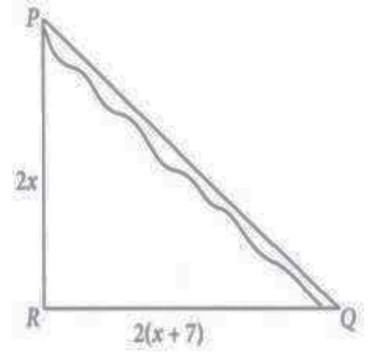  Based on the above information, answer the following questions.  (i) Which concept can be used to get the value of x?  (a) Thale’s theorem (b) Pythagoras theorem  (c) Converse of Thales theorem (d) Converse of Pythagoras theorem  (ii) The value of x is  (a) 4 (b) 6 (c) 5 (d) 8  (iii) The value of PR is  (a) 10 km (b) 20 km (c) 15 km (d) 25 km  (iv) The value of RQ is  (a) 12 km (b) 24 km (c) 16 km (d) 20 km | 4
4 | There is a mirror M situated on the ground. Roshan is watching the reflection of the flag in the mirror. This condition is shown with the help of two triangles in the adjoining figure. If point P represents head of Roshan and point Q represents top of the pole (in which the flag is filing). We know with the help of law of reflection, ∠ PMG =∠QMF. Answer the questions given below.  (i) By which criterion of similarity are $∆$PGM and $∆$QFM similar?  (ii) Find the height of the pole (h).  (iii) What is the ratio between the corresponding sides of these two similar triangles?  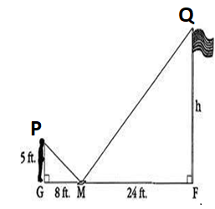 | 4
5 | Below you see a student's mathematical model of a farmhouse roof with measurements. The attic floor, ABCD in the model, is a square. The beams that support the roof are the edges of a rectangular prism, EFGHKLMN. E is the middle of AT, F is the middle of BT, G is the middle of CT, and H is the middle of DT. All the edges of the pyramid in the model have length of 12 m.  (i) Which shape is shown by EFGH?  (ii) What is the length of EF, where EF is one of the horizontal edges of the block?  (iii) Is EF $∥$ AB? If yes, why?  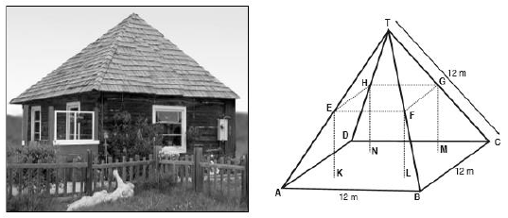 | 4
6 | Class teacher draw the shape of quadrilateral on board. Ankit observed the shape and explored on his notebook  in different ways as shown below. In fig ,  - In fig 1, if AB II CD, and DO=3x-19, OB= x-5, OC=x-3 and AO=3, then find the value of x.  - In fig 2, in ΔDEF, if RS ||EF, DR=4x-3 ,DS=8x-7, ER=3x-1  and FS=5x-3, then find the value of x.  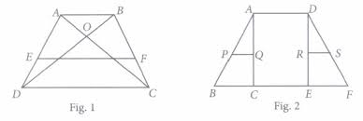 | 4
7 | Ankita wants to make a toran for Diwali using some pieces of cardboard. She cut some cardboard pieces as shown below. If perimeter of ΔADE and ΔBCE are in the ratio 2:3.  (i) If the two triangles here are similar by SAS similarity rule, then which corresponding sides are proportional and find BC.  (ii) Find length of AD and ED.  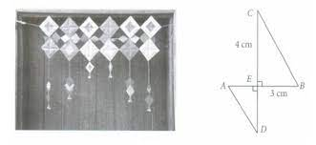 | 4
 | ANSWERS
1 | $$\left(a\right)\frac{123}{45}=\frac{x}{30}$$  x=82 meters  (b) AA-criterion of similarity  (c ) 82-72.5= 9.5 meters | 4
2 | (i) (a) 100 m  (ii) (a) 75 m  (iii) (c) 40 m  (iv) (c) 16 m | 4
3 | (i) (b) Pythagoras theorem  (ii) (c) 5  (iii) (a) 10 km  (iv) (b) 24 km | 4
4 | (i) $∆$PGM and $∆$QFM are similar by AAA similarity.  (ii) By solving PG / QF = GM / FM, we get QF = 15ft  (iii) 1 : 3 | 4
5 | (i) Square  (ii) By using Basic Proportionality Theorem, we can find EF = 6m.  (iii) Yes, EF $∥$ BC, because it is passing through the mid points of two sides of the triangle and it will be parallel to the third side. | 4
6 | - Since $ΔAOB similar to ΔCOD$ [AA similarity criterion]  $\frac{AO}{OC}$ = $\frac{BO}{OD}$ ⇒ $\frac{3}{x-3}$ = $\frac{x-5}{3x-19}$  ⇒ 3 (3x -19) =(x-5)(x-3)  ⇒9x -57=$x^{2}$ -3x-5x+ 15 ⇒$x^{2}$-17x+72 =0  (x-8)(x-9) =0 ⇒ x=8 or 9  - Since Δ DRA Similar to ΔDEF (By AA Similarity criterion )  $\frac{DE}{DR}$ = $\frac{DF}{DS}$ ⇒ = $\frac{DE}{DR}$ -1 = $\frac{DF}{DS}$ -1  ⇒$\frac{DE-DR}{DR}$ = $\frac{DF-DS}{DS}$ ⇒ = $\frac{ER}{DR}$ = $\frac{FS}{DS}$  $\frac{DR}{ER}$ = $\frac{DS}{FS}$ ⇒ = $\frac{4X-3}{3X-1}$ = $\frac{8X-7}{5X-3}$  ⇒ 20$x^{2}$-12x-15x + 9 =24$x^{2}$-8x-21x+ 7  ⇒ 4$x^{2}$ -2x-2=0  ⇒ 2$x^{2}$-x-1 =0  X= 1 satisfies this equation. | 4
7 | - If ΔAED and ΔBEC, are similar by SAS similarity rule, then their corresponding proportional sides are  $\frac{BE}{AE}$ = $\frac{CE}{DE}$  By Pythagoras theorem, we have  BC = $\sqrt{{CE}^{2}+{EB}^{2}}$ = $\sqrt{4^{2}+3^{2}}$ =$\sqrt{16+9 }$  =$\sqrt{25}$ =5cm  (ii)If ΔAED and ΔBEC, are similar by SAS similarity rule, then their corresponding proportional side are $\frac{BE}{AE}$ = $\frac{CE}{DE}$  By Pythagoras theorem, we have  BC = $\sqrt{{CE}^{2 }+ }{EB}^{2}$ =$\sqrt{4^{2}}$ + $3^{2}$ =5cm  Since ΔADE and ΔBCE are similar  $\frac{Perimeter of ΔADE}{Perimeter of Δbce }$ =$\frac{AD}{BC}$  $\frac{2}{3}$ = $\frac{AD}{5}$ ⇒ AD =$\frac{5 ×2}{3}$ =$\frac{10}{3}$ cm  $\frac{Perimeter of ΔADE}{Perimeter of Δbce }$ =$\frac{ED}{CE}$  $\frac{2}{3}$ = $\frac{ED}{5}$ ⇒ ED =$\frac{4×2}{3}$ =$\frac{8}{3}$ cm | 4
 | 5 – MARKS TYPE QUESTIONS
1 | In a Trapezium shaped field ABCD, AB II DC and DC =2AB. EFIIAB, where E and F lie on BC and AD respectively, such that $\frac{BE}{EC}$ = $\frac{4}{3}$. Diagonal DB intersects EF at G. Prove that 7EF = 11AB. | 5
2 | In a mathematics class, a teacher drew the following figure where $\frac{TQ}{QR}$ = $\frac{1}{3}$. She then asked, “What is the sufficient condition required to prove $∆$TQP $\sim$ $∆$RQS ?”  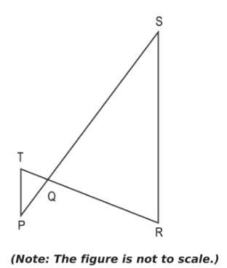  Darsh said that it is sufficient if it is given that $\frac{TP}{SR}$ = $\frac{1}{3}$.  Bhargav said that it is sufficient if it is given that ∠P = ∠S.  Tanvi said that it is sufficient if it is given that $\frac{PQ}{QS}$ = $\frac{1}{3}$.  Examine whether each of their responses is correct or incorrect. Give reasons. | 5
3 | A vertical pole of 6m casts a shadow 4m long on the ground and at the same time a tower casts a shadow 28m long. Find the height of the tower. | 5
4 | In a ∆ PQR, PR^2 –PQ^2 = QR^2 and M is a point on side PR such that QM ⊥ PR. Prove that QM2 = PM × MR | 5
5 | In the given figure, ∆ABC is right-angled at C and DE ⊥ AB. Prove that ∆ABC ~ ∆ADE and hence find the lengths of AE and DE  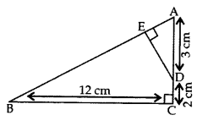 | 5
 | ANSWERS
1 | In $∆$DFG and $∆$DAB  ∠1 = ∠2 (corresponding ∠S $∴$ BA||FG)  ∠FDG = ∠ADE [common]  $∆$DFG - $∆$DAB [By AA rule of similarity]  $\frac{DF}{DA}=\frac{FG}{AB}$.....(1)  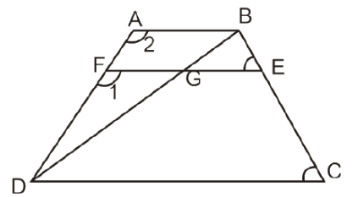  ∠FDG = ∠ADB [common]  $∴$ $∆$DFG - $∆$DAB [By AA rule of similarity]  ∴ $\frac{DF}{DA}$ = $\frac{FG}{AB}$  Again in trapezium ABCD  EF II AB II DC  ∴ $\frac{AF}{DF}$ = $\frac{BE}{EC}$  ⟹ $\frac{AF}{DF}$ = $\frac{4}{3}$ [$\frac{BE}{EC}=\frac{3}{4}$ (Given)]  ⟹ $\frac{AF}{DF}$ + 1 = $\frac{4}{3}$ + 1  ⟹ $\frac{AF+DF}{DF}=\frac{7}{3}$  ⟹ $\frac{AD}{DF}=\frac{7}{3}$ ⟹ $\frac{DF}{AD}=\frac{3}{7}$ ....(ii)  From (i) and (ii) we get  $\frac{FG}{AB}$ = $\frac{3}{7}$ i.e. FG = $\frac{3}{7}$ AB ....(iii)  In $∆$BEG and ∆BCD we have  ∠BEG = ∠BCD [corresponding angle $∴$ EG II CD]  ∠GBE = ∠DBC [common]  $∴ ∆$BEG - $∆$BCD [By AA rule of similarity]  ∴ $\frac{BE}{BC}=\frac{EG}{CD}$  ∴ $\frac{4}{7}= \frac{EG}{CD}$  [ $\frac{BE}{EG}=\frac{4}{7}$ i.e. $\frac{EC}{BE}= \frac{3}{4}$ ⟹ $\frac{EC+BE}{BE}$ = $\frac{4+3}{4}$ ⟹ $\frac{BC}{BE}$ =$\frac{7}{4}$]  ∴ EG = $\frac{4}{7}$CD = $\frac{4}{7}$(2AB)[$∴$ CD = 2AB (given)]  ∴ EG = $\frac{8}{7}$ AB  Adding (iii) and (iv), we get  FG + EG = $\frac{3}{7}$ AB + $\frac{8}{7}$ AB = $\frac{11}{7}$AB  ⟹ EF = $\frac{11}{7}$ AB i.e. 7EF = 11AB Hence proved. | 5
2 | Writes that Darsh's answer is incorrect.  Writes that in order to apply any of the similarity criterion, atleast one more piece of information is necessary.  Writes that Bhargav's answer is correct.  Gives the following reason:  $∆$TQP = ∆RQS [Vertically opposite angles]  ∠P = ∠S [Given]  ∠T = ∠R [Angle sum property]  Hence, concludes that by AAA criterion of similarity of triangles, ∆TQP ~ ∆RQS.  Writes that Tanvi's answer is correct.  Gives the following reason:  $\frac{TQ}{QR}$= [Given]  ∠TQP = ∠RQS [Vertically opposite angles]  $\frac{PQ}{QS}$ = [Given]  Hence, concludes that by SAS criterion of similarity of triangles, ∆TQP ~ ∆RQS. | 5
3 | Length of the vertical pole = 6 m  Shadow of the pole = 4 m  Let the height of the tower be h m.  Length of the shadow of the tower = 28 m  In ΔABC and ΔDFE,  ∠C = ∠E (angle of elevation)  ∠B = ∠F = 90°  By AA similarity criterion,  ΔABC ~ ΔDFE  We know that the corresponding sides of two similar triangles are proportional.  AB/DF = BC/EF  6/h = 4/28  h = (6 ×28)/4  h = 6 × 7  h = 42  Hence, the height of the tower = 42 m. | 5
4 | Given:  In ∆ PQR, PR²-PQ²= QR² & QM ⊥ PR  To Prove: QM² = PM × MR  Proof:  Since, PR² - PQ²= QR²  PR² = PQ² + QR²  So, ∆ PQR is a right-angled triangle at Q.  In ∆ QMR & ∆PMQ  ∠QMR = ∠PMQ [ Each 90°]  ∠MQR = ∠QPM [each equal to (90°- ∠R)]  ∆ QMR ~ ∆PMQ [ by AA similarity criterion]  By the property of an area of similar triangles,  ar(∆ QMR ) / ar(∆PMQ)= QM²/PM²  1/2× MR × QM / ½ × PM ×QM = QM²/PM²  MR / PM = QM²/PM²  QM² × PM = PM² × MR  QM² =( PM² × MR)/ PM  QM² = PM × MR. | 5
5 | Given: ∆ABC is right angled at C and DE ⊥ AB.  AD = 3 cm, DC = 2 cm, BC = 12 cm  To prove:  (i) ∆ABC ~ ∆ADE; (ii) AE = ? and DE = ?  Proof. (i) In ∆ABC and ∆ADE,  ∠ACB = ∠AED … [Each 90°]  ∠BAC = ∠DAE …(Common angle)  ∴ ∆ABC ~ ∆ADE …[AA Similarity Criterion]  (ii) $∴\frac{AB}{AD}=\frac{BC}{DE}=\frac{AC}{AE}$ …[sides are proportional]  $\frac{AB}{3}=\frac{12}{DE}=\frac{3+2}{AE}$ ….[In ΔACB, ${BC}^{2}+{AC}^{2}={AB}^{2}$(By Pythagoras theorem)  $∴AB=13 cm]$  $$∴\frac{13}{3}=\frac{12}{DE}=\frac{5}{AE}$$  Or, $\frac{13}{3}=\frac{12}{DE}$ and $\frac{13}{3}=\frac{5}{AE}$  Or, 13DE = 36 and 13AE = 15  $$∴DE= \frac{36}{13} and AE= \frac{15}{13}$$  Or, DE = 2.8 cm (approx.) and AE = 1.15 cm (approx.) | 5

CHAPTER – 7
COORDINATE GEOMETRY

SYLLABUS:
Concepts of coordinate geometry, graphs of linear equations. Distance formula. Section formula (internal division).

SL NO | QUESTION | MARK
 | MULTIPLE - CHOICE QUESTIONS
1 | Three students named Bibhu, Kalyan and Loknath are playing a game If coordinates of Bibhu, Kalyan and loknath are (0,0), (3,0) and (3,3) respectively, if they have to reach to a flag which have coordinates (5,5) then which student will reach to flag first if their speed is same.  - Kalyan  - Bibhu  - Loknath  - Can not be determined. | 1
2 | 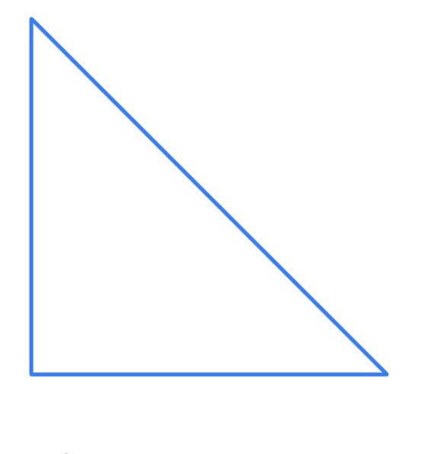  (0,8)  (0,0) (11,0)  A triangular shape has to be painted in Vidyalaya under BALA program. The charges of painting is ₹3 per meter square, then how much money has to be paid by Vidyalaya. | 1
3 | A man walks near a wall such that the distance between him and the wall is 10 units. Consider the wall to be the Y axis . The path travelled by the man is-  - X=10  - Y=10  - X=0  - Y=0 | 1
4 | Find the equation of the line whose slope is 3 and y intercept is – 4.  A.y = 2x – 3  B. Y=3x+4  C. Y=3x- 4  D. y=√3x-2 | 1
5 | The ratio in which the point (-3, k) divides the line-segment joining the points (-5, -4) and (-2,3)-  - 2:1  - 1:2  - 4:1  - 1:4 | 1
6 | If the point P(x, y) is equidistant from the points A (a + b, b – a) and B(a -b,a+ b then which of the following is correct-  - by=ax  - bx=ay  - ab=xy  - None of these | 1
7 | If the point C(k,4) divides the join of the points A(2,6) and B(5,1) in the ratio 2:3 then the value of k is  (a) 16  (b) 28/5  (c) 16/5  (d) 8/5 | 1
8 | The perimeter of the triangle with vertices (0,4), (0,0) and (3,0) is  (a) 7 + √5  (b) 5  (c) 10  (d) 12 | 1
9 | If A(1,3) B(-1,2) C(2,5) and D(x,4) are the vertices of a parallelogram ABCD then the value of x is  (a) 3  (b) 4  (c) 0  (d) 3/2 | 1
10 | To find a point P on a line segment AB such that AP/AB=3/7,  the segment AB is to be divided in the ratio?​  - 3:7 b.7:3  c.4:3 d.3:4 | 1
11 | The distance of the point (2, 3) from x-axis is ________.  - 2  - 3  - 4  - 5 | 1
12 | Meghna and Karan are siblings. She was taught a chapter named Coordinate geometry in the class. She was so enthusiastic to teach this to her younger brother returning home.  She arranged few cards at some distance whose explanation is given below. She again measured it with the help of measuring and found to be absolutely right. Now she wants her brother to do the same. Let’s verify if he has done it correctly or not.  The midpoint of the line segment joining A ( 3 , -7 ) and B ( 5 , -5 ) is :  (a) ( 3 , 7 )  (b) ( 3 , -5 )  (c) ( 4 , -6 )  (d) ( 4 , -7 ) | 1
13 | The distance between the points A(cosθ+bsinθ,0) and (0, asinθ−bcosθ)is _____.  - $\sqrt{a^{2}+b^{2}}$  - $\sqrt{a^{2}-b^{2}}$  - 1  - 0 | 1
14 | Find the coordinates of the point where the line x+ y = 5 cut y axis  ​a.(0,5)  b. (5,0)  c. (0,0)  d. (-5,0) | 1
15 | 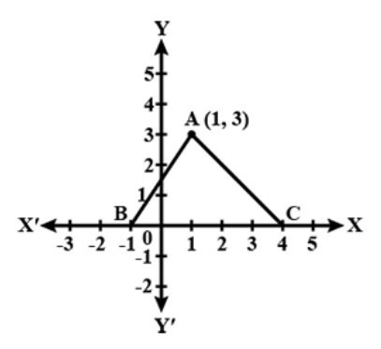  In fig., the area of triangle ABC (in cm sq. units) is:  - 25  - 15  - 7.5  - 8 | 1
16 | The fourth vertex D of a parallelogram ABCD whose three vertices are A(-2, 3), B (6, 7) and C (8 , 3) is  - (0,-1)  - (1,-1)  - (0,1)  - (-1,0) | 1
17 | If a circle drawn with origin as the centre, passes through (13/2,0), then the point which does not lie in the interior of the circle is  (A) (−3/4,1)  (B) (2,7/3)  (C) (5,−1/2)  (D) (−6,5/2) | 1
18 | If the distance between the points (4,p) and (1,0) is 5 then value of p is  - 4  - -4  - 4 and -4  - None of these | 1
19 | The perimeter of a triangle with vertices ( 0 , 4 ) , ( 0 , 0 ) and ( 3 , 0 ) is ….  ( a ) 5  ( b ) 12  ( c ) 11  ( d ) 10 | 1
20 | A round clock is traced on a graph paper . The boundary intersect the coordinate axis a t a distance of 4/3 units from the origin.  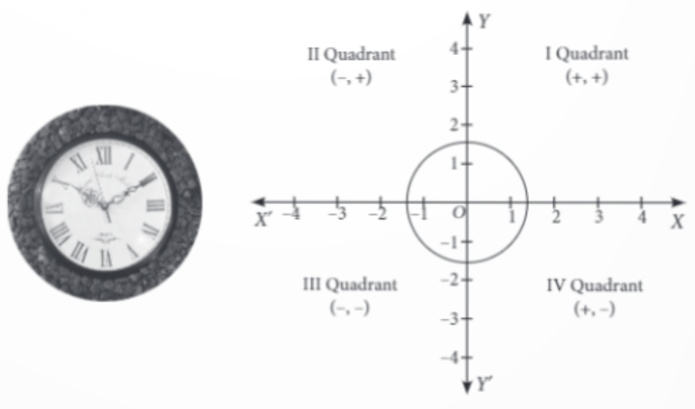  The radius of the circle is:  (a) 4/3 units (b) ¾ units (c) 1 units (d) None of these | 1
21 | If the points (p, 0), (0, q) and (1, 1) are collinear then 1/p+1/q is equal to  (a) – 1  (b) 1  (c) 2  (d) 0 | 1
22 | The coordinates of reflection of Q (- 1, -3) in x- axis are  (a) (1, 3)  (b) (-1,3)  (c) (1, -3)  (d) none of these | 1
23 | Find the positive value of m if the distance between the points A (5,-3) and B(13,m) is 10 units.  a)-3 b)3 c)4 d)5 | 1
24 | If the distance between the points (4,k) and (1,0) is 5, then what will be the possible values k?  a)4 b)- 4 c)5 d) none of these | 1
25 | Find the distance of a point P(x,y) from the origin.  a)$\sqrt{x^{2}{+y}^{2}}$ b)$\sqrt{x^{2}{- y}^{2}}$ a)$\sqrt{x^{2}y^{2}}$ a) none of these | 1
 | ANSWERS | 1
1 | Option C | 1
2 | ₹ 132 | 1
3 | Option A | 1
4 | Option C | 1
5 | Option A | 1
6 | Option B | 1
7 | Option C | 1
8 | Option D | 1
9 | Option B | 1
10 | c. 4:3 | 1
11 | 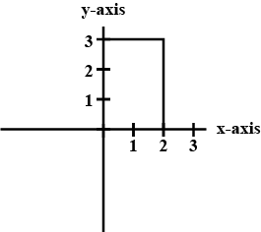  b. 3 units | 1
12 | Using mid point formula:  $$\left(\frac{x_{1}+x_{2}}{2},\frac{y_{1}+y_{2}}{2}\right)$$  (c) ( 4 , -6 ) | 1
13 | c. 1 | 1
14 | For obtaining the point at which the graph cuts the y axis, put x=0.(x coordinate is 0 for points at y axis)  (0,5) | 1
15 | c. 7.5 | 1
16 | (0,-1)  Let the fourth vertex D =(x,y)  We know that the diagonals of a parallelogram bisect each other. So,the  midpoint of AC is same as the midpoint of BD.  Using midpoint formula:  $$\left(\frac{x_{1}+x_{2}}{2},\frac{y_{1}+y_{2}}{2}\right)$$  So, midpoint of AC= Mid point of BD  X=0, y=-1 | 1
17 | It is given that, centre of circle is (0,0) and it passes through the point (13/2,0).  ∴ Radius of circle = Distance between (0,0) and (13/2,0)  Using distance formula:  $$=\sqrt{{(x_{2}-x_{1})}^{2}{+(y_{2}-y_{1})}^{2}}$$  Radius is 6.5 units  A point lie outside, on or inside the circle if the distance of point from the centre of the circle is greater than, equal to or less than radius of the circle respectively.  Now, to get the correct option, we have to check the option one by one.  (a), (b) and (c) lie in the interior of the circle  But the (d) does not lie on the interior but on the circle (-6,5/2) | 1
18 | 4 and -4 | 1
19 | b. | 1
20 | a)4/3 units | 1
21 | (b) 1 | 1
22 | (b) (-1,3) | 1
23 | b)3 | 1
24 | a)4 | 1
25 | a)$\sqrt{x^{2}{+y}^{2}}$ | 1
 | 2 MARKS TYPE QUESTIONS
1 | If three students A ( x,2) , B (-3,4) and C (7,-5) are standing in a line, then what will be the value of x. | 2
2 | ABCD is a rectangle whose three vertices are B(4, 0), C(4, 3) and D(0, 3). Calculate the length of one of its diagonals. | 2
3 | 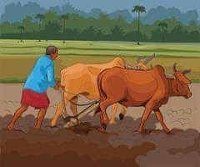  Jayant is a farmer in small village. In the village he is living with his wife and two sons Rahul and vikash. Jayant has a rectangular field with vertices (0,0), (a,0), (a,b) and (0,b). As time passed Jayant become older so at that stage, he decided to divide his rectangle field equally between his two sons. For this he constructed a wall diagonally. Now that rectangular field is divided into two equal triangular fields. Now find the area of each triangular field. | 2
4 | a The vertices of a ΔABC are given by A(2, 3) and B(–2, 1) and its centroid G 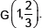  Find the coordinates of the third vertex C of the ΔABC. | 2
5 | Check whether the points (20, 3), (19, 8) and (2, - 9) are all equidistant from the point (7, 3). | 2
6 | Find the perimeter of the triangle formed by points (0,0),(1,0) and (0,1). | 2
7 | Check the points (1,-1), (5,2) and (9,5) are collinear. | 2
8 | If the point P(x,y) is equidistant from the points A(5,1) and B(-1,5), Prove that 3x=2y. | 2
9 | Find the coordinates of the point which divides the line joining the points (4,−3) and (8,5) in the ratio 3:1 internally. | 2
10 | Write the coordinates of a point ‘P' on X-axis which is equidistant from the points A(-4, 0) and B(-10, 0) | 2
 | ANSWERS | 2
1 | -63 | 2
2 | 5cm | 2
3 | Area of triangle = ½[x₁(y₂ – y₃) + x₂ (y₃ – y₁) + x₃ (y₁- y₂) ]  Vertices of field which Rahul get are ( 0,0) , ( a,0) , (0, b)  Area of plot which Rahul get = ½ ab sq. unit  Vertices of field which Vikash get are (a,0) , ( 0,b) , (a,b)  Area of plot which Vikash get = ½ ab sq. unit | 2
4 | (-2, 3) | 2
5 | Yes, the points are equidistant. | 2
6 | We have a triangle whose co-ordinates are A (0, 0); B (1, 0); C (0, 1). So clearly the triangle is right angled triangle, right angled at A. So,  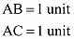  Now apply Pythagoras theorem to get the hypotenuse,  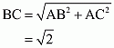  So the perimeter of the triangle is,  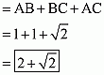 | 2
7 | Let A(1,-1), B(5,2) and (9,5) be the given points.  We know the distance formula:  $$=\sqrt{{(x_{2}-x_{1})}^{2}{+(y_{2}-y_{1})}^{2}}$$  Then, we have  AB$=\sqrt{{\left(5-1\right)}^{2}{+\left(2+1\right)}^{2}}=\sqrt{16+9}=\sqrt{25}=5$  BC= $\sqrt{{\left(5-9\right)}^{2}{+\left(2-5\right)}^{2}}=\sqrt{16+9}=\sqrt{25}=5$  and, AC= $\sqrt{{\left(1-9\right)}^{2}{+\left(1-5\right)}^{2}}=\sqrt{64+36}=\sqrt{100}=10$  Clearly, AC=AB+BC  Hence, A,B,C are collinear points. | 2
8 | Let the point P(x,y) be equidistant from the points A(5,1) and B(-1,5). We know the distance formula:  $$=\sqrt{{(x_{2}-x_{1})}^{2}{+(y_{2}-y_{1})}^{2}}$$  then,  PA=PB  $${PA}^{2}={PB}^{2}$$  $${(x-5)}^{2}+{(y-1)}^{2}={(x+1)}^{2}+{(y-5)}^{2}$$  $${(x)}^{2}+{(y)}^{2}-10x-2y+26={\left(x\right)}^{2}+{\left(y\right)}^{2}+2x-10y+26$$  12x − 8y=0  12 x = 8 y  3x = 2y | 2
9 | We are given,  ($x_{1},y_{1})=(4,-3)$& ($x_{2},y_{2})=(8,5)$  Let (x,y)coordinates which divides the line joining the point ($x_{1},y_{1}$)  and ($x_{2},y_{2})$ in ratio m:n=3:1 internally.  So,(x,y)=$\frac{mx_{2}+{nx}_{1}}{m+n},\frac{my_{2}+{ny}_{1}}{m+n}$  =$\frac{3×8+1×4}{3+1}$, $\frac{3×5+1×-3}{3+1}$  =$\frac{28}{4},\frac{12}{4}$  (x,y)=(7,3) | 2
10 | Let the coordinates of a point P on X-axis be P(x,0)  Thus AP=BP  ⇒${(AP)}^{2}$=${(BP)}^{2}$  By distance formula,  ⇒${(x+4)}^{2}$+0=${(x+10)}^{2}$+0  ⇒8x-20x=100-16  ⇒-12x=84  ⇒x=-7  Hence the coordinates of a point P on X-axis is (-7,0) | 2
 | 3 – MARKS TYPE QUESTIONS
1 | Show that △ABC, where A(−2,0), B(2,0),C(0,2) and △DEF where D(−4,0), E(4,0), F(0,4) are similar triangles. | 3
2 | 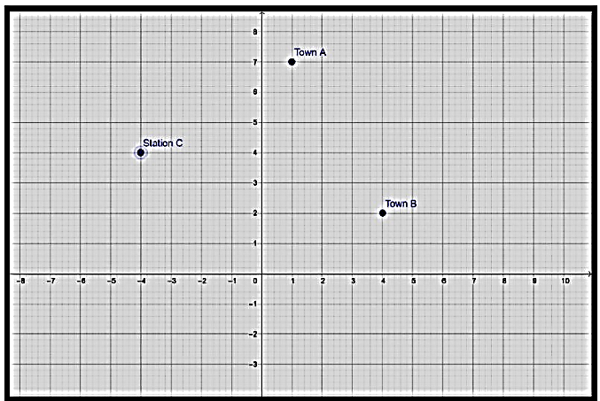  Two friends Seema and Aditya work in the same office at Delhi. In the Christmas vacations, both decided to go to their hometowns represented by Town A and Town B respectively in the figure given below. Town A and Town B are connected by trains from the same station C (in the given figure)in Delhi. Based on the given situation, answer the following:  - Who will travel more distance, Seema or Aditya, to reach to their hometown?  - Seema and Aditya planned to meet at a location D situated at a point D represented by the mid-point of the line joining the points represented by Town A and Town B. Find the coordinates of the point represented by the point D  - Find the PERIMETRE of the triangle formed by joining the points represented by A, B and C. ($\sqrt{34}=5.83 AND \sqrt{17}=4.12$) | 3
3 | Show that the four points (0, -1), (6, 7), (-2, 3) and (8, 3) are the vertices of a rectangle. | 3
4 | If the two vertices of an equilateral triangle be (0, 0), (3,$\sqrt{3}$) then find the third vertex. | 3
5 | Let the opposite angular points of a square be (3, 4) and (1, -1). Find the coordinates of the remaining angular points. | 3
6 | In$∆ABC$, in which A (2, 1), B (4, 3) and C (2, 7).D and E are the midpoints of the BC and AC respectively. Find the relation between DE and AB. | 3
7 | A circle with origin as the centre, passes through$\left(\frac{13}{2}, 0\right)$. The point which does not lie in the interior of the circle: | 3
8 | In a right-angled triangle ABC, in which A (-2, 1), B (2, -2) and C (5, 2)  - Triangle is right angled at  - A c) B  - C d) None  - The ratio of $\frac{AB}{BC}$ is:  - $1:\sqrt{2}$ c) $\sqrt{2}$:1  - $1:1$ d) None  - The measure of $acute angle is:$  - $45°$ c) $30°$  $b)60°$ d) $90°$ | 3
9 | If A(-2,1),B(a,0), C(4, b) and D(1,2) are the vertices of a parallelogram ABCD. Find the values of a and b. Hence find the length of its sides. | 3
10 | In what ratio does the point P(-4,y) divide the line segment joining the point A (-6, 10) and B(3,-8) .Hence find the value of y. | 3
 | ANSWERS
1 | Given A(−2,0); B(2,0); C(0,2) & D(−4,0);E(4,0);F(0,4)  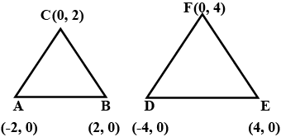  We know the distance formula:  $$=\sqrt{{(x_{2}-x_{1})}^{2}{+(y_{2}-y_{1})}^{2}}$$  AB=$\sqrt{{(0+2)}^{2}+{(2-0)}^{2}}$  =$\sqrt{4+4}=\sqrt{8}=2\sqrt{2}$ units  BC=$\sqrt{{(2-0)}^{2}+{(0-2)}^{2}}=$=$\sqrt{4+4}=\sqrt{8}=2\sqrt{2}$ units  CA=$\sqrt{{(-2-2)}^{2}+{(0-0)}^{2}}$  $$\sqrt{{(-4)}^{2}+{(0)}^{2}}$$  ==$\sqrt{16}$=4 units  FD=​$\sqrt{{(0+4)}^{2}+{(0-4)}^{2}}$  ==$\sqrt{16+16}=\sqrt{32}=4\sqrt{2}$ units  FE=$\sqrt{{(4-0)}^{2}+{(0-4)}^{2}}$  ==$\sqrt{16+16}=\sqrt{32}=4\sqrt{2}$ units  DE=$\sqrt{{(-4-4)}^{2}+{(0-0)}^{2}}$  =$\sqrt{64}=8$units.  Two triangles are similar, if  $$\frac{AB}{DE}=\frac{BC}{EF}=\frac{AC}{FD}$$  $$\frac{4}{8}=\frac{2\sqrt{2}}{4\sqrt{2}}=\frac{2\sqrt{2}}{4\sqrt{2}}$$  Hence, $∆ABC is similar to ∆DEF$  Here, we see that sides of △DEF are twice sides of a △ABC.  Hence, both triangles are similar. | 3
2 | Using distance formula:  $$=\sqrt{{(x_{2}-x_{1})}^{2}{+(y_{2}-y_{1})}^{2}}$$  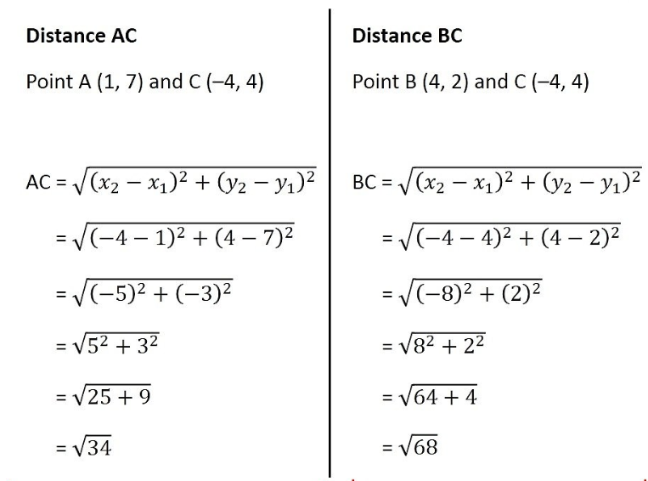  Since, BC>AC  Therefore, Aditya travels more distance.  ii. we need to find the mid point:  iii)  Let the coordinate of town A (1,7). Town B(4,2) and Station C(-4,4)  Using distance formula:  $$\sqrt{{(x_{2}-x_{1})}^{2}{+(y_{2}-y_{1})}^{2}}$$  AB=$\sqrt{{(x_{2}-x_{1})}^{2}{+(y_{2}-y_{1})}^{2}}$  =$\sqrt{{\left(4-1\right)}^{2}{+\left(2-7\right)}^{2}}$  =$\sqrt{{(3)}^{2}{+(-5)}^{2}}$  =$\sqrt{9+25}$  =$\sqrt{34} units$  BC$=\sqrt{{\left(x_{2}-x_{1}\right)}^{2}{+\left(y_{2}-y_{1}\right)}^{2}}$  =$\sqrt{{\left(-4-4\right)}^{2}{+\left(4-2\right)}^{2}}$  =$\sqrt{{(-8)}^{2}{+(2)}^{2}}$  =$\sqrt{64+4}$  =$\sqrt{68}$  =$2\sqrt{17}$units  CA$=\sqrt{{\left(x_{2}-x_{1}\right)}^{2}{+\left(y_{2}-y_{1}\right)}^{2}}$  =$\sqrt{{\left(-4-1\right)}^{2}{+\left(4-7\right)}^{2}}$  =$\sqrt{{(-5)}^{2}{+(-3)}^{2}}$  =$\sqrt{25+9}$  =$\sqrt{34}$units  Perimetre of the tringle :AB+BC+CA=$\sqrt{34}+\sqrt{34}+2\sqrt{17}=$19.90 sq. units i.e 20 sq. units ( approx.) | 3
3 | Let A(0,-1),B(6,7),C(-2,3) and D(8,3) be the given points .  Then by distance formula  AD=4$\sqrt{5}$ unit  BC=4$\sqrt{5}$ unit  AC=2$\sqrt{5}$ unit  BD=2$\sqrt{5}$ unit  Here AD=BC and AC=BD  So ,ADBC is a parallelogram,  AB=10 unit  CD=10 unit  Clearly , ${(AB)}^{2}$=${(AD)}^{2}$+ ${(DB)}^{2}$  ${(CD)}^{2}$=${(CB)}^{2}{+(BD)}^{2}$  Hence ADBC is a rectangle. | 3
4 | O(0,0) and A(3,$\sqrt{3}$) be the given points and let B(x,y) be the third vertex of equilateral triangle OAB.  Then OA=OB=AB  Or,${(OA)}^{2}$=${(OB)}^{2}$=${(AB)}^{2}$  ${\left(OA\right)}^{2}=12$ ,${(OB)}^{2}$ =$x^{2}$+$y^{2}$  ${(AB)}^{2}$=x²+y²-6x-2$\sqrt{3}$y+12  ${(OA)}^{2}$=${(OB)}^{2}$and${(OB)}^{2}$ =${(AB)}^{2}$  i.e. x²+y²=12 and x²+y²=x²+y²-6x-2$\sqrt{3}$y +12  Or, x²+y²=12 and 6x+2$\sqrt{3}$y=12  Now, x²+((6-3x)/2)²=12 since y=(6-3x)/2  Then, x=0,3  Putting x in y=(6-3x)/2  Y=2$\sqrt{3}$ , $\sqrt{3}$ | 3
5 | AB = BC  AB² =BC²  (X-3)²+(Y-4)² = (X-1)²+(Y+1)²  4X +10Y-23 =0  X =(23-10Y)/4 …….(1)  IN triangle ABC, we have  AB²+BC² =AC²  (X-3 )²+(Y-4)² +(X-1)²+(Y+1)²= (3-1)²+(4+1)²  X²+y²- 4X -3Y - 1 = 0 …..(2)  Substituting the value of X from (1) and (2), we get  [(23-10Y)/4]² + Y² - (23- 10Y) - 3Y – 1= 0  4Y – 12Y +5 = 0  (2Y -1)(2Y-5) = 0  - Y = ½ OR 5/2  Putting Y = ½ and Y = 5/2 respectively in (1)  we get X = 9/2 and X= -1/2  hence the required vertices of the squares are  ( 9/2, 1/2)and (-1/2 , 5/2) | 3
6 | C  Midpoint D$\left(\frac{4+2}{2} , \frac{3+7}{2}\right)= \left(3,5\right)$  Midpoint E$\left(\frac{2+2}{2} , \frac{1+7}{2}\right)= \left(2,4\right)$  $$DE= \sqrt{{\left(3-2\right)}^{2}+ {\left(5-4\right)}^{2}}$$  $$DE=\sqrt{{\left(1\right)}^{2}+{\left(1\right)}^{2}}$$  $$DE=\sqrt{2}units$$  $$AB= \sqrt{{\left(4-2\right)}^{2}+ {\left(3-1\right)}^{2}}= \sqrt{{\left(2\right)}^{2}+ {\left(2\right)}^{2}}=2\sqrt{2}units$$ | 3
7 | D  Radius = distance between (0,0) and $\left(\frac{13}{2}, 0\right)$ = $\sqrt{{\left(\frac{13}{2}\right)}^{2}+ {\left(0\right)}^{2}}$ =$\frac{13}{2} units=6.5 units$  distance between (0,0) and $\left(\frac{-3}{4}, 1\right)$ = $\sqrt{{\left(\frac{-3}{4}\right)}^{2}+ {\left(1\right)}^{2}}$ =$\frac{25}{16} units=$  $$\frac{5}{4} units=1.25 units< 6.5 units$$  distance between (0,0) and $\left(2, \frac{7}{3}\right)$ = $\sqrt{{\left(\frac{7}{3}\right)}^{2}+ {\left(2\right)}^{2}}$ =$\sqrt{\frac{85}{9}} units=$  $$\frac{9.2}{3} units=3.1 units< 6.5 units$$  distance between (0,0) and $\left(5, \frac{-1}{2}\right)$ = $\sqrt{{\left(\frac{-1}{2}\right)}^{2}+ {\left(5\right)}^{2}}$ =$\sqrt{\frac{101}{4}}units=$  $$\frac{10.04}{2} units=5.02 units< 6.5 units$$  distance between (0,0) and $\left(-6, \frac{5}{2}\right)$ = $\sqrt{{\left(\frac{5}{2}\right)}^{2}+ {\left(-6\right)}^{2}}$ =$\sqrt{\frac{169}{4}} unit$  $$=\frac{13}{2} units= 6.5 units$$  So it lies on the circle while the other lies inside the circle as its length is less than the radius of the circle. | 3
8 | - B  distance between (-2,1) and $\left(2, -2\right)$ = $\sqrt{{\left(4\right)}^{2}+ {\left(3\right)}^{2}}$ =$5 units$  distance between (-2,1) and $\left(5, 2\right)$ = $\sqrt{{\left(7\right)}^{2}+ {\left(1\right)}^{2}}$ =$5\sqrt{2} units$  distance between (2,-2) and $\left(5, 2\right)$ = $\sqrt{{\left(3\right)}^{2}+ {\left(4\right)}^{2}}$ =$5 units$  - B  - A  $tanθ$ = 1  $tanθ$ = tan 45  $θ$ = 45 | 3
9 | a=1, b=1,length= $\sqrt{10}$ | 3
10 | 2:7, y =6 | 3
 | 4 – MARKS TYPE QUESTIONS
1 | 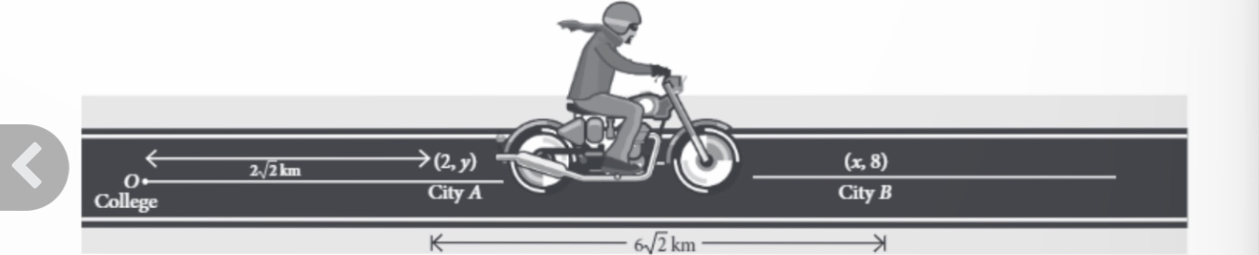  A person is riding his bike on a straight road towards East from his college to City A and then to City B. At some point in between city A and B ,he suddenly realise that there is not enough petrol for the journey. Also there is no petrol pump on the road between these two cities.  Based on the above information, Answer the following formation  - If M is any point exactly between City A and City B,then coordinates of M are-  - (3,3)  - (4,4)  - (5,5)  - (6,6)  - If the person analyze the petrol at Point M( the midpoint of AB), then what should be his decision?  - Should he travel back to college  - Should try his luck to move towards city B  - Should be travel back to city A  - None of these
2 |   To raise social awareness about hazards of smoking, a school decided to start NO SMOKING campaign. 10 students are asked to prepare campaign banners in the shape of a triangle. The vertices of one of the triangle are P(-3,4) , Q (3,4) and R (-2,-1).  Based on the above information, answer the following questions-  - If S be the midpoint of line joining P and Q, then coordinates of S are  - (4,0)  - (2,0)  - (0,2)  - None of these  - The coordinates of centroid of triangle PQR are-  - (2/3,7/3)  - (1/3,1/3)  - (-2/3,7/3)  - (7/3,2/3)
3 | Students of a school are standing in rows and columns in their playground for a drill practice. A, B, C and D are the positions of four students as shown in figure.  Is it possible to place Jaspal in the drill in such a way that he is equidistant from each of the four students A, B, C and D? If so, what should be his position?  Determine the distance between the points C and D.  Find the perimeter of the figure formed.  Find the area of the figure formed by joining these points.  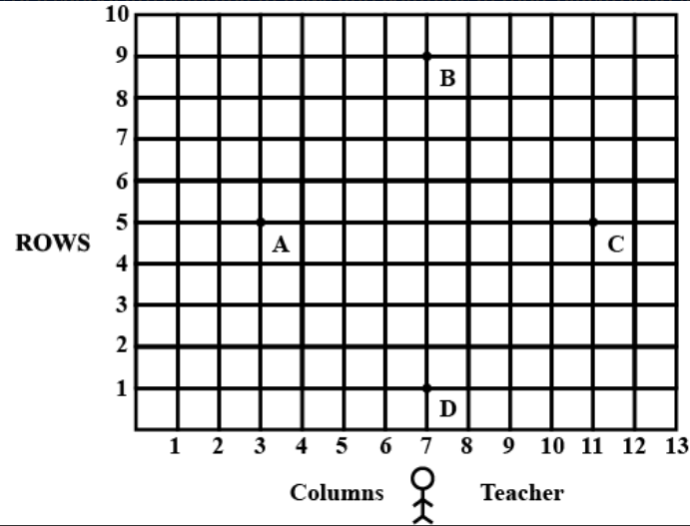
4 | 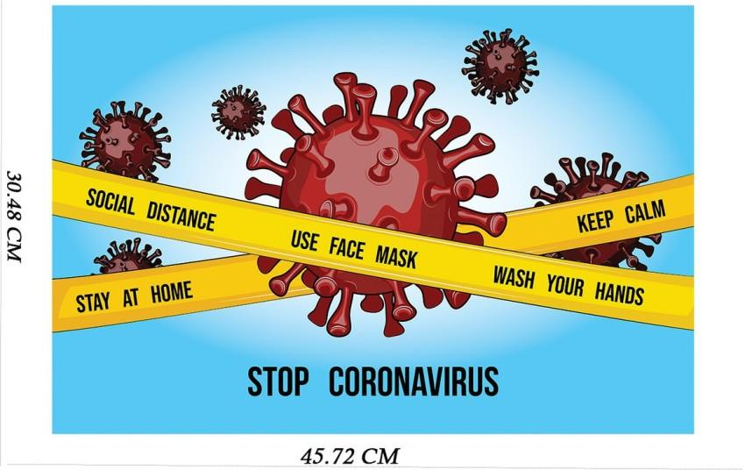  Coronavirus disease (COVID-19) is an infectious disease caused by the SARS-CoV-2 virus.  Most people infected with the virus will experience mild to moderate respiratory illness and recover without requiring special treatment. However, some will become seriously ill and require medical attention. Older people and those with underlying medical conditions like cardiovascular disease, diabetes, chronic respiratory disease, or cancer are more likely to develop serious illness. Anyone can get sick with COVID-19 and become seriously ill or die at any age.  Suppose three friends go to the park , but decided to maintain the social distance due to CORONA virus pandemic. They sit at the point P, Q and R . If the coordinates of P ,Q and R are ( 4 , - 3) ,( 7 , 3 ) and ( 8 , 5 ) respectively , then answer the followings:  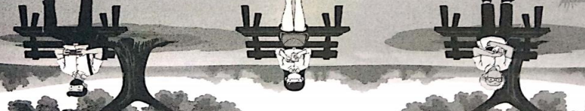  The point P, Q and R lie on the ……. Triangle .  ( a ) Isosceles  ( b ) Equilateral  ( c ) Scalene  ( d ) None of these  The ratio in which Q divides the line segment joining P and R is  ( a ) 2 : 1  ( b ) 3 : 1  ( c ) 1 : 2  ( d ) None of these  The distance between P and Q is ….  ( a ) √5 units  ( b ) 4√5 units  ( c ) 3√5 units  ( d ) None of these
5 | 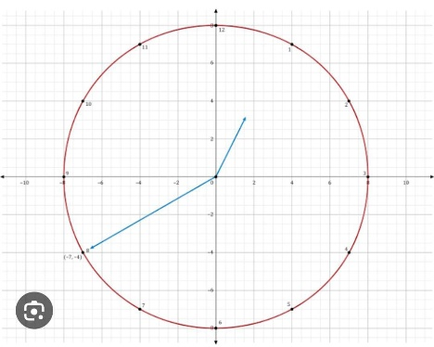  A round clock is traced on a graph paper as shown. The boundary intersect the coordinate axis at a distance of $\frac{4}{3} units$from origin.  - Circle intersect the positive y-axis at:  - $\left(\frac{2}{3}, 0\right)$ c) $\left(0, \frac{2}{3}\right)$  - $\left(\frac{4}{3}, 0\right)$ d) $\left(0, \frac{4}{3}\right)$  - The centre of the circle is the:  - Midpoint of points of intersection with x-axis.  - Midpoint of points of intersection with y-axis.  - Both (a) and (b).  - None of these.  - The radius of the circle is:  - $\frac{4}{3} units$ c) $\frac{2}{3} units$  - $\frac{3}{4} units$ d) $\frac{3}{2} units$  - If $\left(1, \frac{\sqrt{7}}{3}\right)$ is one of the ends of the diameter, then its other end is:  - $\left(1, \frac{\sqrt{7}}{3}\right)$ c) $\left(-1, \frac{\sqrt{7}}{3}\right)$  $\left(-1, -\frac{\sqrt{7}}{3}\right)$ d) $\left(1, -\frac{\sqrt{7}}{3}\right)$
6 | “Two polygons having the same number of sides are similar, if their corresponding angles are equal and their corresponding sides are proportional.” In a triangle ABC, where A (0, 4), B (-4, 0) and C (4, 8).Point P (-1, 3) and Q (1, 5) lies on the side AB and AC respectively.  - P divides AB in the ratio:  - 1:3 c) 2:3  - 3:1 d) 3:2  - Q divides AC in the ratio:  - 3:1 c) 3:2  - 1:3 d) 2:3  - What have you observed?  - $\frac{AP}{PB}= \frac{AQ}{QC}$ c) Both (a) and (b)  - PQ $⃦$ BC d) none of these  - Which theorem have you applied?  - Thales theorem.  - Converse of midpoint theorem.  - Converse of Basic Proportional theorem.  None of the above.
7 | In order to conduct Sports Day activities in your School, lines have been drawn with chalk powder at a distance of 1 m each, in a rectangular shaped ground ABCD, 100 flower pots have been placed at a distance of 1 m from each other along AD, as shown in given figure below. Niharika runs 1/4 th the distance AD on the 2nd line and posts a green flag. Preet runs 1/5th distance AD on the eighth line and posts a red flag.  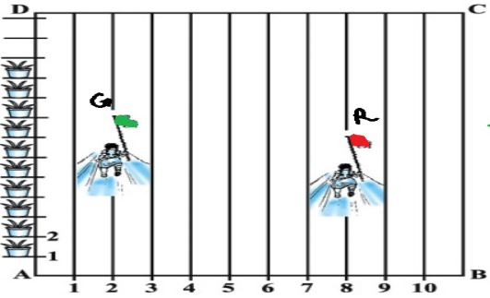  - Find the position of green flag  - (2,25) b) (2,0.25) c) (25,2) d) (0, -25)  - Find the position of red flag  - (8,0) b) (20,8) c) (8,20) d) (8,0.2)  - What is the distance between both the flags?  - $\sqrt{41}$ b) $\sqrt{11}$ c) $\sqrt{61}$ d) $\sqrt{51}$  - If Rashmi has to post a blue flag exactly halfway between the line segment joining the two flags, where should she post her flag?  a) (5, 22.5) b) (10,22) c) (2,8.5) d) (2.5,20)
 | ANSWERS
1 | - Option C  - Option B
2 | - Option D  - Option C
3 | 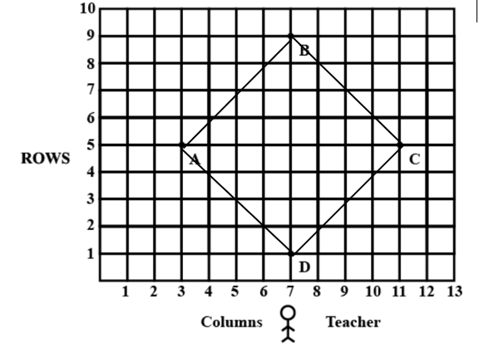  Given that the coordinates of the figure ABCD,  A(x1​,y1​)=(3,5), B(x2​,y2​)=(7,8), C(x3​,y3​)=(11,5) and D(x4​,y4​)=(7,2).  Putting distance formula:  $$\sqrt{{(x_{2}-x_{1})}^{2}{+(y_{2}-y_{1})}^{2}}$$  finding the distance AB,BC, DA  AB=$\sqrt{{\left(7-3\right)}^{2}{+\left(8-5\right)}^{2}}$  =$\sqrt{{(4)}^{2}{+(3)}^{2}}$  =$\sqrt{16+9}$  =$\sqrt{25}$  = 5 units  BC=$\sqrt{{\left(11-7\right)}^{2}{+\left(5-8\right)}^{2}}$  =$\sqrt{{(4)}^{2}{+(-3)}^{2}}$  =$\sqrt{16+9}$  =$\sqrt{25}$  = 5 units  CD=$\sqrt{{\left(7-11\right)}^{2}{+\left(2-5\right)}^{2}}$  =$\sqrt{{(-4)}^{2}{+(-3)}^{2}}$  =$\sqrt{16+9}$  =$\sqrt{25}$  =$5$units  DA=$\sqrt{{\left(7-3\right)}^{2}{+\left(2-5\right)}^{2}}$  =$\sqrt{{(4)}^{2}{+(-3)}^{2}}$  =$\sqrt{16+9}$  =$\sqrt{25}$  = 5 units  Thus, ABCD is a square.  The position of Jaspal will be the midpoint M(x,y) between AC or BD.  (AC=BD so, ABCD is a square).  By the section formula for the midpoint M$\left(\frac{X_{1}+X_{3}}{2},\frac{Y_{1}+Y_{3}}{2}\right) OR \left(\frac{X_{2}+X_{4}}{2},\frac{Y_{2}+Y_{4}}{2}\right)$  $=>M\left(\frac{3+11}{2},\frac{5+5}{2}\right)=>M\left(\frac{14}{2},\frac{10}{2}\right)=>$M(x,y)=(7,5). So the position co−ordinates of jaspal is (7,5).  II) Distance CD,  Using Distance Formula:  $$\sqrt{{(x_{2}-x_{1})}^{2}{+(y_{2}-y_{1})}^{2}}$$  =$\sqrt{{\left(7-11\right)}^{2}{+\left(2-5\right)}^{2}}$  =$\sqrt{{(-4)}^{2}{+(-3)}^{2}}$  =$\sqrt{16+9}$  =$\sqrt{25}$  =$5$units  iii) the distance CD=$\sqrt{{\left(7-11\right)}^{2}{+\left(2-5\right)}^{2}}$  =$\sqrt{{(-4)}^{2}{+(-3)}^{2}}$  =$\sqrt{16+9}$  =$\sqrt{25}$  =$5$units  Iii the perimeter of the figure ABCD  The perimeter of the given by AB+BC+CD+DA=(5+5+5+5) units= 20 units  The area of the figure is Side x Side= 5 x 5=25 sq. units.
4 | - D) none of these  - Using section formula: ,(x,y)=$\frac{mx_{2}+{nx}_{1}}{m+n},\frac{my_{2}+{ny}_{1}}{m+n}$  B) 3:1  iii. Using distance formula:$\sqrt{{(x_{2}-x_{1})}^{2}{+(y_{2}-y_{1})}^{2}}$  C) 3$\sqrt{5}$ units
5 | - D  - C  - A  Radius = distance between (0,0) and $\left(\frac{4}{3}, 0\right)$ = $\sqrt{{\left(\frac{4}{3}\right)}^{2}+ {\left(0\right)}^{2}}$ =$\frac{4}{3} units$  - B  Let the coordinates of the other end be (x, y). Then (0,0) will be the midpoint of $\left(1, \frac{\sqrt{7}}{3}\right) and \left(x,y\right).$ So, by the section formula  $$\left(\frac{1+x}{2},\frac{\frac{\sqrt{7}}{3}+y}{2} \right)=(0,0)$$  $$\frac{1+x}{2}=0 and \frac{\frac{\sqrt{7}}{3}+y}{2}=0$$  $x= -1 and y= -\frac{\sqrt{7}}{3}$
6 | - A  - B  - C  C
7 | 1. a) (2,25)  2. c) (8,20)  3. c) $\sqrt{61}$  4. a) (5, 22.5)
 | 5 – MARKS TYPE QUESTIONS
1 | Ayush starts his journey from his house to office. There were two options to go either by bus or by auto. Auto costs him around Rs.18 per km while bus is cheaper than the auto and costs him around Rs. 5 per Km. Instead of going to the office directly, he goes to a bank first by bus, from there to his daughter’s school and then reaches the office.  - What is the extra distance travelled by Ayush in reaching his office? (Assume that all distance covered area ins straight lines). If the house is situated at (2,4), bank at (5,8), school at (13,14) and office at (13,26) and coordinates are in km. What type of quadrilateral is formed on joining all the coordinates?  - How much far bank from office?  - How much does he pay in total?  - How much money does he saves by not travelling by auto?  or  - What is the total displacement covered by Ayush?  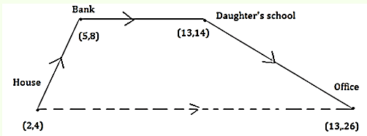 | 5
2 | Akash, Barsa and Chirayu are three best friends staying at the Points A, B, C represented in the Cartesian plane.  - Find the distance between Akash and Barsa.  - Find the distance between Barsa and Chirayu.  - Find the distance between Chirayu and Akash.  - Which type of triangle does the figure depicts?  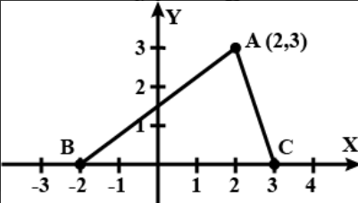  What is the perimeter of the triangle formed? Take $\sqrt{10}=3.16$ | 5
3 | Show that the points (3, 0), (4, 5), (-1, 4) and (-2, -1) are the vertices of rhombus respectively and find the area of the rhombus. | 5
4 | Find the ratio in which the line 2x+3y-5=0 divides the line segment joining the points (8, -9) and (2, 1) . Also find the coordinates of the point of division. | 5
5 | To raise the social awareness about hazards of smoking, a school decided to start “NO SMOKING “campaign.10 students are asked to prepare campaign banner in the shape of a triangle. The vertices of one of the triangle are P (-3, 4), Q (3, 4) and R (-2,-1).    - The coordinates of centroid of $∆PQR are:$  a) $\left(\frac{2}{3}, \frac{7}{3}\right)$ c) $\left(\frac{1}{3}, \frac{1}{3}\right)$  b) $\left(\frac{-2}{3}, \frac{7}{3}\right)$ d) $\left(\frac{7}{3}, \frac{2}{3}\right)$  - If S be the midpoint of line joining P and Q, then coordinates of S are:  a) (4, 0) c) (0, 2)  b) (2, 0) d) (0, 4)  - If T be the midpoint of line joining R and Q, then coordinates of T are:  a) $\left(\frac{1}{2}, \frac{1}{2}\right)$ c) $\left(\frac{3}{2}, \frac{1}{2}\right)$  b) $\left(\frac{1}{2}, \frac{3}{2}\right)$ d) None of them  - If U be the midpoint of line joining R and P, then the coordinates of U are:  a) $\left(\frac{-5}{2}, \frac{3}{2}\right)$ c) $\left(\frac{3}{2}, \frac{-5}{2}\right)$  b) $\left(\frac{3}{2}, \frac{5}{2}\right)$ d) $\left(\frac{5}{2}, \frac{3}{2}\right)$  - The coordinates of centroid of $∆STU are:$  a) $\left(\frac{2}{3}, \frac{7}{3}\right)$ c) $\left(\frac{1}{3}, \frac{1}{3}\right)$  b) $\left(\frac{-2}{3}, \frac{7}{3}\right)$ d) $\left(\frac{7}{3}, \frac{2}{3}\right)$ | 5
 | ANSWERS
1 | - By given condition, we drawn a figure in which every place are indicated with his coordinates and direction also. The shape is a TRAPEZIUM.  We know that, distance between two points ($x_{1},y_{1}$) and ($x_{2},y_{2}$) is given by distance formula:  d= $\sqrt{{(x_{2}-x_{1})}^{2}{+(y_{2}-y_{1})}^{2}}$  Now, distance between house and bank = $\sqrt{{(5-2)}^{2}{+(8-4)}^{2}}$  $$=\sqrt{{(3)}^{2}{+(4)}^{2}}$$  $=\sqrt{9+16}$=$\sqrt{25}$=5  Distance between bank and daughter’s school  $$=\sqrt{{(13-5)}^{2}{+(14-8)}^{2}}$$  =$\sqrt{{(8)}^{2}{+(6)}^{2}}$  $\sqrt{64+36}$=$\sqrt{100}$=10  Distance between daughter’s school and office = $\sqrt{{(13-13)}^{2}{+(26-14)}^{2}}$  =$\sqrt{{(0)}^{2}{+(12)}^{2}}$  $=\sqrt{0+144}$=$\sqrt{144}$=12  Total distance (House + Bank + School + Office) travelled = 5 + 10 + 12 = 27 km  Distance between house to offices  $$=\sqrt{{(13-2)}^{2}{+(26-4)}^{2}}$$  $$=\sqrt{{(11)}^{2}{+(22)}^{2}}$$  $=\sqrt{121+484}$=$\sqrt{605}$=24.59$≈24.6 km$  So, extra distance travelled by Ayush in reaching his office =  27 - 24.6 = 2.4km  Hence, the required extra distance travelled by Ayush is 2.4km.  - Distance between bank to office:  =$\sqrt{{(13-5)}^{2}{+(26-8)}^{2}}$  =$\sqrt{{(8)}^{2}{+(18)}^{2}}=\sqrt{64+324}=\sqrt{388}=19.69km ≈20km$  - Total distance travelled by Ayush is:  (5+10+12+24.6) km=51.6 km  - Cost for 1 km by bus = Rs.5  Cost for 51.6km= Rs. 51.6 x 5 = Rs. 258  Thus, he spend Rs.258 by bus  - Cost for 1 km by auto = Rs. 18  Cost for 51.6 km = Rs. 51.6 x 18 =Rs. 928.8  Rs. 928.8 - Rs. 258 = Rs. 670.80  Thus, he saved Rs. 670.80 by not travelling by auto.  Or  The displacement covered by Ayush is 0. (Displacement is the shortest path covered by the body.) | 5
2 | The coordinates of Akash(2,3), Barsa(-2,0) and Chirayu(3,0)  - The distance between Akash and Barsa is found by using distance formula:  d= $\sqrt{{(x_{2}-x_{1})}^{2}{+(y_{2}-y_{1})}^{2}}$  =$\sqrt{{\left(-2-2\right)}^{2}{+\left(0-3\right)}^{2}}$  $$=\sqrt{{\left(-4\right)}^{2}{+\left(-3\right)}^{2}}$$  $$=\sqrt{16+9}$$  $$=\sqrt{25}$$  $$=5 units$$  - The distance between chirayu and Barsa is found by using distance formula:  =$\sqrt{{\left(3-(-2\right))}^{2}{+\left(0-0\right)}^{2}}$  $$=\sqrt{{\left(5\right)}^{2}}$$  $$=5 units$$  - The distance between chirayu and Akash is found by using distance formula:  =$\sqrt{{\left(3-2\right)}^{2}{+\left(0-3\right)}^{2}}$  $$=\sqrt{{\left(1\right)}^{2}{+\left(-3\right)}^{2}}$$  $$=\sqrt{1+9}$$  =$\sqrt{10} units$  - The triangle formed is an Isosceles triangle.  - The perimeter of the triangle:  = (5+5+$\sqrt{10}$) units  =10+$\sqrt{10}$ units =13.16 units | 5
3 | Given the coordinates of the variables are A(3,0) ,B(4,5) , C(-1,4) and D(-2,-1)  Of the quadrilateral ABCD  By the distance formula,  AB = $\sqrt{26}$  BC = $\sqrt{26}$  CD = $\sqrt{26}$  AD =$\sqrt{26}$  $∴$ AB= AC =CD =AD =$\sqrt{26}$  Since all the sides are equal .so, ABCD is a rhombus .  AC and BD are the diagonals of the rhombus ABCD  AC =$\sqrt{32}$  BD = $\sqrt{72}$  Area of rhombus = ½ product of two diagonals  =24 sq. units | 5
4 | Given, the line 2x + 3y - 5 = 0 divides the line segment joining the points (8, -9) and (2, 1)  We have to find the ratio in which the given line divides the line segment and the coordinates of the point of division.  By section formula,  The coordinates of the point P(x, y) which divides the line segment joining the points A (x₁ , y₁) and B (x₂ , y₂) internally in the ratio k : 1 are [(kx₂ + x₁)/k +1, (ky₂ + y₁)/k + 1]  Here, (x₁ , y₁) = (8, -9) and (x₂ , y₂) = (2, 1)  Let the coordinates of the point be (x, y)  [(k(2) + 8)/k + 1, (k(1) + (-9))/k + 1] = (x, y)  [(2k + 8)/k + 1, (k - 9)/k + 1] = (x, y) -------------(1)  The point lies on the line 2x + 3y - 5 = 0.  Now, 2((2k + 8)/k + 1) + 3((k - 9)/k + 1) = 5  2(2k + 8) + 3(k - 9) = 5(k + 1)  4k + 16 + 3k - 27 = 5k + 5  By grouping,  4k + 3k - 5k = 5 + 27 - 16  7k - 5k = 5 + 11  2k = 16  k = 16/2  k = 8  Therefore, the point divides the line segment in the ratio 8 : 1.  To find the coordinates of the point of division,  Put k = 8 in (1)  (x, y) = [(2(8) + 8)/8 + 1, (8 - 9)/8 + 1]  (x, y) = [(16 + 8)/9, -1/9]  (x, y) = [24/9, -1/9]  (x, y) = [8/3, -1/9]  Therefore, the coordinates of the point of division are 8/3 and -1/9. | 5
5 | - B  - D  - B  - A  - B | 5

CHAPTER – 8
INTRODUCTION TO TRIGONOMETRY

SYLLABUS:
Trigonometric ratios of an acute angle of a right-angled triangle. Proof of their existence (well defined); motivate the ratios whichever are defined at 0o and 90o. Values of the trigonometric ratios of 30⁰, 45⁰ and 60⁰. Relationships between the ratios.
Proof and applications of the identity sin²A + cos²A = 1. Only simple identities to be given.

SL NO | QUESTION | MARK
 | MULTIPLE - CHOICE QUESTIONS
1 | If two tangents inclined at an angle 60⁰ are drawn to a circle of radius 3 cm, then the length of each tangent is  (A) 32√3 cm (B) 6 cm (C) 3 cm (D) 3√3 cm | 1
2 | In the given figure, AT is a tangent to the circle with centre O such that OT = 4 cm and ∠ OTA = 30⁰. Then AT = ?  (A) 4 cm (B) 2 cm (C) 2√3 cm (D) 4√3cm  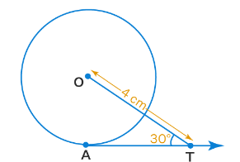 | 1
3 | If cos(α + β ) = 0, then the value of sin(α - β )is  (A) sinα (B) sin2α (C) cos β (D) cos 2β | 1
4 | In the given figure, AOB is a diameter of a circle with centre O. The value of tanA tanB is  (A)1 (B) 2 (C) 3 (D) √3  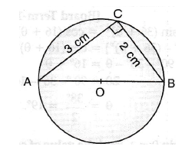 | 1
5 | If cos(81⁰+Ө) = sin($\frac{k}{3}$ – Ө), then k is equal to:  (A)43$\frac{1}{2}$° (B) 54° (C)27° (D)13$\frac{1}{2}$° | 1
6 | If sinӨ – cosӨ = 0, then the value of sin⁴Ө + cos⁴Ө is  (A) 1 (B)$\frac{1}{2}$ (c)$\frac{1}{4}$ (D) $\frac{3}{4}$ | 1
7 | The Value of cos1°cos2°cos3°……….cos180°  (A)1 (B)0 (C)-1 (D) None of these | 1
8 | If k +1 = sec²Ө(1 + sinӨ)(1- sinӨ)  (A)1 (B) 2 (C)0 (D)-1 | 1
9 | If sinӨ – cosӨ = 0,then the value of sin⁶Ө + cos⁶Ө is  (A)$\frac{2}{3}$ (B)$\frac{1}{3}$ (C)$\frac{3}{4}$ (D)$\frac{1}{4}$ | 1
10 | If $\frac{\cos^{2}20°+\cos^{2}70°}{2(\sin^{2}59°+\sin^{2}31°)}$ = $\frac{2}{k}$,then k is equal to  (A)3 (B)1 (C)2 (D) 4 | 1
11 | If cotA= $\frac{3}{4}$ then the value of cosB when right angled at C is  (a) $\frac{3}{5}$ (b) $\frac{2}{5}$ (c) $\frac{4}{5}$ (d) $\frac{5}{3}$ | 1
12 | The value of sin 0°. cos 1°. sin 2°. cos 3°… sin 89° cos 90° is  (a) 0 (b) -2 (c) 1 (d) 3/√2 | 1
13 | If x + y =90⁰ , then which relation is correct:  (a) sin x = sin y (b) tan x = cot y (c) cos x = cos y (d) sec x = sec y | 1
14 | cos 2A = cos A is true when A is equal to:  (a) 90° (b) 60° (c) 30° (d) 0° | 1
15 | What is the minimum value of tan A, 0 ≤ A ≤ 90°  (a) -1 (b) 0 (c) 1 (d) 12 | 1
16 | If in ΔABC, ∠C = 90°, then cos (A + B) = ?  (a) 0 (b) $\frac{1}{2}$ (c) $\frac{1}{√2}$ (d) 1 | 1
17 | sin2A = 2 sinA is true when A= ?  (a) 45⁰ (b) 0⁰ (c) 30⁰ (d) 60⁰ | 1
18 | The value of θ, for which tan2θ = √3 is:  (a) 15 (b) 45 (c) 30 (d) 90 | 1
19 | If cosecα = 2 and cosecβ = 2/√3, then the value of sin(α+β) is:  (a) 2 (b) 4 (c) 0 (d) 1 | 1
20 | What happens to the value of sin when θ increases from $0^{0}$to ${90}^{0}$ ?  (a) Will increase (b) will decrease (c) no change (d) none of these. | 1
21 | If tanx = √3 then what is the value of 1/4 cot x/2?  (a) 1/2 (b) √3/4 (c) √3/2 (d) 1/4 | 1
22 | If sin2A = 1/2 $\cot^{2}{{45}^{0}}$, where A is an acute angle, then the value of A is:  (a) 45 (b) 30 (c) 15 (d) 60 | 1
23 | In the right triangle PQR, PR=5cm, PQ=4cm, RQ=3cm then the value of secR is:  (a) 3/5 (b) 4/3 (c) 5/3 (d) 3/4 | 1
24 | If sinA + $\sin^{2}{A}$ = 1, then the value of $\cos^{2}{A}$ + $\cos^{4}{A}$ is:  (a) 0 (b) 1 (c) 3 (d) 4 | 1
25 | In a right triangle PQR, right-angled at Q, if cotR = 1 then the value of 2cosecRsecR is:  (a) 4 (b) 2√2 (c) 2 (d) 1 | 1
 | ANSWERS | 1
1 | D | 1
2 | C | 1
3 | D | 1
4 | A | 1
5 | C | 1
6 | B | 1
7 | B | 1
8 | C | 1
9 | D | 1
10 | D | 1
11 | (c) | 1
12 | (a) | 1
13 | (b) | 1
14 | (d) | 1
15 | (b) | 1
16 | (a) | 1
17 | 0° | 1
18 | (c) | 1
19 | (d) | 1
20 | (a) | 1
21 | (b) | 1
22 | (c) | 1
23 | (c) | 1
24 | (b) | 1
25 | (a) | 1
 | ASSERTION & REASON QUESTIONS
Choose the correct option in the following questions of Assertion – Reason Questions.
(a) Both A and R are correct; R is the correct explanation of A.
(b) Both A and R are correct; R is not the correct explanation of A.
(c) A is true but R is false
(d) A is false but R is true
1 | Assertion(A):- If x = a cos 0 and y = b sin 0, then b2x2 + a2y2 = a²b².  Reason(R)- b2x2 + a2y2 = a²b² where x = a and y = 0. | 1
2 | Assertion:- For the value of θ = 60⁰ , for sin 2θ = 1,where 0⁰ < θ < 90⁰.  Reason- for any angle (θ), sin² θ + cos² θ =1. | 1
3 | Assertion: - The value of cos60⁰ cosec30⁰ – cot60⁰ cot30⁰ is 0.  Reason: - complementary relations are cosθ=sin (90⁰- θ), cosecθ = sec (90⁰- θ), cotθ = tan (90⁰- θ). | 1
4 | Assertion: If x sin³θ + y cos³θ = sinθ cosθ and x sinθ = y cosθ, then x²+ y² = 1  Reason: For any value of θ, sin²θ + cos²θ = 1. | 1
5 | Assertion: (cos4A-sin4A) is equal to 2cos2A-1.  Reason: The value of cosθ decreases as θ increases. | 1
 | ANSWERS
1 | a | 1
2 | d | 1
3 | a | 1
4 | b | 1
5 | b | 1
 | 2 MARKS TYPE QUESTIONS
1 | In the following figure, find the value of cosφ  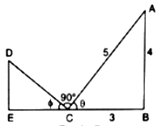 | 2
2 | In the given figure if D is the mid-point of BC, then find the value of $\frac{coty°}{cotx°}$  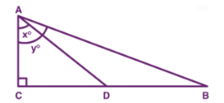 | 2
3 | In the figure given below if AD = 4cm, BD = 3cm and CB = 12cm, then find the value of cot Ө.  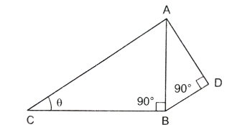 | 2
4 | If $\frac{{xcosec}^{2}30°\sec^{2}45°}{{8cos}^{2}45°\sin^{2}60°}$ = $\tan^{2}60°-\tan^{2}30°$,then find the value of x | 2
5 | If (sinӨ + cosecӨ)² + (cosӨ + secӨ)² = k + tan²Ө + cot²Ө, then find the value of k | 2
6 | At what value of A, $\frac{1}{cosec A}$ show the maximum value? | 2
7 | If sin θ = $\frac{a-b}{a+b}$ , then find cot θ ? | 2
8 | If cot θ = tan (90⁰- θ ) the what is the value of tan 48° tan 23° tan 42° tan 67° ? | 2
9 | If sin (A + B) = 1 and cos (A - B) = 1, then determine the value of A and B ? | 2
10 | If 3tan θ = 4 then determine (sin θ + cos θ) ? | 2
 | ANSWERS | 2
1 | Cosφ = cos(90°- Ө) = sinӨ = $\frac{4}{5}$ | 2
2 | $\frac{coty°}{cotx°}$ = $\frac{\frac{AD}{BC}}{\frac{AD}{CD}}$ = $\frac{AD}{BC}$ × $\frac{CD}{AD}$ = $\frac{CD}{BC}$ = $\frac{CD}{2CD}$ = $\frac{1}{2}$ | 2
3 | AB = $\sqrt{{AD}^{2}+{BD}^{2}}$ = $\sqrt{4^{2}+3^{2}}$ = $\sqrt{16+9}$ = 5 cm  AC = $\sqrt{{AB}^{2}+{BC}^{2}}$ = $\sqrt{5^{2}+{12}^{2}}$ = $\sqrt{25+144}$ = 13 cm  cotӨ = $\frac{BC}{AB}$ = $\frac{12}{13}$ | 2
4 | $\frac{x{(2)}^{2}{(\sqrt{2)}}^{2}}{8{(\frac{1}{\sqrt{2}})}^{2}{(\frac{\sqrt{3}}{2})}^{2}}$ = (√3)² - ${(\frac{1}{\sqrt{3}})}^{2}$ ⇒ x = $\frac{1}{2}$ × $\frac{3}{4}$ × $\frac{8}{3}$ ⇒ x = 1 | 2
5 | Sin²θ + cosec²θ + 2 × sinθ × cosecθ + cos²θ + sec²θ + 2 cosθ × secθ = k + tan²θ + cot²θ  ⇒ sin²θ + cos²θ + 1 + cot²θ + 2 + 1 + tan²θ + 2 = k + tan²θ + cot²θ  ⇒ 1 + 1 + 2 + 1 + 2 + tan²θ + cot²θ = k + tan²θ + cot²θ  ⇒ 7 + tan²θ + cot²θ = k + tan²θ + cot²θ  ⇒ k = 7 | 2
6 | We know that, for the maximum value of $\frac{1}{cosec A}$.  Cosec A = 1 → cosec A = cosec 90⁰ .  Therefore A=90⁰. | 2
7 | If sin θ = $\frac{a-b}{a+b}$ ,  then, H2 = P2 + B2.  (a+b)2 = (a-b)2 + (base)2 a+b  (a+b)2 - (a-b)2 = (base)2 a-b  (base)2 = 4ab → base = √4ab or 2√ab {(a+b)2 - (a-b)2 = 4ab}  Therefore cot θ = $\frac{base}{perp.}$ = $\frac{ 2√ab }{(a-b).}$ . base | 2
8 | tan 48° tan 23° tan 42° tan 67°  tan 48° tan 42° tan 67° tan 23°  tan 48° cot (900-480) tan 67° cot (900-670)  tan 48° cot 480 tan 67° cot 670 { cot θ = tan (900- θ)}  tan 48° $\frac{1}{tan 48°}$ tan 67° $\frac{1}{tan 67°}$ = 1 { cot θ = $\frac{1}{tan θ}$ } | 2
9 | If sin (A + B) = 1 and cos (A - B) = 1,  Then,  sin (A + B) = 1, sin (A + B) = sin 90⁰  A + B = 90⁰ , A = 90⁰ – B eq. (i)  cos (A - B) = 1, cos (A - B) = cos 0⁰,  A - B = 0⁰ eq.(ii)  From eq.(i) and (ii)  We get,  90⁰ - B - B = 0⁰  2B = 90⁰ → B = 45⁰  A - B = 0⁰ → A = B  Therefore, A = B = 45⁰. | 2
10 | 3tan θ = 4 → tan θ = $\frac{4}{3}$  H2 = P2 + B2 H  H2 = (4)2 + (3)2 P=4  H2 = 16 + 9  H2 = 25→ H2 = 52→ H = 5  then (sin θ + cos θ) = $\frac{4}{5}$ + $\frac{3}{5}$ = $\frac{7}{5}$ { sin θ = $\frac{P}{H}$ & cos θ = $\frac{B}{H}$ } | 2
 | 3 – MARKS TYPE QUESTIONS
1 | If $\cos^{2}{θ}$ - $\sin^{2}{θ}$ = $\tan^{2}{ϕ}$, prove that  $\cos{ϕ}$ = 1/√2 cosθ | 3
2 | Consider a right triangle with one angle measuring 45 degrees. The hypotenuse is 10 units long. Calculate the lengths of the other two sides using trigonometric ratios. | 3
3 | The ratio of the sine of an angle to its cosine is 8:15. Find their actual value. | 3
4 | Rajat is partitioning his rectangular field for his two sons.  He draws a line AE and gives the trapezium shaped part to his elder son. Find the perimeter of trapezium ABCE.  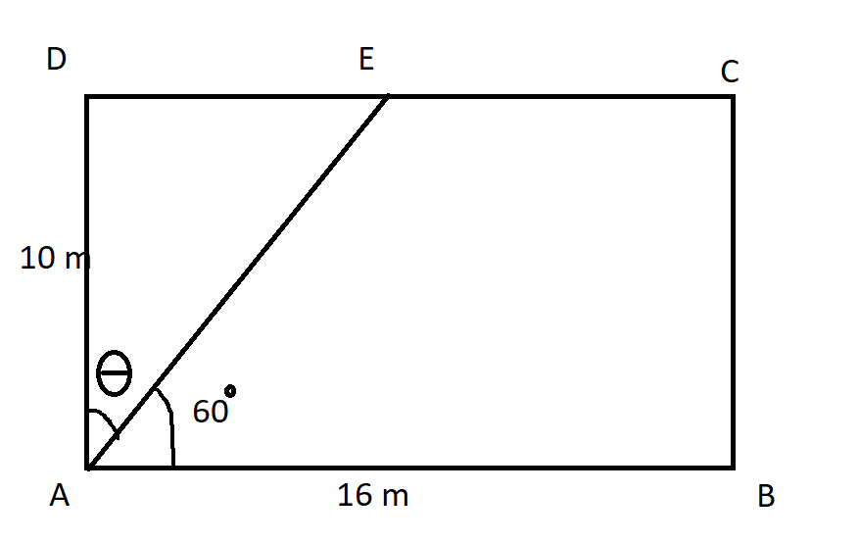 | 3
5 | A floor is to be tiled with parallelogram shaped tiles. Find the area of one tile in the figure shown below.  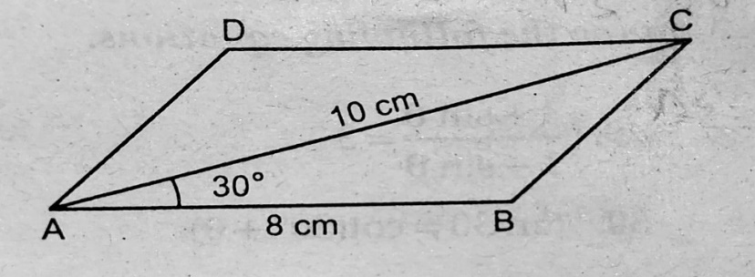 | 3
6 | What is the value of sin²θ+ $\frac{1}{1+tan²θ}$ | 3
7 | Prove that (sin x+ cos x)(tan x+ cot x) = sec x + cosec x. | 3
8 | Prove that (sinθ + 1+ cosθ)(sinθ – 1 + cosθ) (secθ) (cosecθ) = 2. | 3
9 | If cosA + cos²A = 1, then show that sin²A + sin⁴A = 1 | 3
 | ANSWERS
1 | $\cos^{2}{θ}$ – $\sin^{2}{θ}$ = $\tan^{2}{ϕ}$  $\cos^{2}{θ}$ – ( 1 - $\cos^{2}{θ}$ ) = $\sec^{2}{ϕ}$ – 1  2$\cos^{2}{θ}$ – 1 = $\sec^{2}{ϕ}$ – 1  2$\cos^{2}{θ}$ = $\sec^{2}{ϕ}$  Taking square root  √2 cosθ = secΦ  √2 cosθ = 1/ cosΦ  cosΦ = 1/√2 cosθ | 3
2 | In a right triangle with a 45-degree angle, the two legs are congruent.  Using the Pythagoras theorem: Leg length = Hypotenuse/√2  = 10/√2  = 7.07 units approx. | 3
3 | Let θ be the angle for which sinθ/cosθ = 8/15  tanθ = 8/15  Consider a right triangle ABC, with angle B = 90 and angle ACB = θ  tanθ = AB/BC = 8/15  AB = 8k, BC = 15k  By applying Pythagoras theorem, we will get AC = 17k  Thus sinθ = AB/AC = 8k/17k = 8/17  Cosθ = BC/AC = 15K/17K = 15/17 | 3
4 | Θ=30$°$. cos30$°=\frac{AD}{EA}=>EA=\frac{20}{\sqrt{3}}$ m  Using tan30$°, DE=\frac{10}{\sqrt{3}}$m  EC= DC-DE= (16-10/$\sqrt{3})m$  Perimeter= sum of all sides= (42+$\frac{10\sqrt{3}}{3}$) m. | 3
5 | 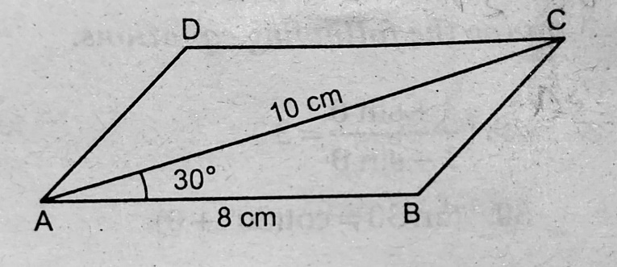  Draw BE⏊AC.  sin30$°$ = $\frac{BE}{AB}=>$BE= 4 cm. Area of parallelogram= 2*area of $∆ABC$  =40 ${cm}^{2}$ | 3
6 | For correct proof proportionate marks for steps to be given | 3
7 | For correct proof proportionate marks for steps to be given | 3
8 | For correct proof proportionate marks for steps to be given | 3
9 | According to the question,  cos A+cos2 A = 1  i.e., cos A = 1- cos2 A  Since,  sin2 θ+cos2 θ = 1  sin2 θ = 1- cos2 θ  We get,  cos A = sin2 A …(1)  Squaring L.H.S and R.H.S,  cos2 A = sin4 A …(2)  Adding equations (1) and (2),  We get  sin2A + sin4 A= cos A + cos2 A  Therefore, sin2A+ sin4 A = 1 | 3
 | 4 – MARKS TYPE QUESTIONS (CASE BASED QUESTIONS)
1 | Anita, a student of class 10th, has to made a project on 'Introduction to Trigonometry' She decides to make a bird house which is triangular in shape. She uses cardboard to make the bird house as shown in the figure. Considering the front side of bird house as right-angled triangle PQR, right angled at R, answer the following questions.  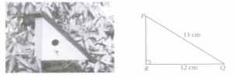  (i) The value of $\frac{tanθ}{1+\tan^{2}θ}$ =  (A) $\frac{5}{12}$ (B) $\frac{12}{5}$ (C) $\frac{60}{169}$ (D) $\frac{169}{60}$  (ii) The value of cot2θ – cosec2θ = (A) -1 (B) 0 (C) 1 (D) 2  (iii) The value of sin2θ + cos2θ =  (A) 0 (B) 1 (C) -1 (D) 2 | 4
2 | Aanya and her father go to meet her friend Juhi for a party. When they reached to [uhi's place, Aanya saw the roof of the house, which is triangular in shape. If she imagined the dimensions of the roof as given in the figure, then answer the following questions.  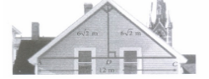  (i) If D is the midpoint of AC, then BD =  (ii) Find the value of sin A + cos C.  (iii) Find the value of tan2A + tan2C  (A) 0 (B) 1 (C) 2 (D) $\frac{1}{2}$ | 4
  (A) 2m | (B) 3m | (C) 4m | (D) 6m
  (A) 0 | (B) 1 | (C) $\frac{1}{2}$ | (D) √2
3 | The angle of elevation of the top Q of a vertical tower PQ from a point X on the ground is 60. At a point Y, 40m vertically above X, the angle of elevation is 45.  (i) Find the distance XP.  (ii) Find the distance YT.  (iii) Find the distance QT.  (iv) Find the height of the tower.  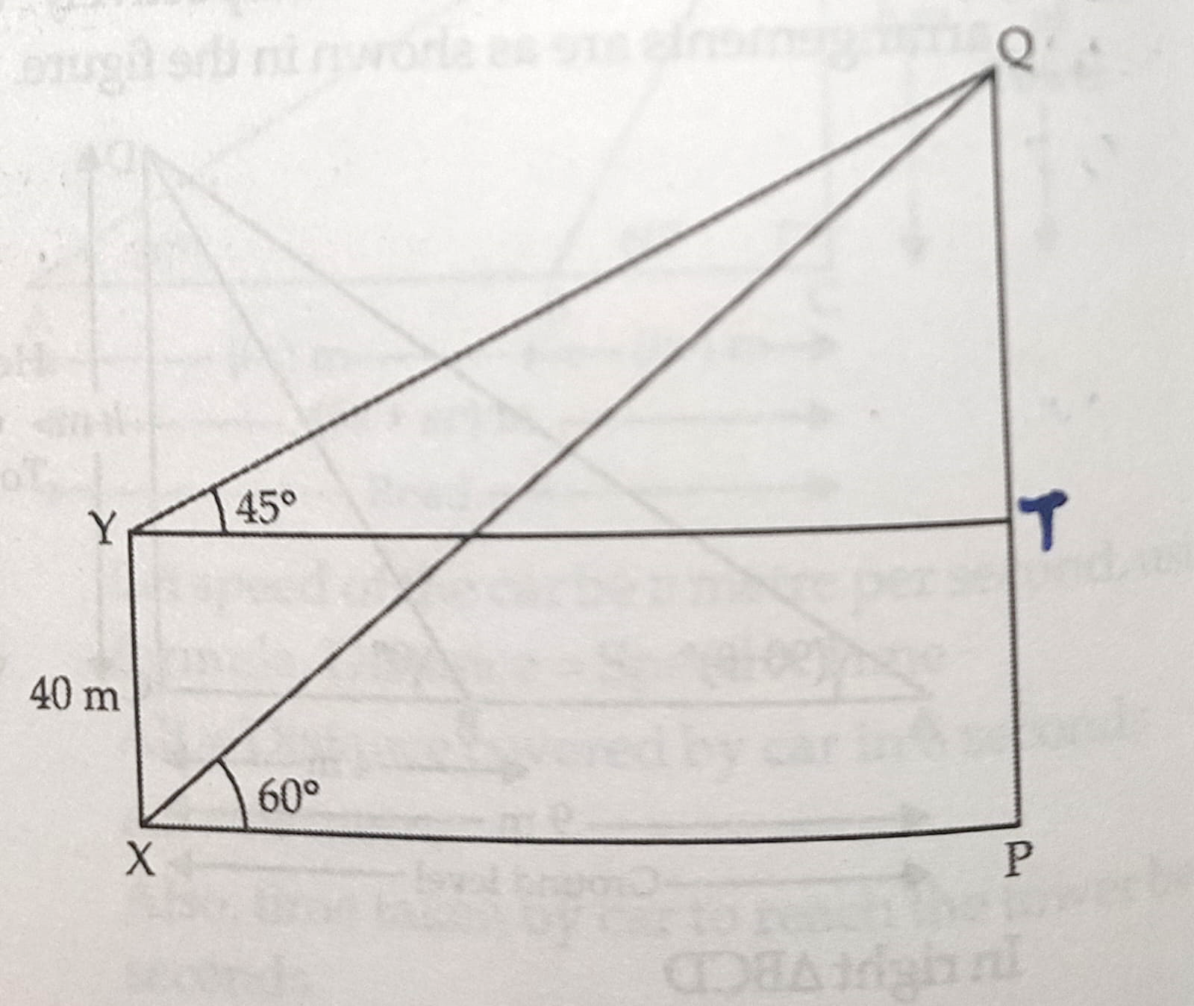 | 4
4 | 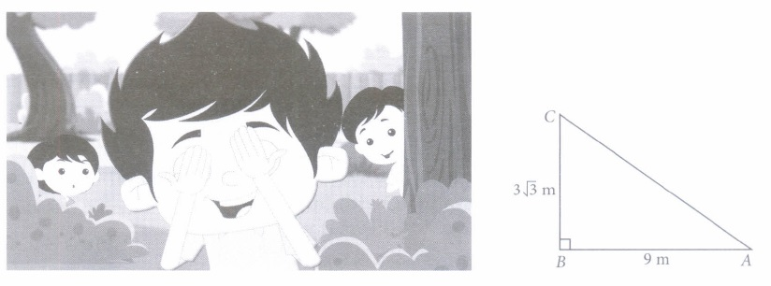  Three friends - Anshu, Vijay and Vishal are playing hide and seek in a park. Anshu and Vijay hide in the shrubs and Vishal have to find both of them. If the positions of three friends are at A, Band C respectively as shown in the figure and forms a right angled triangle such that AB = 9 m, BC = 3√3m and ∠B = 90°, then answer the following questions.  (i) The measure of ∠A is  (a)30° (b) 45° (c) 60° (d) None of these  (ii) The measure of ∠C is  (a) 30° (b) 45° (c) 60° (d) None of these  (iii) The length of AC is  (a)2√3 m  (b) √3 m  (c) 4√3 m  (d) 6√3 m  (iv) cos A =  (a) 0 (b)½ (c) 1/√2 (d)√3/2 | 4
5 | Aanya and her father go to meet her friend Juhi for a party. When they reached to Juhi's place, Aanya saw the roof of the house, which is triangular in shape. If she imagined the dimensions of the roof as given in the figure, then answer the following questions.  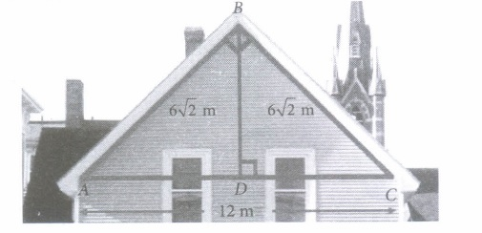  (i) If D is the mid point of AC, then BD =  (a) 2m (b) 3m (c) 4m (d) 6m  (ii) Measure of ∠A =  (a) 30° (b) 60° (c) 45° (d) None of these  (iii) Measure of ∠C =  (a) 30° (b) 60° (c) 45° (d) None of these  (iv) Find the value of sinA + cosC.  (a) 0 (b) 1 (c) 1/2 (d) √2 | 4
6 | Ananya is feeling so hungry and so thought to eat something. She looked into the fridge and found a bread pieces. She decided to make a sandwich. She cut the piece of bread diagonally and found it forms a right-angled triangle, with sides 4 cm, 4√3 cm and 8 cm.  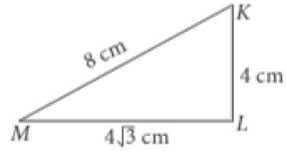  On the basis of above information, answer the following questions.  (i)The value of ∠M is  A. 30° B. 60° C. 45° D. None of these  (ii) The value of ∠K is  A. 45° B. 30° C. 60° D. None of these  (iii) Find the value of tanM.  A. √3 B. 1/√3 C. 1 D. None of these  (iv) sec2M – 1 =  A. tanM B. tan2M C. tan3M D. None of these | 4
 | ANSWERS
1 | (i)C  (ii)A  (iii)B | 4
2 | (i)D  (ii)D  $$(iii)C$$ | 4
3 | (i) 54.79m approx.  (ii) 54.79m approx.  (iii) 54.79m approx.  (iv) 94.79m approx | 4
4 | (i) a. 30 (ii) c. 60 (iii) c. 6$√3$ (iv) d. √3/2 | 4
5 | (i)d (ii) c (iii) c (iv) d | 4
6 | (i)M = 30 degree  (ii) K = 60 degree  (iii)tanM = $\frac{1}{\sqrt{3}}$  - b | 4
 | 5 – MARKS TYPE QUESTIONS
1 | If a man throw a ball at the height of 3m. the ball travel 4m and stop after third bounce.  A  3  B C D E  |----------2m----------|-------------1.5m---------------|------0.5m------|  (i) what is the value of tanE ? (1)  (ii) if sec θ = $\frac{H}{B}$, then find sec C ? (1)  (iii) what is the value of cos C + cosD ? (2)  (iv) At what angle the height (AB) = Distance (BE)? (1)
2 | The rod of the TV disc antenna is fixed at the right angle to wall AB and a rod CD supports the disc, as shown in Figure. If AC = 1.5 m long and CD = 3 m.  - Find the length of the rod AD.  - Compute the value of sec θ + cosec θ  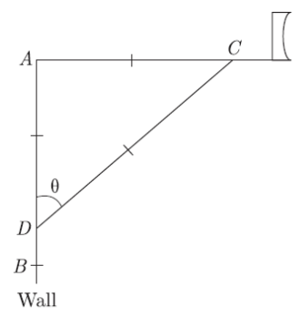
3 | Prove that (a) $\sqrt{\frac{1+ sin A}{1- sin A}}$ $=$ $sec A + tan A$  (b) $\frac{tan θ}{1- cot θ}$+ $\frac{cot θ}{1- tanθ}$ = 1 + $sec θ cosec θ$
4 | If 1 + sinθ/1 – sinθ = 36/25, then find the value of 1 + tanθ/1 – tanθ.
5 | If a sin² x + b cos ² x = c , b sin² y+a cos² y =d and a tan X = b tan y , then find $\frac{a^{2}}{b^{2}}$
 | ANSWERS
1 | B C D E  |----------2m----------|-------------1.5m---------------|------0.5m------|  By using pythagores theorem,  (Hypo.)² = (Perp.)² + (Base)²  (AE)² = (AB)² + (BE)²  (AE)² = (3)² + (4)² → (AE)² = 9+16 → (AE)² =25 → (AE)² = (5)² → AE = 5.  (AC)² = (AB)² + (BC)²  (AC)2 = (3)2 + (2)2 → (AC)2 = 9+4 → (AC)2 =(√13)2 → AC =√13  (i) tanE = $\frac{P}{B}$ = $\frac{AB}{BE}$ = $\frac{3}{4}$ → tanE = $\frac{3}{4}$  (ii) if sec θ = $\frac{H}{B}$, then sec C = $\frac{AC}{BC}$ = $\frac{√13}{2}$  (iii) cos C + cot D → $\frac{BC}{AC}$ + $\frac{BD}{AB}$ = $\frac{2}{√13}$ + $\frac{3.5}{3}$ = $\frac{6+3.5√13}{3√13}$  (iv) height (AB) = Distance (BE) = 3  $\frac{AB}{BE}$ = tan θ = $\frac{3}{3}$ , tan θ = 1 → tan θ = tan 450  Therefore, θ = 450.
2 | (a) 2.6m or 2.59m (approx) (b) 41/13
3 | Proof 1 (2 marks) & Proof 2 (3 marks)
4 | 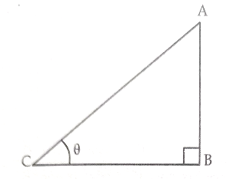  1 + sinθ/1 – sinθ = 36/2525 (1 + sinθ ) = 36 (1 - sinθ )  25 + 25 sinθ = 36 – 36sinθ  (25 + 36 )sinθ = 36 – 25  Sinθ = 11/61  Consider a right triangle ABC, angle B = 90 and angle ACB = θ  Sinθ = AB/AC = 11/61  AB = 11k, AC = 61k  By using Pythagoras theorem, we will get BC = 60k  Now tanθ = AB/BC = 11k/60k = 11/60  By putting the value of tanθ in the required expression and solving them we will get 1 + tanθ/1 – tanθ = 71/49.
5 | dividing equation, a sin²x+b cos ²x = c  by cos² x  a tan² x+ b =c sec² x  ⇒ a tan² x +b =c(1+ tan² x)  ⇒ a tan² x + b = c + c tan² x  = tan²x(a – c) = c - b  tan² x = $\frac{c-b}{a - c}$​  Similarly, dividing equation b sin² y+a cos² y =d  by cos² y  b tan² y+ a=d sec² y  ⇒b tan² y +a=d(1+ tan² y)  ⇒b tan²y + a = d +d tan² y  ⇒ tan² y (b – d) =d−a​  = tan² y = $\frac{d-a}{b-d}$  Now, a tanx=b tany  ⇒a² tan²x =b² tan² y  ⇒​$\frac{a^{2}}{b^{2}}$ = $\frac{\tan^{2}y}{\tan^{2}x}$  ⇒​$\frac{a^{2}}{b^{2}}$ = $\frac{\frac{d-a}{b-d}}{\frac{c-b}{a - c}}$  ⇒$\frac{a^{2}}{b^{2}}$ = $\frac{(d-a)(a-c)}{(b-d)(c-b)}$

CHAPTER – 9
APPLICATION OF TRIGONOMETRY

SYLLABUS:
Angle of elevation, Angle of depression, Simple problems on heights and distances. Problems should not involve more than two right triangles. Angles of elevation / depression should be only 30°, 45°, and 60°.

SL NO | QUESTION | MARK
 | MULTIPLE - CHOICE QUESTIONS
1 | 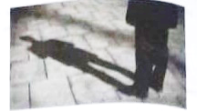  A man while walking on a hot day, noticed how the length of his shadow changes with the sun’s altitude. If the height and length of the shadow of a man are the same, the angle of elevation of the sun is  (a) 450 (b) 600(c) 900(d) 1200 | 1
2 | If the height of a tower and the distance of the point of observation from its foot, both are increased by 10%, then the angle of elevation of its top  (a) increases (b) decreases  (c) remains unchanged (d) have no relation. | 1
3 | In a parallelogram type sweet one side is 10 cm and other side is 4$\sqrt{3}$ cm. What is the distance between the sides of 10 cm, if one angle is 600.  (a) 2 cm (b) 4 cm  (c) 6 cm (d) 8 cm | 1
4 | The kite flying festival in India falls on 14th of January every year marking the arrival of spring and the transaction of the sun into the Makara Rashi (the Capricorn zodiac sign). In quite a few states in India, Makar Sankranti is considered as a major harvest festival. Kite flying on Independence Day in a tradition in North India especially in Delhi, Lucknow Barely and Moradabad.  A kite is flying at a height of 30m from the ground. The length of string from the kite to the ground is 60m. Assuming that there is no stack in the string, the angle of elevation of the kite at ground is  (a) 450 (b) 300 (c) 900 (d) 600 | 1
5 | An observer 1.5-metre-tall is 20.5 metres away from a tower 22 metres high. Determine the angle of elevation of the top of the tower from the eye of the observer.  (a) 30° (b) 45° (c) 60° (d) 90° | 1
6 | 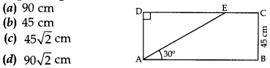  In given figure, the value of AE is  (a) 90cm (b) 45cm  (c) 45$\sqrt{2}$ cm (d) 90$\sqrt{2}$ cm | 1
7 | 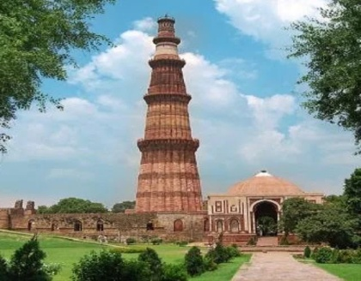  he Qutub Minar is one of the most visited tourist spots in Delhi city. It was named for Qutubud-din-Aibak (the first ruler of the Delhi Sultanate), who began it in A.D 1198. The height of Qutub Minar is 72.5 meters. It is the tallest minaret in the world built of bricks. Qutub Minar was an inspiration and prototype for many minarets and towers built.  One day Shyam visited The Qutub Minar.  If the height of Qutub Minar is 80 meters and Shyam saw the top of the tower, making an angle 450 with the ground, then distance of foot of tower from Shyam is  (i) 160 meters(ii) 100 meters(iii) 80 meters(iv) 60 meters | 1
8 | 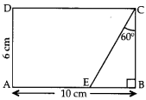  In given figure, the value of CE is  (a) 12 cm (b) 6 cm  (c) 9 cm (d) 6√3 cm | 1
9 | There is fire incident in the house. The house door is locked so, the fireman is trying to enter the house from the window. He places the ladder against the wall such that its top reaches the window as shown in the figure .  Based on the above information, answer the following question.  If window is 6 m above the ground and angle made by the foot ofladder to the ground is 30°, then length of the ladder is  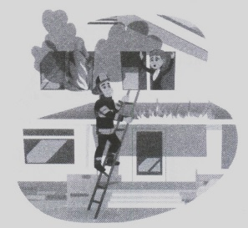  (a) 8m (b) 10m (c) 12m (d) 14m | 1
10 | There are two windows in a house. First window is at the height of 2 m above the ground and other window is 4 m vertically above the lower window. Ankit and Radha are sitting inside the two windows at 2m and 4m respectively. At an instant, the angles of elevation of a balloon from these windows are observed to be 60° and 30° as shown below  Based on the above information, answer the following question.  (i) Who is closer to the balloon? | 1
  (a) Ankit | (b) Radha
  (c) Both are at equal distance | (d) Can't be determined
11 | A ladder placed against a wall such that it reaches the top of the wall of height 6 m and the ladder is inclined at an angle of 60°. Find how far the ladder is from the foot of the wall.  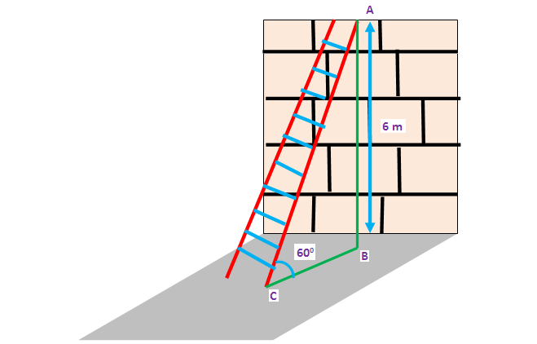  a) 3.46 m b)4.64 m c)3.64m d)none of these | 1
12 | The ratio of the height of a tower and length of its shadow on the ground is √3 : 1 what is the angle of elevation of the sun ?  a)60° b)30° c)45° d)75° | 1
13 | Consider the figure shown  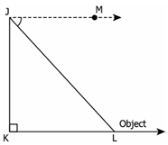  If ∠LJM is the angle of depression, what is the line of sight in the figure shown?  - JM b) JL c) JK d) KL | 1
14 | The angles of elevation of two cars, from the car to the top of a building are 45° and 30°. If the cars are on the same side of the building and are 50 m apart, what is the height of the building?  a)25√3−1 m b) 25√3+1 m c) 50√3−1m d)50√3+1 m | 1
15 | From the top of a 42 m high light house, the angles of depression of two ships that are in a straight line are 60° and 45° respectively. What is the distance between the two ships? (Use√3=1.73)  17.8 m b) 24.2 m c) 32.39 m d) 66.28 m | 1
16 | If the angle of depression from the top of a building to a point situated $10\sqrt{3}$ m away from the bottom of the building is 60$°$, then the height of the building will be  a)$\frac{10}{√3}$ m b)15 m c) 30 m d) 30$\sqrt{3}m$ | 1
17 | If a ladder of length 40 leaning against a wall makes an angle of 30$°$ with the ground, then the height from the ground where the ladder meets the wall will be  a)20m b) 10 m c) 20$\sqrt{3}m$ d) 10$\sqrt{3} m$ | 1
18 | Two men on either side of a temple 75 m high have angles of elevation as 45$° each.$The distance between them is  125 m b) $\frac{150}{√3}$ m c) 150$√3$ m d) 150 m | 1
19 | There are two lamp-posts $L_{1 and }L_{2} of$equal height on either side of the road having width equal to 100m. If angles of elevation of the lamp-posts from a point on the road are 30$°$ and 45$°$, then the height of the lamp-post will be  a) 36 m b) 63.6 m c)63 m d) 36.6 m | 1
20 | A person standing on the bank of a river finds that the angle of elevation of the top of a tower on the opposite bank is 45$°$. Which of the following statement is correct?  - Breadth of the river is twice the height of the tower  - Breadth of the river is half the height of the tower  - Breadth of the river is same as the height of the tower  - None of the above | 1
21 | 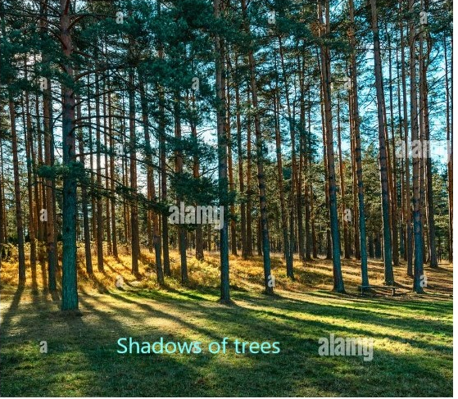  If the length of the shadow of a tree is decreasing then the angle of elevation is:  (a) Increasing (b) Decreasing (c) Remains the same (d) None of the above | 1
22 | 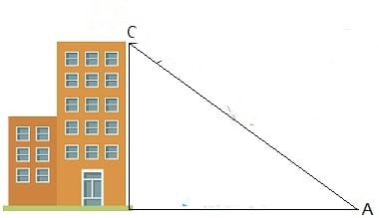  The angle of elevation of the top of a building from a point on the ground, which is 30 m away from the foot of the building, is 30°. The height of the building is:  (a) 10 m (b) 30/√3 m (c) √3/10 m (d) 30 m | 1
23 | 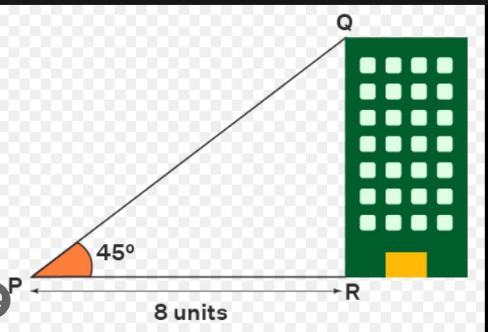  If, both, the height of the building and distance from the building’s foot to a point is increased by 20%, then the angle of elevation of the top of the building:  (a) Increases (b) Decreases (c) Do not change (d) None of the above | 1
24 | 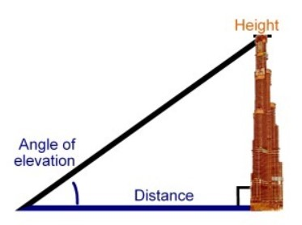  If a tower 6m high casts a shadow of 2√3 m long on the ground, then the sun’s elevation is:  (a) 60° (b) 45° (c) 30° (d) 90° | 1
25 | 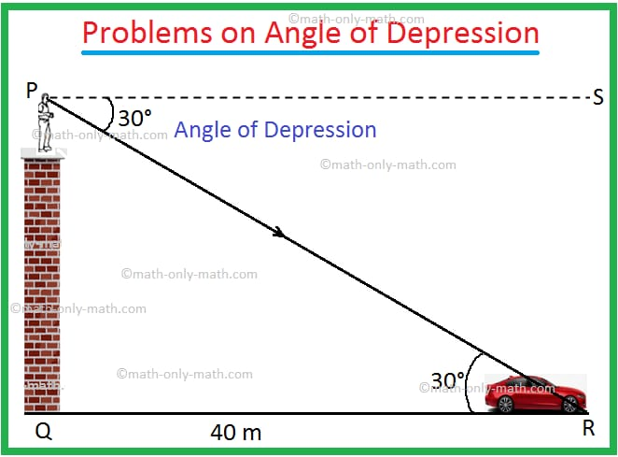  The angle formed by the line of sight with the horizontal when the point is below the horizontal level is called:  (a) Angle of elevation (b) Angle of depression  (c) No such angle is formed (d) None of the above | 1
 | ANSWERS | 1
1 | 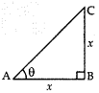  Let  The height of man BC = x m and sun’s altitude = θ  Then Length of its shadow, AB = x m  In right triangle. ∆ABC,  ⇒ tan θ = $\frac{BC}{AB}$= $\frac{x}{x}$= 1  ⇒ tan θ = tan 45°  ∴ θ = 45° | 1
2 | We know, for an angle of elevation θ  tan θ = $\frac{Height of tower}{Distance from the point}$  If we increase both the values, there will be no change in the angle of elevation. | 1
3 | 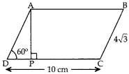  Since ABCD is a || gm  ∴ AD = BC = 4√3  In rt ∆APD, sin 60° = $\frac{AP}{AD}$  ⇒ $\frac{\sqrt{3}}{2}$=$\frac{AP}{4\sqrt{3}}$  ⇒ 2AP = 4 × $\sqrt{3}$ × $\sqrt{3}$= 12cm  ∴ AP = 6 cm | 1
4 | 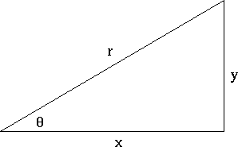  Here y = 30m  r = 60m  sin θ = $\frac{y}{r}$ = $\frac{30}{60}$ = $\frac{1}{2}$ = sin 30°  θ = 30° | 1
5 | 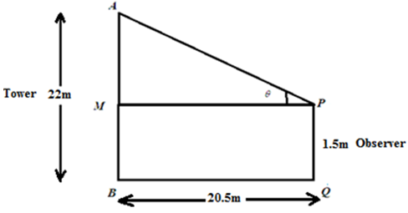  Let the angle of elevation of the tower from the eye of observer be θ.  Given that:  AB = 22m, PQ = 1.5m = MB  QB = PM = 20.5m  AM = AB − MB = 22 − 1.5 = 20.5m  Now in triangle APM  tan θ = $\frac{AM}{PM}$  tan θ = $\frac{20.5}{20.5}$  tan θ = 1  θ = 45° | 1
6 | 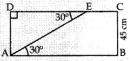  ∠AED = ∠EAB = 30°…[alternate interior angles]  In Right triangle. ∆AED, sin 30° = $\frac{AD}{AE}$  ⇒ $\frac{1}{2}$ = $\frac{45}{AE}$(∵sin 30° = $\frac{1}{2}$ , AD = BC = 45cm)  ⇒ AE = 2 X 45 = 90 cm | 1
7 | Here y = 80m  Θ = 45°  tan θ = $\frac{y}{x}$  tan45°=$\frac{80}{x}$  1 = 80/x  X = 80m | 1
8 | In right triangle. ∆EBC,  cos 60° = $\frac{BC}{CE}$  ⇒ $\frac{1}{2}$ = $\frac{6}{CE}$ (∵cos 60°=$\frac{1}{2}$ , BC = AD = 6cm)  ⇒ CE = 6 × 2 = 12 cm | 1
9 | 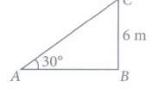  Let AC be the length of the ladder.  BC = 6m ,θ = 30°  sin θ = $\frac{BC}{AC}$ =$\frac{6}{AC}$  sin 30°=$\frac{1}{2}$ = $\frac{6}{AC}$  AC = 2 x 6 = 12 | 1
10 | 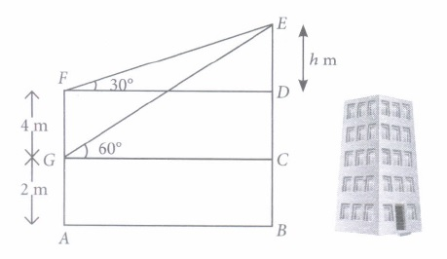  The person who makes small angle of elevation is closer to the balloon.  ∴ Radlra is closer to the balloon. | 1
11 | A | 1
12 | A | 1
13 | JL | 1
14 | b ) $25\sqrt{3 }$ + 1 | 1
15 | 17.8 m | 1
16 | C ) 30 m | 1
17 | a)20m | 1
18 | d)150 m | 1
19 | d)36.6 m | 1
20 | C ) Breadth of the river is same as the height of the tower | 1
21 | a | 1
22 | $$\frac{30}{\sqrt{3}}$$ | 1
23 | Do not change | 1
24 | (a) 60° | 1
25 | (b) Angle of depression | 1
 | 2 MARKS TYPE QUESTIONS
1 | A tree is broken by wind. The top struck the ground at an angle of 30° and at a distance of 30m from the root. Find the height of the whole tree. | 2
2 | The angle of elevation of a ladder leaning against a wall is 60° and the foot of the ladder is 9.5m away from the wall. Find the length of the ladder. | 2
3 | If the length of the ladder placed against a wall is twice the distance between the foot of the ladder and the wall. Find the angle made by the ladder with the horizontal. | 2
4 | The shadow of a tower standing on a level plane is found to be 50m longer when Sun’s elevation is 30° than when it is 60°. Find the height of the tower. | 2
5 | A group of students of class X visited India Gate on an education trip. The teacher and students had interest in history as well. The teacher narrated that India Gate, official name Delhi Memorial, originally called All-India War Memorial, monumental sandstone arch in New Delhi, dedicated to the troops of British India who died in wars fought between 1914 and 1919. The teacher also said that India Gate, which is located at the eastern end of the Rajpath (formerly called the Kingsway), is about 138 feet (42 metres) in height  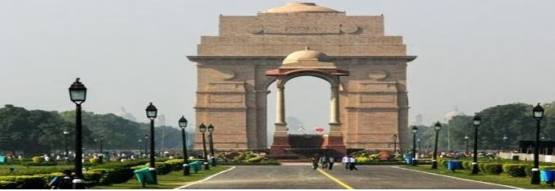  1. What is the angle of elevation if they are standing at a distance of 42m away from the monument?  2. They want to see the tower at an angle of 60°. So, they want to know the distance where they should stand and hence find the distance | 2
6 | A Satellite flying at height h is watching the top of the two tallest mountains in Uttarakhand and Karnataka, them being Nanda Devi(height 7,816m) and Mullayanagiri (height 1,930 m). The angles of depression from the satellite, to the top of Nanda Devi and Mullayanagiri are 30° and 60° respectively. If the distance between the peaks of the two mountains is 1937 km, and the satellite is vertically above the midpoint of the distance between the two mountains.  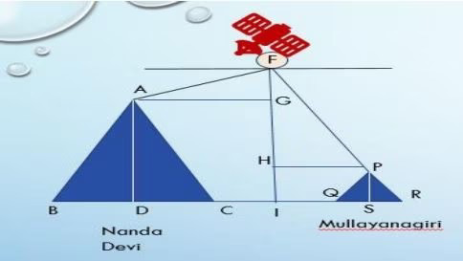  1. The distance of the satellite from the top of Nanda Devi is___  2. The distance of the satellite from the top of Mullayanagiri is___ | 2
7 | An electrician has to repair an electric fault on the pole of height of8 m. He needs to reach a point 2 m below the top of the pole to undertake the repair work.  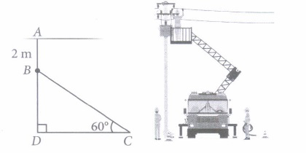  Based on the above information, answer the following questions.  (i) Length of BD is  (a) 10 m (b) 6 m (c) 4 m (d) 4 m  (ii) What should be the length of ladder, so that it makes an angle of 60° with the ground? | 2
8 | A circus artist is climbing through a 15 m long rope which is highly stretched and tied from the top of a vertical pole to the ground as shown below. Based on the above information, answer the following questions.  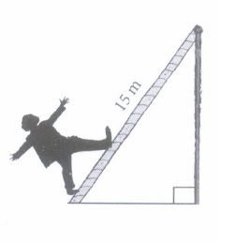  (i) Find the height of the pole, if angle made by rope to the ground level is 45°.  (ii) If the angle made by the rope to the ground level is 45°, then find the distance between artist and pole at ground level. | 2
9 | The angle of elevation of the top of a building 30 m high from the foot of another building in the same plane is 60°, and also the angle of elevation of the top of the second tower from the foot of the first tower is 30°, then find the distance between the two buildings. | 2
10 | When the shadow of a pole h metres high is √3h metres long, find the angle of elevation of the Sun. | 2
 | ANSWERS | 2
1 | 30√3 m | 2
2 | 19m | 2
3 | 60° | 2
4 | 25√3 m | 2
5 | 1.45° 2. 25.24m | 2
6 | 1. 1139.4 km 2.1937 km | 2
7 | b 2. 2√3 m | 2
8 | 1. 15/√2m 2. 15/√2m | 2
9 | 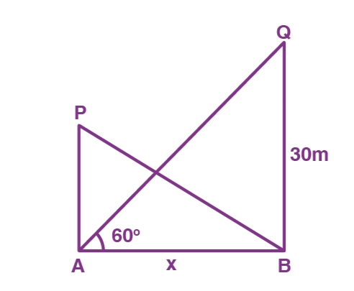  Hence,  tan 60° = 30/x  √3 = 30/x  x = 30/√3  x = 10√3m | 2
10 | Let AB be the pole and BC be its shadow.  Consider θ is the angle of elevation of the Sun.  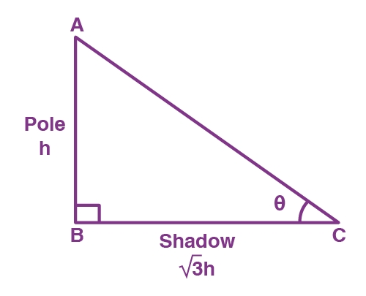  In right triangle ABC,  tan θ = AB/BC = h/√3h = 1/√3  tan θ = tan 30°  θ = 30° | 2
 | 3 – MARKS TYPE QUESTIONS
1 | The angles of elevation of the top of a rock from the top and foot of 100 m high tower are respectively 30° and 45°. Find the height of the rock . | 3
2 | The angles of depression of two ships from the top of a light house and on the same side of it are found to be 45° and 30°. If the ships are 200 m apart, find the height of the light house. | 3
3 | From the top of a 60 m high building, the angles of depression of the top and the bottom of a tower are 45°and60°respectively. Find the height of the tower. | 3
4 | The ratio of the height of an aeroplane and the horizontal distance it travelled before it touched down is √3 : 1. Find the angle at which it began descending and touched down? Also find the angle it made with the altitude while descending.  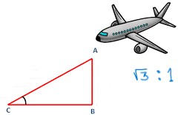 | 3
5 | In the figure given below, AB is a 6 m high electric pole and CD is a ladder inclined to it at an angle of 60° to the horizontal ground and reaches up to a point D of the pole. If AD = 2.54 m, find the length of the ladder. (Use √3 1.73).  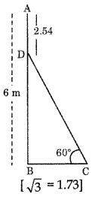 | 3
6 | A high mast flood light of height of 60 m is standing above the ground straightly tethered by two thick iron wire cables on either side, at an angle of 600 on each side to the ground.  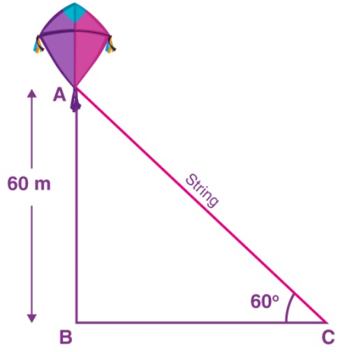  Find the cost of the cable used at the rate of Rs500√3 per metre. | 3
7 | A 1.5 m tall boy is standing at some distance from a 30 m tall building. The angle of elevation from his eyes to the top of the building increases from 30$°$ to 60$°$ as he walks towards the building. Find the distance he walked towards the building.  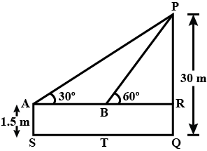 | 3
8 | A contractor plans to install two slides for the children to play in a park. For the children below the age of 5 years, she prefers to have a slide whose top is at a height of 1.5 m, and is inclined at an angle of 30$°$ to the ground, whereas for elder children, she wants to have a steep slide at a height of 3m, and inclined at an angle of 60∘ to the ground. What should be the length of the slide in each case?  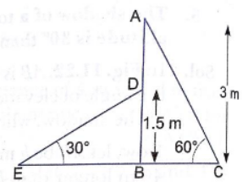 | 3
9 | A man is standing on the deck of a ship which is 10m above the water level. He observes the angle of elevation of the top of hill as 60$°$ and the angle of the base of hill as 30$°$. Find the height of the hill from the base.  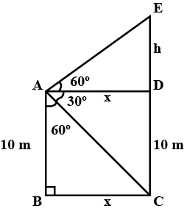 | 3
10 | The angle of elevation of a aeroplane from a point A on the ground is 60°. After a flight of 30 seconds, the angle of elevation changes to 30°. If the aeroplane is flying at a constant height of 3600$\sqrt{3}$ metres then find the speed of the aeroplane. | 3
 | ANSWERS
1 | 50(3 + √3) | 3
2 | 273 m | 3
3 | 25.4 m | 3
4 | Let AB be the height of the plane and BC be the horizontal distance it travels before touching down.  Then $\frac{AB}{BC}$ = $\sqrt{3}$ : 1 $⇒$ $\frac{AB}{BC}$ = tan60⁰ $⇒$ $∠C$= 60⁰  So $∠$A = 90⁰ $-$ 60⁰ = 30⁰  Therefore the angle at which the plane touched down is 60⁰ and the angle it made with the altitude while descending is 30⁰. | 3
5 | AB = AD + DB = 6 m (given)  ⇒ 2.54 m + DB = 6 m  ⇒ DB = 3.46 m  Now, in the right ∠d ABCD.  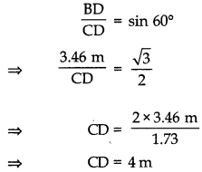  Thus, the length of the ladder CD is 4 m. | 3
6 | Let A be the flood light of height 60 m above the ground.  Thus, AB = 60 m  Also, AC is the length of the wire cable.  Angle of inclination = ∠ACB = 60  In right triangle ABC,  sin 60° = AB/AC  √3/2 = 60/AC  AC = (60 × 2)√/3  = (120 × √3)/(√3 × √3)  = (120√3)/3  = 40√3  Therefore, the length of the cable is 40√3 m.  Cost of the string is 40√3 x 500√3 = 40 x 1500 = Rs 60000 | 3
7 | 19$\sqrt{3}$ meter | 3
8 | 2$√3$ meter | 3
9 | 40 meter | 3
10 | Let the position of plane be at C, after 30 seconds, it will be at Cʹ  Let AB = x m and ABʹ = y m  In ABC, we have  tan 60° = $\frac{BC}{AB}$  $\sqrt{3}$ = $\frac{3600\sqrt{3}}{x}$  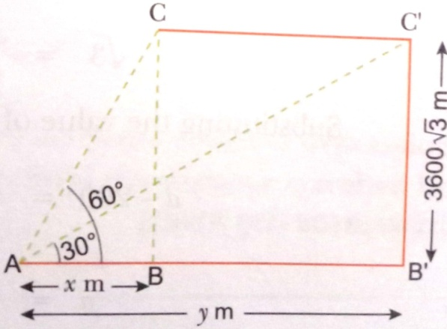  x = 3600 m  Now, In ABʹCʹ, we have  tan 30° = $\frac{BʹCʹ}{ABʹ}$  $\frac{1}{\sqrt{3}}$ = $\frac{3600\sqrt{3}}{y}$  y = 3600 X 3 = 10800 m  Distance covered in 30 seconds = y – x = (10800 – 3600) m = 7200 m  Speed of the plane = $\frac{7200}{30}$ = 240 m/sec. = 240 X $\frac{18}{5}$ km/h = 864 km/h | 3
 | 4 – MARKS TYPE QUESTIONS (CASE BASED QUESTIONS)
1 | 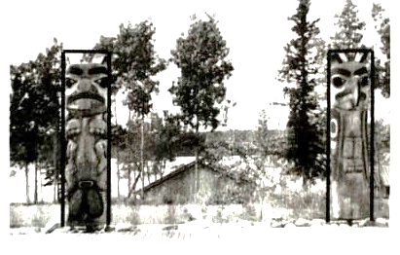  In the given picture, two such poles of equal heights are standing 80m apart. From a point somewhere between them in the same line, the angles of elevation of the top of the two poles are 60⁰ and 30⁰ respectively.  Based on the above, answer the following questions:  (i) Draw a neat labelled diagram.  (ii) Find the height of the pole.  (iii) Find the location of the point of observation. | 4
2 | A group of students of class X visited India Gate on an education trip. The teacher and students had interest in history as well. The teacher narrated that India Gate, official name Delhi Memorial, originally called All-India War Memorial, monumental sandstone arch in New Delhi, dedicated to the troops of British India who died in wars fought between 1914 and 1919. The teacher also said that India Gate, which is located at the eastern end of the Rajpath, is about 42 metres in height.  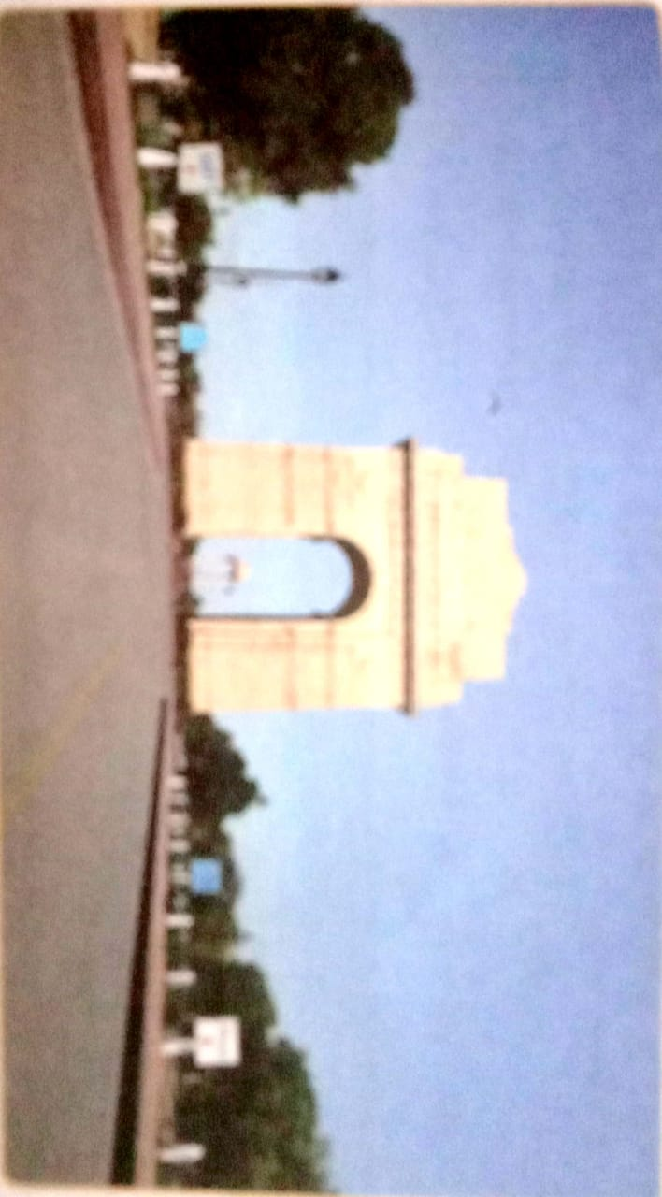  - What is the angle of elevation if they are standing at a distance of 42 m away from the monument?  - They want to see the tower at an angle of 60°. So they want to know the distance where they should stand and hence the distance is  - If the altitude of Sun is at 60° then the height of the vertical tower that will cast a shadow of length 20 m, is  - The ratio of length of a rod and its shadow is 1:1. The angle of elevation of the Sun is | 4
3 | A guard, stationed at the top of a 300 m tower, observed an unidentified boat coming towards it. A clinometer or inclinometer is an instrument used for measuring angles or slopes. The guard used the clinometer to measure the angle of depression of the boat coming towards the lighthouse and found it to be 30°.  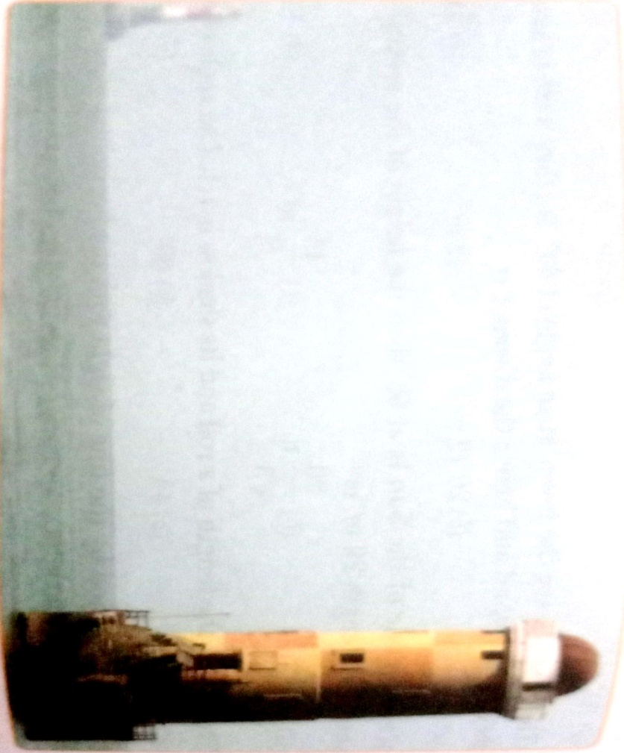  - Make a labelled figure on the basis of the given information and calculate the distance of the boat from the foot of the observation tower.  After 10 minutes, the guard observed that the boat was approaching the tower and its distance from tower is reduced by 300 ( $\sqrt{3}$ - 1 ) m. He immediately raised the alarm. What was the new angle of depression of the boat from the top of the observation tower? | 4
4 | Two hoardings are put on two poles of equal heights standing on either side of the road. From a point between them on the road the angle of elevation of the top of poles are 60° and 30°recpectively. Height of the each pole is 20m  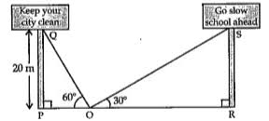  (i) Find the length of PO  (ii) Find the length of RO  (iii) The width of the road is  (iv) If the angle of elevation made by pole PQ is 45°, then the length of PO | 4
5 | A boy 4m tall spots a pigeon sitting on the top of a pole of height 54m from the ground. The angle of elevation of the pigeon from the eyes of boy at any instant is 60°. The pigeon flies away horizontally in such a way that it remained at a constant height from the ground. After 8 seconds, the angle of elevation of the pigeon from the same point is 45° (take √3=1.73)  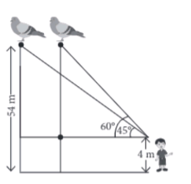  (i) Find the distance of first position of the pigeon from the eyes of the boy.  (ii) Find the distance between the boy and the pole.  (iii) How much distance the pigeon covers in 8 seconds?  (iv) If the distance between the position of pigeon increases then the angle of elevation  a) Increases b) decreases  c) remains unchanged d) can’t say | 4
6 | A group of students of class X visited India Gate on an education trip. The teacher and students had interest in history as well. The teacher narrated that India Gate, official name Delhi Memorial, originally called All-India War Memorial, monumental sandstone arch in New Delhi, dedicated to the troops of British India who died in wars fought between 1914 and 1919. The teacher also said that India Gate, which is located at the eastern end of the Rajpath (formerly called the Kingsway), is about 138 feet (42 metres) in height.  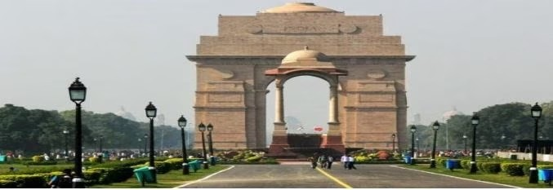  (i)What is the angle of elevation if they are standing at a distance of 42m away from the monument?  a) 30° b) 45° c) 60° d) 0°  (ii)They want to see the tower at an angle of 60o. So, they want to know the distance where they should stand and hence find the distance.  a) 25.24 m b) 20.12 m c) 42 m d) 24.64 m  (iii)If the altitude of the Sun is at 60o, then the height of the vertical tower that will cast a shadow of length 20 m is  a) 20√3 m b) 20/ √3 m c)15/ √3 m d)15√3 m  (iv) The ratio of the length of a rod and its shadow is 1:1. The angle of elevation of the Sun is  a) 30° b)45° c)60° d)90° | 4
7 | A Satellite flying at height h is watching the top of the two tallest mountains in Uttarakhand and Karnataka, them being Nanda Devi(height 7,816m) and Mullayanagiri (height 1,930 m). The angles of depression from the satellite, to the top of Nanda Devi and Mullayanagiri are 30° and 60° respectively. If the distance between the peaks of the two mountains is 1937 km, and the satellite is vertically above the midpoint of the distance between the two mountains.  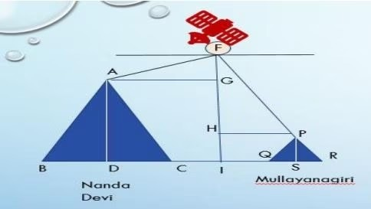  (i)The distance of the satellite from the top of Nanda Devi is  a) 1139.4 km b) 577.52 km c) 1937 km d) 1025.36 km  (ii)The distance of the satellite from the top of Mullayanagiri is  a) 1139.4 km b) 577.52 km c) 1937 km d)1025.36 km  (iii) The distance of the satellite from the ground is  a) 1139.4 km b) 577.52 km c)1937 km d) 1025.36 km  (iv) What is the angle of elevation if a man is standing at a distance of 7816m from Nanda Devi?  a) 30° b) 45° c) 60° d) 0° | 4
 | ANSWERS
1 | 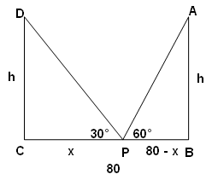  Let AB and CD be the two poles of equal height and their heights be h m. BC be the 80 m wide road. P be any point on the road.  Let CP be x m, therefore BP = (80 – x) .  Also, ∠APB = 60° and ∠DPC = 30°  In right angled triangle DCP,  tan30°=CD/CP ⇒h/x=1/√3  ⇒h =x/√3−−−−−−−−−−(1)  In right angled triangle ABP,  tan60°=AB/AP⇒h/(80–x)=√3  ⇒h=√3(80–x)--------------------- (2)  From equation (1) and (2)  ⇒x/√3=√3(80–x)⇒x=3(80–x)⇒x=240–3x⇒x+3x=240⇒4x=240⇒x=60  Height of the pole, h=x/√3=60/√3=20√3.  Thus, position of the point P is 60 m from C and height of each pole is 20√3 m. | 4
2 | - Let ѳ be the angle of elevation.  tan ѳ = $\frac{42}{42}$ = 1 = tan 45°  ѳ = 45°  Angle of elevation is 45°.  - Let x m be the required distance.  Tan 60° = $\frac{42}{x}$  $\sqrt{3}$ = $\frac{42}{x}$  x = $\frac{42}{\sqrt{3}}$ x $\frac{\sqrt{3}}{\sqrt{3}}$ = $\frac{42\sqrt{3}}{3}$ = 14$\sqrt{3}$ = 14 x 1.732 = 24.24 m  - Let h m be the height of the vertical tower.  tan 60° = $\frac{h}{20}$  $\sqrt{3}$ = $\frac{h}{20}$  $h=20\sqrt{3 }$ m  $\left(iv\right)$ Let ѳ be the angle of elevation.  $\tan{ѳ= \frac{1}{1}}$ = 1 = tan 45°  ѳ = 45° | 4
3 | - In ABC, tan 30° = $\frac{300}{x}$  x = 300$\sqrt{3}$ m.  - Distance of boat from tower = 300 $\sqrt{3}$ –300 ( $\sqrt{3}$ - 1 ) = 300 m  Let the angle of depression = ѳ  tan ѳ = $\frac{300}{300}$ = 1  ѳ = 45° | 4
4 | (i) In △OPQ  tan60°=$\frac{PQ}{OP}$  √3 =$\frac{20}{OP}$  OP=$\frac{20}{\sqrt{3}}m$  (ii) i) In △ORS  tan30°=$\frac{RS}{OR}$  $\frac{1}{√3}$=$\frac{20}{OR}$  OR=$20√3m$  (iii) Width of the road =PR  PO+OR=$\frac{20}{\sqrt{3}}+20\sqrt{3}=\frac{80\sqrt{3}}{3}m$  (iv) In △OPQ if ∠POQ=45°  tan45°=$\frac{PQ}{OP}$  1=$\frac{20}{OP}$  OP= 20m | 4
5 | 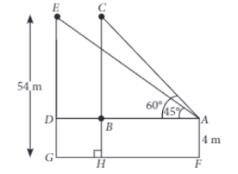  (i) Distance of first position of the pigeon from the eyes of boy = AC  In △ABC  sin60°=$\frac{BC}{AC}$  $\frac{√3}{2}$ =$\frac{CH-BH}{AC}$  $\frac{√3}{2}$ =$\frac{54-4}{AC}$  AC =$\frac{100}{√3}m$  (ii) distance between boy and pole=AB  Cos60° =$\frac{AB}{AC}$  $\frac{1}{2}$ =$\frac{AB√3}{100}$m  AB =$\frac{50}{√3}m$  (iii) 4.3m  (iv) b If the distance increases, then the angle of elevation decreases. | 4
6 | (i)(b) 45°  (ii)(a)25.24 m  (iii) (a)20√3 m  (iv) (b)45° | 4
7 | (i)(a)1139.4 km  (ii)(c)1937 km  (iii) (b) 577.52 km  (iv) (b) 45° | 4
 | 5 – MARKS TYPE QUESTIONS
1 | The angle of elevation of an aeroplane from a point A on the ground is 60°. After a flight of 15 seconds, the angle of elevation changes to 30°. If the aeroplane is flying at a constant height of 1500√3m.find the speed of the plane in km/hr. | 5
2 | A man standing on the deck of a ship, which is 10 m above water level, observes the angle of elevation of the top of a hill as 60° and the angle of depression of the base of hill as 30°. Find the distance of the hill from the ship and the height of the hill. | 5
3 | 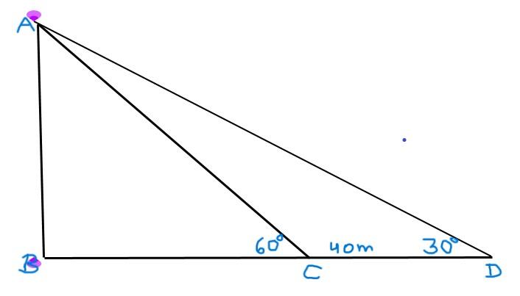  The shadow of a vertical wall on level ground is found to be 40 m longer when  the Sun’s altitude is 30° than when it is  60°. Find the height of the wall. | 5
4 | From the top of a 7 m high watch tower, the angle of elevation of the top of a mobile network tower is 60° and the angle of depression of its foot is 45°. Determine the height of the mobile network tower.  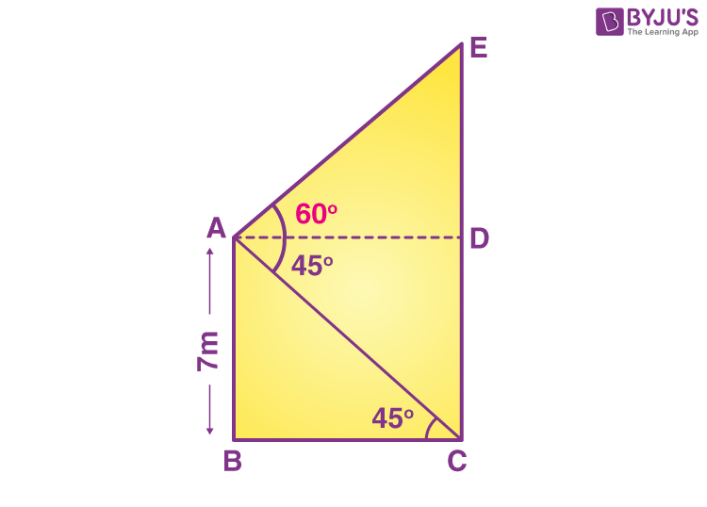 | 5
5 | A vertical tower stands on a horizontal plane and is surmounted by a flagsataff of height 5 m. From a point on a ground, the angles of elevation of the top and bottom of the flagstaff are 60$°$ and 30$°$ respectively. Find the height of the tower and the distance of the point from the tower.  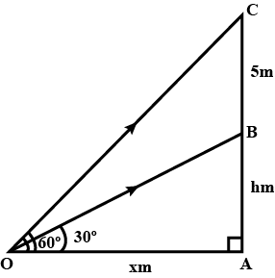 | 5
 | ANSWERS
1 | 720km/h | 5
2 | 40 m | 5
3 | Let AB be the wall and BC be the length of its shadow when the sun’s altitude (angle of elevation from the top of the wall to the tip of the shadow) is 60° and DB be the length of the shadow when the angle of elevation is 30°.  Let us assume, AB = h m, BC = x m  DB = (40 +x) m  In the right triangle ABC,  tan 60° = AB/BC  √3 = h/x  h = √3 x……….(i)  In the right triangle ABD,  tan 30° = AB/BD  1/√3 =h/(x + 40) ……..(ii)  From (i) and (ii),  x(√3 )(√3 ) = x + 40  3x = x + 40  2x = 40  x = 20  Substituting x = 20 in (i),  h = 20√3  Hence, the height of the wall is 20√3 m. | 5
4 | Let AB be the height of the watch tower and CE be the height of the mobile network tower.  Also, let A be the point from where the angle of elevation of the mobile network tower is 60° and the angle of depression of its foot is 45°.  EC = DE + CD  From the figure,  CD = AB = 7 m  BC = AD  In right ΔABC,  tan 45° = AB/BC  1 = 7/BC  BC = 7 {since BC = AD}  Thus, AD = 7 m  In right triangle ADE,  tan 60° = DE/AD  √3 = DE/7  ⇒ DE = 7√3 m  EC = DE + CD = (7√3 + 7) = 7(√3 + 1)  Therefore, the height of the mobile network tower is 7(√3 + 1) m. | 5
5 | 4.33 meter | 5

CHAPTER – 10
CIRCLES

SYLLABUS:
Tangent to a circle at, point of contact
1. (Prove) The tangent at any point of a circle is perpendicular to the radius through the point of contact.
2. (Prove) The lengths of tangents drawn from an external point to a circle are equal.

SL NO | QUESTION | MARK
 | MULTIPLE - CHOICE QUESTIONS
1 | 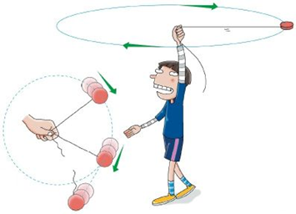  A boy is whirling a stone tied with a string in a circular path, the centripetal force acts towards the center of the circular path. However, when the string breaks the centripetal force ceases and there is no force acting. Thus, the stone as per Newtons first law will continue in a straight line and fly off along the tangent to the circular path.  What will be the angle between the radius of the circular path and tangential path followed when the thread breaks.  (a) 45° (b) 90° (c) 60° (d) 180° | 1
2 | How many parallel tangents can a circle have?  (a) 1 (b) 2 (c) infinite (d) 0 | 1
3 | From a point P which is at 13 cm from the centre O of a circle of radius 5 cm, the pair of tangents PQ and PR to the circle are drawn. Then the area of the quadrilateral PQOR is  (A) 60 cm² (B) 65 cm² (C) 30 cm² (D) 32.5 cm² | 1
4 | If two tangents inclined at an angle 60° are drawn to a circle of radius 3 cm, then length of each tangent is equal to  (A) $\frac{3√3}{2}$ cm (B) 6 cm (C) 3 cm (D) 3$√3$ cm | 1
5 | 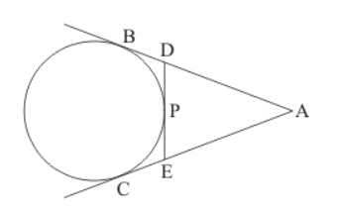  In the given figure, if AB = 8 cm and PE = 3 cm, then AE =  (A) 11 cm (B) 7 cm (C) 5 cm (D) 3 cm | 1
6 | Rahul found the design of a logo on internet. He found the measurements of sides to be AB = 12 cm, BC = 8 cm and AC = 10 cm but could not measure AD. Based on the information provided calculate AD for him.  (a) 5 cm  (b) 4 cm  (c) 6 cm  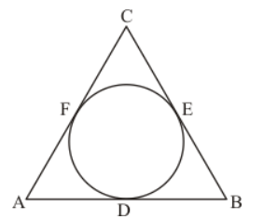  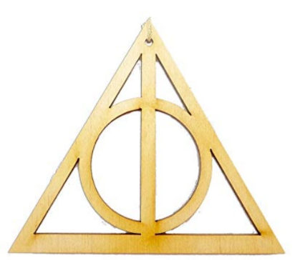  (d) 7 cm | 1
7 | 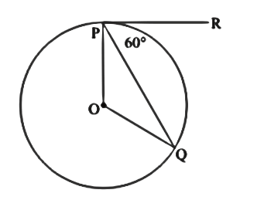  In the given figure, if PR is tangent to the circle at P and Q is the centre of the circle, then ∠POQ =  (a) 110°  (b) 100°  (c) 120°  (d) 90° | 1
8 | 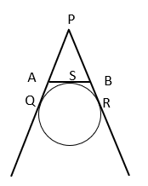  In the figure given below PQ, PR and AB are tangents at points Q, R and S of a circle. If PQ= 8 cm, find the perimeter of the triangle.  (a) 5 cm  (b) 4 cm  (c) 6 cm  (d) 16 cm | 1
9 | A tangent is drawn from a point at 17 cm of circle C (0, r) of radius 8 cm. The length of its tangent is  (a) 5 cm  (b) 9 cm  (c) 15 cm  (d) 23 cm | 1
10 | At one end A of a diameter AB of a circle of radius 5 cm, tangent XAY is drawn to the circle. The length of the chord CD parallel to XY and at a distance 8 cm from A is  (A) 4 cm (B) 5 cm (C) 6 cm (D) 8 cm | 1
11 | A tangent PQ at a point P of a circle of radius 5cm meets a line through the centre O at a point Q so that OQ=12cm. Length of PQ is :  - 12cm  - 13cm  - 8.5cm  - $\sqrt{119}$cm | 1
12 | PA is a tangent to a Circle from a point P with centre O. Find the radius OA if PA =4cm and OP=5cm  - 2cm  - 3cm  - 1.5cm  - None | 1
13 | If the length of tangent from a point A at a distance of 26cm from the centre of the circle is 10cm, then the radius of the circle is:  - 22cm  - 24cm  - 21cm  - 23cm | 1
14 | A tangent PT from an outside point P is drawn to a circle with centre O. If PT=4cm and P lies 5cm away from the centre, the radius of the circle is :  - 3cm  - 4.5cm  - 4cm  - $\sqrt{5^{2}+4^{2}}$ | 1
15 | In the below figure, PA and PB are tangent to a Circle with centre O. If ∠AOB=120°, the ∠OPA is equal to  - 60°  - 15°  - 30°  - 40° | 1
16 | The distance between two parallel tangents of a circle of radius 4 cm is  (a) 2 cm  (b) 4 cm  (c) 6 cm  (d) 8 cm | 1
17 | The length of tangents drawn from an external point to the circle  (a) are equal  (b) are not equal  (c) sometimes are equal  (d) are not defined | 1
18 | In the given figure, if ZRPS = 25°, the value of ZROS is  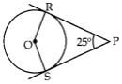  a)135°  b)145°  c)165°  d)155° | 1
19 | Tangent is drawn from a point at a distance of 17 cm of circle C(0, r) of radius 8 cm. The length of its tangent is  (a) 5 cm  (b) 9 cm  c) 15 cm  (d) 23 cm | 1
20 | In the given figure, two equal circles touch each other at T. If QP = 4.5 cm, then QR is _____ cm.  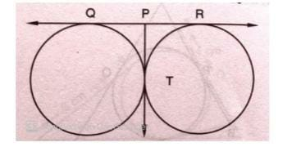  9 (b) 18 (c) 15 (d) 13.5 | 1
21 | In the given figure, APB is a tangent to a circle with centre O at point P. If angle QPB = 50⁰, then the measure of the angle POQ is ______.  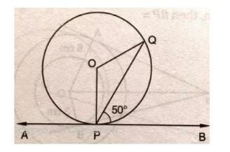  120⁰ (b) 100⁰ (c) 140⁰ (d) 150⁰ | 1
22 | If two tangents inclined at an angle of 60⁰ are drawn to a circle of radius 3 cm, then the length of the tangent is _____ cm.  √3 (b) 6 (c) 3 (d) 3√3 | 1
23 | In the given figure, PA and PB are tangents to the circle with centre O such that angle APB is 50⁰, then the measure of the angle OAB is ______.  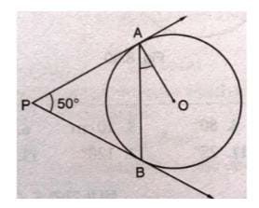  50⁰ (b) 25⁰ (c) 90⁰ (d) 40⁰ | 1
24 | If four sides of a quadrilateral ABCD are tangential to a circle, then ___________.  - AB + CD = BC + AD  - AC + AD = BD + CD  - AB + CD = AC + BC  AC + AD = BC + BD | 1
25 | Two circles of radii 5 cm and 3 cm touch each other internally. The distance between their centres is ______.  5 cm (b) 3 cm (c) 2 cm (d) 8 cm | 1
 | ANSWERS | 1
1 | (b) 90° | 1
2 | (c) infinite | 1
3 | (A) 60 cm² | 1
4 | (D) 3$√3$ cm | 1
5 | (C) 5 cm | 1
6 | (d) 7 cm | 1
7 | (c) 120° | 1
8 | (d) 16 cm | 1
9 | (c) 15 cm | 1
10 | (D) 8 cm | 1
11 | OQ²=OP²+PQ²  (12)²=(5)² + PQ²  PQ= $\sqrt{119}$ cm | 1
12 | (b) 3cm | 1
13 | (b) 24cm | 1
14 | (a)3cm | 1
15 | (c) 30° | 1
16 | (d) 8cm | 1
17 | a)Equal | 1
18 | d) 155°, | 1
19 | c) 15 | 1
20 | 9 | 1
21 | 100⁰ | 1
22 | 3√3 | 1
23 | 25⁰ | 1
24 | AB + CD = BC + AD | 1
25 | 2 cm | 1
 | 2 MARKS TYPE QUESTIONS
1 | In the given figure, the sides AB, BC and CA of a triangle ABC touch a circle at P, Q and R respectively. If PA = 4 cm, BP = 3 cm and AC = 11 cm, find the length of BC (in cm).  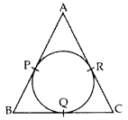 | 2
2 | Find the perimeter (in cm) of a square circumscribing a circle of radius ‘a’ cm. | 2
3 | Prove that the tangents drawn at the ends of a diameter of a circle are parallel. | 2
4 | In the figure, AB is the diameter of a circle with centre O and AT is a tangent. If ∠AOQ = 58°, find ∠ATQ.  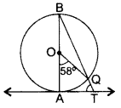 | 2
5 | In the figure, the chord AB of the larger of the two concentric circles, with centre O, touches the smaller circle at C. Prove that AC = CB.  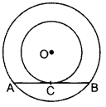 | 2
6 | In figure, from an external point P, two tangents PT and PS are drawn to a circle with centre O and radius r. if OP=2r, show that ∠OTS=∠OST=30°  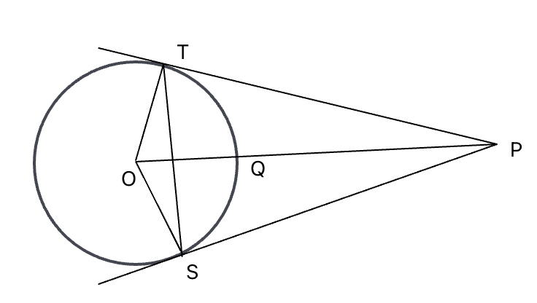 | 2
7 | The angle between two tangents drawn from a point P to a circle of radius ‘a’ and centre O is 90°. Find OP. | 2
8 | In the figure, AB is the diameter of a circle with centre O and AT is a tangent. If ∠AOQ = 58°, find ∠ATQ. | 2
9 | In the given figure , ABCD is a quadrilateral in which ∠ADC=90°, BC=38cm, CD=28cm and BP=25cm. Find the radius of the circle with centre O.  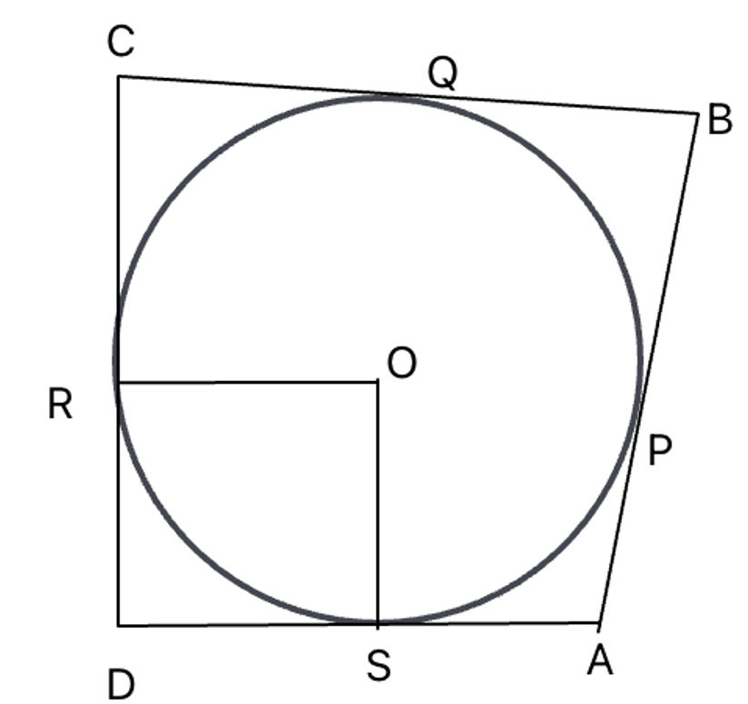 | 2
10 | In figure, common tangents AB and CD to the two circles with centre O1 and O2 intersect at E. Prove that AB=CD.  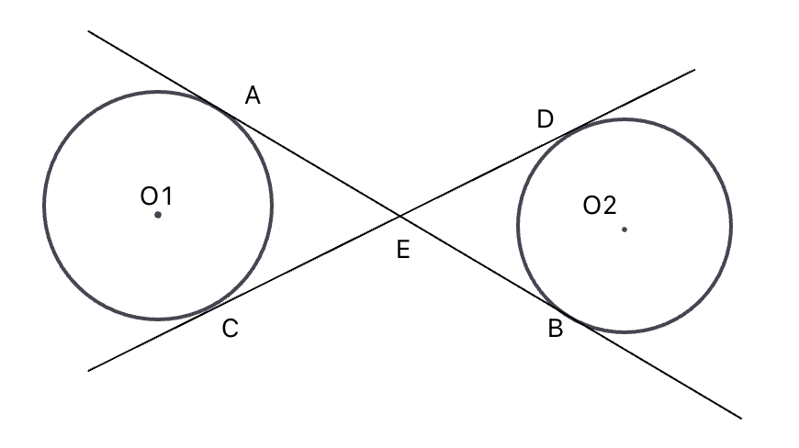 | 2
 | ANSWERS | 2
1 | BC = BQ + QC = 3 + 7 = 10 cm | 2
2 | 8a | 2
3 | The tangents will be parallel. | 2
4 | ∠ATQ = 610 | 2
5 | ∴ AC = CB … [⊥ from the centre bisects the chord (Join OC) | 2
6 | ∠APB=90°  ∠OAP=90°  ∠OBP=90°  ∠AOB=360°-90°-90°-90°=90°  OBPA ia square  OA=OB=PA=PB=a  in right angle traingle OAP  =OP=OP+PA  OP=$\sqrt{2}$a | 2
7 | ∠ATQ = 610 | 2
8 | BQ=BP  CQ=25cm  RD=15cm  ∠SDR=∠OSD=∠ORD=∠ROS=900  OR=OS=SD=RD  OR=15cm | 2
9 | EA=EC  EB=ED  EA+EB=EC+ED  AB=CD | 2
10 | ACB = 90° …[Angle in the semi-circle  In ∆ABC,  ∠CAB + ∠ACB + ∠CBA = 180°  30 + 90° + ∠CBA = 180°  ∠CBA = 180° – 30° – 90° = 60°  ∠PCA = ∠CBA …[Angle in the alternate segment  ∴ ∠PCA = 60° | 2
 | 3 – MARKS TYPE QUESTIONS
1 | In the given figure, a circle touches all the four sides of a quadrilateral ABCD whose sides are AB = 6 cm, BC = 9 cm and CD = 8 cm. Find the length of side AD.  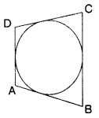 | 3
2 | Prove that the parallelogram circumscribing a circle is a rhombus.  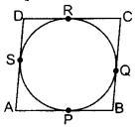 | 3
3 | In the given figure, PA and PB are tangents to the circle from an external point P. CD is another tangent touching the circle at Question If PA = 12 cm, QC = QD = 3 cm, then find PC + PD.  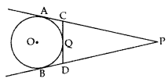 | 3
4 | A circles touches the side QR of a △PQR at ‘M’ and side PQ and PR on producing at ‘S’ and ‘T’ respectively . If PS=8cm. Find the perimeter of △PQR.  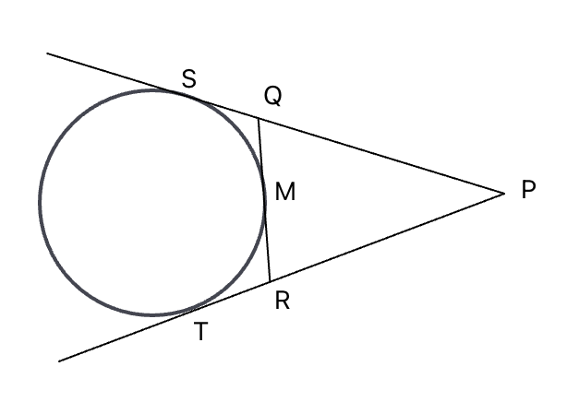 | 3
5 | In the figure, PQRS is a quadrilateral such that ∠S=90°. A circle with centre O and radius r touches the sides PQ, QR, RS and SP at A,B,C and D respectively . If QR=38cm, SR=28 cm and AQ=27cm, Find r.  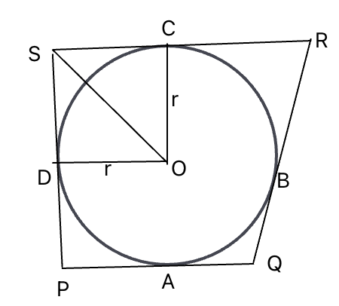 | 3
6 | If a circle touches the side BC of a tringle ABC at P and extended sides AB and AC at Q and R respectively. Prove that AQ= $\frac{1}{2}$(BC+CA+AB) | 3
7 | Prove that the tangent at any point of a circle is perpendicular to the radius through the point of contact | 3
8 | Prove that the lengths of tangents drawn from an external point to a circle are equal. | 3
9 | TP And TQ are tangents from T to the circle with Centre O and R is any point on circle. If AB is the tangent to circle at R then prove that TA+AR=TB+BR | 3
10 | If a hexagon circumscribes a circle, show that sum of three alternate sides of the hexagon is equal to the other three alternate sides. | 3
 | ANSWERS
1 | AD = 5 cm | 3
2 | ॥gm ABCD is a rhombus | 3
3 | PC + PD = 18 cm | 3
4 | PQ+QS=8  PQ+QM=8  PS=8cm  PT=8  PR+RT=8  PR+RM=8  Perimeter of triangle PQR=16cm | 3
5 | QB+BR=38cm  BR=11cm  RC=11cm  SC+CR=28cm  SC=17  ∠COD=90°  OC=OD=r  rectangle OCSD is a square  OC=CS=17cm | 3
6 | 2AQ=(AB+BP)+(AC+CP)  =BC+CA+AB  AQ=$\frac{1}{2}$ (BC+CA+CP) | 3
7 | 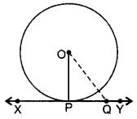  XY is a tangent at point P to the circle with centre O.  To prove: OP ⊥ XY  Const.: Take a point Q on XY other than P and join to OQ  Proof: If point Q lies inside the circle, then XY will become a secant and not a tangent to the circle.  ∴ OQ > OP  This happens with every point on the line XY except the point P.  OP is the shortest of all the distances of the point O to the points of XY  ∴ OP ⊥ XY … [Shortest side is ⊥ | 3
8 | 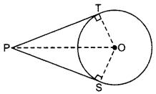  prove: PT = PS  Const.: Join O to P,  T & S  Proof: In ∆OTP and  ∆OSP,  OT = OS …[radii of same circle  OP = OP …[circle  ∠OTP – ∠OSP …[Each 90°  ∴ AOTP = AOSP …[R.H.S  PT = PS …[c.p.c.t | 3
9 | Using the above, do the following:  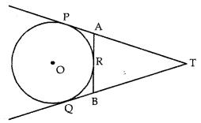  In figure TP and TQ are tangents from T to the circle with centre O and R is any point on the circle. If AB is tangent to the circle at R, prove that TA + AR = TB + BR.  Answer:  Refer Theorem II in Synopsis for first part.  Next,  TP = TQ [∵ Theorem II]  ⇒ TA + AP = TB + BQ ………. (i)  But AP = AR ………………. (ii) [AP, AR are tangents drawn from external point A]  Similarly, BQ = BR ……………. (iii)  Putting for AP and BQ in (i) from (ii) and (iii) we get  TA + AR = TB + BR (Proved) | 3
10 | 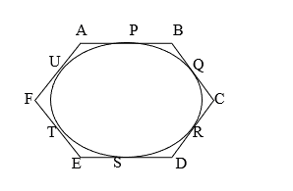  Tangents drawn from an external point to a circle are equal in length  AP = AU ……………1  BP = BQ………………2  CR = CQ………………3  DR = DS………………4  ET = ES……………….5  FT = FU ………………6  Adding equations 1 to 6  AP + BP + CR+ DR+ ET + FT = AU + BQ + CQ + DS + ES + FU  AB + CD + EF = BC + DE+ AF | 3
 | 4 – MARKS TYPE QUESTIONS (CASE BASED QUESTIONS)
1 | When a person is riding a bicycle, he applies some force on the pedals due to which the chain over the pulley attached to the pedals starts to rotate. Ultimately the wheel rotates and the bicycle covers a certain path. As the wheels rotate on their axis, they perform a rotational motion. Due to this rotation with the contact of the ground the bicycle covers a certain longitudinal distance. So, the wheels also perform a translational motion concerning the ground. The bicycle is dragged by a path due to the rotational motion performed by the wheels of the bicycle.  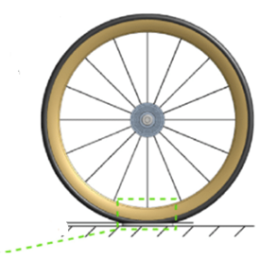  In a moving bicycle all the spokes of a wheel are along its radii.  - What is the angle between spokes of the wheel and its movement on the ground at the point of contact.  - 45°  - 90°  - 60°  - 180°  - The shortest distance between the axel of the wheel and the point of contact will be equal to  - the diameter of the circle  - length of tangent to the circle  - the radius of the circle  - can be any length.  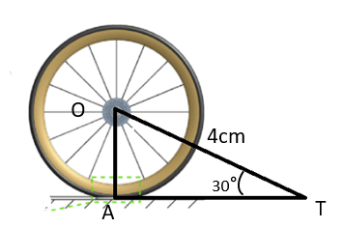  - Consider a point on ground in Fig. AT is a tangent to the circle with centre O such that OT = 4 cm and ∠OTA = 30°. Then AT is equal to  - 4 cm  - 2cm  - 2$√$3cm  - 4$√$3cm | 4
2 | People of the village want to construct a road nearest to the circular village Parli. The road cannot pass through the village. But the people want the road to be at the shortest distance from the centre of the village. Suppose the road starts from point O which is outside the circular village and touches the boundary of the circular village at point A such that OA = 20 m. And also, the straight distance of the point O from the center C of the village is 25 m.  1. Find the shortest distance of the road from the centre of the village  a) 15m  b) 14m  c) 13m  d) 12m  2. Which method should be applied to find the shortest distance?  a) Concept of tangent to a circle  b) Pythagoras theorem  c)Both a and b  d) None of these  3. If a point is inside the circle, how many tangents can be drawn from that point  a) 0  b) 1  c) 2  d)  4.If we draw two tangents at the end of the diameter, these tangents are always  a) Parallel  b) perpendicular  c) coincident  d) None of these | 4
3 | A Ferris wheel is an amusement ride consisting of a rotating upright wheel with multiple passenger-carrying components attached to the rim in such a way that as the wheel turns, they are kept upright, usually by gravity.  After taking a ride in Ferris wheel Sohum came out from the crowd and was observing his friends who were enjoying the ride. He was curious about different angles and measures that the wheel will form. He forms a figure as given below.  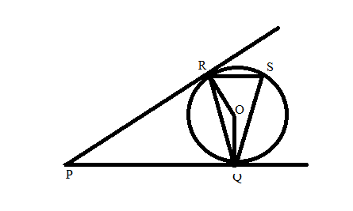  a) If ∠QPR = 45ᵒ, find ∠ROQ.  b) Find ∠RQO.  c) Find ∠RQP. | 4
4 | There is a circular fountain in a park and four poles A,B, C and D are standing around the fountain such that fencing joining the poles touches the fountain at P, Q, R and S respectively as shown in figure below:  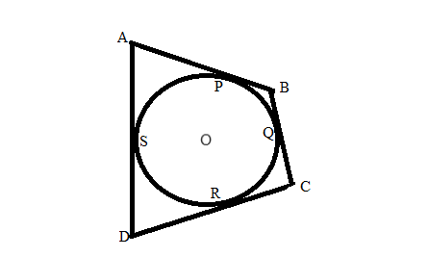  a) If O is the centre of the circle, find ∠OSD.  b) Show that AB + DC = AD + BC  c) If AP = 5cm and AD = 13 cm, find DR. | 4
5 | People of the village want to construct a road nearest to the circular village Parli. The road cannot pass through the village. But the people want the road to be at the shortest distance from the centre of the village. Suppose the road starts from point O which is outside the circular village and touches the boundary of the circular village at point A such that OA = 20 m. And also, the straight distance of the point O from the center C of the village is 25 m  1. Find the shortest distance of the road from the centre of the village  a) 15m b) 14m c) 13m d) 12m  2. Which method should be applied to find the shortest distance?  a) Concept of tangent to a circle b) Pythagoras formula  c)Both a and b d) None of these  3. If a point is inside the circle, how many tangents can be drawn from that point  a) 0 b) 1 c) 2 d) 3  4. If we draw two tangents’ roads at the end of the diameter, these tangents roads are always  a) Parallel b) perpendicular c) coincident d) None of these | 4
 | ANSWERS
1 | - (b)90°  - length of tangent to the circle  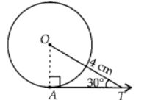  - (c)Join OA.  We know that, the tangent at any point of a circle is perpendicular to the radius through the point of contact.  In right angles $ΔOAT$  $\frac{AT}{OT}$ = cos 30°  $\frac{√3}{2}$ = $\frac{AT}{4}$  AT= $\frac{\sqrt{3}×4}{2}$  AT = 2$√3$ | 4
2 | - A)15 m  - B) Pythagoras theorem  - A) 0  - A) parallel | 4
3 | a) ROQ = 180ᵒ - 45ᵒ  = 135ᵒ  b) OR = OQ (Radius)  ∠ORQ = ∠OQR = x  x + x + 135ᵒ = 180ᵒ  2x = 180ᵒ - 135ᵒ  x = 45ᵒ/2 = 22.5ᵒ  c) ∠RQP = ∠OQP - ∠OQR  = 90ᵒ - 22.5ᵒ = 67.5ᵒ | 4
4 | a) ∠OSD = 90ᵒ (Tangent to a circle is perpendicular to  the radius through the point of contact)  b) Tangents drawn from an external point to a circle are equal in length  AP = AS …… 1  BP = BQ ….... 2  CR = CQ …….3  DR = DS ……. 4  Adding 1 to 4,  AB + DC = AD + BC  c) AP = AS = 5cm  Therefore, DS = 13 – 5 = 8cm  DR = DS = 8 cm | 4
5 | 1. 15 m 2. Phythagoras formula  3. 0 4. Parallel | 4
 | 5 – MARKS TYPE QUESTIONS
1 | PA and PB are tangents to a circle with centre O, diameter 10cm,OP=10cm, OA,OB and AB are joined.  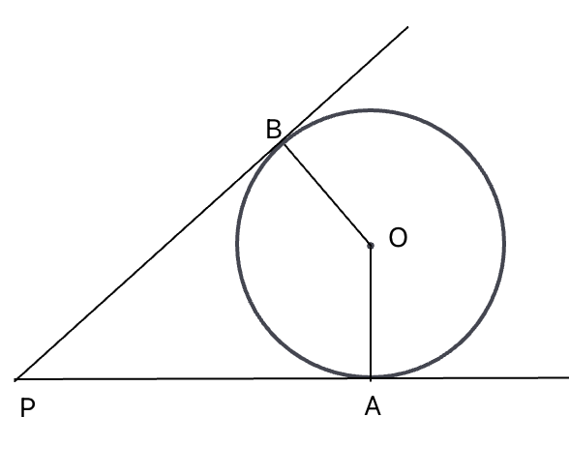  - The measure of ∠PAO=____  - 30°  - 60°  - 90°  - 120°  - The measure of ∠APB=___  - 30°  - 60°  - 90°  - 120°  - Length of PB=______cm  - 5$\sqrt{3}$  - 5  - 2.5  - 2.5$\sqrt{3}$  - The measure of ∠AOB=___  - 30°  - 60°  - 90°  - 120°  - The measure of ∠OAB=__  - 30°  - 60°  - 90°  - 120° | 5
2 | In the following figure AD and BC are common tangents to the two circle with centre O and Q.  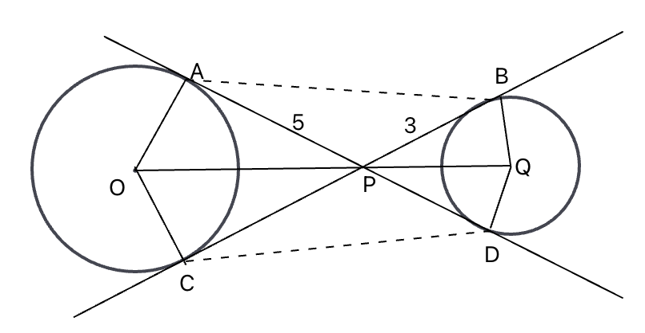  a. If PA=5cm and PB=3cm, the length of BD is  - 2cm  - 8cm  - $\sqrt{34}$cm  - 4cm  b. if ∠APC=50, then ∠AOC =  - 130°  - 30°  - 80°  - 100°  c. if ∠BQP=60, then ∠BDQ=  - 130°  - 30°  - 80°  - 100°  d.If radius QA=4cm, OP=  - 3cm  - 8cm  - $\sqrt{41}$cm  - 6cm  - If ∠AOC=100, then ∠BQD=  - 130°  - 30°  - 80°  - 100° | 5
3 | ∆ABC, AB = 8 cm, BC = 6 cm, CA = 4 cm. With the vertices of triangle as centre, three circles are described, each touching the other two externally. Find the radii of each circle | 5
4 | Prove that the line segment joining the points of contact of two parallel tangents of a circle, passes through its centre | 5
5 | Prove that tangents drawn from an external point to a circle are equal.  Using the above theorem in the figure given below, show that PR + RC = PQ + CQ  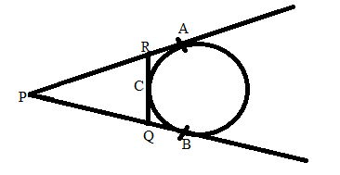 | 5
 | ANSWERS
1 | a) iii 90°  b) ii. 60°  c) i. 5$\sqrt{3}$  d). iv 120°  e). i 30° | 5
2 | a) ii 8cm  b). i 130°  c) ii. 30°  d) iii. $\sqrt{41}$cm  e). iv 100° | 5
3 | 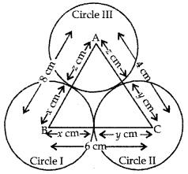  x+ y = 6 cm …(1)  y + z = 4 cm …(2)  z + x = 8 cm …(3)  Adding (1), (2), (3), we get  2 (x + y + z) = 18  x + y + z = 9 …(4)  (4) – (1) gives, z = 3  (4) – (2) gives, x = 5  (4) – (3) gives, y = 1  ∴ Radii of circles are 5 cm, 1 cm and 3 | 5
4 | CD and EF are two C parallel tangents at points A and B of a circle with centre O.  To prove: AB passes through centre O or AOB is diameter of the circle.  Const.: Join OA and OB. Draw OM || CD.  Proof: ∠1 = 90° … (i)  …[∵ Tangent is I to the radius through the point of contact  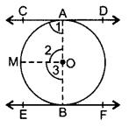  OM || CD  ∴ ∠1 + ∠2 = 180° …(Co-interior angles  90° + ∠2 = 180° …[From (i)  ∠2 = 180° – 90o = 90°  Similarly, ∠3 = 90°  ∠2 + ∠3 = 90° + 90° = 180°  ∴ AOB is a straight line.  Hence AOB is a diameter of the circle with centre O.  ∴ AB passes through centre 0. | 5
5 | 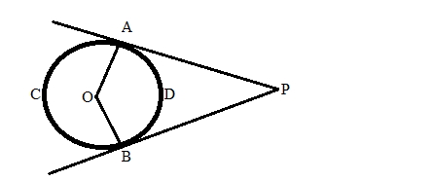  Join OP.  In △APO and △BPO  OA = OB ( radius )  OAP = OBP (each 90ᵒ)  OP = OP (common)  △APO ≅ △BPO  PA = PB (CPCT)  PR + RC = PQ + CQ  PA = PB (tangents from external point)  PR + RA = PQ + QB  PR + RC = PQ + CQ (because RA = RC and BQ = CQ) | 5

CHAPTER – 12
AREA RELATED TO CIRCLES

SYLLABUS:
Area of sectors and segments of a circle. Problems based on areas and perimeter / circumference of the above said plane figures. (In calculating area of segment of a circle, problems should be restricted to central angle of 60°, 90° and 120° only.

SL NO | QUESTION | MARK
 | MULTIPLE - CHOICE QUESTIONS
1 | If the perimeter and the area of a circle are numerically equal, then, the radius of the circle is:  - 2 units  - $π$ units  - 4 units  - 7 units | 1
2 | The radius of two circles are 19 cm and 9 cm. Then the radius of the circle which has circumference equal to the sum of the circumferences of the two circles is:  - 10 units  - 28 units  - 442 units  - None | 1
3 | The radii of two circles are 8 cm and 6 cm respectively. The radius of the circle whose area is equal to the sum of the areas of the two circles is:  - $\sqrt{28}$  - 14  - 10  - 2 | 1
4 | The area of a quadrant of a circle whose circumference is 22 cm  - 9.625 cm  - 96.25 cm  - 6.925 cm  - 2.695 cm | 1
5 | The length of the minute hand of a clock is 14cm. The area swept by the minute hand in 5 minutes:  - 541/3  - 154/3  - 451/3  - 531/4 | 1
6 | Observe the figure:  What is the area of the segment PQR, if the radius of the circle is 7cm ($∠O=90°$)? (use $π=\frac{22}{7}$)  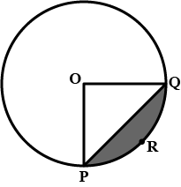  - 14 cm²  - 17.3 cm²  - 28 cm²  - 91 cm² | 1
7 | The area of a circle which can be inscribed in a square of side 6cm is:  - 36π cm²  - 18π cm²  - 12π cm²  - 9π cm² | 1
8 | An arc of a circle of radius 14 cm subtends an angle of 45$°$ at the centre as shown. Which of the following is correct?  - The arc shown in minor arc and its length is 5.5 cm  - The arc shown is a major arc and its length is 77 cm  - The arc shown is a major arc and its length is 38.5 cm  - The arc shown is a minor arc and its length is 11 cm.  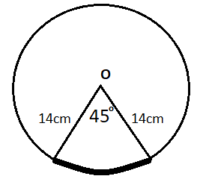 | 1
9 | The perimeter of a circle is equal to that of a square, then the ratios of their areas is:  - 22:7  - 14:11  - 7:22  - 11:14 | 1
10 | The diameter of a wheel is 1m. The number of revolutions it will make to travel a distance of 22km will be:  - 2800  - 4000  - 5500  - 7000 | 1
11 | If the perimeter of a square has the same perimeter of a circle, then the ratio of their areas are?  a) 11:14 b) 22:13 c) 14:11 d) 13:22 | 1
12 | If the areas of two circles have a ratio of 4:9, Then the ratio of the perimeter of their semicircles are?  a) 2:3 b) 3:2 c) 1:2 d) 1:2 | 1
13 | The circumference of a circle is 100cm. Then the side of a square inscribed in the circle is?  a) 50√2cm. b) $\frac{100 }{π }$cm c)$\frac{50√2 }{π }$ cm d) $\frac{100√2 }{π }$ cm | 1
14 | If the difference between the radius and the circumference of a circle is 37cm, Then the circumference of the circle is?  a) 15:4 b) 44 c) 14 d) 7 | 1
15 | Area of a sector of a circle is 1/6 to the area of the circle. The degree major of the minor arc is?  a) 90° b) 60° c) 45° d) 30° | 1
16 | There are three sectors of a circle with radius 7cm, making angle 60$°$,80$°$ and 40$°$. at the center. The area of the shaded region is?  a) 77 b)154 c)44 d)22 | 1
17 | A bicycle wheel makes 5000 revolutions in moving 11km. Find the diameter of the wheel  a) 80cm b)90cm c)75cm d)70cm | 1
18 | A wheel has diameter 84cm, Find how many complete revolutions it take to cover 729 meters  a) 300 b)500 c)400 d)350 | 1
19 | A Japanese fan can be made by sliding open its 7 small sections (or leaves) which are each in the form of sectors of a circle having central angle of 15°. If the radius of this fan is 24cm, find the area of this fan.  a)630cm2 b)572 cm2 c) 528 cm2 d)628cm2 | 1
20 | A car has wheels which are 80 cm in diameter. How many complete revolutions does each wheel make in 10 minutes when the car is travelling at a speed of 66 km per hour? | 1
21 | In a circle of diameter 42cm, if an arc subtends an angle of 60˚ at the centre  then the length of arc is  (a) 11 cm (b) 22 cm (c) 33 cm (d) 44 cm | 1
22 | The number of revolutions made by a circular wheel of radius 0.7m in rolling a  distance of 176m is  (a) 22 (b) 24 (c) 75 (d) 40 | 1
23 | If the area of a circle is 154 cm², then its circumference is  (a) 11 cm (b) 22 cm (c) 44 cm (d) 55 cm | 1
24 | It is proposed to build a single circular park equal in area to the sum of areas of  two circular parks of diameters 16 m and 12 m in a locality. The radius of the  new park would be  (a) 10 m (b) 15 m (c) 20 m (d) 24 m | 1
25 | A race track is in the form of a ring whose inner and outer circumference are 437  m and 503 m respectively. The area of the track is  (a) 66 sq. cm (b) 4935 sq. cm. (c) 9870 sq. cm (d) None | 1
 | ANSWERS | 1
1 | a | 1
2 | b | 1
3 | c | 1
4 | a | 1
5 | b | 1
6 | a | 1
7 | d | 1
8 | d | 1
9 | b | 1
10 | d | 1
11 | (a) 4a = 2πr => a = π/2r  $\frac{Ar(sq.)}{Ar(cir.)}$= $\frac{(π²/4 r²)}{π r²}$= $\frac{22}{7 x 4}$= 11/14 = 11:14 | 1
12 | (a) $\frac{πR2}{π r2 }$π r22 = 4/9 = r1/r2 = 2/3; $\frac{p1}{p2}$ = $\frac{π r1+2r1}{π r2+2r2 }$ = $\frac{r1(π + 2)}{r2(π+2) }$= 2:3 | 1
13 | (c) 2πr = 100 => r = 50/π  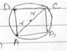  Side of square = $√$2r = 50$√$2/π cm | 1
14 | (b) If the difference between circumference and radius  2π r – r = 37  - r($\frac{22}{7}$-1) = 37 => r = 7cm  Circumference = 2πr =2x22/7 x 7 = 44cm. | 1
15 | (b) $\frac{θ}{360°}$ x πr2 = $\frac{1}{6}$ π r2 => θ = 60$°$ | 1
16 | (a) A = (40$°$/360$°$ + 60$°$/360$°$ + 80$°$/360$°$) x $\frac{22}{7}$x 72 cm2  A = ($\frac{1}{9}$+ $\frac{1}{6}$+ $\frac{2}{9}$) x 155 cm2 = 77cm2 | 1
17 | (d)Dist. Covered by wheel in 5000 rev. = 5000 x 2πr cm = 10000 π $\frac{r}{100000}$ km =  $\frac{π r}{10}$km  Given that, wheel covers 11 km in 5000rev.  $\frac{π r}{10}$ = 11 ; $\frac{11r}{35}$= 11 ; r = 35cm  Diameter = 2r = 2x35cm = 70cm. | 1
18 | (a)Let wheel completes n rev. covering 792m.  Let r be the radius of the wheel. It is given that the diameter of the wheel is 84cm  2r = 84 ; r = 42cm  Circumference of wheel = 2 πr cm = 2x$\frac{22}{7}$x42 = 264 cm = 2.64  Dist. covered by wheel in 1 revolution = 2.64m  Dist. covered by wheel in n rev = 2.64 x n metres  2.64 x n = 792 => n = $\frac{792}{2.64}$= 300 | 1
19 | (c)Area of fan = 7(area of 1 sector)  = 7 x$\frac{∅}{360}$ x πr²  =7 x $\frac{15}{360}$ x $\frac{22}{7}$x 24²  =7/24 x $\frac{22}{7}$ x 24 x 24  = 22 x 24 = 528cm² | 1
20 | Distance travelled by the car in 1hour = 66km  Distance travelled by the car in 10min =($\frac{66}{60}$ x 100 )km = 11km = 11 x 1000 x 100 cm  Radius of car wheels = 40 cm  Therefore, Circumference of the wheels = 2 x $\frac{22}{7}$ x 40 cm  But, distance covered by each wheel in completing n revolutions is equal to the distance travelled by the car in 10 minutes.  Therefore, 2 x $\frac{22}{7}$x 40 x n = 11 x 1000 x 100 = n  = $\frac{11 x 1000 x 100 x 7}{2 x 22 x 40}$= 4375 | 1
21 | (b) 22cm | 1
22 | (d) 40 | 1
23 | (c) 44cm | 1
24 | (a) 10m | 1
25 | (b)4935 sq.cm | 1
 | 2 MARKS TYPE QUESTIONS
1 | A piece of wire 22 cm in length is bent into the form of a circle subtending an angle of 60$°$ at its centre. Find the radius of the circle. | 2
2 | A race track is in the form of a ring whose inner circumference is in 352m and the outer circumference is 396m. Find the width of the track. | 2
3 | 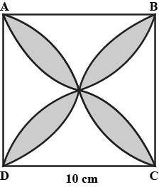  ABCD is a square of side 10cm. Semicircles are drawn with each side of the square as diameter. Find the area of the shaded region. ($π=3.14$) | 2
4 | 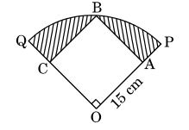  In the adjoining figure, a square OABC is inscribed in a quadrant OPBQ. If OA=15cm, find the area of the shaded region. ($π=3.14$) | 2
5 | In the figure find the area of the shaded region.  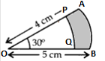 | 2
6 | Find the number of revolutions made by a circular wheel of area 1.54m² in rolling a distance of 176m. | 2
7 | A piece of wire 20cm long is bent into the form of an arc of a circle subtending an angle of 60$°$at its centre. Find the radius of the circle. | 2
8 | To warn ships for underwater rocks, a light house throws a red colored light over a sector of 80$°$ angle to a distance of 16.5km. Find the area of the sea over which the ships area warned.( use π = 3.14) | 2
9 | AB and CD are respectively arcs of two concentric circles of radii 21 cm and 7cm and centre O. If $<$AOB = 30degree, find the area of the shaded region | 2
10 | A square park has each side of 100m. At each corner of the park, there is a flower bed in the form of a quadrant of radius 14m. Find the area of the remaining part of the park. (Use π = $\frac{22}{7}$)  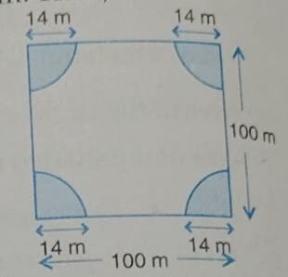 | 2
 | ANSWERS | 2
1 | Let r be the radius and $θ$ be the angle subtended at the centre.  $$Length of arc=\frac{θ}{360°}*2πr$$  $$⇒22=\frac{60°}{360°}*2πr$$  $$⇒22=\frac{1}{6}*2*\frac{22}{7}*r$$  $$⇒r=\frac{22*6*7}{22*2}$$  $$⇒r=21 cm$$ | 2
2 | Let the radius of inner track = r  $$⇒2πr=352$$  $$⇒2*\frac{22}{7}*r=352$$  $$⇒r=56m$$  let the radius of outer track = R  $$⇒2πR=396$$  $$⇒2*\frac{22}{7}*R=396$$  $$⇒R=63m$$  Width of track = radius of outer track−radius of inner track  = 63 – 56 = 7m. | 2
3 | 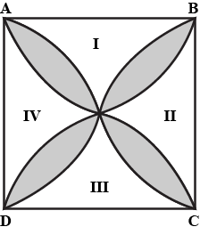  57cm² | 2
4 | Radius of quadrant = OB² = 15² + 15²  OB = 15√2 cm  Shaded area = Area of quadrant – Area of square  = 1/4 × (3.14) × (15√2)² – (15)²  = (15)² (1.57 – 1)  = 128.25 cm² | 2
5 | Area of shaded region = Area of OAB sector – Area of OPQ sector  $$=\frac{30}{360}π*5^{2}-\frac{30}{360}π*4^{2}$$  $$=\frac{30}{360}π*{(5}^{2}-4^{2})$$  $$=\frac{1}{12}*3.14*\left(5+4\right)\left(5-4\right)$$  $$=\frac{1}{12}*3.14*9=2.355cm^{2}$$ | 2
6 | Let the number of revolutions made by a circular wheel be n and the radius of circular wheel be r.  Given that, area of circular wheel =1.54m²  ⇒πr²=1.54 [∵area of circular=πr²]  ⇒r²=1.5422×7⇒r²=0.49  r=0.7m  =2πr  =2×$\frac{22}{7}$×0.7  =225=4.4m [∵circumference of a circle=2πr]  Since, distance travelled by a circular wheel = 176 m  ∴ Number of revolutions  =Total distance in one revolution=1764.4=40 | 2
7 | Length of arc of circle = 20 cm  Here, central angle $∅$=60$°$  ∴ Length of arc =$\frac{π}{360}$×2πr  ⇒20=$\frac{π}{360}°$×2πr⇒20×62π=r  r=$\frac{60}{π}$ | 2
8 | When a lighthouse spreads a red-colored light underwater, it forms a sector of angle 80$°$and radius =16.5km  ∴ Area of sector =$\frac{∅}{360}$​ × πr2  ∴ Area of sector =$\frac{80}{360}$​ × 3.14 × 16.5 × 16.5  =189.97km² | 2
9 | Shaded area = Area of sector OAB – Area of sector OCD  Shaded region = ($​ \frac{30}{360}$×722​×21×21−36030​×722​×7×7)cm²  Shaded region = ($\frac{30}{360}$×722​×21×21−36030​×722​×7×7)cm²  Shaded area = $\frac{11}{42}$x (21+7) x(21-7)cm²  Shaded region = 4211 x 28 x 14cm2 = 102.67cm² | 2
10 | Area of remaining park = area of park −4×area of 1 quadrant  =(100)2−4×41×πr²  =10000− 722×14×14  =10000−616  =9384 m² | 2
 | 3 – MARKS TYPE QUESTIONS
1 | Four poles are erected at four corners of a rectangular field of dimensions 80 m by 50 m. Rahim tethered a cow at one corner of the field with a rope. After tying the length of rope from pole to cow is 7 m and Ram tethered a buffalo at another pole of the same field and the length of rope from pole to animal is 6.3 m.Find the ratio of grazing areas of the field by the cow and the buffalo. | 3
2 | A round thali has 2 inbuilt triangular for serving vegetables  and a separate semi-circular area for keeping rice or chapati.If radius of thali is 21 cm, find the area of the thali that is shaded in the figure. | 3
3 | 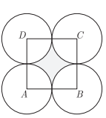  Four equal circles are described at the four corners of a square so that each touches two of the others. The shaded area enclosed between the circle is 7 /24 cm² . Find the radius of each circle. | 3
4 | An archery target has three regions formed by three concentric circles as shown in the below figure. If the diameters of the concentric circles are in the ratio 1: 2:3, then find the ratio of the areas of three regions. | 3
5 | A calf is tied with a rope of length 6 m at the corner of a square grassy lawn of side 20 m. If the length of the rope is increased by 5.5m, find the increase in area of the grassy lawn in which the calf can graze. | 3
6 | Sneha had a rectangular table cloth with one side measuring 30 cm which she wanted to keep on circular table of radius 25 CM please stop after keeping it on the table she realized that the corners of the table cloth just test the edge of the circulate table as shown in the figure.  Find the area of the table not covered by the table cloth. Show your steps with valid reason.($π=3.14$) | 3
7 | In figure, three sectors of a circle of radius 7 𝑐𝑚, making angles of 60°, 80°, 40° at the centre are shaded. The area of the shaded region (in 𝑐𝑚2 ) is? | 3
8 | 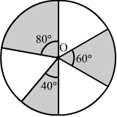  In figure, 𝐴𝐵𝐶𝐷 is a trapezium with 𝐴𝐵 ∥ 𝐷𝐶, = 18 𝑐𝑚, 𝐷𝐶 = 32 𝑐𝑚 and the distance between 𝐴𝐵 and 𝐷𝐶 is 14 𝑐𝑚. If arcs of equal radii 7 𝑐𝑚 have been drawn, with centres 𝐴, 𝐵, 𝐶 and 𝐷, then find the area of the shaded region. | 3
9 | A steel wire when bent in the form of a square encloses an area of 121 sq. cm. If the same wire is bent into the form of a circle, find the area of the circle.  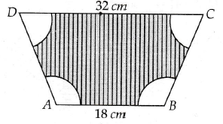 | 3
10 | 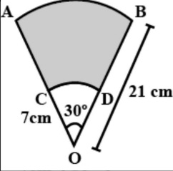  AB and CD are respectively areas of two concentric circles of radii 21 cm and 7 cm with centre O (see the figure). If ∠AOB-30°, then find the area of the shaded region. | 3
 | ANSWERS
1 | cows and buffaloes are tethered at the corners  Hence they can graze 1 quarter of circle  So,area grazed = (1/4) π ( radius)²  radius = Length of rope  length of rope of cow is greater 7m  length of rope of buffalo is 6.3m  Hence the ratio of grazing areas of the field by the cow and the buffalo  = (1/4) π ( 7)² : (1/4) π ( 6.3)²  = ( 7)² : ( 6.3)²  = ( 70)² : ( 63)²  = 10² : 9²  = 100 : 81  => ratio of grazing parts of the field by both.​ = 100 : 81 | 3
2 | Given the radius of the thali = 21cm  By the diagram, we can infer that,  Area of the shaded region = Area of semicircle − Area of triangle of ∆𝐴𝐵𝐶  = πr²/2 – 1/2× base × height  = $\frac{22/7×21×21}{2}$ - 1/2×42×21 (Here, the base will be the diameter (2 × 21 𝑐𝑚) and the height will be the radius.)  =(693- 441)cm²  = 252cm² | 3
3 | As per question statement the figure is shown below. Let r be the radius of each circle  ATQ ,Area of square – Area of 4 sectors =24/7 cm²  =>(2 r)²– 4[ $\frac{θ}{{360}^{0}}$π r²] =24/7  =>4r²– π r²=24/7  =>4r²– 22/7 r²=24/7  =>6r²/7=24/7  =>6r²=24  =>r²=4  =>r$=±$2. Thus radius of each circle is 2 cm(As r cannot be negative) | 3
4 | 1:3:5 | 3
5 | 75.56m² | 3
6 | 762.5cm² | 3
7 | (π/360) x r² x (60+80+40)=77 cm² | 3
8 | Area of four sectors= (π/360) x r² x ($<A+<B+<C+D)$)  =154 cm^{2.} (($<A+<B+<C+D)$=360, sum of all interior angles of quadrilateral)  Area of shaded part= area of trapezium – area of four sectors  =(1/2)x(AB+CD)xh - 154  =(1/2)x(18+32)x14 – 154=196 cm² | 3
9 | Side of the square=$√121$=11 cm.  So, lenth of wire i.e perimeter of square=4X11=44 cm  =perimeter of circle  Radius of circle=perimeter/(2π)=44/(2xπ)=7 cm  Area of circle= πr²=(22/7)x7x7=154 sq.cm. | 3
10 | Area of shaded region  = Area of sector AOB - Area of sector COD  Area of sector AOB.  radius =r= 21 cm; θ=30 °  Area of sector AOB = 360/θ × πr²  = 360/30 × 22/7 ×21×21  = 1/12×22×3×21  =231/2 cm² (OR) 115.5 cm²  Area of sector COD :  radius = r = 7 cm ; θ=30°  Area of sector COD=  360/θ ×π×r²= 360/30 ×22/7 ×7×7  = 1/12× 22/7×7×7  = 77/6 cm² (OR) 12.83 cm²  Area of shaded region = Area of sector OAB - Area of sector OCD  = 231/2 − 77/6  =(3x 231−77)/6  = (693−77)/6  Hence, area of shaded region = 616/6 = 308/3 cm² (OR) 102.667 cm² | 3
 | 4 – MARKS TYPE QUESTIONS (CASE BASED QUESTIONS)
1 | Pookalam is the flower bed or flower pattern designed during Onam in Kerala. It is similar as Rangoli in North India and Kolam in Tamil Nadu. During the festival of Onam, your school is planning to conduct a Pookalam competition. Your friend who is a partner in competition, suggests two designs given below. Observe these carefully.  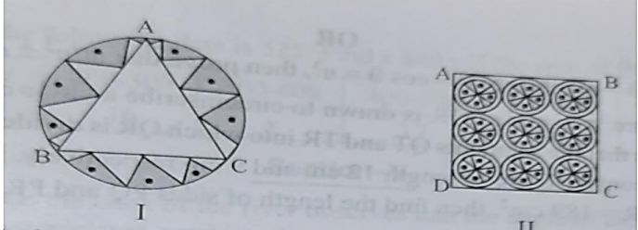  Design I: This design is made with a circle of radius 32cm leaving equilateral triangle ABC in the middle as shown in the given figure.  Design II: This Pookalam is made with 9 circular design each of radius 7cm.  Refer Design I:  i. The side of equilateral triangle is  a) 12√3 cm  b) 32√3 cm  c) 48cm  d) 64cm  ii. The altitude of the equilateral triangle is  a) 8 cm  b) 12 cm  c) 48cm  d) 52cm  Refer Design II:  iii. The area of square is  a) 1264 cm²  b) 1764 cm²  c) 1830 cm²  d) 1944 cm²  iv. Area of each circular design is  a) 124 cm²  b) 132 cm²  c) 144 cm²  d) 154 cm² | 4
2 | A brooch is a small piece of jewellery which has a pin at the back so it can be fastened on a dress, blouse or coat. Designs of some brooch are shown below. Observe them carefully.  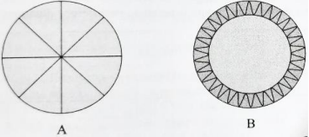  Design A: Brooch A is made with silver wire in the form of a circle with diameter 28mm. The wire used for making 4 diameters which divide the circle into 8 equal parts.  Design B: Brooch b is made two colours: Gold and silver. Outer part is made with Gold. The circumference of silver part is 44mm and the gold part is 3mm wide everywhere.  Refer to Design A  1. The total length of silver wire required is  a) 180 mm  b) 200 mm  c) 250 mm  d) 280 mm  2. The area of each sector of the brooch is  a) 44 mm²  b) 52 mm²  c) 77 mm²  d) 68 mm²  Refer to Design B  3. The circumference of outer part (golden) is  a) 48.49 mm  b) 82.2 mm  c) 72.50 mm  d) 62.86 mm  4. The difference of areas of golden and silver parts is  a) 18$π$  b) 44 $π$  c) 51 $π$  d) 64 $π$ | 4
3 | ABCD is a square field of side 14 m with E, F,G AND H as the mid points of  sides AB,BC, CD and DA respectively. A farmer wants to farm in the area  EFGH as shown in the figure .  i)Find the area of the shaded portion where he  wants to farm.  ii) Find the area which is not farmed.  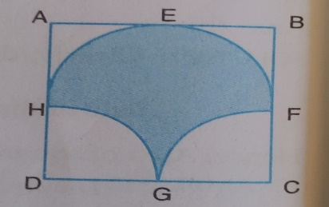 | 4
4 | Shiva made a painting on a square chart paper ABCD. The painting is made up of squares , semi-circular arcs(painted with flowers) and arcs of quadrants of circles as shown below. He painted the same type of region with same colors. Based on the above information, answer the following questions:  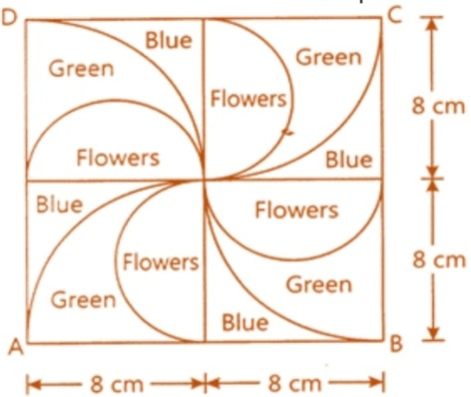  (i) What is the total area painted with flower?  a) 90.8 cm² b)100. 57 cm² c) 105. 6 cm² d) 111. 20 cm²  (ii) What is the area of all quadrant given in the figure?  a) 190 cm² b)198.14 cm² c) 201.14 cm² d) 222.14 cm²  (iii) What is the total length of the boundary of the region which is painted green?  a) 128.57 cm b) 132.56 cm c) 145.57 cm d) 150 cm | 4
5 | Jawaharlal Nehru Stadium is a multi-purpose sports stadium and a very popular sports stadium of Delhi. The stadium is a part of the Jawaharlal Nehru sports complex in central Delhi, which also houses the headquarters of the Sports Authority of India, the field arm of the Ministry of Youth Affairs and Sports, and the Indian Olympic Association. It has a capacity to seat 60,000 people. It is the third largest multi-purpose stadium in India. In 2010, the Jawaharlal Nehru Stadium was the main stadium for XIX Commonwealth Games; a major sporting event. Jawaharlal Nehru stadium is conducting the annual sports  competition soon. The curator of the stadium is tasked  to figuring out the dimensions for carving out some areas  allotted for a hockey court and a shooting range, as shown in the figure below. The shapes of the hockey court and the shooting range are square and triangle respectively. Both of the courts have a common edge that touches the centre of stadium. The construction of the shooting range is such that the angle to centre is 90⁰. The radius of the stadium is 200 meters.  Based on the above information, answer the following questions:  (i) What is the area allotted to shooting range?  (a) 80000 m² (b) 40000 m² (c) 20000 m² (d) 25600 m²  (ii) What is the area allotted to hockey court?  (a) 80000 m² (b) 40000 m² (c) 20000 m² (d) 25600 m²  (iii) If the team of the curators managing the stadium, likes  to allot space for some more sports, how much area is  available to them? (Use л = 3.14)  (a) 85600 m² (b) 40000 m² (c) 120000 m² (d) 125600 m² | 4
6 | Pookalam is the flower bed or flower pattern designed during Onam in Kerala. It is similar as Rangoli in North India and Kolam in Tamil Nadu. During the festival of Onam, your school is planning to conduct a Pookalam competition. Your friend who is a partner in competition, suggests two designs given below.  Observe these carefully.  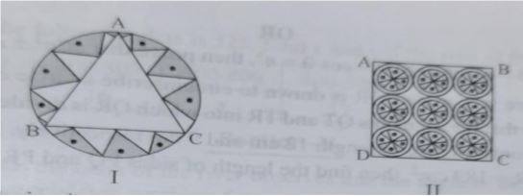  1. The side of equilateral triangle is  a) 12√3 cm b) 32√3 cm c) 48cm d) 64cm  2. The altitude of the equilateral triangle is  a) 8 cm b) 12 cm c) 48cm d) 52cm  Refer Design II:  3. The area of square is  a) 1264 cm² b) 1764 cm² c) 1830 cm² d) 1944 cm²  4. Area of each circular design is  a) 124 cm² b) 132 cm² c) 144 cm² d) 154 cm² | 4
 | ANSWERS
1 | i. b) 32√3 cm  ii. c) 48cm  iii. b) 1764 cm²  iv. d) 154 cm² | 4
2 | i. b) 200mm  ii. c) 77mm  iii. d) 62.86 mm  iv. c) 51 $π$ | 4
3 | Ans = (c)  Area of shaded region = Area of semi-circle FEHF  + Area of rectangle HDCF  - Area of two quadrants  =>area of shaded region = area of semicircle of radius 7cm  + ½ ( area of square ABCD)  - Area of semi-circle of radius 7cm.  = ½ (Area of square ABCD) = ½ x 14 x 14 cm² = 98 cm²  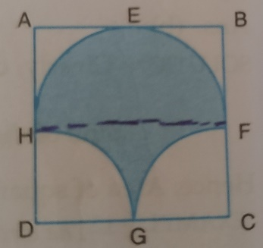 | 4
4 | i) Region which is painted with flowers are 4 semi-circles of diameter 8cm i.e., 2 circles of radius 4cm each.  So total Region which is painted with flowers =2πr²  =2x$\frac{22}{7}$ x4 x4  =100. 57 cm²  ii) In the figure, we have 4 quadrants of radius 8cm  So total area of 4 quadrants =4x$\frac{1}{4}$π r² = π r²=$\frac{22}{7}$ x8 x8 = 201.14 cm²  iii)Total length of the boundary of the region which is painted green = 4 [circumference of semi-circles of radius 4cm each + length of the arcs of quadrants of radius 8cm + radius of quadrant ]  = 4[$\frac{1}{2}$ x 2π (4) +$\frac{1}{4}$ x 2xπ x8 + 8]  = 4[4π + 4π + 8]  = 4[8π + 8]  = 4[8x22/7 + 8]  = 4[33.14]  = 132.56 cm | 4
5 | i) Shooting range is a right angled triangle  area of the right triangle = 1/2 x r x r  = 1/2 x 200 x 200  =20000 m²  (ii) The area of hockey court is a square.  we know that the radius of the stadium forms the diagonal of the hockey court. Therefore the sides of the hockey court will be $\frac{r}{\sqrt{2}} .$(applying Pythagoras Theorem in a square)  So the area of the square = a² = ($\frac{r}{ \sqrt{2}}$)²  = r ² / 2 = 200² / 2  =20000 m²  (iii) The unallocated area = The total circular area of the  stadium - Area of the hockey court - Area of the shooting range .  = л r² -20000-20000  = 3.14 x 200x200 - 40000 = 3.14 x 40000- 40000  =125600-20000-20000  = 85600 m² | 4
6 | Answer: 1) d) 154 cm²  Answer: 2) b) 32√3 cm  Answer: 3) c) 48cm  Answer: 4) b) 1764 cm² | 4
 | 5 – MARKS TYPE QUESTIONS
1 | In adjoining figure, a sector OAP of a circle with centre O, containing ∠θ. AB is perpendicular to the radius OA and meets OP produced at B. Prove that the perimeter of shaded region is $r[tanθ+secθ-1+\frac{πθ}{180}]$  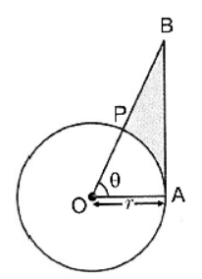 | 5
2 | A chord PQ of the circle of radius 10 cm subtends an angle of 60 degrees at the centre of the circle. Find the area of minor and major segment of the circle. | 5
3 | Rithika bought a pendulum clock for her living room. That clock contains a small pendulum of length 15cm. the minute hand and hour hand are 9cm and 6cm long respectively. Based on the above information answer the following questions.  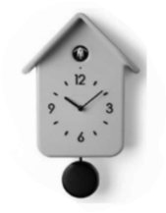  i) Find the area swept by the hour hand in 1 hour?  ii) Find the area swept by the hour hand between 11am and 5pm?  iii) Find the area swept by the minute hand in 10minutes? | 5
4 | Sashi made a painting on a square chart paper ABCD. The painting is made up of squares, semicircular arcs(painted with flowers) and arcs of quadrant of circles as shown below. He painted the same type of region with the same colors. Based on the above information answers the following questions.  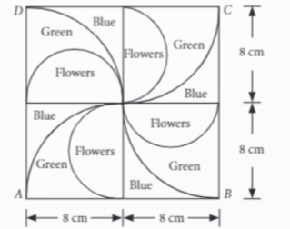  i) Find the total area of the region which is painted with flowers?  ii) Find the area of the region which is painted blue.  iii) Find the area of all the quadrants. | 5
5 | Jawaharlal Nehru Stadium is conducting the annual sports competition soon. The  curator of the stadium is tasked to figuring out the dimensions for carving out  some areas allotted for a hockey court and a shooting range, as shown in the  figure. The shapes of the hockey court and the  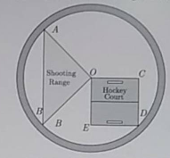  shooting range are square and triangle respectively.  Both of the courts have a common  edge that touches the centre of  stadium. The construction of the  shooting range is such that the angle  to centre is 90°  . The radius of the  stadium is 180 metres.  a) What is the area allotted to shooting range?  b) What is the area allotted to hockey court?  c) If the team of the curators managing the stadium, likes to allot space for  some more sports, how much area is available to them? | 5
 | ANSWERS
1 | Correct proof | 5
2 | Area of minor segment  = Area of minor sector having angle 60$°$ at centre – Area of equilateral $∆OPQ$  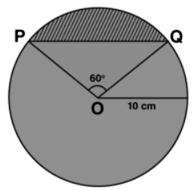  = $\frac{22}{7}*10*10*\frac{60°}{360°}-\frac{\sqrt{3}}{4}*10*10$  = $10*10*[\frac{22}{7}*\frac{1}{5}-\frac{\sqrt{3}}{4}]$  = $\frac{100}{84}\left(44-21\sqrt{3}\right)cm^{2}$  = $\frac{25}{21}\left(44-21\sqrt{3}\right)cm^{2}$  Area of major segment  = Area of circle – Area of minor segment  = $\frac{22}{7}*10*10- \frac{25}{21}\left(44-21\sqrt{3}\right)$  = $\frac{2200}{7}- \frac{25}{21}\left(44-21\sqrt{3}\right)$  =$\frac{6600-1100+25*21\sqrt{3}}{21}$ = $\frac{5500+25*21\sqrt{3}}{21}$ = $\frac{25}{21}\left(220+21\sqrt{3}\right)cm^{2}$ | 5
3 | Length of hour hand = 6cm  In 12 hours central angle = 360$°$  1 hour “ “ = $\frac{360°}{12}$= 30$°$  ii) Arc hour hand 21 am to 5 pm  (11a.m to 5 p.m) = 6 places  Hour hand moves central angle = 6 x 30$°$ = 180 $°$  Area = $\frac{180}{360}$x $\frac{22}{7}$x 6 x 6 = $\frac{396}{7}$= 56.571cm²  iii) length of minute hand = 9cm  In 10 mins. = 2 places = 30$°$ x 2 = 60$°$  Area (formed in 10 mins.) = $\frac{60}{360°}$x $\frac{22}{7}$x 9 x 9 = $\frac{297 }{7}$  = 42.42cm² | 5
4 | i) Ar(painted flowers) =  Diameter of semicircle(flower) = 8cm  =>r = 4cm  Ar(4 semi-circles) = (2 circles)  = 2 x $\frac{22}{7}$x 4 x 4 = $\frac{704}{7}$  = 100.57cm²  ii) Ar(Blue Painted Area)  =Ar(square)-Ar(4th quadrant)  =16² – 4 x ¼ x $\frac{22}{7}$x 8 x 8  =256 – 201.14 = 54.86cm²  iii) Ar(All quadrants) = 4 x ¼.π r² = $\frac{22}{7}$x 8 x 8 = $\frac{1408 }{7}$= 201.14cm² | 5
5 | (a)Area of shooting range  = Area of triangle  =1/2*180*180 =16,200m²  (b)Area of hockey court  =Area of Square  =4*(1/2*180/2*180/2)  =2*90*90=8100*2=16,200m²  (c) Circle= πr²=3.14*(180)²=101736  remaining area= circle-area of shooting range-area of hockey court  =101736-16200-16200  =69336m² | 5

CHAPTER – 13
SURFACE AREA & VOLUMES

SYLLABUS:
Surface areas and volumes of combinations of any two of the following: cubes, cuboids, spheres, hemispheres and right circular cylinders/cones.

SL NO | QUESTION | MARK
 | MULTIPLE - CHOICE QUESTIONS
1 | The sum of the length, breadth and height of a cuboid is 6√3cm and the length of its diagonal is 2√3cm. The total surface area of the cuboid is  (a) 48 cm² (b) 72 cm² (c) 96 cm² (d) 108 cm² | 1
2 | On a Sunday, your Parents took you to a fair. You could see lot of toys displayed, and you wanted them to buy a RUBIK’s cube and strawberry ice-cream for you. Observe the figures and answer the question  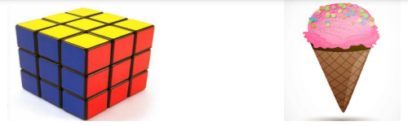  The length of the diagonal if each edge measures 6cm is  a) 3√3 b) 3√6 c) √12 d) 6√3 | 1
3 | Two identical solid hemispheres of equal base radius r cm are stuck together along their bases. What will be the surface area of the solid formed ?  a)6πr² (b) 3πr² (c) 4πr² (d) 9πr² | 1
4 | Two identical cubes each of volume 64 cm³ are joined together end to end. What is the surface area of the resulting cuboid? | 1
5 | During conversion of a solid from one shape to another, the volume of the new shape will  (A) increase (B) decrease (C) remain unaltered (D) be doubled | 1
6 | Three group of students went for a trekking. Each group had 551m2 of canvas with them to make conical tent for their rest at night. Assuming that all the stitching and wasting incurred while cutting, would amount to 1m2, the students put the tents. The radius of the tent is 7m.  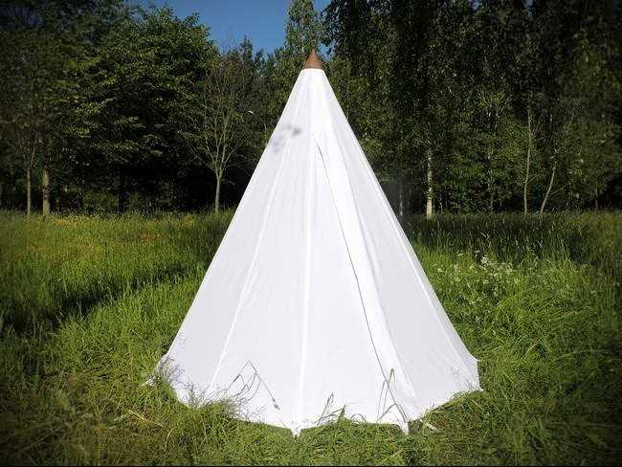  How much space on the ground is occupied by each student in the conical tent  a) 54 m2  b) 38.5 m2  c) 86 m2  d) 24 m2 | 1
7 | An open water tank of cuboidal shape has the measurement 2m×1.6mx1.8m. The thickness of the wall of the water tank is 10cm. Which of the following gives the capacity (in litre) of the tank?  a.1.8 × 1.4 × 1.6  b.1.9 × 1.5 × 1.7  c.2 × 1.6 × 1.8  d.2.1 × 1.7 × 1.9 | 1
8 | In the above question if a lid is placed on the water tank made up of cement with thickness 3cm, then what is the volume of the cement used?  a)3.412m²  b)6.4m²  c)6.62m²  d)19.576m² | 1
9 | The picture given is a flask used in chemistry labs. The radius of the upper rim is 3 cm and the radius of the base of the flask is 9 cm.  For an experiment water is filled upto slant height of the flask. Find the volume of the water.  a) 63 π  b)135√43π  c).156√70π  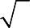  d).(192 70+63)π  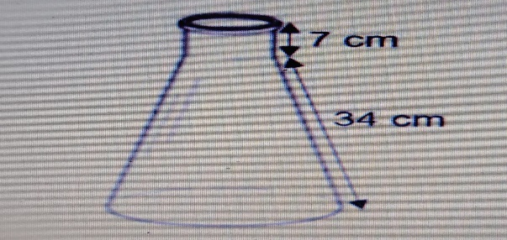 | 1
10 | Sheela went to a science exhibition. There she saw a hemispherical structure with diameter mentioned as 140cm. What is the surface area of the table top?  i)0.49π m²  0.98π m²  iii)1.47π m²  iv)5.88π m² | 1
11 | A cubical ice cream brick of edge 22 cm is to be distributed among some children by filling ice cream cones of radius 2cm and height 7cm upto its brim. How many children will get the ice cream cones?  (a)163 (b) 263 (c) 363 (d) 463 | 1
12 | A right triangle with sides 3cm, 4cm and 5cm is rotated about the side of 3cm to form a cone. The volume the cone so formed is:  (a)20$π$ cm³ (b) 12$π$ cm³ (c) 15$π$ cm³ (d) 16$π$ cm³ | 1
13 | How many balls each of radius 1cm can be made by melting a big ball whose diameter is 8 cm?  (a)54 (b) 64 (c) 76 (d) 36 | 1
14 | A largest possible right circular cylinder is cut out from a wooden cube of edge 7 cm. The volume of wood left over after cutting the cylinder is  (a)73.5 cm³ (b) 82.5 cm³ (c) 76 cm³ (d) 92 cm³ | 1
15 | If each edge of a cube is increased by 25%, the percentage increase in its surface area is  (a)25 % (b) 48.75 % (c) 50 % (d) 56.25 % | 1
16 | A cube having edge 4cm is cut into 1 cm cubes. The total surface area of all the cubes will be:  (a)348 cm² (b) 340 cm² (c) 384 cm² (d) 380 cm² | 1
17 | A solid sphere of radius r is melted to form a solid cone of height r, the radius of base of cone is :  (a) 2r (b) 3r (c) r (d) 4r | 1
18 | How many square meters of the canvas is required for a conical tent whose height is 3.5 meter and the radius of the base is 12m?  474.12 m² (b) 470.42 m² (c) 471.42 m² (d) 417.42 m² | 1
19 | A closed cylindrical tank of radius 7m and height 3m is made from a sheet of metal. How much sheet of metal is required?  400 m² (b) 420 m² (c) 440 m² (d) 460 m² | 1
20 | The dimensions of a warehouse are 40m, 25m and 10m. If it is filled with cuboidal boxes each of dimensions 2m x 1.25m x 1m, then what will be the number of boxes?  1800 (b) 8000 (c) 2000 (d) 4000 | 1
21 | If the radius of the sphere is increased by 100%, the volume of the corresponding sphere is increased by  (a) 200% (b) 500%(c) 700% (d) 800% | 1
22 | Two identical solid hemispheres of equal base radius r cm are stuck together along their bases. The total surface area of the combination is  (a) 6πr²  (b) 5πr²  (c) 4πr²  (d) 3πr² | 1
23 | From a solid circular cylinder with height 10 cm and radius of the base 6 cm, a right circular cone of the same height and same base is removed, then the volume of remaining solid is  (a) 280π cm³ (b)330π cm³ (c) 240π cm³ (d)440π cm³ | 1
24 | A cuboidal ice cream brick of dimension 30 cm × 22 cm × 10 cm is to be distributed among some children by filling ice cream cones of radius 2.5 cm and height 8 cm up to its brim .    How many children will get ice cream cones ?  (a) 150 (b) 126 (c) 136 (d) 144 | 1
25 | The dimension of metallic cube are 100 cm × 80 cm × 64 cm . It is melted and recast in to a cube .    The surface area of the cube so formed is  (a) 27500 cm ² (b) 42000 cm ²  (c) 38400 cm ² (d 25400 cm ² | 1
 | ANSWERS | 1
1 | (c) 96 cm² | 1
2 | (d) 6$\sqrt{3}$ cm | 1
3 | (c) 4πr² | 1
4 | 640 cm² | 1
5 | (c) remain unaltered | 1
6 | 38.5m² | 1
7 | 1.8 × 1.4 × 1.6 | 1
8 | 6.62m² | 1
9 | 156√70π | 1
10 | 0.49π m² | 1
11 | (c) 363 | 1
12 | (d) 16$π$ cm³ | 1
13 | (b ) 64 | 1
14 | 73.5 cm³ | 1
15 | (d) 56.25 % | 1
16 | (c) 384 cm² | 1
17 | 2r | 1
18 | (c) 471.42 m² | 1
19 | (c) 440 m² | 1
20 | 2000 | 1
21 | C | 1
22 | C | 1
23 | C | 1
24 | (b) 126  Solution : number of cones = n  n× $\frac{1}{3}$×$\frac{22}{7}$× 2.5 × 2.5 × 8 = 30 × 22 × 10  n = $\frac{30×22×10 ×3×7}{22 × 2.5 ×2.5 ×8}$ = $\frac{30×22×10 ×3×7 × 100}{22 × 25 ×25 ×8}$ = 126 | 1
25 | ( c) 38400 cm ²  Solution : Let a cm be the edge of the cube .  Since, volume of the cube = volume of the cuboid  So a ³cm ³ = 100 × 80 × 60 cm ³  a ³ = 512000  a = 80 cm  Surface area of the cube = 6 a² = 6× 80² cm² = 38400 cm² | 1
 | ASSERTION & REASON QUESTIONS
Choose the correct option in the following questions of Assertion – Reason Questions.
(a) Both A and R are correct; R is the correct explanation of A.
(b) Both A and R are correct; R is not the correct explanation of A.
(c) A is true but R is false
(d) A is false but R is true
1 | (Assertion): Total Surface area of the top is the sum of the curved surface area of the hemisphere and the curved surface area of the cone.  R( Reason) : Top is obtained by joining the plane surfaces of the hemisphere and cone together. | 1
2 | Statement A (Assertion): The volume of two sphere are in the ratio 27: 8 then their surface area in the ratio 3:2.  Statement R (Reason): Volume of sphere = 4/3 πr 3 and it’s surface area = 4π² | 1
3 | Assertion : Total surface area of the cylinder having radius of the base 14 cm and height 30 cm is 3872 cm²  Reason : If r be the radius and h be the height of the cylinder, then total surface area = 2 πr ( h + r ) | 1
 | ANSWERS
1 | a | 1
2 | d | 1
3 | a | 1
 | 2 MARKS TYPE QUESTIONS
1 | A solid metallic sphere of radius 10.5 cm is melted and recast into a number of smaller cones, each of radius 3.5 cm and height 3 cm. Find the number of cones so formed. | 2
2 | A cubical ice cream brick of edge 22 cm is to be distributed among some children by filling ice cream cones of radius 2 cm and height 7 cm up to its brim. How many children will get the ice cream cones? | 2
3 | In a coffee shop, coffee is served in two types of cups. One is cylindrical in shape with diameter 7 cm and height 14 cm and the other is hemispherical with diameter 21 cm.  What is the capacity of the hemispherical cup ?  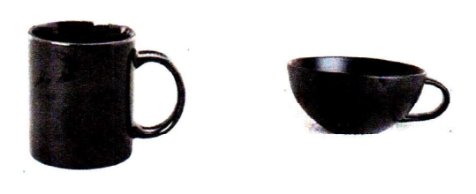 | 2
4 | From a solid right circular cylinder of height 14 cm and base radius 6 cm, a right circular cone of same height and same base removed. Find the volume of the remaining solid. | 2
5 | A right circular cylinder and a cone have equal bases and equal heights. If their curved surface areas are in the ratio 8 : 5, show that the ratio between radius of their bases to their height is 3:4. | 2
6 | A hemisphere depression is cut-out from one face of the cubical wooden block such that the diameter l of the hemisphere is equal to the edge of the cube. Determine the surface area of the solid. | 2
7 | During a study tour, students witnessed a big hemispherical dome surmounted by a cuboidal structure.  (i) The cloth requires to cover the hemispherical dome if the radius of its base is 14m is:  a) 1222 sq.m  b) 1232 sq.m  c) 1200 sq.m  d) 1400 sq.m  (ii)The total surface area of the combined figure i.e. hemispherical dome with radius 14m and cuboidal shaped top with dimensions 8m 6m 4m is  a)1200 sq. m  b) 1232 sq. m  c) 1392 sq.m  d) 1932 sq. m | 2
8 | a) What is the volume of the greatest sphere which can be cut out from a cube of volume 216cm³. (π=3.14)  i)37.68cm3  ii)56.52cm3  iii) 113.04cm3  iv)452.16cm3  b) What is the radius of the sphere?  i)2cm  ii)3cm  iii)4cm  iv)5cm | 2
9 | Anuja went to the market and bought a cuboidal box of volume 105cm³. The dimensions of box are 7cm x 3cm x y cm,  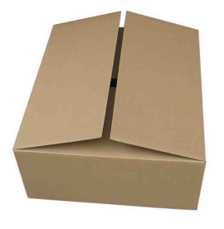  - Find y  - She wants to cover four faces of the box by coloured paper, leaving top and bottom uncovered. How much square cm of paper is required to cover it? | 2
10 | Ashin is playing with building blocks which are cube shaped. She builds a structure as shown above. If the edge of a cube is 3 cm, find the volume of the structure built by her.  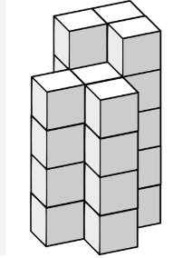 | 2
 | ANSWERS | 2
1 | The volume of the solid metallic sphere = 4/ 3 π(10.5)³ cm³  Volume of a cone of radius 3.5 cm and height 3 cm = 1 /3$π$ × (3.5)² × 3 cm³  Number of cones so formed= 126 | 2
2 | 363 | 2
3 | Capacity = 2/3 $π$³  = 2425.5 cm³ | 2
4 | V of the remaining solid= v of cylinder-v of cone=2/3πr²h=1056cm³ | 2
5 | Csa of cylinder:csa of cone=2πrh:πrl=8:5  H:l= 4:5  H²:l²=16:15  L²=(25/16)h²  H²+r²=25/16h²  (r/h)²⁼(3/4)²  r/h=3:4 | 2
6 | SA of the remaining solid=TSA of cubical part+CSA of hemispherical part-area of the base of the hemispherical part  = 6l²+2$π$r²- $π$r²=1/4l²(π+24) | 2
7 | i) 1232 sq.m  ii) 1392 sq.m | 2
8 | i)V=216  Side³=216  Side=6cm  d=6cm  r=3cm  v=113.04cm³  ii) 3cm | 2
9 | - Volume = l x b x h,  105 =7 x 3 x y  y = 5cm (1)  - Paper required to cover it = CSA of cuboid  = 2(l+b) x h = 2(7+5) x 3  =72 square cm. (1) | 2
10 | Volume of one cube = (edge)³= 3³ = 27  Volume of structure = No. of cubes X Volume of one cube.  Volume = 15 X 27 = 405 cm³ | 2
 | 3 – MARKS TYPE QUESTIONS
1 | A heap of rice is in the form of a cone of base diameter 24 m and height 3.5 m. Find the volume of the rice. How much canvas cloth is required to just cover the heap? | 3
2 | A solid wooden toy is in the form of hemisphere surmounted by a cone of same radius. The radius of hemisphere is 3.5 cm and the total wood used in the making of toy is 166 56cm³. Find the height of the toy. Also, find the cost of painting the hemispherical part of the toy at the rate of ₹ 10 per cm². (Use π=22/7) | 3
3 | A hollow cube of internal edge 22 cm is filled with spherical marbles of diameter 0.5 cm and it is assumed that $\frac{1}{8}$ space of the cube remain unfilled. Thus find the number of marbles that the cube can be accommodated .  22 CM  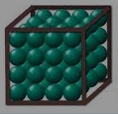 | 3
4 | Water is flowing at the rate of 15 km/hr through a pipe of diameter 14 cm into a rectangular tank , which is 15 m long and 44 m wide . Find the time in which the level of water rise by 21 cm.  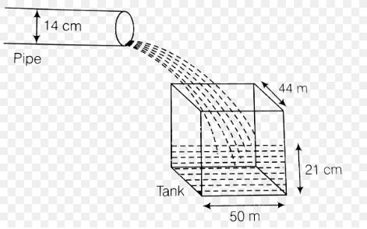 | 3
5 | A 21 m deep well with diameter 6m is dug and the earth from digging is evenly spread out to form a Platform 27 m by 11 m. Find the height of the platform .  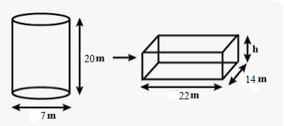 | 3
6 | 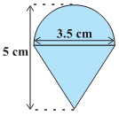  Rasheed got a playing top (lattu) as hisbirthday present, which surprisingly had no colour on  it. He wanted to colour it with his crayons. The top is  shaped like a cone surmounted by a hemisphere  (see Fig.). The entire top is 5 cm in height and  the diameter of the top is 3.5 cm. Find the area he  has to colour. (Take π= 22/7). | 3
7 | Shanta runs an industry in a shed which is in the shape of a cuboid surmounted by a half cylinder (see Fig.).  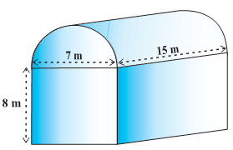  If the base of the shed is of dimension 7 m × 15 m, and the height of the cuboidal portion is 8 m, find the volume of air that the shed can hold. Further, suppose the machinery in the shed occupies a total space of 300 m³, and there are 20 workers, each of whom occupy about 0.08 m³ space on an average. Then, how much air is in the shed? (Take π= 22/7). | 3
8 | A hemispherical tank full of water is emptied by a pipe at the rate of 3$\frac{4}{7}$ litres per second. How much time will it take to empty half the tank, if it is 3m in diameter? (Take π =22/7) | 3
9 | Acube whose edge is 20 cm long, has circles on each of its faces painted black. What is the total area of the unpainted surface of the cube if the circles are of the largest possible areas?  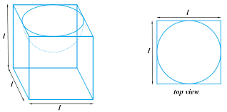 | 3
10 | Given that 1 cu cm of marble weight 25g, the weight of a marble block of 28 cm in width and 5 cm thick, is 112 kg. Find the length of the block. | 3
 | ANSWERS
1 | Base diameter of cone = 24 m.  Therefore, Radius, r = 12 m  Height of cone, h = 3.5 m  Volume of rice in conical heap = 1/3 πr²h  = 1/3 × 22/7 × 12 × 12 × 3.5  = 528 m³  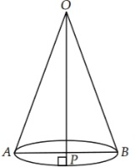  Now, slant height, l = √(h²+r²)  = √{(3.5)² + (12)²}  = √(156.25)  = 12.5 m  Canvas cloth required to just cover the heap = CSA of conical heap = πrl  = 22/7× 12 × 12.5  = 3300/7 m²  = 471.43 m² | 3
2 | Given, the radius of hemisphere is 3.5 cm and let the height of the cone be h cm.  Now, Volume of wood = 166 5 cm³  6  ⇒ 2πr³/3 + 1 πr²h/3 = 166 56  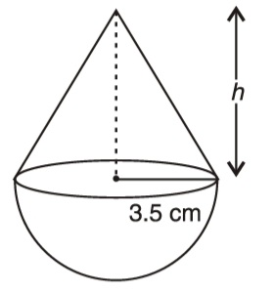  ⇒ 2 × 22/7 ×3.5×3.5×3.5/3 + 22/7 ×3.5×3.5×h/3 =1001/6  ⇒ 7 + h = 1001×7×3 /22× 3.5×3.5×6 cm  h = 1001/77 - 7  h = 6  Area of hemispherical part of the toy = 2πr²  = 2 × 22/7 × 7/2 × 7/2  = 77 cm²  Therefore, the cost of painting the hemispherical part of the toy  = ₹(77 × 10)  = 770 | 3
3 | Let number of spherical marbles be n  Diameter of each spherical marble be = 0.5 cm  ∴ Radius of each spherical marble be = $\frac{0.5}{2}$ cm = $\frac{1}{4}$ cm  Internal edge of a hollow cube a = 22 cm  A/Q ⇒ volume of the each marble × n = ( 1 ‒ $\frac{1}{8}$ ) × volume of the cube  ⇒ $\frac{4}{3 }$ πr 3× n = $\frac{7}{8 }$ a3  ⇒ $\frac{4}{3 }$ × $\frac{22 }{7} ×( \frac{1}{4}$ ) 3 × n = $\frac{7}{8 }$ × (22) 3  ∴ n = $\frac{7×7×22 ×22 ×22 ×4 ×4 ×3}{8 × 22}$ = 7×7 × 22× 22× 2 × 3  = 142296  Hence , required number of spherical marbles is 1,42,296 . | 3
4 | Length of the tank = 50 m  and width of the tank = 44 m  Rise in water level = 21 cm = $\frac{21}{100}$ m  ∴ Volume of water in the tank = 50 × 44 × $\frac{21}{100}$ m3 = 462 m3  Now , radius of the cylindrical pipe , r = $\frac{14}{2}$ cm = 7 cm = $\frac{7}{100}$ m  Length of water column , flows from the pipe in 1 hour = 15 km = 15000 m  ∴ Volume of water , flows from the pipe in 1 hour = πr 2 h  = $\frac{22}{7}$ × $\frac{7}{100} ×$ $\frac{7}{100}$ × 15000 m3  = 231 m3  Let , the required time be t hour  So , 231 × t = 462  Hence , required time , t = $\frac{462}{231}$ hour = 2 hours . | 3
5 | Diameter of the well = 7 m  So, radius of the well ( r) = $\frac{7}{2}$ m  Height of the well ( h ) = 20 m  Length of the platform ( L ) = 22 m  Breadth of the platform ( B ) = 14 m  Let , height of the platform be H m  So, volume of the plat form = L × B × H  A/Q ⇒  Volume of the earth dug out from the well = volume of the platform formed  ⇒ πr 2 h = L × B × H  ⇒ $\frac{22}{7}$ × $\frac{7}{2}$ × $\frac{7}{2}$ × 20 = 22 × 14 × H  ⇒ 11 × 7 × 10 = 22 × 14 × H  ⇒ H = $\frac{11×7×10}{22×14}$ = $\frac{5}{2}$ = 2.5  Hence , the height of the platform = 2.5 m | 3
6 | TSA of the toy =CSA of hemisphere + CSA of cone  Now, the curved surface area of the hemisphere =(1/2)(4 πr²)=2 πr²  =2x(22/7)x(3.5/2)²cm²  Also, the height of the cone = height of the top – height (radius) of the hemispherical part  =5-(3.5/2)cm= 3.25 cm  So, the slant height of the cone (l) = $\sqrt{r^{2}+h^{2}}$ = 3.7 cm (approx.)  Therefore, CSA of cone = πrl= (22/7)x( 3.5/2)x3.7cm² .  This gives the surface area of the top = 2x(22/7)x(3.5/2)²cm²+(22/7)x( 3.5/2)x3.7cm²  =39.6 cm ²(approx.) | 3
7 | ANS: The volume of air inside the shed (when there are no people or machinery)  is given by the volume of air inside the cuboid and inside the half cylinder, taken together.  Now, the length, breadth and height of the cuboid are 15 m, 7 m and 8 m, respectively.  Also, the diameter of the half cylinder is 7 m and its height is 15 m.  So,the required volume = volume of the cuboid + ½(volume of the cylinder)  =[15x7x8+(1/2)x(22/7)x(7/2)x(7/2)x15]m³= 1128.75 m³  Next, the total space occupied by the machinery = 300 m³  And the total space occupied by the workers = 20 × 0.08 m³= 1.6 m³  Therefore, the volume of the air, when there are machinery and workers  = 1128.75 – (300.00 + 1.60) = 827.15 m³ | 3
8 | Radius of the hemispherical tank = (3/2)m  Volume of the tank =( 2/3)( 22/7)( 3/2)³m³=(99/14) m³  So,the volume of the water to be emptied =(1/2)x(99/14) m³=(99/28)x1000 litres =  (99000/28) litres  Since, 25/7 litres of water is emptied in 1 second, 99000/28 litres of water will be emptied in (99000/28)x(7/25) seconds, i.e., in 16.5 minutes. | 3
9 | Diameter of largest circle = 20 cm  Area of circle = ∏r² = 100∏ cm²  Area of 6 circles = 600∏ cm²  Surface area of cube = 6 X side² = 6 X 20 X 20 = 2400 cm²  Area of unpainted surface = 2400 - 600∏ = 2400 - 600 X 22/7 = 514.28 cm² | 3
10 | 1 cu cm = 25g  Total weight = 112kg  Volume = $\frac{112 X 1000}{25}$ = 4480 cm³  l X b X h = 4480  l X 28 X 5 = 4480  l = 32 cm | 3
 | 4 – MARKS TYPE QUESTIONS (CASE BASED QUESTIONS)
1 | Aahana went to a store and there she saw a beautiful spherical table lamp with wooden stand. She noticed that the wooden stand is made up of 6 identical cuboidal blocks each having dimensions 7cm x 1cm x 1cm. She wants to paint it with golden colour. Help her in finding  - The volume of wood used  - Surface area of stand to be painted.  (c) If cost of painting is 50 paise per sq. meter, then find the total cost of painting.  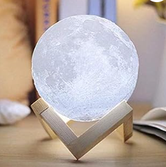 | 4
2 | On a Sunday, your Parents took you to a fair. You could see lot of toys displayed, and you wanted them to buy a RUBIK’s cube and strawberry ice-cream for you. Observe the figures and answer the questions:-  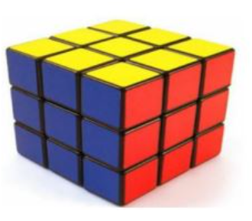  1. The length of the diagonal if each edge measures 6cm is  a) 3√3 b) 3√6 c) √12 d) 6√2  2. Volume of the solid figure if the length of the edge is 7cm is  a)256 cm3 b) 196 cm3 c) 343 cm3 d) 434 cm3  3. What is the curved surface area of hemisphere (ice cream) if the base radius is 7cm?  a) 309 cm2 b) 308 cm2 c) 803 cm2 d) 903 cm2  4. The total surface area of cone with hemispherical ice cream if the radius is 7cm and the height of the cone is 24 cm  a) 858 cm² b) 885 cm² c) 588 cm² d) 855 cm² | 4
3 | Rahul and Rohit have 12 and 8 cions respectively.  Each of radius 3.5 cm and thickness 0.5 cm . They place their coins one above the other to form solid cylinder .  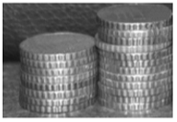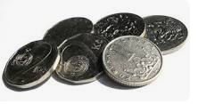  Based above information answer the following questions :  1. Curved surface area of the cylinder made by Rahul is  a) 144 cm2 b) 132 cm2 c) 154 cm2 d) 142 cm2  2. The ratio of the curved surface area of the cylinder made by Rahul and Rohit  a) 2 : 5 b) 3: 2 c) 1: 2 d) 2:7  3. The volume of the cylinder made by Rohit is  a)154 cm³ b) 144 cm³ c) 132 cm³ d) 142 cm³  4. When two coins are shifted from Rahul’s  Cylinder to Rohit’s cylinder then  (a) Volume of Rahul’s Cylinder $>$ volume of Rohit’s cylinder  (b) Volume of Rohit’s Cylinder $>$ volume of Rahul’s cylinder.  (c) Volume of Rahul’s Cylinder = volume of Rohit’s cylinder  (d) None of these. | 4
4 | On a Sunday, you are going with your parents to your uncle’s house. A room of this house is 8 m long, 4.5 m wide and 2.8 m high. It has one door 1.4 m wide and 2 m high with a semi-circular ventilator and two rectangular windows2 m by 1.5 m each as shown in the given figure:  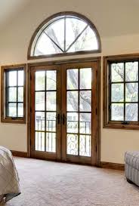  i) What is the area of inner four walls?  - 70 m ² (b) 100 m ²  c) 35 m ² (d) 140 m ²  ii) The area of semicircular ventilator is  a) 70 m ² (b) 0.77 m ²  c) 0.70 m ² (d) 7.7 m ²  iii) The cost of white washing the inner four walls of the room at the rate of Rs 10 per square cm _____________  a) Rs 660.40 (b) Rs 892.50  c) Rs 604.30 (d) Rs 1000 | 4
5 | The Great Stupa at Sanchi is one of the oldest stone structures in India, and an important monument of Indian Architecture.  It was originally commissioned by the emperor Ashoka in the 3rd century BCE. Its nucleus was a simple hemispherical brick structure built over the relics of the Buddha. It is a perfect example of combination of solid figures. A big hemispherical dome with a cuboidal structure mounted on it. (Take $π=22/7$)  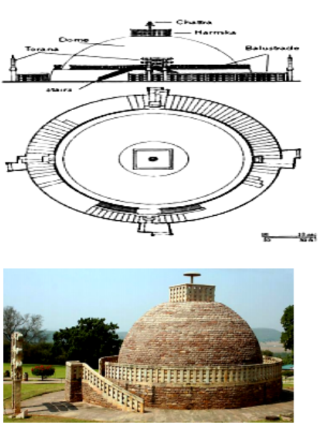  (i) Calculate the volume of the hemispherical dome if the height of the dome is 21 m –  a) 19404 cu. m b) 2000 cu .m  c) 15000 cu. m d) 19000 cu. m  (ii) The formula to find the Volume of Sphere is-  a) 2/3 π r³ b) 2/3 π r³ c) 4 π r² d) 2 π r²  (iii)The cloth require to cover the hemispherical dome if the radius of its base is 14m is  a) 1222 sq. m b) 1232 sq. m  c) 1200 sq. m d) 1400 sq. m  (iv) The total surface area of the combined figure i.e. hemispherical dome with radius 14m and cuboidal shaped top with dimensions 8m x 6m x 4m is  a)1200 sq. m b) 1232 sq. m  c) 1392 sq. m d) 1932 sq. m | 4
6 | The Great Stupa at Sanchi is one of the oldest stone structures in India, and an important monument of Indian Architecture. It was originally commissioned by the emperor Ashoka in the 3rd century BCE. Its nucleus was a simple hemispherical brick structure built over the relics of the Buddha. .It is a perfect example of combination of solid figures. A big hemispherical dome with a cuboidal structure mounted on it. (Take π = 22/7)  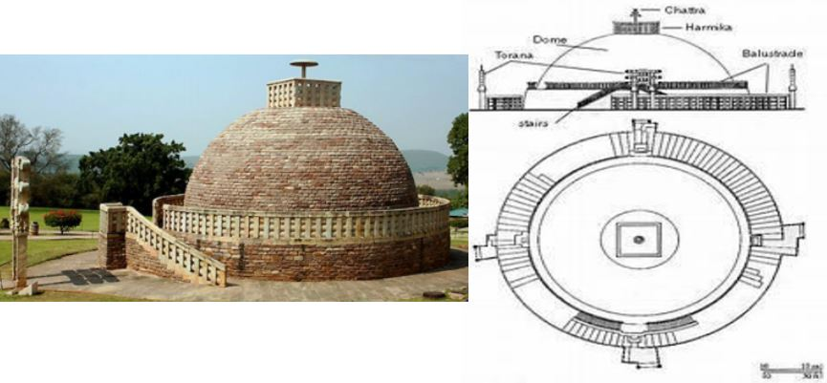  - The volume of the hemispherical dome if the height of the dome 21 m, is:  - 19404 m3 b) 2000 m3 c) 15000 m3 d) 19000 m3  - The formula for finding the volume of a hemi-sphere of radius r is:  - $\frac{2}{3 }πr$3 b) $\frac{4}{3 }πr$3 c) 4$πr$2 d) 2$πr$2  - The volume of the cuboidal shaped top with dimensions 8m x 6m x 4m is:  182.45 m3 b) 282.45 m3 c) 292 m3 d) 192 m3 | 4
7 | On a Sunday, your Parents took you to a fair. You could see lot of toys displayed, and you wanted them to buy a RUBIK’s cube and strawberry ice-cream for you. Observe the figures and answer the questions:-  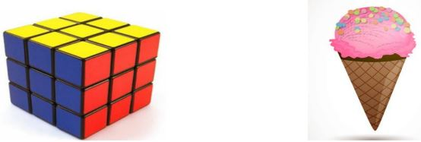  - The length of the diagonal, if each edge measure 6 cm, is:  - 3√3 cm b) 3√6 cm c) 2√3 cm d) 6√3 cm  - Volume of the solid figure, if the length of the edge is 7 cm, is:  - 256cm3 b) 196cm3 c) 343cm3 d) 434cm3  - What is the curved surface area of hemisphere if the base radius is 7 cm?  - 309cm2 b) 308cm2 c) 803cm2 d)903cm2 | 4
 | ANSWERS
1 | Volume of wood used = 6 x (7 x 1 x1) = 42 cm³  Surface area to be painted = 6 [ 3( 7 x 1) + 1 x 1 + 6 x 1) = 168 cm²  Cost of painting = 0.50 x 168 = Rs 84 | 4
2 | 1. The length of the diagonal if each edge measures 6cm = $\sqrt{36+36 }$  = $\sqrt{2×36}$ = 6 $\sqrt{2}$  Ans : (d)  2. Volume of the solid = 7×7×7 cm³ = 343 cm³  Ans : ( c )  3. curved surface area of hemisphere = 2πr ²= 2 × $\frac{22}{7}$ × 7×7 cm²= 308 cm²  Ans : (b)  4. Slant height of the cone = $\sqrt{24×24+7×7}$ cm = $\sqrt{576+49}$ cm  =$\sqrt{625}$ cm = 25 cm  The total surface area of cone with hemispherical ice cream  = CSA of hemisphere + CSA of cone =2πr ²+ πrl = πr ( 2r + l )  = $\frac{22}{7}$ × 7× ( 2×7 + 25) cm²  = 22× 39 cm²= 858 cm²  Ans : (a) | 4
3 | 1. Curved surface area of the cylinder made by Rahul = 2πrh  = 2×$\frac{22}{7}$× 3.5 ×0.5×12 cm²= 44×0.25× 12 cm²= 132 cm²  Ans : (b)  2.The ratio of the curved surface area of the cylinder made by Rahul and Rohit:  Curved surface area of the cylinder made by Rohit = 2πrh  = 2×$\frac{22}{7}$× 3.5 ×0.5×8 cm²= 44×0.25× 8 cm²= 88 cm²  Required ratio = $\frac{132}{88}$ = $\frac{3}{2}$ = 3:2  Ans : (b)  3. The volume of the cylinder made by Rohit = πr ² h=$\frac{22}{7}$ × 3.5×3.5×0.5× 8 cm³  = 22×0.5×3.5×0.5× 8 cm³= 11×14 cm³ = 154 cm³  Ans : (a)  4. When two coins are shifted from Rahul’s cylinder to Rohit’s  cylinder then:  Ans : (c) Volume of Rahul’s Cylinder = volume of Rohit’s cylinder. | 4
4 | i) Area of four walls = 2 (l + b) X h = 2 (8 + 4.5) X 2.8 = 70 sq. Cm  ii) Area of semi circular ventilator = ½ ∏r² = ½ X $\frac{22}{7}$ X 0.7 X 0.7 = 0.77 sq. m  iii) Area of door = l X b = 2 X 1.4 = 2.8 sq. M  Area of two windows = 2 X( 2 X 1.5) = 6 sq. M  Area to be white-washed = 70 - (2.8 + 0.77 + 6) = 60.43 sq. M  Cost of white washing = Rs 10 X 60.43 = Rs 604.30 | 4
5 | (i)a  (ii)b  (iii)b  (iv)c | 4
6 | (i)a (ii) a (iii) d | 4
7 | (i)d (ii) c (iii) b | 4
 | 5 – MARKS TYPE QUESTIONS
1 | The decorative block shown in Figure is made of two solids — a cube and a hemisphere. The base of the block is a cube with edge 5 cm, and the hemisphere fixed on the top has a diameter of 4.2 cm. Find the total surface area of the block.  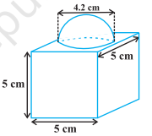 | 5
2 | The boilers are used in thermal power plants to store water and then used to produce steam. One such boiler consists of a cylindrical part in middle and two hemispherical parts at its both ends. Length of the cylindrical part is 7m and radius of cylindrical part is 7 / 2 m. Find the total surface area and the volume of the boiler. Also, find the ratio of the volume of cylindrical part to the volume of one hemispherical part.  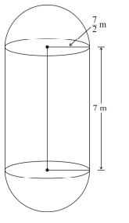 | 5
3 | From a market you purchased a cube and an ice-cream cone for your sister. Seeing these your sister became very happy and asked you some questions. Observe the figures and answer the questions-:  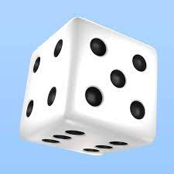  1. The length of the diagonal of the cube if each edge measures 6cm is:  a) 4√3  b) 3√6  c) 7√2  d) 6√2  - If the length of the edge of the cube is 7cm, then its volume is:  a) 256 cm³  - 196 cm³  - 343 cm³  - 434 cm³  - What is the curved surface area of hemisphere (ice cream) if the base radius is 7cm?  - 309 cm²  - 308 cm²  - 803 cm²  - 903 cm²  - Slant height of a cone if the radius is 7cm and the height is 24 cm is:  - 26cm  - 25 cm  - 52 cm  - 62cm  - The total surface area of cone with hemispherical ice cream is:  - 858 cm²  - 885 cm²  - 588 cm²  855 cm² | 5
4 | A toy is in the form of a cylinder with hemispherical ends. If the whole length of the toy is 90 cm and its diameter is 42 cm, find the cost of painting the toy at the rate of 70 paise per square cm. | 5
5 | A cylinder vessel of radius 18 cm and height 70 cm is half filled with water. Rohan put a spherical ball in the vessel. By doing this the height of water raised 24 cm. On the basis of this find answer of the following questions:  - Find the radius of the sphere. (1 marks)  - Find the capacity of cylindrical vessel in litres. (2 marks)  If Rohan wanted to paint the sphere with blue colour then find the cost of painting at the rate of Rs 57 per square cm. (2 marks) | 5
 | ANSWERS
1 | The total surface area of the cube = 6 × (edge)² = 6 × 5 × 5 cm² = 150 cm² the surface area of the block = TSA of cube – base area of hemisphere + CSA of hemisphere  =150 – πr² + 2 πr² = (150 + πr² ) cm²  = 163.86 cm² | 5
2 | Total surface area = CSA of cylinder + 2 CSA of hemisphere  = 2πrh + 4 πr²  Total volume= volume of cylinder + 2 volume of hemisphere  = πr²h +4/3 πr³  ratio of the volume of cylindrical part to the volume of one hemispherical part = πr²h / 2/3πr³= 3:1 | 5
3 | i) ) 6√2  ii)343cm³  iii)308cm²  iv)25cm  v)858cm² | 5
4 | Length of clylinder=90-42=48cm  Area to be painted= CSA of cylinder+CSA of hemisphere  =2πrh+4πr²=2πr(h+2r)  =2x22x3(90)cm²  Cost of painting=132x90x70/100  =rs 8316 | 5
5 | - Let radius of sphere is R cm  Volume of sphere = volume of water raised in cylinder  $\frac{4}{3}$ 𝜋 R³ = 𝜋 𝑟² ℎ  $\frac{4}{3}$ 𝜋 R³ = 𝜋 x 18² x 24  R³ = 18 × 18 × 18  R = 18 cm. (1.5 marks)  - Capacity of cylindrical vessel = 𝜋𝑟² ℎ  = 22/ 7 × 18² × 70  = 22× 18 × 18 × 10 = 71,280 cm³  = 712.8 litre ( 1 litre = 1000 cubic cm)  (1.5 marks)  - Surface area of sphere = 4𝜋𝑟 ²  = 4 × 22/7 × 18 × 18  = 28512 /7  = 4073.14 sq. cm  Cost of painting = 4073.14 × 5 = 4073.14 x 5 =20365.7 paise  = Rs 203.65  (2 marks) | 5

CHAPTER – 14
STATISTICS

SYLLABUS:
Mean, median and mode of grouped data (bimodal situation to be avoided).

SL NO | QUESTION | MARK
 | MULTIPLE - CHOICE QUESTIONS
1 | The Arithmetic Mean of 1,2, 3, 4, …. n is  (a) 𝑛+1/ 2 (b) 𝑛 /2 (c) 𝑛−1/ 2 (d) 𝑛 /2 +1 | 1
2 | Which is the empirical relation between Mean, Median and Mode  (a) 3Mean =Mode +2Median  (b) 3Median=Mode +2Mean  (c) 2Median= Mode +3Mean  (d) 3Median=Mode -2Mean | 1
3 | If Median of data 16,18, 20, 24-x, 20 + 2x, 28, 30, 32 is 24 then x is  (a) 4 (b) 18 (c) 16 (d) 20 | 1
4 | If Mode of data 64, 60, 48, x, 43, 48, 43, 34 is 43 then x+3 is  (a) 44 (b) 45 (c) 46 (d) 48 | 1
5 | Mean of the following distribution is 2.5. Find the value of ‘y’  (a) 3 (b) 4 (c) 5 (d) 2 | 1
6 | If Arithmetic Mean of x, x+2, x+4 and x+6 is 5. Then find the value of x is  (a) 3 (b)2 (c) 1 (d) 5 | 1
7 | If mean of first n natural number is 5𝑛/ 9 then n is  (a) 5 (b) 4 (c) 9 (d) 10 | 1
8 | The Mean of five number is 15. If we include one more number, the mean of 6 numbers become 17. The included number is  (a) 24 (b) 2 (c) 26 (d) 27 | 1
9 | The algebraic sum of deviation of frequency distribution from its mean is  (a) 0 (b) 1 (c) -1 (d) 2 | 1
10 | 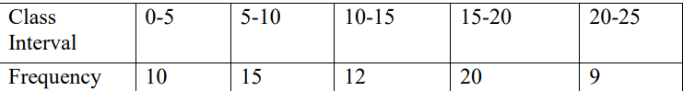  For the following distribution, The sum of lower limits of Median class and Modal  class is  (a) 15 (b) 25 (c) 30 (d) 35 | 1
11 | If the mean of first n natural numbers is 3n/5, then the value of n is:  - 3  - 4  - 5  - 6 | 1
12 | If the sum of frequencies is 24, then the value of x in the observation: x, 5,6,1,2, will be:  - 4  - 6  - 8  - 10 | 1
13 | 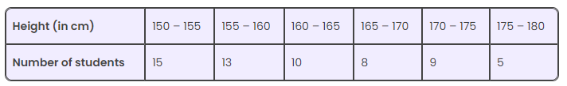  Consider the following frequency distribution of the heights of 60 students of a class:  The sum of the lower limit of the modal class and upper limit of the median class is:  - 310  - 315  - 320  - 325 | 1
14 | The times, in seconds, taken by 150 athletes to run a 110 m hurdle race are tabulated below:  The number of athletes who completed the race in less than 14.6 seconds is  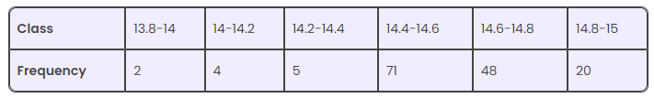  - 11  - 71  - 82  - 130 | 1
15 | If the mean of frequency distribution is 7.5 and ∑fi xi = 120 + 3k, ∑fi = 30, then k is equal to:  - 40  - 35  - 50  - 45 | 1
16 | If Arithmetic Mean of a, a+3, a+6, a+9 and a+12 is 10, then a is equal to:  - 1  - 2  - 3  - 4 | 1
17 | The mean of 25 observations is 9. If each observation is increased by 4, then the new mean is  - 14  - 17  - 15  - d)13 | 1
18 | The mean age of combined group of men and women is 30 years. If the mean of the age of men and women are respectively 32 and 27, then the percentage of women in the group is:  - 30  - 20  - 50  - 40 | 1
19 | A data has 25 observations arranged in descending order. Which observation represents the median?  - 12th  - 13th  - 14th  - 15th | 1
20 | If a is mode, b is mean and c is median of a given data, then  - 3c = a + 2b  - 3b = 2a + c  - 3b = a + 2c  - a= b + c | 1
21 | Construction of cumulative frequency table is useful in determining the?  - MEAN b) MEDIAN c) MODE d)NONE | 1
22 | Find the mode of the following items.  0, 5, 5, 1, 6, 4, 3, 0, 2, 5, 5, 6  - 1 b) 5 c) 6 d)0 | 1
23 | If Median of data 16,18, 20, 24-x, 20 + 2x, 28, 30, 32 is 24 then x is  - 4 b) 5 c) 6 d)0 | 1
24 | Find the class marks of classes 10-25  - 17.5 b) 18.5 c) 17.66 d)NONE | 1
25 | If the mean of data is 27 and mode is 45 then median is:  a. 30 b. 27 c. 32 d. 33 | 1
 | ANSWERS | 1
1 | (n+1)/2 | 1
2 | 3Median=Mode +2Mean | 1
3 | 4 | 1
4 | 46 | 1
5 | 4 | 1
6 | 2 | 1
7 | 9 | 1
8 | 27 | 1
9 | 0 | 1
10 | 25 | 1
11 | c) 5 | 1
12 | d)10 | 1
13 | b) 315 | 1
14 | C) 82 | 1
15 | b) 35 | 1
16 | d)4 | 1
17 | d)13 | 1
18 | d)40% | 1
19 | b) 13 | 1
20 | 3c = a + 2b | 1
21 | b) | 1
22 | b) | 1
23 | a)X = 4 | 1
24 | a)Class mark of 10-25 = (10+25)/2=35/2 = 17.5 | 1
25 | d | 1
 | ASSERTION & REASON QUESTIONS
Choose the correct option in the following questions of Assertion – Reason Questions.
(a) Both A and R are correct; R is the correct explanation of A.
(b) Both A and R are correct; R is not the correct explanation of A.
(c) A is true but R is false
(d) A is false but R is true
1 | Assertion: The mode of the call received on 7 consecutive day 11,13,13,17,19,23,25 is 13.  Reason: Mode is the value that appears most frequent. | 1
2 | Assertion: If the value of mode and mean is 60 and 66 respectively, then value of median is 64.  Reason: Median = (mode+2mean) | 1
 | ANSWERS
1 | a | 1
2 | c | 1
 | 2 MARKS TYPE QUESTIONS
1 | In a class test, the mean score of the class is 60. Half the students of the class scored 80 marks or above in the test.  Dipti said, “Each of the remaining half of the students would have definitely got 40 marks or below in the test for the mean to be 60 marks.”  Prove or disprove Dipti’s statement with a valid example. | 2
2 | The mileage (km per litre) of 50 cars of the same model was tested by a manufacturer and details are tabulated as given below:  Find the mean mileage. The manufacturer claimed that the mileage of the model was 16 km/l. | 2
  Mileage(km/l) | 10-12 | 12-14 | 14-16 | 16-18
  No. of persons | 7 | 12 | 18 | 15
3 | If the mean of the following distribution is 8.find the value of P. | 2
  x | 2 | 4 | 6 | 10 | P+5
  y | 3 | 2 | 3 | 1 | 2
4 | Given that the mean of 5 numbers is 27.If one of the number is excluded, the mean gets reduced by 2 . Determine the excluded number. | 2
5 | Find the value of x , if the mode of the following data is 25:  15, 20, 25, 18,14,15,25, 15,18,16,20,25,20, x, 18. | 2
6 | If the mean of the following distribution is 50. Find the value of F₁ . | 2
  Class-interval | 0-20 | 20-40 | 40-60 | 60-80 | 80-100
  Frequency | 17 | 28 | 32 | F₁ | 19
7 | 250 apples of a box were weighed and the distribution of masses of the apples is given  in the following table :  Find the modal mass of the apple. | 2
  Mass(in grams) | 80-100 | 100-120 | 120-140 | 140-160 | 160-180
  No of apples | 20 | 60 | 70 | x | 60
8 | If the mean of 4 numbers, 2, 6, 7 and a is 15 and also the mean of other 5 numbers, 6, 18, 1, a, b is 50. What is the value of b? | 2
9 | The modal class of the grouped size frequency table given below is | 2
  5-5.2 | 5.2-5.4 | 5.4-5.6 | 5.6-5.8 | 5.8-6.0
  20 | 5 | 5 | 12 | 8
10 | The points scored by a basketball team in a series of matches are as follows:  17, 2, 7, 27, 25, 5, 14, 18, 10. Find the median. | 2
 | ANSWERS | 2
1 | Writes that Dipti’s claim is not correct - 0.5  Writes a valid example by showing scores of some students where the mean is 60 marks, half of the students scored 80 marks or above, but the rest have scored both above and below 40 marks.  For example , consider there are 4 students in the class with scores 80,90,20 and 50. The mean is 60 marks, half of them got 80 or above, but one score in the remaining half is above 40. - 1.5 | 2
2 | 14.48 km/l | 2
3 | Mean= Σxy/Σy ⇒ 8=(52+2p)/11  2p=36 , So p=18 | 2
  x | y | xy
  2 | 3 | 6
  4 | 2 | 8
  6 | 3 | 18
  10 | 1 | 10
  P+5 | 2 | 2p+10
   | Σy =11 | Σxy=52+2p
4 | Solution:- Mean of 5 numbers=27  Sum of 5 numbers =27x5=135  Mean of remaining 4 numbers=27-2=25  Sum of remaining 4 numbers =25x4=100  ∴ Excluded number=135 -100=35 | 2
5 | Soln : Mode = 25  ∴ 25 has maximum frequency.  Hence x = 25 | 2
6 | Mean= Σx_{i}f_{i} / Σf_{i}  ⇒50(96+f₁) = 4320+70f1  ⇒4800 + 50f₁ = 4320+70f1  ⇒4800 - 4320 = 70f₁ – 50f₁  ⇒20f₁ =480  ∴f₁ =24 | 2
  C. I. | x_{i} | f_{i} | x_{i}f_{i}
  0-20 | 10 | 17 | 170
  20-40 | 30 | 28 | 840
  40-60 | 50 | 32 | 1600
  60-80 | 70 | F₁ | 70f₁
  80-100 | 90 | 19 | 1710
   |  | Σf_{i}=96+f₁ | Σx_{i}f_{i}=4320+70f₁
7 | Solution: 20+60 +70 +x +60 = 250  ∴ x = 250-210=40  Modal class= 120-140  Mode = l +[(f₁-f₀)/(2f₁ –f₀ –f₂ )] x h  = 120 + [(70 – 60)/(140-60-40)]x20  =125  Hence modal mass is 125 g. | 2
8 | 180 | 2
9 | 5-5.2 | 2
10 | 14 | 2
 | 3 – MARKS TYPE QUESTIONS
1 | The median of the distribution given below is 14.4. Find the values of x and y, if the sum of all the frequencies is 20. | 3
  Class interval | 0-6 | 6-12 | 12-18 | 18-24 | 24-30
  Frequency | 4 | X | 5 | Y | 1
2 | Following is the distribution of marks obtained by 60 students in science test:  Calculate the arithmetic mean. | 3
  Marks | No. of students
  More than 0 | 60
  More than 10 | 56
  More than 20 | 40
  More than 30 | 20
  More than 40 | 10
  More than 50 | 3
3 | If mode of data is 23/7 , then find x and y | 3
  Class interval | 1-3 | 3-5 | 5-7 | 7-9 | 9-11 | Total
  Frequency | X | 8 | Y | 2 | 1 | 20
4 | Bowling strike rate for a bowler is defined as the average number of balls bowled per wicket taken. A bowler has taken 148 wickets so far with a strike rate of 27. In his next match, he bowls 48 balls and takes 2 wickets.  What is his new strike rate? Show your work. | 3
5 | The frequency distribution of daily rainfall in a town during a certain period is shown below.  Unfortunately, due to manual errors, the information on the 20-40 mm range got deleted from the data. If the mean daily rainfall for the period was 35mm, find the number of days when the rainfall ranged between 20-40 mm. Show your work | 3
  Rainfall (in mm) | Number of days
  0-20 | 7
  20-40 | x
  40-60 | 10
  60-80 | 4
6 | If the mean of the following distribution is 6, find the value of‟p‟. | 3
  x | 2 | 4 | 6 | 10 | p+6
  y | 3 | 2 | 3 | 1 | 2
7 | Find the median of the following data: | 3
  Wages(Rs) | No of workers
  More than 150 | nil
  More than 140 | 12
  More than 130 | 27
  More than 120 | 60
  More than 110 | 105
  More than 100 | 124
  More than 90 | 141
  More than 80 | 150
8 | If mode of the following frequency distribution is 55, then find the value of x. | 3
  class | freuency
  0-15 | 10
  15-30 | 7
  30-45 | X
  45-60 | 15
  60-75 | 10
  75- 90 | 12
9 | The mean of the following frequency distribution is 25. Find the value of f. | 3
  class | 0-10 | 10-20 | 20-30 | 30-40 | 40-50
  Frequency | 5 | 18 | 15 | f | 6
10 | The mean of the following data is 18.75. Find the value of P | 3
  Class Mark | Frequency
  10 | 5
  5 | 10
  P | 7
  25 | 8
  30 | 2
 | ANSWERS
1 | X=4 and Y=6 | 3
2 | Mean = 26.5 | 3
3 | X= 7 and y= 2 | 3
4 | Find the total number of balls bowled by the baller so far as 148x27=3996  Finds the total number of balls bowled after the last match as 3996+48=4044.  and the total number of wickets taken after the latest match as 148+2=150.  Find the new strike rate of the bowler as (total number of balls bowled)/(total number of wickets taken) = 4044/150 = 26.96 | 3
5 | Complete the frequency table as :  Writes the equation for mean as ;  850+30x/21+x =35  Solves the equation in step 2 to find the value of x as 23. | 3
  Rainfall (in mm) | No. of days (f_{i}) | class mark (x_{i}) | (f_{i}x_{i})
  0-20 mm | 7 | 10 | 70
  20-40 mm | x | 30 | 30x
  40-60 mm | 10 | 50 | 500
  60-80 mm | 4 | 70 | 280
  Total | 21+x |  | 850+30x
6 | P = 7 | 3
7 | N=150 , N/2 = 75  ∴Median class= 110 – 120  I= 110, f=45 ,c f =45 ,h=10  Median =l + [(N/2- cf)/f] xh  =110 + ( 30/45) x 10 = 116.67 | 3
  Wages(Rs) | f | cf
  80-90 | 9 | 9
  90-100 | 17 | 26
  100-110 | 19 | 45
  110-120 | 45 | 90
  120-130 | 33 | 123
  130-140 | 15 | 138
  140-150 | 12 | 150
8 | Mode=55 , So Modal class= 45-60  Mode = l +[(f₁-f₀)/(2f₁ –f₀ –f₂ )] x h  Or,55 =45 + 15x(15-x)/(2x15-x-10 )  Or, 55 = 45 + (225- 15x)/ 30-x-10  Or, 55(20-x) = 45(20-x) +225-15x  Or,1100 - 55x = 900 -45x +225 -15x  Or, 5x=1125-1100  ∴x=5 | 3
9 | Mean= Σx_{i}f_{i} / Σf_{i}  Or,25 = (940+35f)/ (44 +f)  ∴ f = 16 | 3
  Class | x_{i} | f_{i} | x_{i}f_{i}
  0-10 | 5 | 5 | 25
  10-20 | 15 | 18 | 270
  20-30 | 25 | 15 | 375
  30-40 | 35 | f | 35f
  40-50 | 45 | 6 | 270
  Total |  | Σf_{i}=44 +f | Σxif_{i} =940+35f
10 | 20 | 3
 | 4 – MARKS TYPE QUESTIONS (CASE BASED QUESTIONS)
1 | Formula one Portuguese Grand Prix technical team at the Algarve International Circuit are analysing last year data of drivers’ performance to provide valuable inferences to commentators on how the drivers can improve this year. The length of time taken by 80 drivers to complete a journey is given in the table below: Times (in minutes)  (i) What is the estimate of the mean time (in minutes) taken to complete the journey (a) 105 (b) 94 (c) 101 (d) 112  (ii) In which interval does the median of the distribution lie?  (a) 80-90 (b) 90-100 (c) 100-110 (d) 110-120  (iii)In which interval does the mode of the distribution lie?  (a) 80-90 (b) 90-100 (c) 100-110 (d) 110-120  (iv) What is the model time taken to complete journey ?  (a) 112 (b) 118 (c) 101 (d) 108 | 4
2 | Apples are most widely planted and are commercially the most important fruit crop in Jammu and Kashmir. The cultivation of apple crop in Jammu and Kashmir shows particular interest for a number of reasons. In terms of both area and production, apple is very beneficial fruit crop. This provides a major source of income and employment in Jammu and Kashmir.  Horticultural department has tasked their statistical officer to create a model for farmers to be able to predict their produce output based on various factors. A box containing 250 apples was opened and each apple was weighed. The distribution of the masses of the apples is given in the following table:  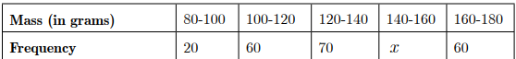  (i) How many apples are in the range 140-160 mass?  (a) 40 (b) 50 (c) 60 (d) 70  (ii) What is the mean mass of the apples?  - 131 grams (b) 135 grams (c) 150 grams (d) 156 grams  (iii) What is the upper limit of the median class?  - 80 (b) 100 (c) 120 (d) 140  (iv) What is the modal mass of the apples?  (a) 122 grams (b) 125 grams (c) 128 grams (d) 132 grams | 4
3 | 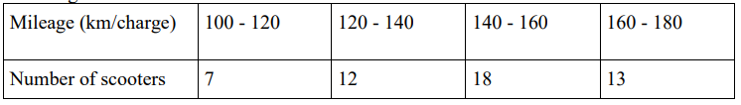  An electric scooter manufacturing company wants to declare the mileage of their electric scooters. For this, they recorded the mileage (km/charge) of 50 scooters of the same model. Details of which are given in the following table.  Based on the above information, answer the following questions.  (i) The average mileage is  (a) 140 km/charge (b) 150 km/charge (c) 130 km/charge (d) 144.8 km/charge  (ii) The modal value of the given data is  (a) 150 (b) 150.91 (c) 145.6 (d) 140.9  (iii) The median value of the given data is  - 140 (b) 146.67 (c) 130 (d) 136.6  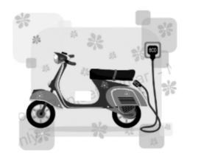  (iv) The manufacturer can claim that the mileage for his scooter is  (a) 144 km/charge  (b) 155 km/charge  (c) 165 km/charge  (d) 175 km/charge | 4
4 | An inspector in an enforcement squad of electricity department visit to a locality of 100 families and record their monthly consumption of electricity, on the basis of family members, electronic items in the house and wastage of electricity, which is summarise in the following table.  Based on the above information, answer the following questions.  (i) The value of x + y is  (ii) If the median of the above data is 525, then x is equal to  iii) What will be the upper limit of the modal class?  (iv) The average monthly consumption of a family of this locality is approximately | 4
  Monthly consumption in kwh | No. of families
  0-100 | 2
  100-200 | 5
  200-300 | X
  300-400 | 12
  400-500 | 17
  500-600 | 20
  600-700 | Y
  700-800 | 9
  800-900 | 7
  900-1000 | 4
  (a) 100 | (b) 42 | (c) 24 | (d) 200
  (a) 10 | (b) 8 | (c) 9 | (d) none of these
  (a) 400 | (c) 650 | (b) 600 | (d) 700
  (a) 520 kwh | (b) 522 kwh | (c) 540 kwh | (d) none of these
5 | During the annual sports meet in a school , all the athletes were very enthusiastic .They all wanted to be a winner so that their house could stand first. The instructor noted down the time taken by a group of students to complete a certain race .the data recorded is given below:  Based on the above information, give the answer of the following:  - What is the class mark of the model class?  - Find the median class of the given data.  - Find the mode of the given data. | 4
  Time(in seconds) | No. of students
  0-20 | 1
  20-40 | 4
  40-60 | 3
  60-80 | 7
  80-100 | 5
 | ANSWERS
1 | (i)a is correct option (ii) c is correct option.  (iii) Class 110-120 has the maximum frequency 24, therefore this is model class. (d) is correct option.  (iv) Here, l = 110, f1 = 24, f0 = 20, f2 = 8 and h = 10 (d) is correct option | 4
2 | 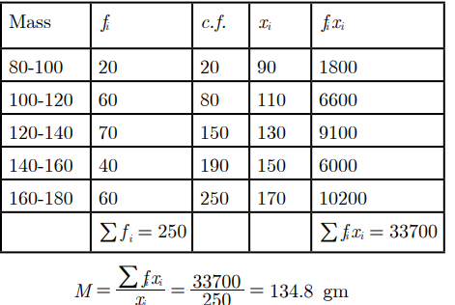  (I)Ans : 20 +++ 60 70 x + 60 = 250 210 + x = 250 x = 250 − 210 = 40Thus (a) is correct option  (II) (b) is correct option.  (III) Cumulative frequency just greater than N/2=250/2=125 is 150 and the corresponding class is 120-140. Thus median class is 120-140 and upper limit is 140. Thus (d) is correct option.  (IV) Class 120-140 has the maximum frequency 70, therefore this is model class. Here, l = 120, f1 = 70, f0 = 60, f2 = 60 and h = 20, Thus (b) is correct option. | 4
3 | i)d ii)b iii)b iv)a | 4
4 | We have the following table:  - (c): Here, it is given that total frequency = 100  ∴ 76 + x + y = 100 ⇒⇒ x + y = 24  - (c)  - (b) Since, maximum frequency is 20, so modal class is 500 - 600. Hence, upper limit of modal class is 600  - (b) : Since, x + y = 24 ⇒⇒ y = 24 - 9 = 15  Required average consumption=  $$\frac{50×2+150×5+250×9+350×12+450×17+550×20+650×15+750×9+850×7+950×4}{100}$$  = $\frac{52200}{100}$ = 522kwh | 4
  Class interval | Frequency | Cumulative frequency
  0-100 | 2 | 2
  100-200 | 5 | 7
  200-300 | x | 7+ x
  300-400 | 12 | 19 + x
  400-500 | 17 | 36 + x
  500-600 | 20 | 56 + x
  600-700 | y | 56 + x + y
  700-800 | 9 | 65 + x + y
  800-900 | 7 | 72 + x + y
  900-1000 | 4 | 76 + x + y
  Total | 76 + x + y
5 | - 60-80 (ii) 60-80  (iii) Mode = l +[(f₁-f₀)/(2f₁ –f₀ –f₂ )] x h  =60+[(7-3)/(14-3-5)]x20  =60+(4/6) x20 =60+13.3=73.3 | 4
 | 5 – MARKS TYPE QUESTIONS
1 | The following distribution shows the daily pocket allowance of children of a locality.  The mean pocket allowance is Rs. 18. Find the missing frequency f. | 5
  Daily pocket allowance(in Rs.) | 11-13 | 13-15 | 15-17 | 17-19 | 19-21 | 21-23 | 23-25
  Number of children | 7 | 6 | 9 | 13 | f | 5 | 4
2 | If the median of the distribution given below is 28.5, find the values of x and y. | 5
  Class interval | Frequency
  0−10 | 5
  10−20 | x
  20−30 | 20
  30−40 | 15
  40−50 | y
  50−60 | 5
  Total | 60
3 | The mean of the following distribution is 53. Find the missing frequencies f1 and f2 | 5
4 | If the median of the distribution is 28.5, find the values of x and y | 5
5 | Find the missing frequencies when the mean of dats is 53. | 5
  Age | 0-20 | 20-40 | 40-60 | 60-80 | Total
  Number of people | 15 | F1 | 21 | F2 | 17
 | ANSWERS
1 | Σf_{i}x_{i}= 752+20f , Σf_{i} = 44 + f  Mean= Σf_{i}x_{i /} Σf_{i}  18 = (752 + 20f) = (44 + f)  ∴ f = 20 | 5
  C .I | 11-13 | 13-15 | 15-17 | 17-19 | 19-21 | 21-23 | 23-25
  x_{i} | 12 | 14 | 16 | 18 | 20 | 22 | 24
  f_{i} | 7 | 6 | 9 | 13 | f | 5 | 4
  X_{i} f_{i} | 84 | 84 | 144 | 234 | 20f | 110 | 96
2 | Median = 28.5 , so median class=20-30, l=20 , f=20 , c f = 5+ x , h =10 ,n=60  Median= l + h (n/2 –cf)/ f  28.5= 20+ 10(30-5-x)/20 ∴x= 8  Again, 45+x+y =60  45+8+y =60  ∴ y = 7 | 5
  C I | f | C F
  0-10 | 5 | 5
  10-20 | x | 5+x
  20-30 | 20 | 25+x
  30-40 | 15 | 40+x
  40-50 | y | 40+x+y
  50-60 | 5 | 45+x+y
  Total | 60
3 | 53+f1+f2= 100,  f1+ f2 =47…………. (A)  mean=53  (2730+30𝑓1+70𝑓2)/ 100 = 53…………...(B)  Solving A and B f1= 18, f2=29 | 5
4 | median= 28.5, n=60, median class 20-30, l=20, h=10, f=20,  cf=5+x  28.5= 20+30−(5+𝑥) /20 ∗ 10  x=8, also x+y+45=60,  y=7 | 5
5 | F1=18  F2=29 | 5
CHAPTER – 15
PROBABILITIY

SYLLABUS:
Classical definition of probability. Simple problems on finding the probability of an event.

SL NO | QUESTION | MARK
 | MULTIPLE - CHOICE QUESTIONS
1 | Which of the following cannot be the probability of an event?  (a) 0.01 (b) 3% (c) 16/17 (d) 17/16 | 1
2 | Ishan is a wholesale dealer in eggs. He procures eggs directly from the poultry farms and sells them to the nearby stores.  The probability of getting a bad egg in a lot of 500 is 0.014. the number of bad eggs in the lot is:  (a) 14 (b) 7 (c) 17 (d) 21 | 1
3 | f P(A) denotes the probability of an event A then:  (a) P(A) < 0 (b) P(A) > 0 (c) 0 < P(A) < 1 (d) -1 < P(A) < 0 | 1
4 | A die is thrown once. What is the probability of getting a number less than 3?  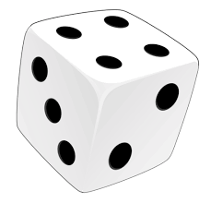  (a) 1/4 (b) 1/3 (c) 1/7 (d) 1/2 | 1
5 | A coin is tossed two times. Find the probability of getting at most one head.  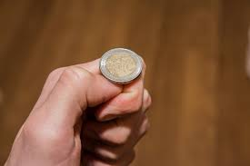  (a) 1/4 (b) 1/2 (c) 3/4 (d) 4/3 | 1
6 | If you flip a fair coin twice, what's the probability of getting heads both times?  a)1/4. b) 1/2. c) 3/4. d)1 | 1
7 | Two dice are rolled. What's the probability that the sum of the numbers on the dice is 7?  a) 1/3. b) 2/3. c) 1/6. d)5/6 | 1
8 | A bag contains 5 red balls and 3 blue balls. If you draw a ball, what's the probability of getting a red ball?  a) 3/8. b) 5/8. c) 1. d)none of these | 1
9 | A spinner is divided into 4 equal sections, numbered 1 to 4. If the spinner is spun once, what's the probability of getting an odd number?  a) 1 b) 1/4 c) 1/2 d)3/4 | 1
10 | In a deck of cards, what's the probability of drawing a heart or a diamond?  a) 1/2 b) 1/13. c) 1/4 d)5/13 | 1
11 | If you roll a six-sided die, what's the probability of rolling a number greater than 4?  a) 1/2. b) 1/3. c) 2/3 d)1 | 1
12 | A jar contains 10 green marbles and 5 yellow marbles. If a marble is drawn at random, what's the probability of getting a yellow marble?  a) 1/2. b) 1/3. c) 1/4 d)2/3 | 1
13 | A bag contains 8 white balls and 4 black balls. What's the probability of drawing a black ball without looking?  a) 1 b) 2/3 c) 1/3 d)5/6 | 1
14 | A letter is chosen at random from the word "PROBABILITY". What's the probability that the letter chosen is a vowel?  a) 1/11 b) 2/11 c) 7/11 d)4/11 | 1
15 | A spinner is divided into 8 sections, labeled A to H. If the spinner is spun once, what's the probability of landing on a consonant?  a) 1/2. b) 1/4 c) 1/8. d)5/8 lo | 1
16 | Which of the following cannot be the probability of an event?  (a) $\frac{1}{3}$ (b) 0.1 (c) 3% (d) $\frac{115}{31}$ | 1
17 | The probability that a number selected at random from the numbers 1, 2, 3, ......, 15 is a multiple of 4 is  (a) $\frac{4}{15}$ (b) $\frac{2}{15}$ (c) $\frac{1}{15}$ (d) $\frac{1}{5}$ | 1
18 | If the probability of an event is x, then the probability of its complementary event will be  (a) x – 1 (b) x (c) 1 - x (d) 1 - $\frac{1}{x}$ | 1
19 | The probability of getting a bad egg in a lot of 600 is 0.035. The number of bad eggs in the lot is  (a) 7 (b) 14 (c) 21 (d) 28 | 1
20 | Out of one-digit prime numbers, one number is selected at random. The probability of selecting an even number is  (a) $\frac{1}{3}$ (b) $\frac{1}{4}$ (c) $\frac{3}{4}$ (d) $\frac{2}{3}$ | 1
21 | A single letter is selected at random from the word SQUARE. The probability that the selected letter is a vowel is  (a) $\frac{2}{3}$ (b) $\frac{1}{2}$ (c) $\frac{3}{5}$ (d) 0 | 1
22 | The probability that a two-digit number selected at random will be a multiple of 3 and not a multiple of 5 is  (a) $\frac{2}{15}$ (b) $\frac{1}{15}$ (c) $\frac{4}{15}$ (d) $\frac{2}{45}$ | 1
23 | If the probability of winning a game is 0.07, what is the probability of losing it?  (a) 0.7 (b) 0.03 (c) 0.93 (d) 0.28 | 1
24 | A die is thrown once. Find the probability of getting a composite number.  (a) $\frac{1}{6}$ (b) $\frac{1}{3}$ (c) $\frac{4}{5}$ (d) $\frac{2}{5}$ | 1
25 | A pair of dice is thrown once. What is the probability of getting a doublet?  (a) $\frac{1}{6}$ (b) $\frac{1}{36}$ (c) $\frac{4}{15}$ (d) $\frac{2}{15}$ | 1
 | ANSWERS | 1
1 | (d) | 1
2 | (b) | 1
3 | ( c) | 1
4 | (b)  Total number of outcomes = n(S) = 6  i.e. S = {1, 2, 3, 4, 5, 6}  n(E) = Number of outcomes favourable to the event E = 2  Since E = {1, 2}  Hence, the required probability = P(E) = n(E)/n(S)  = 2/6  = 1/3 | 1
5 | ( c)  When two coins are tossed, the total no of outcomes = 22 = 4  i.e. (H, H) (H, T), (T, H), (T, T)  Possible outcomes = (H, T), (T, H), (H, H)  Number of possible outcomes = 3  Hence, the required probability = ¾ | 1
6 | a) The probability of getting heads on a fair coin is 1/2. Since each coin flip is independent, the probability of getting heads on both flips is (1/2) * (1/2) = 1/4. | 1
7 | c). The possible outcomes that result in a sum of 7 are (1, 6), (2, 5), (3, 4), (4, 3), (5, 2), and (6, 1). There are 6 favorable outcomes out of a total of 36 possible outcomes, so the probability is 6/36 = 1/6. | 1
8 | b) The bag contains a total of 5 + 3 = 8 balls. The probability of drawing a red ball is 5/8. | 1
9 | a) The spinner has 4 odd numbers out of a total of 4 possible outcomes. Therefore, the probability of getting an odd number is 4/4 = 1. | 1
10 | a) There are 26 red cards in a deck of 52 cards (13 hearts + 13 diamonds). The probability of drawing a heart or a diamond is 26/52 = 1/2. | 1
11 | b)The numbers greater than 4 on a six-sided die are 5 and 6. The probability of rolling a number greater than 4 is 2/6 = 1/3. | 1
12 | b)The jar contains a total of 10 + 5 = 15 marbles. The probability of drawing a yellow marble is 5/15 = 1/3. | 1
13 | c)The total number of balls is 8 + 4 = 12. The probability of drawing a black ball without looking is 4/12 = 1/3. | 1
14 | d)The word "PROBABILITY" has 4 vowels (O, I, A, I). The probability of drawing a vowel is 4/11. | 1
15 | d)There are 5 consonants (B, R, B, L, T) out of a total of 8 letters. The probability of landing on a consonant is 5/8. | 1
16 | (d) $\frac{115}{31}$ | 1
17 | (d) $\frac{1}{5}$ | 1
18 | (c) 1 - x | 1
19 | (c) 21 | 1
20 | (b) $\frac{1}{4}$ | 1
21 | (b) $\frac{1}{2}$ | 1
22 | (c) $\frac{4}{15}$ | 1
23 | (c) 0.93 | 1
24 | (b) $\frac{1}{3}$ | 1
25 | (a) $\frac{1}{6}$ | 1
 | ASSERTION & REASON QUESTIONS
Choose the correct option in the following questions of Assertion – Reason Questions.
(a) Both A and R are correct; R is the correct explanation of A.
(b) Both A and R are correct; R is not the correct explanation of A.
(c) A is true but R is false
(d) A is false but R is true
1 | Assertion: Probability of getting a prime number greater than 5 on a single throw of die is 1/6.  Reason: Probability of sure event is always 1 | 1
2 | Assertion: Probability of drawing a face card is more than probability of drawing a red card.  Reason: there are 52 cards of which 26 are red cards and 12 are face cards. | 1
3 | Assertion (A): If a box contains 5 White, 2 Red and 4 Black marbles. Than the probability of not drawing a white marble from the box is 5/11.  Reason (R): P(Not E) = 1 – P(E), where E is an event. | 1
4 | Assertion (A): Card numbered as 1,2,3….15 are put in a box and mixed, one card is than drawn at random. The probability of drawing an even number is 1/2.  Reason (R): For any event E, we have 0 ≤ P (E) ≤ 1. | 1
 | ANSWERS
1 | d) | 1
2 | d) Explanation: probability of drawing a red card is $\frac{26}{52}$ = ½  probability of drawing a face card is =$\frac{12}{52}$ =3/13 | 1
3 | D | 1
4 | D | 1
 | 2 MARKS TYPE QUESTIONS
1 | An integer is chosen at random between 1 and 100. Find the probability that it is  (i) Divisible by 8  (ii) Not divisible by 8 | 2
2 | In a family of two children, find the probability of having at least one boy.   | 2
3 | A girl calculates that the probability of her winning the first prize in a lottery is 0.06. if 8000 tickets are sold, then how many tickets has she bought? | 2
4 | You have a bag containing 4 red marbles, 3 blue marbles, and 2 green marbles. If you pick a marble randomly without looking, what is the probability that it's not blue? | 2
5 | A standard deck of playing cards (52 cards) has 4 suits, each with 13 cards. If you draw two cards randomly without replacement, what is the probability that both cards are hearts? | 2
6 | A spinner is divided into four equal sections: A, B, C, and D. If the spinner is spun twice, what is the probability of landing on section A both times? | 2
7 | In a box of chocolates, 6 are filled with caramel and 9 are filled with nuts. If two chocolates are chosen at random without replacement, what is the probability that both are filled with caramel? | 2
8 | A bag contains 5 red balls and 3 green balls. If two balls are drawn without looking, what is the probability that one ball is red and the other ball is green? | 2
9 | A number is chosen at random from the numbers -3, -2, -1, 0, 1, 2, 3. What will be the probability that square of this number is less than or equal to 1. | 2
10 | A letter of English alphabet is chosen at random, find the probability that the letter so chosen is (i) a vowel (ii) a consonant. | 2
 | ANSWERS | 2
1 | Number of integers between 1 and 100:  2, 3, 4, 5, --------------99.  Sample space or total outcomes n(S) = 98  i) Numbers which are divisible by 8 are: 8, 16, 24, 32, 40, 48, 56, 64, 72, 80, 88, 96  so number of possible event n(E) = 12  now probability divisible by 8 , P(E)= n(E) /n(S)= 12/98= 6/49  ii) P (not divisible by 8 ) = 1- 6/49= 43/49 | 2
2 | Possible outcomes of family having two children  [ GG, BG, GB, BB]  Total no. of Outcomes = 4  Outcomes with at least one boy = [ BG, BB, GB]  ∴ Number of favourable outcomes= 3  ∴ P (at least one boy) = ¾ | 2
3 | Suppose she bought n tickets. Total number of tickets is 8000  ∴ Probability of winning the first prize = n/8000  ⇒ 0.06= n/8000  ⇒ n = 480 | 2
4 | The total number of marbles is 4 + 3 + 2 = 9. The number of marbles that are not blue is 4 (red) + 2 (green) = 6. So, the probability of picking a marble that is not blue is 6/9, which simplifies to 2/3. | 2
5 | The probability of drawing a heart on the first draw is 13/52. After the first card is drawn, there are 12 hearts left out of the remaining 51 cards. So, the probability of drawing a heart on the second draw given that the first card was a heart is 12/51. To find the probability of both events happening, multiply the probabilities: (13/52) * (12/51)= 156/2652= 39/664 | 2
6 | Since each section is equally likely, the probability of landing on section A in a single spin is 1/4. When spun twice, the probability of both spins landing on A is (1/4) * (1/4)= 1/16 | 2
7 | The probability of choosing a caramel-filled chocolate on the first draw is 6/15. After the first chocolate is drawn, there are 5 caramel-filled chocolates left out of the remaining 14. So, the probability of drawing a second caramel-filled chocolate is 5/14. Multiply these two probabilities to find the overall probability. Probability= (5/14)*(6/15)= 1/7 | 2
8 | There are two ways this can happen: first drawing a red ball and then a green ball, or first drawing a green ball and then a red ball. Calculate the probability for each case and then add them together  Probability= (3/8)*(5/7)+(5/8)*(3/7)= 30/56= 15/28 | 2
9 | $$\frac{3}{7}$$ | 2
10 | - $\frac{5}{26}$  - $\frac{21}{26}$ | 2
 | 3 – MARKS TYPE QUESTIONS
1 | A bag contains a red ball, a blue ball and a yellow ball, all the balls being of the same size. Kritika takes out a ball from the bag without looking into it. What is the probability that she takes out the  (i) yellow ball?  (ii) red ball?  (iii) blue ball? | 3
2 | A box contains 80 discs which are numbered from 1 to 80. If one disc is drawn at random from the box, find the probability that it bears a perfect square number. | 3
3 | In Figure a disc on which a player spins an arrow twice.  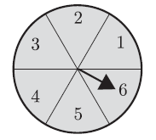  The fraction a/b is formed, where a is the number of sectors on which arrow stops on the first spin and ‘b’ is the number of the sector in which the arrow stops on second spin, On each spin, each sector has equal chance of selection by the arrow. What is the probability that the fraction a/b > 1 | 3
4 | A box contains 5 white balls, 3 red balls, and 2 green balls. If three balls are drawn one by one without replacement, what is the probability that all three balls are of different colors? | 3
5 | In class X, there are 35 boys and 25 girls. In the Mathematics period, 5 students randomly taken out of class one after another without making them entry into the class. Now find the probability that 5 of them are girls? | 3
6 | In a school, there are 500 students. A survey conducted in the school for the favorite subject among Hindi, Mathematics and science. After survey it was found that 250 liked Hindi as their favorite subject, 150 liked Mathematics as their favorite subject and 100 liked Science as their favorite subject. If three students picked from the school randomly, then what is the probability that all three are of different student having different favorite subject. | 3
7 | Two unbiased coins are tossed simultaneously. Find the probability of getting  (i) at least one head  (ii) at most one head  (iii) no head | 3
8 | A bag contains cards numbered 1 to 49. Find the probability that the number on the drawn card is  (i) an odd number  (ii) a multiple of 5  (iii) Even prime | 3
9 | Two dice are tossed simultaneously. Find the probability of getting  (i) an even number on both dice.  (ii) the sum of two numbers more than 9. | 3
10 | Sachin and Saurav are playing with dice. Sachin throws two dice once and compute the product of the two numbers appearing on the top of the dice. Saurav throws one die and square the number appearing on the top of the die. Who has the better chance of getting the number 36 ? Why? | 3
 | ANSWERS
1 | The number of possible outcomes = Number of balls in the bag = n(S) = 3.  (i) The number of outcomes favourable to the event Y = n(Y) = 1.  So, P(Y) = n(Y)/n(S) =1/3Similarly,  (ii) P(R) = 1/3and  (iii) P(B) = | 3
2 | Total number of outcomes = 80  Perfect square numbers from 1 to 80 = 1 ,4, 9, 16, 25, 36, 49, 64  Therefore, favourable outcomes = 8  Probability of getting a perfect square number = 8/80 = 1/10. | 3
3 | For a/b>1, when a=1,b cannot take any value,  a=2,b can take 1 value,  a=3,b can take 2 value,  a=4,b can take 3 values,  a=5,b can take 4 values,  a=6,b can take 5 values.  Total possible outcomes =36  3∴P(a/b>1)=(1+2+3+4+5)/36 ​=15/36​ or 5/12 ​ | 3
4 | Calculate the probability of drawing a white ball first (5/10), then a red ball (3/9), and finally a green ball (2/8). Multiply these three probabilities to find the probability that all three balls are of different colors.  Probability= (5/10)*(3/9)*(2/8)= 1/24 | 3
5 | Total boys and girls= 35+25= 60  Probability for all 5 are girls will be (25/60)*(24/59)*(23/58)*(22/57)*(21/56)= (17710/1820504)= 0.009(approx.) | 3
6 | To calculate this probability, we'll consider the following cases:  First student likes Hindi, second student likes Mathematics, third student likes Science.  First student likes Hindi, second student likes Science, third student likes Mathematics.  First student likes Mathematics, second student likes Hindi, third student likes Science.  First student likes Mathematics, second student likes Science, third student likes Hindi.  First student likes Science, second student likes Hindi, third student likes Mathematics.  First student likes Science, second student likes Mathematics, third student likes Hindi.  So, probability= 6× (250/500)×(150/500)×(100/500)= 6×(1/2)×(3/10)×(1/5)=9/50 | 3
7 | - $\frac{3}{4}$  - $\frac{3}{4}$  - $\frac{1}{4}$ | 3
8 | - $\frac{25}{49}$  - $\frac{9}{49}$  - $\frac{1}{49}$ | 3
9 | - $\frac{1}{4}$  - $\frac{1}{6}$ | 3
10 | FOR SACHIN  No. of all possible outcomes = 36  Let, ‘E ‘ be the event of getting the product of numbers appearing on the top of the dice as 36.  $∴$ No. of outcome favorable to E = 1  $∴$ P( E ) = $\frac{1}{36}$  FOR SAURAV  No. of all possible outcomes = 6  Let, ‘F’ be the event of getting the product of the number appearing on the top of the die as 36.  No. of outcome favorable to F = 1  $∴$ P(F) = $\frac{1}{6}$  Since , $\frac{1}{6}$ $>$ $\frac{1}{36}$  $∴$ SAURAV has better chance of getting 36. | 3
 | 4 – MARKS TYPE QUESTIONS (CASE BASED QUESTIONS)
1 | A card is drawn at random from a well-shuffled deck of playing cards. Find the probability that the card drawn is  (i) A card of spade or an ace.  (ii) A black king.  (iii) Neither a jack nor a king  (iv) Either a king or a queen. | 4
2 | Cards on which numbers 1, 2, 3, 4, --------100 are written (one number on one card and no number is repeated) and put in a bag and are mixed thoroughly. A card is drawn at random from the bag, find the probability that card taken out has:  (i) An even number  (ii) A number which is a multiple of 13.  (iii) A perfect square numbers  (iv) A prime number less than 20. | 4
3 | A middle school decided to run the following spinner game as a fund – raiser on Christmas carnival.  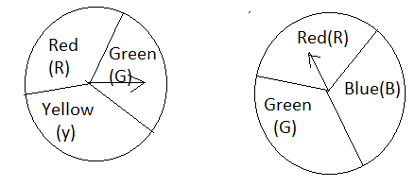  Making purple: Spin each spinner once. Blue and red make purple. So, if one spinner shows Red(R) and another Blue(B) , then you ‘win’. One such outcome is written as ‘RB’.  Based on the above, answer the following questions:  (i) List all possible outcomes of the game.  (ii) Find probability of making purple.  (iii)  - For each win, a participant gets Rs 10 , but he / she loses , he/ she has to pay Rs 5 to school .  - If 99 students played, calculate how much fund could the school have collected?  OR  (b) If the same amount of Rs. 5 has been decided for winning or losing the game, then how much fund could the school had been collected? | 4
4 | Two friends, Suri and Anitha, decided to play the game pocket billiard on their holiday. The game is similar to the carom game , except but it has 6 holes on the board to strike the balls into it . This game consists of 15 numbered color balls and one cue ball which is used to strike the other 15 numbered color balls to the holes . These balls are arranged in a pyramid form. The first player strikes them using the white ball (cue ball) to break the formation and then tries to sink the balls into the holes. Each player takes alternate turns to strike the balls.  (IGNORE the cue ball while taking the total number of balls)    Based on the above fact , answer the following questions.  (i) If Suri plays first , then find the probability that She successfully sinks the ball numbered 2.  (ii) If Anitha plays secondly without replacing the ball numbered 2 , then find the probability that Anitha sinks the ball numbered 15.  (iii) Find the probability that Suri sinks the ball numbered as prime number.  (iv) Find the probability that Anitha sinks a ball numbered divisible by 4 . | 4
5 | There was a quarrel among Bidu, Jadu and Madhu to get first chance in a game. Mr. bean come and says let us solve this problem easily by tossing two coins. If both heads appear, Bidu will take first chance. If both Tails appear ‘Jadu’ will get it & if one head & one tail, ‘Madhu’ will get the first chance.  i) What is the probability of ‘Bidu’ getting the first chance?  ii) What is the probability of ‘Jadu’ getting the first chance?  iii) What is the probability of ‘Madhu’ getting the first chance?  Or  What is the probability of getting at least one head. | 4
6 | Raju finds himself in, during his visit to a dishonest Casino which awards jackpot on drawing an ace. Ignorant Raju does not know that all the red face cards are already removed from the deck of 52 cards that he is dealt from. Raju is offered to draw a card at random from the remaining pack, after reshuffling them.  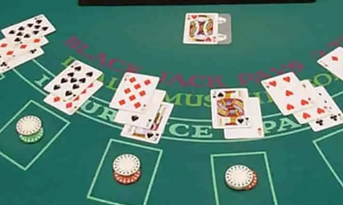  Now answer the followings:  i) Find the probability that Raju draws a red queen.  ii) Find the probability that Raju draws a king.  iii) Find the probability that Raju gets an ace and win the jackpot.  Or  Find the probability that Raju draws a face card. | 4
 | ANSWERS
1 | (i) 4/13  (ii) 1/52  (iii) 11/13  (iv) 2/13 | 4
2 | The total no. of possible outcomes= 100  (i) No. of even numbers from 1 to 100 = 50  ∴ P ( A even number ) = 50/100= ½  (ii) Multiples of 13 from 1 to 100 are 13, 26, 39, 52, 65, 78 and 91  No. of favourable Outcomes = 7  ∴ P (multiple of 13 )= 7/100  (iii) Perfect square no, from 1 to 100 are 1, 4, 9, 16, 25, 36, 49, 64, 81 and 100  No. of favorable outcomes = 10  ∴ P (perfect square number) = 10/100=1/10  (iv) Prime numbers less than 20 are 2, 3, 5, 7, 11, 13, 17 and 19  No. of favorable outcomes = 8  ∴ P ( A prime number less than 20 ) = 8/100= 2/25. | 4
3 | No. of all possible outcome =$\frac{No. of favourable outcome}{No of all possible outcome}$  i)1/4 ii) ¼ iii)1/2 or 3/4 | 4
4 | No of red face card=6  No. of all possible outcome=46  i) 0 ii)1/23 iii) 2/23 or 3/23 | 4
5 | ANSWER | 4
6 | ANSWER | 4
 | 5 – MARKS TYPE QUESTIONS
1 | Eight Ball : This is a game played on a pool table with 15  balls numbered 1 through 15 and a cue ball that is solid  white. Of the 15 numbered balls, 8 are a solid (nonwhite)  color and numbered 1 through 8, and seven are striped balls  numbered 9 through 15.The fifteen numbered pool balls (no cueball) are placed in a large bowl and mixed, then one is drawn out.  (i) What is the probability that the drawn ball bears number 8?  (ii) What is the probability of drawing a number greater than fifteen?  (iii) What is the probability of drawing an even number?  (iv) What is the probability of drawing a multiple of three?  (v) What is the probability of drawing a solid color and an even number? | 5
2 | 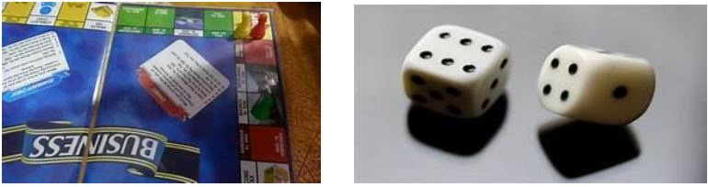  Rahul and Ravi planned to play Business (board game) in which they were supposed to use two dice.  1. Ravi got first chance to roll the dice. What is the probability that he got the sum of the two numbers appearing on the top face of the dice is 8?  a) 1/26 b) 5/36 c) 1/18 d) 0  2. Rahul got next chance. What is the probability that he got the sum of the two numbers appearing on the top face of the dice is 13?  a) 1. b) 5/36. c) 1/18. d) 0  3. Now it was Ravi’s turn. He rolled the dice. What is the probability that he got the sum of the two numbers appearing on the top face of the dice is less than or equal to 12?  a) 1. b) 5/36. c) 1/18. d) 0  4. Rahul got next chance. What is the probability that he got the sum of the two numbers appearing on the top face of the dice is equal to 7?  a) 5/9. b) 5/36. c) 1/6. d) 0  5. Now it was Ravi’s turn. He rolled the dice. What is the probability that he got the sum of the two numbers appearing on the top face of the dice is greater than 8?  a) 1. b) 5/36. c) 1/18. d) 5/18 | 5
3 | On a weekend Rani was playing cards with her family. The deck has 52 cards. If her brother drew one card.  1. Find the probability of getting a king of red color.  a) 1/26. b) 1/13. c) 1/5. d) 1/4  2. Find the probability of getting a face card.  a) 1/26. b) 1/13. c) 2/13. d) 3/13  3. Find the probability of getting a jack of hearts.  a) 1/26. b) 1/52. c) 3/52. d) 3/26  4. Find the probability of getting a jack of hearts.  a) 3/13. b) 1/13. c) 1/52. d) 1/4  5. Find the probability of getting a jack of hearts.  a) 1/26. b) 1/13. c) 1/52. d) 1/4 | 5
4 | In a sample of 50 people, 21 had type O blood, 22 had type A blood, 5 had type B blood, and 2 had type AB blood. Set up a frequency distribution and find the following probabilities.  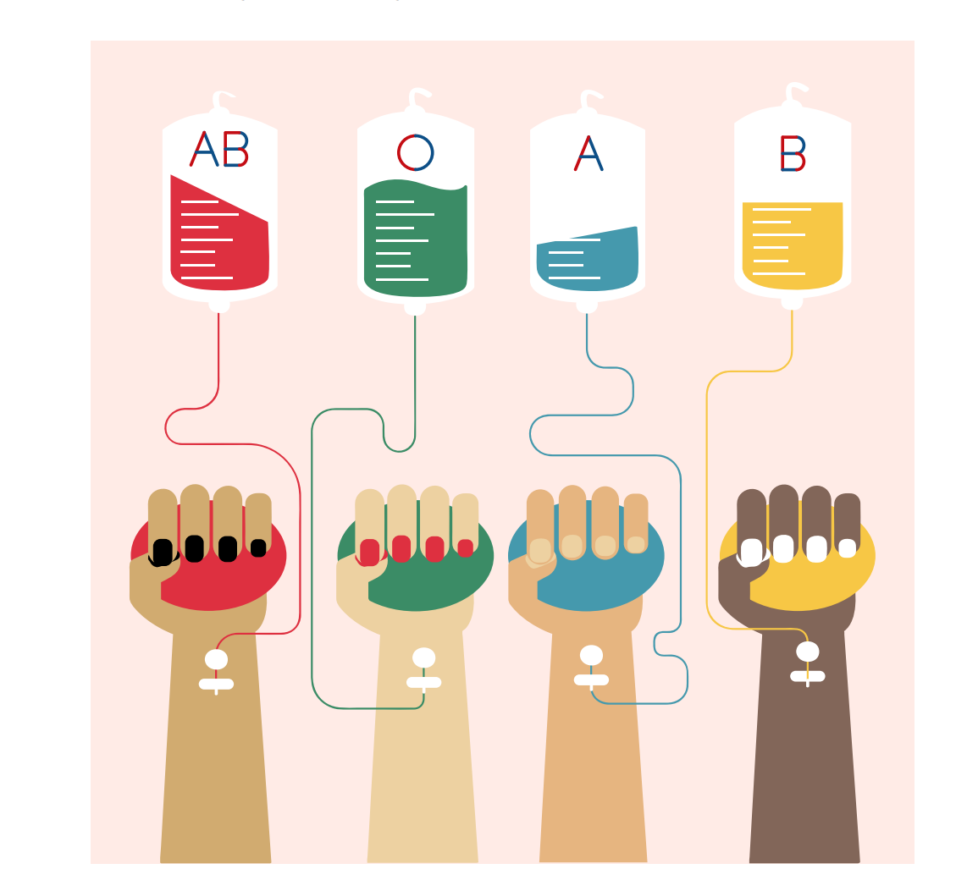  (i) What is the probability that a person has type O blood?  (ii) What is the probability that a person has type A or type B blood?  (iii) What is the probability that a person has neither type A nor type O blood?  (iv) What is the probability that a person does not have type AB blood?  (v) What is the probability of impossible and sure events respectively. | 5
5 | A circular dartboard has a total radius of 8 inch, with circular bands that are 2 inch wide, as shown in figure. Abhinav is still skilled enough to hit this board 100% of the time so he always score at least two points each time he throws a dart. Assume the probabilities are related to area, on the next dart that he throws.  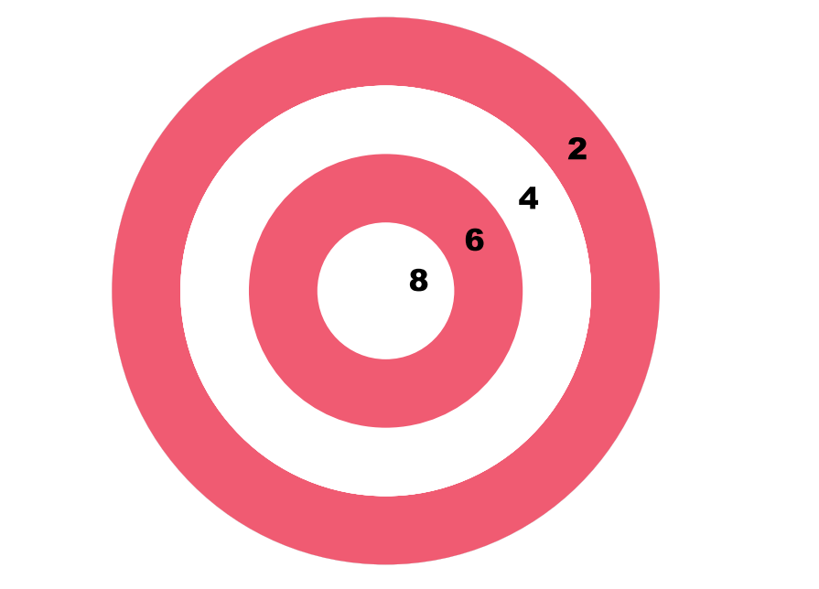  - What is the probability that he scores at least 4?  - What is the probability that he scores at least 6?  - What is the probability that he hit bull’s eye?  - What is the probability that he scores exactly 4 points?  What is the probability that he scores exactly 2 points? | 5
 | ANSWERS
1 | (i) Probability of number 8 = 1/ Total number of balls= 1/15  (ii) Probability of a number greater than 15= 0/15 = 0  (iii) Even number balls are 2, 4, 6, 8, 10, 12, 14  Total no. of even number balls = 7  Probability of an even number ball= no. of even number balls/ Total no. of balls  = 7/15  (iv) multiples of 3 are 3, 6, 9, 12, 15  Probability of multiple of 3 balls = 5/15= 1/3  (v) Solid colored and even number balls are 2, 4, 6, 8  Required probability = No. of favorable Outcomes / Total no. of Outcomes= 4/15 | 5
2 | 1.(b) 2.(d). 3.(a). 4.(c). 5.(d) | 5
3 | 1.(a) 2.(d). 3.(a). 4.(a). 5.(d) | 5
4 | - $\frac{21}{50}$  - $\frac{27}{50}$  - $\frac{7}{50}$  - $\frac{24}{25}$  - 0 and 1 | 5
5 | - $\frac{9}{16}$  - $\frac{1}{4}$  - $\frac{1}{16}$  - $\frac{5}{16}$  - $\frac{7}{16}$ | 5

